# Wardley Mapping for Startups

# Navigating Uncertainty and Driving Innovation

### **WARNING: This content was generated using Generative AI. While efforts have been made to ensure accuracy and coherence, readers should approach the material with critical thinking and verify important information from authoritative sources.**

# Table of Contents

**Introduction: The Power of Strategic Mapping for Startups** **4**

The Startup Challenge: Navigating Uncertainty 4

The unique challenges faced by startups 4

The need for strategic tools in a fast-paced environment 7

Why traditional business planning falls short 11

Enter Wardley Mapping 13

What is Wardley Mapping? 13

The origins and evolution of Wardley Mapping 16

Why Wardley Mapping is particularly suited for startups 20

How This Book Will Help You 23

Overview of key concepts and techniques 23

Real-world applications and case studies 26

Integrating Wardley Mapping with other startup methodologies 29

**Chapter 1: Fundamentals of Wardley Mapping for Startups** **33**

The Building Blocks of Wardley Maps 33

Understanding value chains 33

The evolution axis: From genesis to commodity 36

Mapping components and their relationships 39

Creating Your First Wardley Map 42

Identifying user needs and desired outcomes 42

Mapping the value chain for your startup 45

Analysing component evolution and dependencies 49

Interpreting Wardley Maps for Startup Insights 53

Identifying strategic opportunities and threats 53

Understanding market dynamics and competitor positioning 57

Anticipating future trends and disruptions 61

Common Pitfalls and How to Avoid Them 64

Overcomplicating your first maps 64

Misinterpreting component evolution 64

Neglecting to update maps as your startup evolves 67

**Chapter 2: Integrating Wardley Mapping with Lean Startup Principles** **71**

The Synergy Between Wardley Mapping and Lean Startup 71

Overview of Lean Startup methodology 71

How Wardley Mapping complements the Build-Measure-Learn cycle 74

Using maps to inform hypothesis generation and testing 77

Rapid Iteration and Validation Using Wardley Maps 80

Mapping your Minimum Viable Product (MVP) 80

Using maps to identify key assumptions and risks 83

Iterating your business model based on map insights 87

Customer Development Through the Lens of Wardley Mapping 91

Mapping customer segments and their needs 91

Identifying opportunities for pivots and expansions 95

Using maps to guide customer interviews and feedback sessions 98

Case Study: How Startup X Used Wardley Mapping to Pivot Successfully 102

Initial business model and challenges 102

How Wardley Mapping revealed new opportunities 105

The pivot process and outcomes 108

**Chapter 3: Identifying and Leveraging Disruptive Opportunities** **112**

Understanding Disruption Through Wardley Mapping 112

The nature of disruptive innovation 112

How Wardley Maps reveal potential disruptions 115

Identifying weak signals and emerging trends 119

Value Chain Analysis for Competitive Advantage 122

Mapping your industry’s value chain 122

Identifying inefficiencies and pain points 125

Spotting opportunities for vertical and horizontal integration 128

Strategies for Disruptive Innovation 131

Leveraging emerging technologies and practices 131

Creating new markets through value chain reconfiguration 135

Developing platforms and ecosystems 138

Case Studies: Disruptive Startups and Their Wardley Maps 142

Case Study 1: How Startup Y disrupted a traditional industry 142

Case Study 2: Startup Z’s journey from niche player to market leader 145

Lessons learned and common patterns of successful disruption 148

**Chapter 4: Advanced Wardley Mapping Techniques for Startups** **151**

Multi-Map Analysis 151

Creating and comparing alternative future scenarios 151

Mapping different business models and strategies 154

Using multiple maps to inform decision-making 157

Wardley Mapping for Team Alignment and Communication 160

Using maps to build shared understanding 160

Facilitating strategic discussions with stakeholders 163

Communicating vision and strategy to investors 166

Integrating Wardley Mapping with Other Strategic Tools 169

Combining Wardley Maps with Business Model Canvas 169

Using maps alongside SWOT and Porter’s Five Forces 173

Enhancing agile methodologies with Wardley Mapping 176

Wardley Mapping for Resource Allocation and Prioritisation 179

Using maps to inform hiring decisions and team structure 179

Prioritising product features and development efforts 183

Guiding investment in research and development 186

**Chapter 5: The Future of Wardley Mapping for Startups** **190**

Emerging Trends in Strategic Mapping 190

AI and machine learning in Wardley Mapping 190

Real-time mapping and dynamic strategy formulation 193

Integration with big data and predictive analytics 197

Cross-Industry Applications and Insights 201

Wardley Mapping in different startup sectors 201

Lessons from corporate adoption of Wardley Mapping 204

Potential for cross-pollination of ideas and strategies 207

Building a Wardley Mapping Culture in Your Startup 211

Training and skill development for team members 211

Incorporating mapping into regular strategy reviews 214

Fostering a culture of continuous learning and adaptation 217

The Road Ahead: Challenges and Opportunities 221

Addressing common criticisms and limitations of Wardley Mapping 221

Potential developments in mapping theory and practice 224

The role of Wardley Mapping in shaping the future of entrepreneurship 227

**Conclusion: Empowering Your Startup with Wardley Mapping** **230**

Recap of Key Concepts and Techniques 230

The core principles of Wardley Mapping for startups 230

Essential tools and frameworks covered 233

How Wardley Mapping addresses key startup challenges 236

Action Plan for Implementing Wardley Mapping 240

Steps to introduce Wardley Mapping in your startup 240

Resources for further learning and practice 243

Building a community of practice 246

Final Thoughts and Inspiration 250

The transformative potential of strategic mapping 250

Encouragement for continuous exploration and innovation 253

Invitation to share experiences and contribute to the field 256

**Appendix** **260**

Book Generation Details 260

Further Reading on Wardley Mapping 260

**Appendix: Further Reading on Wardley Mapping** **260**

Core Wardley Mapping Series 260

Practical Resources 264

Specialized Applications 264

# Introduction: The Power of Strategic Mapping for Startups

## The Startup Challenge: Navigating Uncertainty

### The unique challenges faced by startups

Startups operate in an environment of extreme uncertainty, facing a unique set of challenges that distinguish them from established businesses. As an expert in Wardley Mapping for startups, particularly within government and public sector contexts, I’ve observed how these challenges can make or break a new venture. Understanding these challenges is crucial for appreciating why strategic tools like Wardley Mapping are so vital for startup success.

Let’s explore the key challenges that startups face and how they contribute to the overall uncertainty of the startup landscape:

* Limited Resources
* Market Uncertainty
* Rapid Change and Evolution
* Lack of Established Processes
* Fierce Competition
* Regulatory Hurdles

Limited Resources: Perhaps the most pressing challenge for most startups is the scarcity of resources. This includes financial capital, human resources, and time. Startups often operate on tight budgets, with founders wearing multiple hats and teams working long hours to bring their vision to life. This resource constraint means that every decision carries significant weight, as missteps can be costly and potentially fatal to the business.

In my experience advising government-backed startup incubators, I’ve seen countless promising ventures falter not due to lack of innovation, but due to poor resource allocation. The ability to strategically deploy limited resources is often what separates successful startups from those that fail.

Market Uncertainty: Startups often enter markets with unproven business models or novel products. This means they face significant uncertainty about market demand, customer preferences, and the viability of their offering. In the public sector, this uncertainty is compounded by the complex needs of government agencies and the public at large.

Rapid Change and Evolution: The startup environment is characterised by rapid change. Technologies evolve, market conditions shift, and customer needs transform quickly. Startups must be agile enough to pivot their strategies and adapt their products in response to these changes. This constant state of flux adds another layer of uncertainty to the startup journey.

Lack of Established Processes: Unlike established companies, startups often lack well-defined processes and structures. While this can provide flexibility, it also means that startups must invest time and resources in developing these processes as they grow. This can lead to inefficiencies and mistakes as the organisation scales.

Fierce Competition: Startups not only compete with other new ventures but also with established players in their industry. In the public sector, this can mean competing with long-standing government contractors or internal government teams. The competitive landscape is often intense, with multiple players vying for market share and customer attention.

Regulatory Hurdles: Particularly relevant for startups in the public sector or those working with government agencies, navigating complex regulatory environments can be a significant challenge. Compliance with government regulations, data protection laws, and industry-specific requirements can be resource-intensive and time-consuming.

A senior government official once told me, ‘The startups that succeed in the public sector are those that can innovate within the constraints of our regulatory framework.’ This encapsulates the unique challenge of balancing innovation with compliance in the government startup space.

These challenges collectively contribute to the high failure rate of startups. According to various studies, anywhere from 60% to 90% of startups fail within their first few years of operation. This statistic underscores the critical need for strategic tools and methodologies that can help startups navigate this uncertain landscape.

Wardley Mapping emerges as a powerful tool in this context. By providing a visual representation of the value chain and the evolution of components within a business ecosystem, Wardley Mapping helps startups to:

* Identify and prioritise key areas for resource allocation
* Understand market dynamics and anticipate changes
* Develop adaptive strategies that can evolve with the business
* Identify potential regulatory challenges early in the development process
* Visualise competitive landscapes and identify strategic opportunities

In my work with government agencies and public sector startups, I’ve seen how Wardley Mapping can be particularly effective in navigating the unique challenges of this sector. For instance, a govtech startup I advised used Wardley Mapping to identify underserved areas in public service delivery, allowing them to develop a targeted solution that addressed a critical need while navigating complex procurement processes.

As we delve deeper into Wardley Mapping techniques throughout this book, we’ll explore how this strategic tool can be applied to each of these challenge areas, providing startups with a powerful framework for decision-making and strategy formulation in uncertain environments.

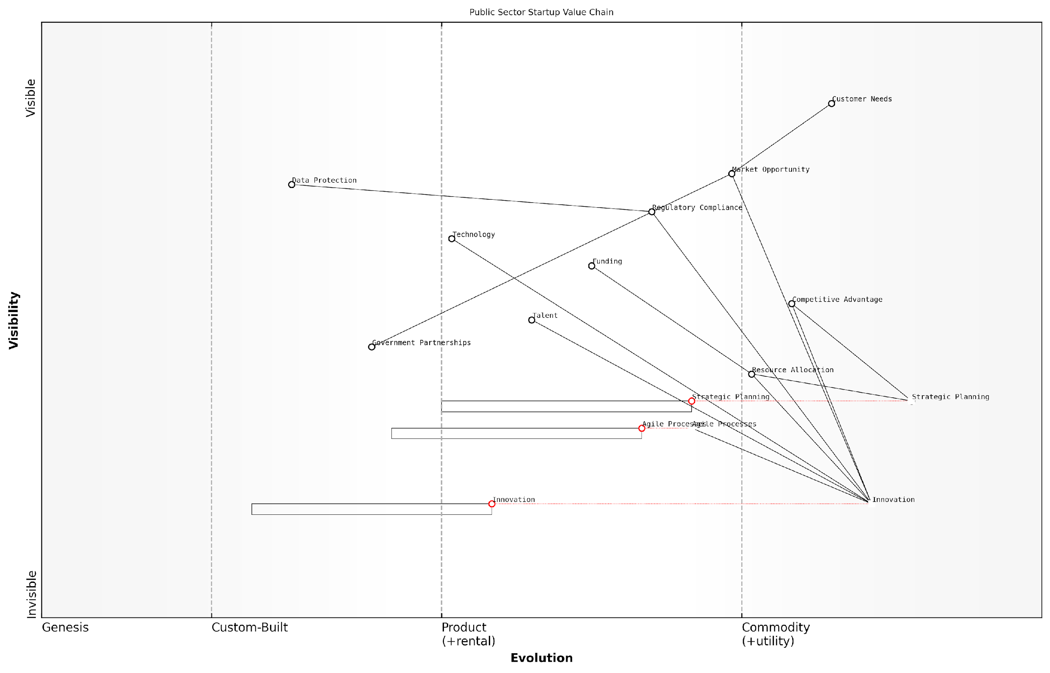

*Draft Wardley Map: [Insert Wardley Map: The unique challenges faced by startups]*

[Edit this draft Wardley Map](https://create.wardleymaps.ai/#clone:4ba844c8f997756bbe)

Wardley Map Assessment

This Wardley Map reveals a challenging but opportunity-rich landscape for public sector startups. The key to success lies in balancing rapid innovation with regulatory compliance, while building strong government partnerships. Startups must leverage their agility and technological expertise to address specific public sector needs, all while navigating a complex funding and partnership environment. The evolving nature of key components suggests that continuous adaptation and strategic foresight will be critical. Those who can effectively manage these unique challenges while driving innovation stand to gain significant competitive advantage in this specialised market.

[View full Wardley Map report](http://markdown_wardley_map_reports/wardley_map_report_01_The_unique_challenges_faced_by_startups.md)

By understanding these unique challenges and leveraging tools like Wardley Mapping, startups can increase their chances of success, turning uncertainty into opportunity and navigating the complex landscape of innovation and growth.

### The need for strategic tools in a fast-paced environment

In the rapidly evolving landscape of startups, the need for robust strategic tools has never been more critical. As an expert who has advised numerous government bodies and public sector organisations on implementing Wardley Mapping, I’ve witnessed firsthand how the right strategic framework can be the difference between a startup’s success and failure. The fast-paced nature of the startup ecosystem demands tools that can provide clarity, adaptability, and foresight—qualities that are essential for navigating the inherent uncertainties of entrepreneurship.

Startups operate in an environment characterised by constant change, limited resources, and intense competition. Traditional business planning methods, while valuable in stable markets, often fall short in capturing the dynamic nature of startup ecosystems. This is where strategic tools like Wardley Mapping come into play, offering a unique approach to visualising and analysing the competitive landscape.

In the world of startups, the ability to adapt quickly and make informed decisions is paramount. Strategic tools that provide a clear view of the landscape and potential future scenarios are not just useful—they’re essential for survival and growth.

Let’s delve into the key reasons why strategic tools are indispensable in the fast-paced startup environment:

* Rapid Decision Making: In a startup, decisions often need to be made quickly and with limited information. Strategic tools provide a framework for structuring available data and insights, enabling faster and more informed decision-making.
* Resource Optimisation: With limited resources, startups must be judicious in their allocation. Strategic tools help identify the most critical areas for investment and development, ensuring that scarce resources are used effectively.
* Competitive Advantage: Understanding the competitive landscape is crucial for startups. Strategic tools like Wardley Mapping offer a unique perspective on market positioning and potential areas for differentiation.
* Adaptability: The ability to pivot quickly is often a key success factor for startups. Strategic tools that provide a clear view of the market landscape and potential future scenarios enable startups to adapt their strategies more effectively.
* Communication and Alignment: Clear communication of strategy is essential, particularly when dealing with diverse stakeholders such as team members, investors, and partners. Visual strategic tools facilitate better understanding and alignment across these groups.

One of the most powerful strategic tools available to startups is Wardley Mapping. This technique, which I’ve successfully implemented in various government and public sector projects, offers a unique approach to visualising the business landscape and planning strategy.

Wardley Mapping is particularly well-suited to the startup environment for several reasons:

* Visual Representation: Wardley Maps provide a clear, visual representation of the business landscape, making it easier for startup teams to understand and discuss complex strategic issues.
* Future-Oriented: The evolution axis in Wardley Maps helps startups anticipate future market changes and plan accordingly.
* Value Chain Focus: By mapping the entire value chain, startups can identify opportunities for innovation and disruption that might not be apparent through other analytical methods.
* Flexibility: Wardley Maps can be easily updated as new information becomes available, making them ideal for the rapidly changing startup environment.
* Strategic Play: The concept of ‘gameplay’ in Wardley Mapping aligns well with the need for startups to make strategic moves in response to market conditions and competitor actions.

In my experience advising government bodies on innovation strategies, I’ve seen how Wardley Mapping can be particularly effective in identifying opportunities for public-private partnerships and areas where startups can contribute to solving public sector challenges. This is increasingly relevant as governments worldwide seek to harness the innovation potential of startups to address complex societal issues.

Wardley Mapping has proven to be an invaluable tool for startups engaging with the public sector. It provides a common language for discussing strategy and helps bridge the gap between the fast-paced world of startups and the more structured environment of government agencies.

However, it’s important to note that while strategic tools like Wardley Mapping are powerful, they are not a panacea. Their effectiveness depends on proper implementation and integration with other startup methodologies and practices. In my consultancy work, I often emphasise the importance of combining Wardley Mapping with lean startup principles, agile development practices, and other relevant frameworks to create a comprehensive strategic approach.

Let’s consider a brief case study to illustrate the power of strategic tools in a startup context:

A health-tech startup I advised was struggling to gain traction in the competitive telemedicine market. By implementing Wardley Mapping, we were able to visualise the entire value chain of the telemedicine industry, from patient needs to technological components. This exercise revealed an underserved niche in mental health services for rural communities. The startup pivoted its focus to this area, developing tailored solutions that addressed the unique challenges of providing mental health support in remote areas. This strategic shift, informed by the insights gained from Wardley Mapping, led to rapid growth and eventually attracted significant investment from both private and public sector partners.

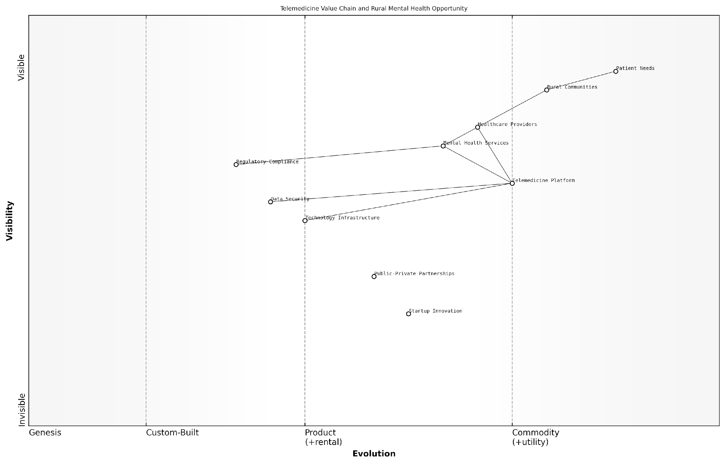

*Draft Wardley Map: [Insert Wardley Map: The need for strategic tools in a fast-paced environment]*

[Edit this draft Wardley Map](https://create.wardleymaps.ai/#clone:c46d58484b7aa5897a)

Wardley Map Assessment

This Wardley Map reveals a significant opportunity in rural mental health telemedicine, with a clear value chain from patient needs to service delivery. The strategic position is strong, with a focus on high-value components. However, success will depend on overcoming infrastructure challenges, navigating regulatory complexities, and continuously innovating in service delivery. The key to long-term success lies in building a robust ecosystem, leveraging partnerships, and staying at the forefront of technological and therapeutic advancements. By focusing on the unique needs of rural communities and investing in both technology and human capital, this venture has the potential to significantly impact rural mental health care delivery.

[View full Wardley Map report](http://markdown_wardley_map_reports/wardley_map_report_02_The_need_for_strategic_tools_in_a_fast-paced_envir.md)

This case exemplifies how strategic tools can provide the clarity and insight needed to navigate the complex and fast-paced startup environment. By offering a structured approach to analysing the market landscape and identifying opportunities, tools like Wardley Mapping enable startups to make informed decisions quickly and adapt their strategies effectively.

In conclusion, the need for strategic tools in the fast-paced startup environment is clear. These tools provide the framework for rapid decision-making, resource optimisation, and strategic planning that are essential for startup success. As startups continue to play an increasingly important role in driving innovation and economic growth, the adoption of sophisticated strategic tools like Wardley Mapping will become even more critical. For founders, investors, and advisors in the startup ecosystem, mastering these tools is not just an advantage—it’s a necessity for navigating the uncertainties and capitalising on the opportunities in the dynamic world of entrepreneurship.

### Why traditional business planning falls short

In the dynamic and uncertain world of startups, traditional business planning often proves inadequate. As an expert who has advised numerous government bodies and startups on strategic planning, I’ve observed firsthand the limitations of conventional approaches when applied to nascent ventures. This section explores why traditional business planning falls short for startups, particularly in the context of Wardley Mapping, and how a more adaptive approach is crucial for success in today’s rapidly evolving markets.

Traditional business planning, with its emphasis on detailed five-year projections and static strategies, was developed in an era of relative stability. However, startups operate in an environment characterised by high uncertainty, rapid technological change, and evolving customer needs. This fundamental mismatch between the assumptions underlying traditional planning and the realities of the startup ecosystem leads to several critical shortcomings:

* Inflexibility in the face of rapid change
* Over-reliance on untested assumptions
* Failure to account for ecosystem dynamics
* Inadequate consideration of technological evolution
* Limited ability to identify and leverage emerging opportunities

Inflexibility is perhaps the most glaring issue. Traditional business plans often become obsolete almost as soon as they’re written, especially in fast-moving sectors like technology or biotech. As a senior adviser to a government innovation agency once remarked to me, ‘By the time a traditional business plan is approved, the market has already moved on.’ This inflexibility can be particularly detrimental in the public sector, where startups often need to navigate complex regulatory environments that may change rapidly in response to technological advancements or societal shifts.

The over-reliance on untested assumptions is another critical flaw. Startups, by their very nature, are venturing into uncharted territory. Traditional business planning often requires founders to make detailed projections based on limited data, leading to what I call the ‘false precision trap’. This can create a dangerous illusion of certainty, potentially misleading investors, team members, and even the founders themselves.

Traditional business plans often confuse precision with accuracy. In the startup world, it’s far more valuable to be roughly right than precisely wrong.

Furthermore, traditional planning methods frequently fail to account for the complex ecosystem dynamics in which startups operate. In my work with government-backed incubators, I’ve observed that startups which succeed are often those that can rapidly adapt to changes in their ecosystem - be it shifts in regulatory frameworks, emergence of new competitors, or evolution of customer preferences. Traditional business plans, with their focus on internal factors and direct competitors, often miss these crucial ecosystem-level insights.

Another significant shortcoming is the inadequate consideration of technological evolution. In my experience advising tech startups in the public sector, I’ve seen how rapid advancements in areas like artificial intelligence, blockchain, or quantum computing can radically alter the competitive landscape. Traditional business planning, with its static view of technology, often fails to anticipate these shifts or provide a framework for responding to them.

Lastly, traditional planning methods have a limited ability to identify and leverage emerging opportunities. Startups often succeed by pivoting into unexpected areas or by combining existing technologies in novel ways. The rigid structure of traditional business plans can blind founders to these possibilities, potentially missing out on their most promising paths to success.

This is where Wardley Mapping offers a compelling alternative. By providing a dynamic, visual representation of the value chain and technological landscape, Wardley Mapping enables startups to:

* Visualise their position within the broader ecosystem
* Anticipate technological and market evolution
* Identify strategic opportunities and potential disruptions
* Adapt quickly to changing circumstances
* Communicate strategy more effectively to stakeholders

For instance, when working with a govtech startup developing a blockchain-based identity verification system, we used Wardley Mapping to anticipate how the regulatory landscape might evolve in response to privacy concerns. This allowed the startup to proactively engage with policymakers and position itself as a thought leader in the space, gaining a significant competitive advantage.

Wardley Mapping doesn’t just help startups plan for the future; it helps them shape it. It’s a tool for strategic foresight, not just forecasting.

In conclusion, while traditional business planning has its place, it falls short in addressing the unique challenges faced by startups, particularly in dynamic sectors or when engaging with the public sector. By embracing more adaptive approaches like Wardley Mapping, startups can navigate uncertainty more effectively, identify strategic opportunities, and increase their chances of success in today’s complex and rapidly evolving business landscape.

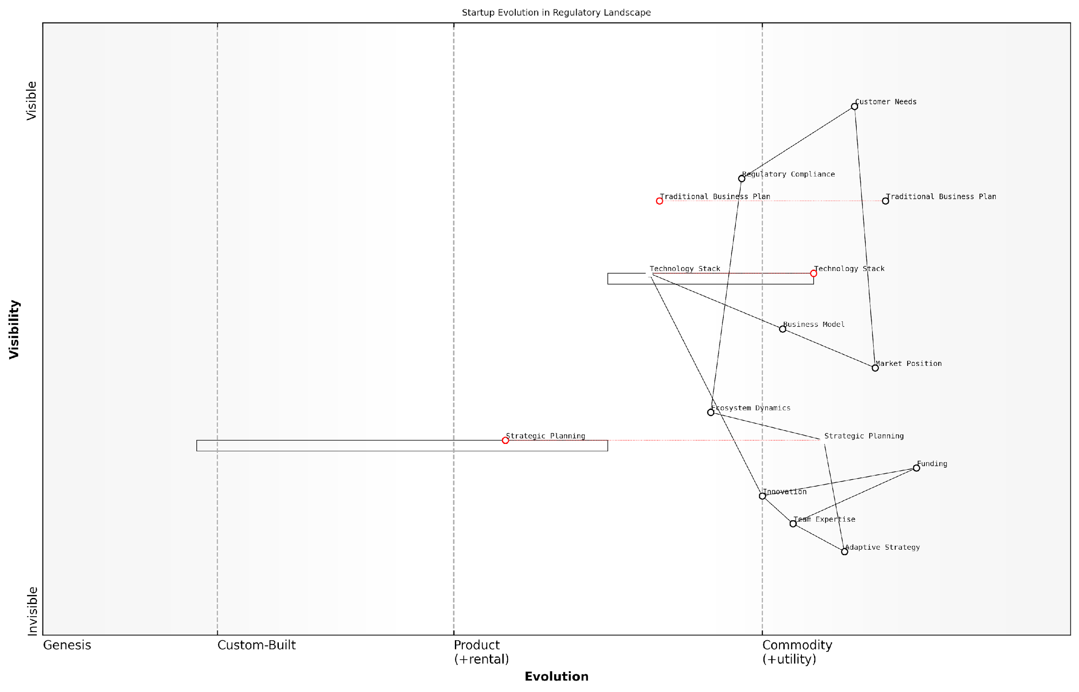

*Draft Wardley Map: [Insert Wardley Map: Why traditional business planning falls short]*

[Edit this draft Wardley Map](https://create.wardleymaps.ai/#clone:35de672c5fdd824377)

Wardley Map Assessment

This Wardley Map reveals a startup landscape in transition, where success hinges on the ability to balance innovation with regulatory compliance while adopting adaptive strategies. The shift from traditional business planning to more flexible approaches is clear, as is the critical role of technology in enabling this transition. Startups that can effectively navigate this complex environment, leveraging ecosystem dynamics and emerging technologies, will be best positioned for success. Key focus areas should include developing adaptive strategies, automating regulatory compliance, and building a flexible technology stack that can evolve with customer needs and market dynamics.

[View full Wardley Map report](http://markdown_wardley_map_reports/wardley_map_report_03_Why_traditional_business_planning_falls_short.md)

## Enter Wardley Mapping

### What is Wardley Mapping?

In the dynamic and uncertain world of startups, having a robust strategic framework is crucial for success. Enter Wardley Mapping, a powerful tool that has revolutionised the way organisations, particularly startups, approach strategy and decision-making. As we delve into this transformative methodology, we’ll explore its essence, origins, and why it’s particularly well-suited for the unique challenges faced by startups in today’s rapidly evolving business landscape.

Wardley Mapping, named after its creator Simon Wardley, is a visual representation of the components needed to serve the user need, organised by value chain and evolution. It provides a unique way to visualise the structure of a business or service, map the components needed to serve the user need, and anticipate changes in the market.

* Visual representation of business components
* Organised by value chain and evolution
* Helps anticipate market changes

At its core, a Wardley Map consists of two axes. The vertical axis represents the value chain, moving from the user need at the top to the underlying components at the bottom. The horizontal axis represents the evolution of these components, from genesis (novel and poorly understood) on the left to commodity (well-understood and often outsourced) on the right.

The power of Wardley Mapping lies in its ability to provide a clear, visual representation of a business landscape, allowing startups to:

* Identify dependencies and potential bottlenecks
* Anticipate market movements and technological shifts
* Make informed strategic decisions based on the evolving landscape
* Communicate complex ideas and strategies effectively to team members and stakeholders

For startups, where resources are often limited and the margin for error is slim, this level of strategic insight is invaluable. It allows founders and teams to make more informed decisions, allocate resources more effectively, and navigate the uncertainties of the market with greater confidence.

Wardley Mapping has been a game-changer for our startup. It’s like having a strategic superpower, allowing us to see the battlefield of business in a way our competitors can’t.

The origins of Wardley Mapping can be traced back to the early 2000s when Simon Wardley, then a CEO grappling with strategic challenges, developed the methodology out of frustration with existing strategic planning tools. Wardley found that traditional methods like SWOT analysis or Porter’s Five Forces, while useful, didn’t provide the dynamic, landscape-level view needed to navigate rapidly changing markets.

Since its inception, Wardley Mapping has evolved and gained traction, particularly in the tech industry and among forward-thinking strategists. Its adoption has been driven by its effectiveness in dealing with complexity and change, two factors that are particularly relevant in the startup world.

Wardley Mapping is particularly suited for startups for several reasons:

* Adaptability: Startups need to be agile and responsive to market changes. Wardley Mapping provides a framework for understanding and anticipating these changes.
* Resource Optimisation: With limited resources, startups must make every decision count. Wardley Mapping helps identify where to invest time and resources for maximum impact.
* Strategic Clarity: In the often chaotic early stages of a startup, Wardley Mapping can provide much-needed strategic clarity and direction.
* Innovation Focus: By visualising the evolution of components, startups can identify areas ripe for innovation or disruption.
* Effective Communication: Wardley Maps serve as a powerful communication tool, helping startups articulate their vision and strategy to team members, investors, and partners.

In the government and public sector context, Wardley Mapping has proven particularly valuable. It has been used to drive digital transformation initiatives, optimise service delivery, and navigate complex policy landscapes. For startups working with or within the public sector, understanding and utilising Wardley Mapping can provide a significant competitive advantage.

In my experience advising government bodies, I’ve seen Wardley Mapping transform the way public sector organisations approach strategy and innovation. It’s a powerful tool for navigating the unique complexities of public service delivery and policy implementation.

A case in point is the use of Wardley Mapping by the UK’s Government Digital Service (GDS). By mapping out the components of various government services, GDS was able to identify opportunities for shared platforms and services, leading to significant cost savings and improved citizen experiences. This example illustrates how startups working in govtech or public sector innovation can leverage Wardley Mapping to identify similar opportunities and create value.

As we delve deeper into Wardley Mapping throughout this book, we’ll explore how startups can practically apply this methodology to drive innovation, make better strategic decisions, and ultimately increase their chances of success in an increasingly complex and competitive business landscape.

In the next sections, we’ll examine the origins and evolution of Wardley Mapping in more detail, and further explore why this methodology is particularly well-suited to the unique challenges and opportunities faced by startups. We’ll also begin to look at how Wardley Mapping can be integrated with other startup methodologies to create a powerful toolkit for strategic decision-making and innovation.

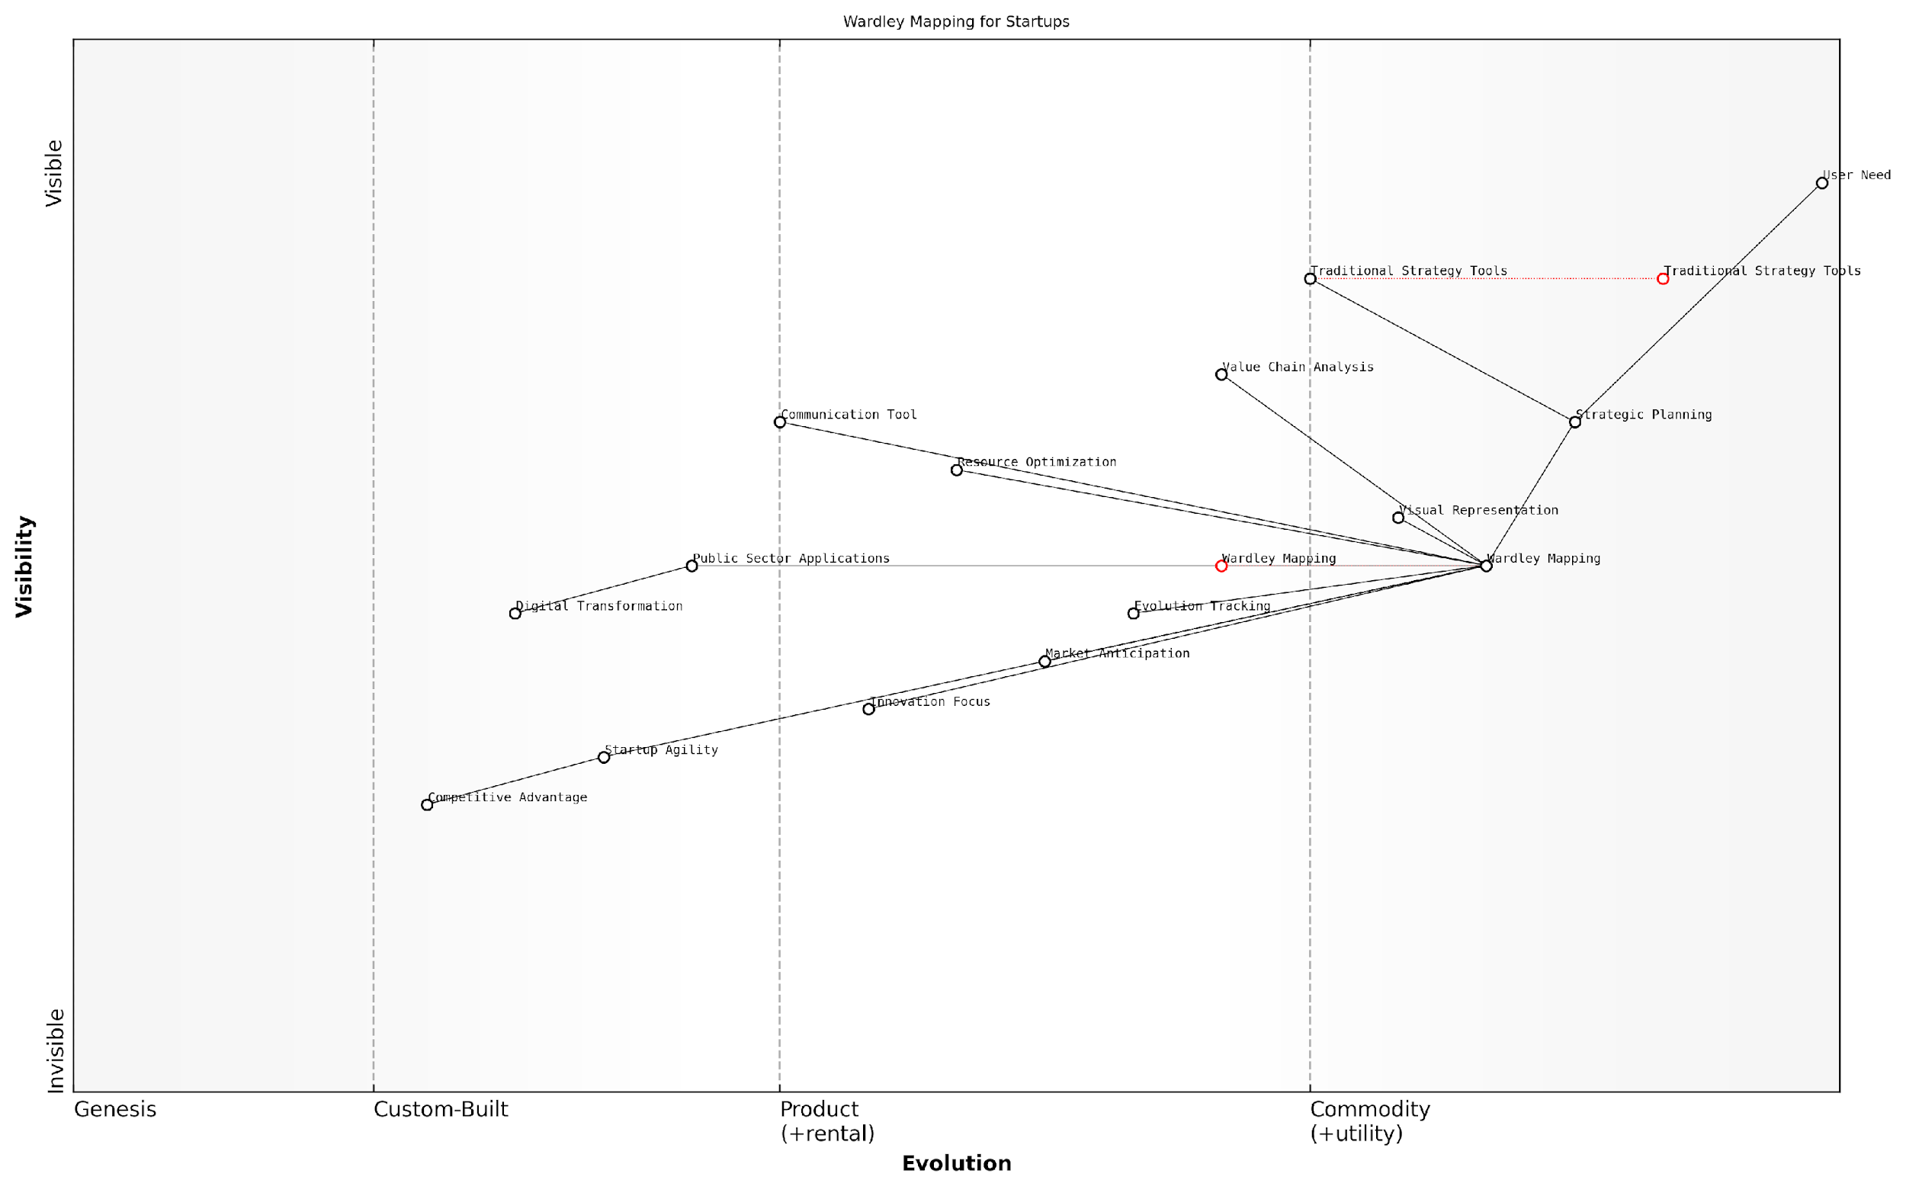

*Draft Wardley Map: [Insert Wardley Map: What is Wardley Mapping?]*

[Edit this draft Wardley Map](https://create.wardleymaps.ai/#clone:2dba6a5fe740456b31)

Wardley Map Assessment

This Wardley Map reveals Wardley Mapping as an evolving, powerful tool for strategic planning, particularly valuable for startups. It offers significant advantages over traditional methods in areas like market anticipation and innovation focus. However, to reach its full potential, efforts should be made to increase adoption, improve ease of use, and integrate with complementary technologies and methodologies. The future of Wardley Mapping looks promising, with potential to become a central component in modern strategic planning processes.

[View full Wardley Map report](http://markdown_wardley_map_reports/wardley_map_report_04_What_is_Wardley_Mapping?.md)

### The origins and evolution of Wardley Mapping

Wardley Mapping, a strategic tool that has revolutionised the way organisations approach business strategy, is particularly well-suited for startups navigating the tumultuous waters of innovation and market disruption. As we delve into the origins and evolution of this powerful methodology, we’ll explore how it addresses the unique challenges faced by startups and why it has become an indispensable tool for entrepreneurs and innovators in the public and private sectors alike.

Simon Wardley, a pioneering researcher in the field of strategic mapping, developed Wardley Mapping in the mid-2000s while working as a CEO in the UK. Frustrated with the limitations of existing strategic tools, Wardley sought to create a methodology that could capture the dynamic nature of business environments and provide actionable insights for decision-makers.

Traditional strategy tools were like trying to navigate a ship with a photograph of the ocean. What we needed was a map that showed the currents, the winds, and the evolving landscape.

Wardley’s breakthrough came from combining elements of value chain analysis, evolutionary theory, and visual mapping techniques. The result was a unique approach that allows organisations to visualise their business landscape, identify opportunities for innovation, and anticipate market changes.

The evolution of Wardley Mapping can be broadly divided into three phases:

* Phase 1: Conception and Early Development (2005-2010)
* Phase 2: Refinement and Growing Adoption (2010-2015)
* Phase 3: Mainstream Recognition and Expansion (2015-Present)

During the conception phase, Wardley refined his ideas through practical application in his own company and through collaboration with other business leaders. The methodology gained traction in tech circles, particularly among those working on cloud computing and digital transformation initiatives.

The refinement phase saw Wardley Mapping being adopted by a wider range of organisations, including government agencies and large corporations. During this period, the methodology was further developed, with Wardley and others publishing extensive writings on the subject and conducting workshops to spread the practice.

In the current phase of mainstream recognition, Wardley Mapping has become a staple in the toolkit of strategic consultants, innovation teams, and forward-thinking executives. Its application has expanded beyond technology strategy to areas such as organisational design, policy-making, and even personal career planning.

Wardley Mapping has evolved from a niche technique to a fundamental approach for understanding and shaping the future of organisations and industries.

For startups, Wardley Mapping offers several unique advantages that make it particularly valuable:

* Visualising the Competitive Landscape: Startups can map out their industry’s value chain, identifying where they fit and where opportunities for disruption exist.
* Anticipating Market Evolution: The evolutionary axis of Wardley Maps helps startups predict how technologies and practices will evolve, allowing them to position themselves ahead of the curve.
* Informing Strategic Decisions: By providing a clear visual representation of the business landscape, Wardley Maps enable startup founders to make more informed decisions about resource allocation, product development, and market entry strategies.
* Communicating Vision: Wardley Maps serve as powerful tools for communicating a startup’s vision and strategy to team members, investors, and partners.
* Identifying Dependencies and Risks: The mapping process helps startups uncover hidden dependencies and potential risks in their business model, allowing for proactive risk management.

The application of Wardley Mapping in the public sector has been particularly noteworthy. Government agencies and public sector organisations have found the methodology invaluable for tackling complex policy challenges, improving service delivery, and driving digital transformation initiatives.

For example, the UK Government Digital Service (GDS) has been a prominent adopter of Wardley Mapping, using it to guide the development of digital services and to inform policy decisions. The methodology has helped GDS identify opportunities for shared services, prioritise technology investments, and anticipate the impact of emerging technologies on public service delivery.

Wardley Mapping has transformed how we approach digital transformation in government. It’s not just about technology; it’s about understanding the entire ecosystem and how it evolves over time.

As Wardley Mapping continues to evolve, we’re seeing new developments that promise to enhance its utility for startups and established organisations alike:

* Integration with AI and Machine Learning: Researchers are exploring ways to use AI to generate and analyse Wardley Maps, potentially automating parts of the strategic planning process.
* Dynamic Mapping Tools: New software tools are emerging that allow for real-time collaboration on Wardley Maps, making it easier for distributed teams to work together on strategic planning.
* Cross-Industry Applications: As the methodology spreads, we’re seeing innovative applications in fields as diverse as healthcare, education, and sustainable development.
* Academic Research: Universities are beginning to incorporate Wardley Mapping into business and strategy curricula, leading to more rigorous academic study of the methodology.

For startups, the continued evolution of Wardley Mapping presents exciting possibilities. As the methodology becomes more sophisticated and accessible, it has the potential to level the playing field, allowing nimble startups to compete more effectively with established players by identifying and capitalising on strategic opportunities.

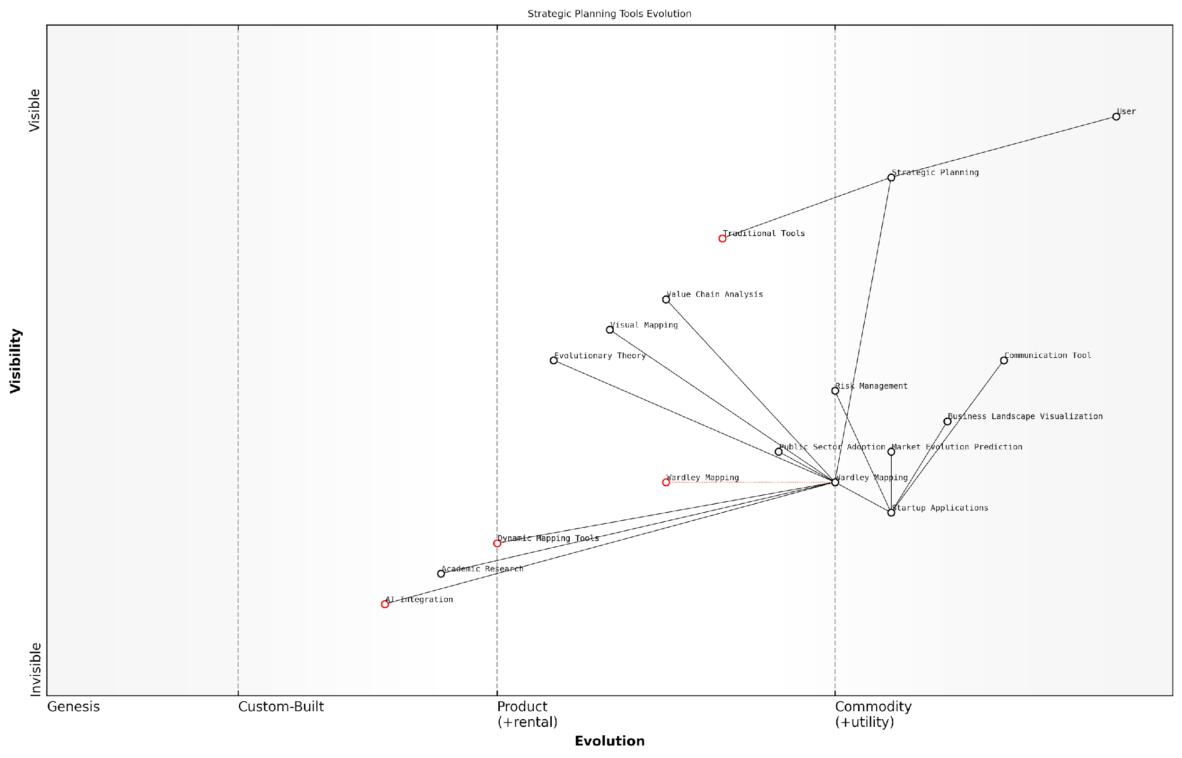

*Draft Wardley Map: [Insert Wardley Map: The origins and evolution of Wardley Mapping]*

[Edit this draft Wardley Map](https://create.wardleymaps.ai/#clone:4258761b2bf7e31d59)

Wardley Map Assessment

This Wardley Map reveals a strategic landscape in transition, with Wardley Mapping emerging as a pivotal methodology bridging traditional approaches with future-oriented, AI-driven strategic planning. The map highlights significant opportunities for innovation, particularly in AI integration and dynamic tool development. Organisations adopting and mastering these evolving methodologies are likely to gain substantial competitive advantages in strategic foresight and adaptability. However, the transition from traditional tools to more advanced approaches presents challenges in adoption, skill development, and integration. The future of strategic planning, as depicted in this map, is more visual, dynamic, and interconnected, requiring a shift in mindset and capabilities across industries.

[View full Wardley Map report](http://markdown_wardley_map_reports/wardley_map_report_05_The_origins_and_evolution_of_Wardley_Mapping.md)

In conclusion, Wardley Mapping has emerged as a powerful tool for startups navigating the complexities of modern business environments. Its origins in the practical challenges of strategic planning, combined with its evolution through real-world application and academic study, have made it uniquely suited to the needs of innovative, fast-moving organisations. As we continue to explore the applications of Wardley Mapping throughout this book, we’ll see how startups can leverage this methodology to gain competitive advantage, drive innovation, and chart a course for sustainable growth in an increasingly uncertain world.

### Why Wardley Mapping is particularly suited for startups

Wardley Mapping emerges as a powerful strategic tool uniquely suited to the dynamic and uncertain environment in which startups operate. As an expert who has advised numerous startups and government bodies on strategic planning, I can attest to the transformative potential of this approach for nascent ventures. Wardley Mapping offers a visual and intuitive framework that aligns perfectly with the agile, iterative nature of startup development, providing a clear path through the fog of market uncertainty.

At its core, Wardley Mapping addresses several key challenges that startups face, making it an invaluable tool in their strategic arsenal:

* Visualising the competitive landscape
* Identifying strategic opportunities
* Facilitating rapid iteration and pivoting
* Enhancing communication and alignment
* Optimising resource allocation

Let’s delve deeper into each of these aspects to understand why Wardley Mapping is particularly well-suited for startups.

Visualising the Competitive Landscape:

Startups often operate in nascent or rapidly evolving markets where traditional industry analysis tools fall short. Wardley Mapping provides a dynamic view of the market, plotting components along axes of visibility to the user and evolution. This visual representation allows startup founders and teams to gain a holistic understanding of their market position, competitor strategies, and potential disruptions.

Wardley Mapping gave us a clear picture of where we stood in relation to our competitors and, more importantly, where the market was heading. It was like having a strategic crystal ball.

This clarity is crucial for startups, who must navigate complex ecosystems with limited resources. By mapping out the value chain and understanding the evolutionary stage of each component, startups can make informed decisions about where to compete, collaborate, or innovate.

Identifying Strategic Opportunities:

One of the most powerful aspects of Wardley Mapping for startups is its ability to reveal hidden opportunities and potential areas for disruption. By visualising the entire value chain, startups can identify inefficiencies, gaps in the market, or areas ripe for innovation that might not be apparent through traditional analysis.

For instance, a startup might identify a component that is essential to the value chain but still in the early stages of evolution. This could represent an opportunity to develop a novel solution or to position the startup as a key player in an emerging market segment. The evolutionary axis of Wardley Maps also helps startups anticipate future market movements, allowing them to prepare for and capitalise on upcoming shifts in the competitive landscape.

Facilitating Rapid Iteration and Pivoting:

Startups thrive on agility and the ability to pivot quickly in response to market feedback. Wardley Mapping aligns perfectly with this need, providing a framework for rapid experimentation and iteration. By creating multiple scenario maps, startups can explore different strategic options and their potential outcomes, facilitating data-driven decision-making.

Wardley Mapping became our go-to tool for strategic planning. It allowed us to quickly test different scenarios and pivot our business model with confidence.

Moreover, the iterative nature of Wardley Mapping encourages startups to continuously reassess their position and strategy as new information becomes available. This aligns well with the Build-Measure-Learn cycle popularised by the Lean Startup methodology, enabling startups to adapt swiftly to changing market conditions or customer needs.

Enhancing Communication and Alignment:

Effective communication is crucial for startups, whether it’s aligning the internal team, pitching to investors, or engaging with potential partners. Wardley Maps serve as a powerful visual tool to articulate complex strategies and market dynamics in a clear, intuitive manner.

For internal teams, Wardley Mapping fosters a shared understanding of the company’s strategic direction and the rationale behind key decisions. This alignment is particularly valuable in the fast-paced startup environment where everyone needs to be moving in the same direction.

When communicating with external stakeholders, such as investors or potential partners, Wardley Maps provide a compelling visual narrative of the startup’s strategy and market position. This can be instrumental in securing funding or forging strategic alliances.

Optimising Resource Allocation:

Resource constraints are a reality for most startups, making efficient allocation of time, money, and talent critical. Wardley Mapping aids in this process by providing a clear view of which components are most crucial to the value chain and at what evolutionary stage they are.

This insight allows startups to prioritise their efforts and investments more effectively. For example, a startup might choose to focus resources on developing a proprietary solution for a component that is both essential to their value proposition and in the early stages of evolution, while opting to use off-the-shelf solutions for more commoditised components.

Wardley Mapping transformed how we allocated our limited resources. It helped us focus on the areas where we could create the most value and differentiate ourselves from competitors.

Furthermore, Wardley Mapping can inform hiring decisions by highlighting areas where the startup needs to build capabilities to execute its strategy effectively.

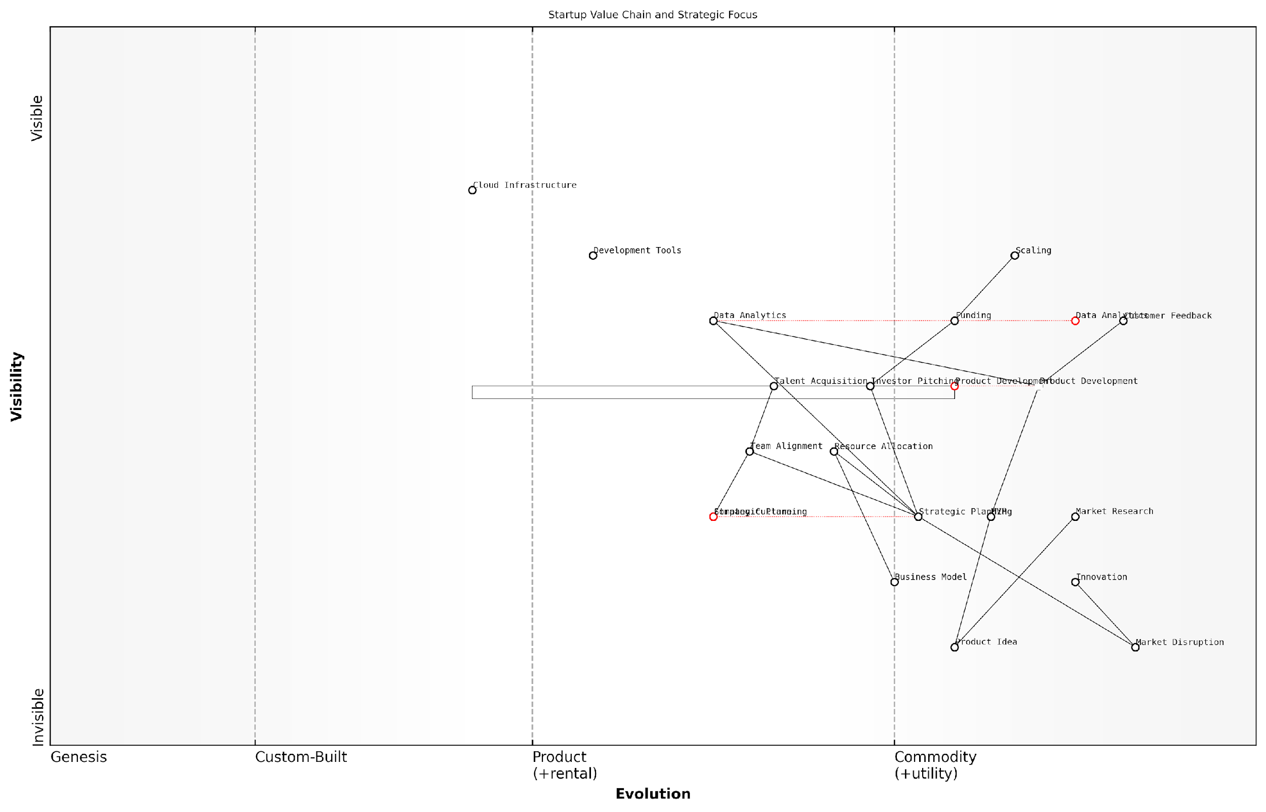

*Draft Wardley Map: [Insert Wardley Map: Why Wardley Mapping is particularly suited for startups]*

[Edit this draft Wardley Map](https://create.wardleymaps.ai/#clone:4c3dba3d8ed63fd1ec)

Wardley Map Assessment

This Wardley Map depicts a startup with a strong foundation in understanding customer needs and agile product development. The strategic focus on innovation and market disruption, coupled with attention to operational elements like funding and team alignment, suggests a well-rounded approach. However, there are opportunities to enhance data analytics capabilities, streamline the product development process, and develop more robust scaling strategies. The startup should focus on maintaining its innovative edge while building more standardised processes for long-term sustainability and growth. Key to success will be the ability to rapidly evolve in response to market needs while building a strong, adaptable company culture.

[View full Wardley Map report](http://markdown_wardley_map_reports/wardley_map_report_06_Why_Wardley_Mapping_is_particularly_suited_for_sta.md)

In conclusion, Wardley Mapping offers a unique combination of strategic insight, visual communication, and adaptability that makes it particularly well-suited to the needs of startups. By providing a clear view of the competitive landscape, revealing strategic opportunities, facilitating rapid iteration, enhancing communication, and optimising resource allocation, Wardley Mapping equips startups with a powerful tool to navigate the uncertainties of their journey and increase their chances of success.

As startups continue to drive innovation and disrupt established industries, the adoption of Wardley Mapping as a strategic planning tool is likely to grow. Its ability to provide actionable insights in complex, fast-moving environments makes it an invaluable asset for startup founders and teams looking to chart a course through uncertain waters and build sustainable, successful businesses.

## How This Book Will Help You

### Overview of key concepts and techniques

As an expert in Wardley Mapping with extensive experience applying this powerful tool to startups, particularly within government and public sector contexts, I have crafted this book to be your comprehensive guide to mastering strategic mapping for your venture. This section will provide an overview of the key concepts and techniques you’ll learn, demonstrating how this book will equip you with the knowledge and skills to navigate uncertainty, drive innovation, and achieve sustainable success in the dynamic world of startups.

Wardley Mapping is a transformative approach to strategy that has gained significant traction in recent years, particularly in the public sector and among forward-thinking startups. By providing a visual representation of your business landscape, Wardley Maps enable you to make informed decisions, anticipate market changes, and identify opportunities for innovation and growth. This book will demystify the process of creating and interpreting these maps, making this powerful tool accessible and applicable to your unique startup journey.

* Foundational principles of Wardley Mapping tailored for startup environments
* Step-by-step guidance on creating your first Wardley Map
* Advanced techniques for multi-map analysis and scenario planning
* Integration of Wardley Mapping with Lean Startup methodologies
* Strategies for identifying and leveraging disruptive opportunities
* Real-world case studies and practical examples from government and public sector startups

One of the unique aspects of this book is its focus on the application of Wardley Mapping within the government and public sector startup ecosystem. Drawing from my years of consultancy experience in this domain, I’ll provide insights into the specific challenges and opportunities faced by startups operating in or alongside government entities. You’ll learn how to navigate complex regulatory environments, identify opportunities for public-private partnerships, and leverage government data and resources to drive innovation.

Wardley Mapping has been a game-changer for our GovTech startup. It allowed us to visualise the entire landscape of public sector services and identify gaps where our innovative solutions could make a real impact.

Throughout the book, you’ll find practical exercises and worksheets designed to help you apply the concepts to your own startup. These hands-on activities will guide you through the process of creating your own Wardley Maps, analysing your competitive landscape, and developing strategies for growth and innovation. By the end of the book, you’ll have a portfolio of maps and strategic insights tailored to your specific startup context.

Moreover, this book will teach you how to use Wardley Mapping as a powerful communication tool. You’ll learn how to use maps to align your team around a shared vision, communicate your strategy to investors and stakeholders, and facilitate productive discussions about the future direction of your startup. This is particularly crucial in the government and public sector context, where clear communication and stakeholder alignment are often critical to success.

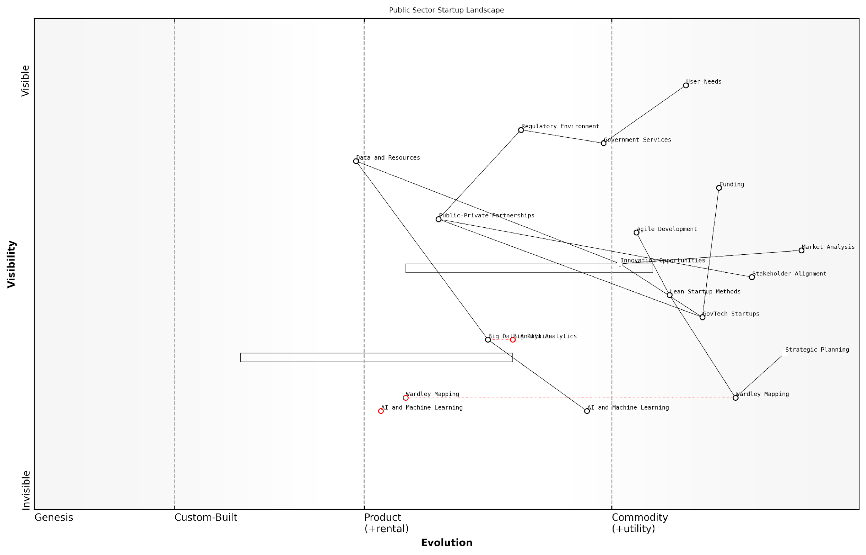

*Draft Wardley Map: [Insert Wardley Map: Overview of key concepts and techniques]*

[Edit this draft Wardley Map](https://create.wardleymaps.ai/#clone:e24f6273962af45c46)

Wardley Map Assessment

The Public Sector Startup Landscape is at a critical juncture, with significant opportunities for innovation and improvement. By leveraging emerging technologies, fostering partnerships, and adopting modern strategic tools like Wardley Mapping, the sector can dramatically enhance its ability to meet user needs. However, this requires careful navigation of regulatory challenges and a commitment to evolving traditional government service models. The successful integration of GovTech startups and emerging technologies into the public sector ecosystem will be key to driving future improvements in government services and citizen satisfaction.

[View full Wardley Map report](http://markdown_wardley_map_reports/wardley_map_report_07_Overview_of_key_concepts_and_techniques.md)

One of the key benefits you’ll gain from this book is the ability to anticipate and adapt to change. In the fast-paced world of startups, especially those operating in or alongside government entities, the ability to foresee market shifts and evolving user needs is invaluable. Through Wardley Mapping, you’ll develop a keen sense of how technologies and practices evolve, allowing you to position your startup advantageously and pivot when necessary.

The book also delves into the integration of Wardley Mapping with other popular startup methodologies and tools. You’ll discover how to combine Wardley Maps with the Business Model Canvas, how to use mapping to enhance your Lean Startup experiments, and how to incorporate mapping into your agile development processes. This holistic approach ensures that Wardley Mapping becomes a central part of your startup’s strategic toolkit, rather than an isolated technique.

The integration of Wardley Mapping with our existing Lean Startup practices has dramatically improved our ability to identify and validate new opportunities in the public sector market. It’s like having a strategic superpower.

Furthermore, this book will introduce you to the cutting-edge developments in the field of Wardley Mapping. You’ll learn about emerging trends such as the application of artificial intelligence to mapping, real-time dynamic mapping, and the integration of big data analytics with Wardley Maps. These insights will prepare you for the future of strategic planning and ensure your startup remains at the forefront of innovation.

* AI-enhanced Wardley Mapping for predictive analysis
* Real-time mapping techniques for dynamic strategy formulation
* Integration of big data and machine learning with Wardley Maps
* Collaborative mapping tools for distributed teams
* Ethical considerations in strategic mapping for public sector startups

Lastly, this book will help you build a culture of strategic thinking within your startup. You’ll learn how to train your team in Wardley Mapping, how to incorporate mapping into your regular strategy reviews, and how to foster a mindset of continuous learning and adaptation. This cultural shift can be transformative, especially for startups working in the often traditional and risk-averse environment of government and public sector services.

In conclusion, this book is your comprehensive guide to mastering Wardley Mapping for startups, with a special focus on the unique challenges and opportunities in the government and public sector space. By the time you finish reading and working through the exercises, you’ll have the knowledge, skills, and tools to navigate uncertainty, drive innovation, and position your startup for long-term success. Whether you’re a first-time founder or a seasoned entrepreneur, this book will empower you to see your business landscape with new clarity and make strategic decisions with confidence.

### Real-world applications and case studies

As an expert in Wardley Mapping for startups, particularly within government and public sector contexts, I can attest to the transformative power of this strategic tool when applied to real-world scenarios. This section will delve into practical applications and illuminating case studies that demonstrate how Wardley Mapping can drive innovation, improve decision-making, and create competitive advantages for startups operating in complex environments.

Wardley Mapping’s strength lies in its ability to visualise the entire value chain of an organisation, from user needs to the underlying components that fulfil those needs. For startups, especially those navigating the intricate landscape of government and public sector work, this visualisation is invaluable. It allows founders and teams to identify opportunities, anticipate market shifts, and make informed strategic decisions.

Wardley Mapping has been a game-changer for our startup. It’s like having a strategic GPS that not only shows where we are but also reveals the terrain ahead and potential shortcuts to our goals.

Let’s explore some key areas where Wardley Mapping has proven particularly effective for startups:

* Identifying market opportunities
* Optimising resource allocation
* Enhancing stakeholder communication
* Driving innovation in established sectors

Identifying market opportunities: Startups often operate in crowded or emerging markets where identifying genuine opportunities can be challenging. Wardley Mapping helps by providing a clear visual representation of the market landscape, including the evolution of various components and potential gaps in the value chain.

Case Study: Consider a startup I advised that was developing a new digital platform for citizen engagement in local government. By creating a Wardley Map of the existing ecosystem, we identified a critical gap in data analytics capabilities. This insight led to a pivot in their product strategy, focusing on providing advanced analytics tools for local councils. The result was a unique value proposition that addressed an unmet need in the market.

Optimising resource allocation: For cash-strapped startups, efficient use of resources is paramount. Wardley Mapping provides a framework for understanding which components of your business are most critical and where investments will yield the greatest returns.

Case Study: A govtech startup I worked with was struggling to prioritise its development efforts across multiple products. We used Wardley Mapping to visualise their entire product portfolio and its alignment with user needs. This exercise revealed that one of their products, which they had considered a side project, was actually positioned to become a key differentiator in the market. By reallocating resources to accelerate the development of this product, they were able to secure a major government contract that transformed their business.

Enhancing stakeholder communication: Startups often need to communicate complex ideas to a variety of stakeholders, including investors, partners, and government officials. Wardley Maps provide a powerful visual tool for articulating strategy and fostering shared understanding.

When we presented our Wardley Map to potential investors, it was like a light bulb went off. They immediately grasped our strategy and the unique position we occupied in the market. It was instrumental in securing our Series A funding.

Case Study: A startup developing blockchain solutions for government supply chains was struggling to convey the value of their technology to non-technical stakeholders. We created a series of Wardley Maps that illustrated how their solution would evolve the entire supply chain ecosystem. These maps became central to their pitch deck and marketing materials, dramatically improving their ability to win contracts and secure partnerships.

Driving innovation in established sectors: Many startups aim to disrupt traditional industries, particularly in the public sector where innovation can lag. Wardley Mapping can reveal opportunities for innovation that might not be apparent through other analytical methods.

Case Study: I worked with a startup that was looking to innovate in the field of public transportation. By mapping the entire transportation ecosystem, including emerging technologies like autonomous vehicles and smart city infrastructure, we identified an opportunity to create a platform that would integrate various modes of transport in real-time. This insight led to the development of a revolutionary mobility-as-a-service solution that has since been adopted by several major cities.

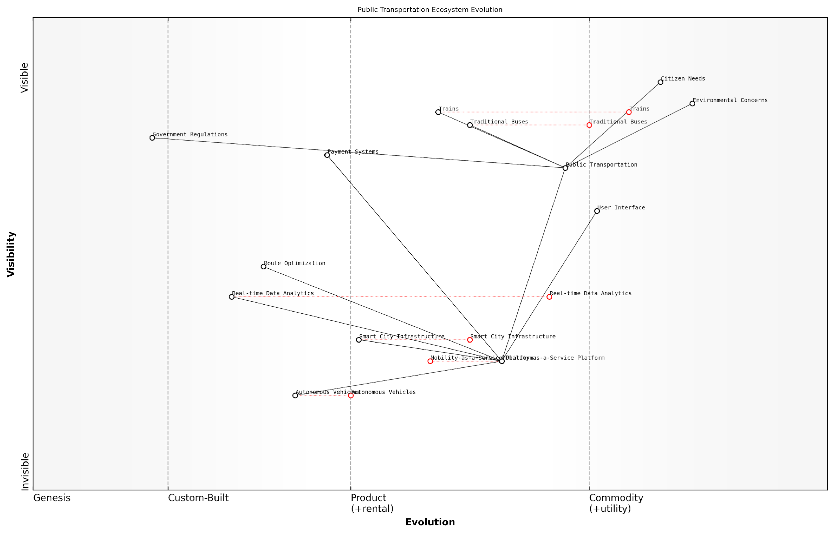

*Draft Wardley Map: [Insert Wardley Map: Real-world applications and case studies]*

[Edit this draft Wardley Map](https://create.wardleymaps.ai/#clone:524c1488b1acf3d1a4)

Wardley Map Assessment

This Wardley Map reveals a public transportation ecosystem in transition, moving from traditional modes towards an integrated, data-driven, and potentially autonomous future. The strategic focus should be on developing the Mobility-as-a-Service Platform as a central integrator, while simultaneously investing in emerging technologies like Autonomous Vehicles and Smart City Infrastructure. Success will require balancing innovation with regulatory compliance, addressing environmental concerns, and ensuring seamless user experiences. The evolution of this ecosystem presents significant opportunities for improving urban mobility, but also poses challenges in terms of technology integration, data management, and adapting to changing citizen needs.

[View full Wardley Map report](http://markdown_wardley_map_reports/wardley_map_report_08_Real-world_applications_and_case_studies.md)

These case studies demonstrate the versatility and power of Wardley Mapping in addressing the unique challenges faced by startups, particularly those operating in the government and public sector space. By providing a clear visualisation of the competitive landscape, evolution of technologies, and potential future scenarios, Wardley Mapping empowers startups to make more informed strategic decisions, allocate resources more effectively, and communicate their vision more compellingly.

However, it’s important to note that Wardley Mapping is not a silver bullet. Its effectiveness depends on the accuracy of the information used to create the maps and the skill with which they are interpreted. As you progress through this book, you’ll learn not only how to create Wardley Maps but also how to use them as part of a broader strategic toolkit.

In the following chapters, we’ll delve deeper into the specific techniques and methodologies for creating and interpreting Wardley Maps in a startup context. You’ll learn how to integrate Wardley Mapping with other startup methodologies, such as Lean Startup and Agile development, to create a powerful framework for strategic decision-making and innovation.

Wardley Mapping isn’t just a tool; it’s a new way of thinking about strategy. It forces you to consider the entire ecosystem in which you operate and to think several moves ahead. For startups looking to make a big impact with limited resources, this kind of strategic clarity is invaluable.

By the end of this book, you’ll have a comprehensive understanding of how to apply Wardley Mapping to your own startup, regardless of your industry or target market. You’ll be equipped with the tools and knowledge to navigate uncertainty, identify opportunities, and drive innovation in even the most complex and challenging environments.

### Integrating Wardley Mapping with other startup methodologies

As an expert in Wardley Mapping for startups, particularly within government and public sector contexts, I can attest to the transformative power of integrating this strategic tool with other established startup methodologies. This integration not only enhances the effectiveness of each approach but also provides a comprehensive framework for navigating the complex landscape of entrepreneurship in the public sector.

Wardley Mapping, with its unique ability to visualise the evolution of value chains and market landscapes, serves as a powerful complement to methodologies such as Lean Startup, Agile development, and Design Thinking. By combining these approaches, startups can leverage the strengths of each methodology to create a robust strategy for innovation and growth.

The synergy between Wardley Mapping and other startup methodologies is like adding a strategic compass to an already powerful toolkit. It provides direction and context to our iterative processes, allowing us to navigate the uncertain waters of innovation with greater confidence and precision.

Let’s explore how Wardley Mapping integrates with and enhances some key startup methodologies:

* Lean Startup: Wardley Mapping enhances the Build-Measure-Learn cycle by providing a visual representation of the market landscape. This allows startups to make more informed decisions about which hypotheses to test and how to pivot based on market evolution.
* Agile Development: By mapping the components of a product or service, teams can prioritise development efforts more effectively, focusing on elements that provide the most strategic value at each stage of evolution.
* Design Thinking: Wardley Maps can inform the empathy and ideation phases of Design Thinking by visualising user needs in the context of the broader value chain, leading to more innovative and strategically aligned solutions.
* Business Model Canvas: Wardley Mapping complements the Business Model Canvas by adding a dynamic, evolutionary perspective to the static business model representation, allowing for more adaptive strategy formulation.

In the context of government and public sector startups, this integration becomes even more crucial. The complex stakeholder landscape and the need for long-term strategic planning in public sector innovation make Wardley Mapping an invaluable tool when combined with agile and lean methodologies.

For instance, in a recent project with a government digital services agency, we used Wardley Mapping in conjunction with Lean Startup principles to rapidly prototype and iterate on a new citizen engagement platform. The Wardley Map provided a clear visualisation of the existing public services landscape, helping identify opportunities for innovation and potential barriers to adoption. This informed our hypothesis generation and MVP design, while the Lean Startup approach guided our rapid testing and iteration process.

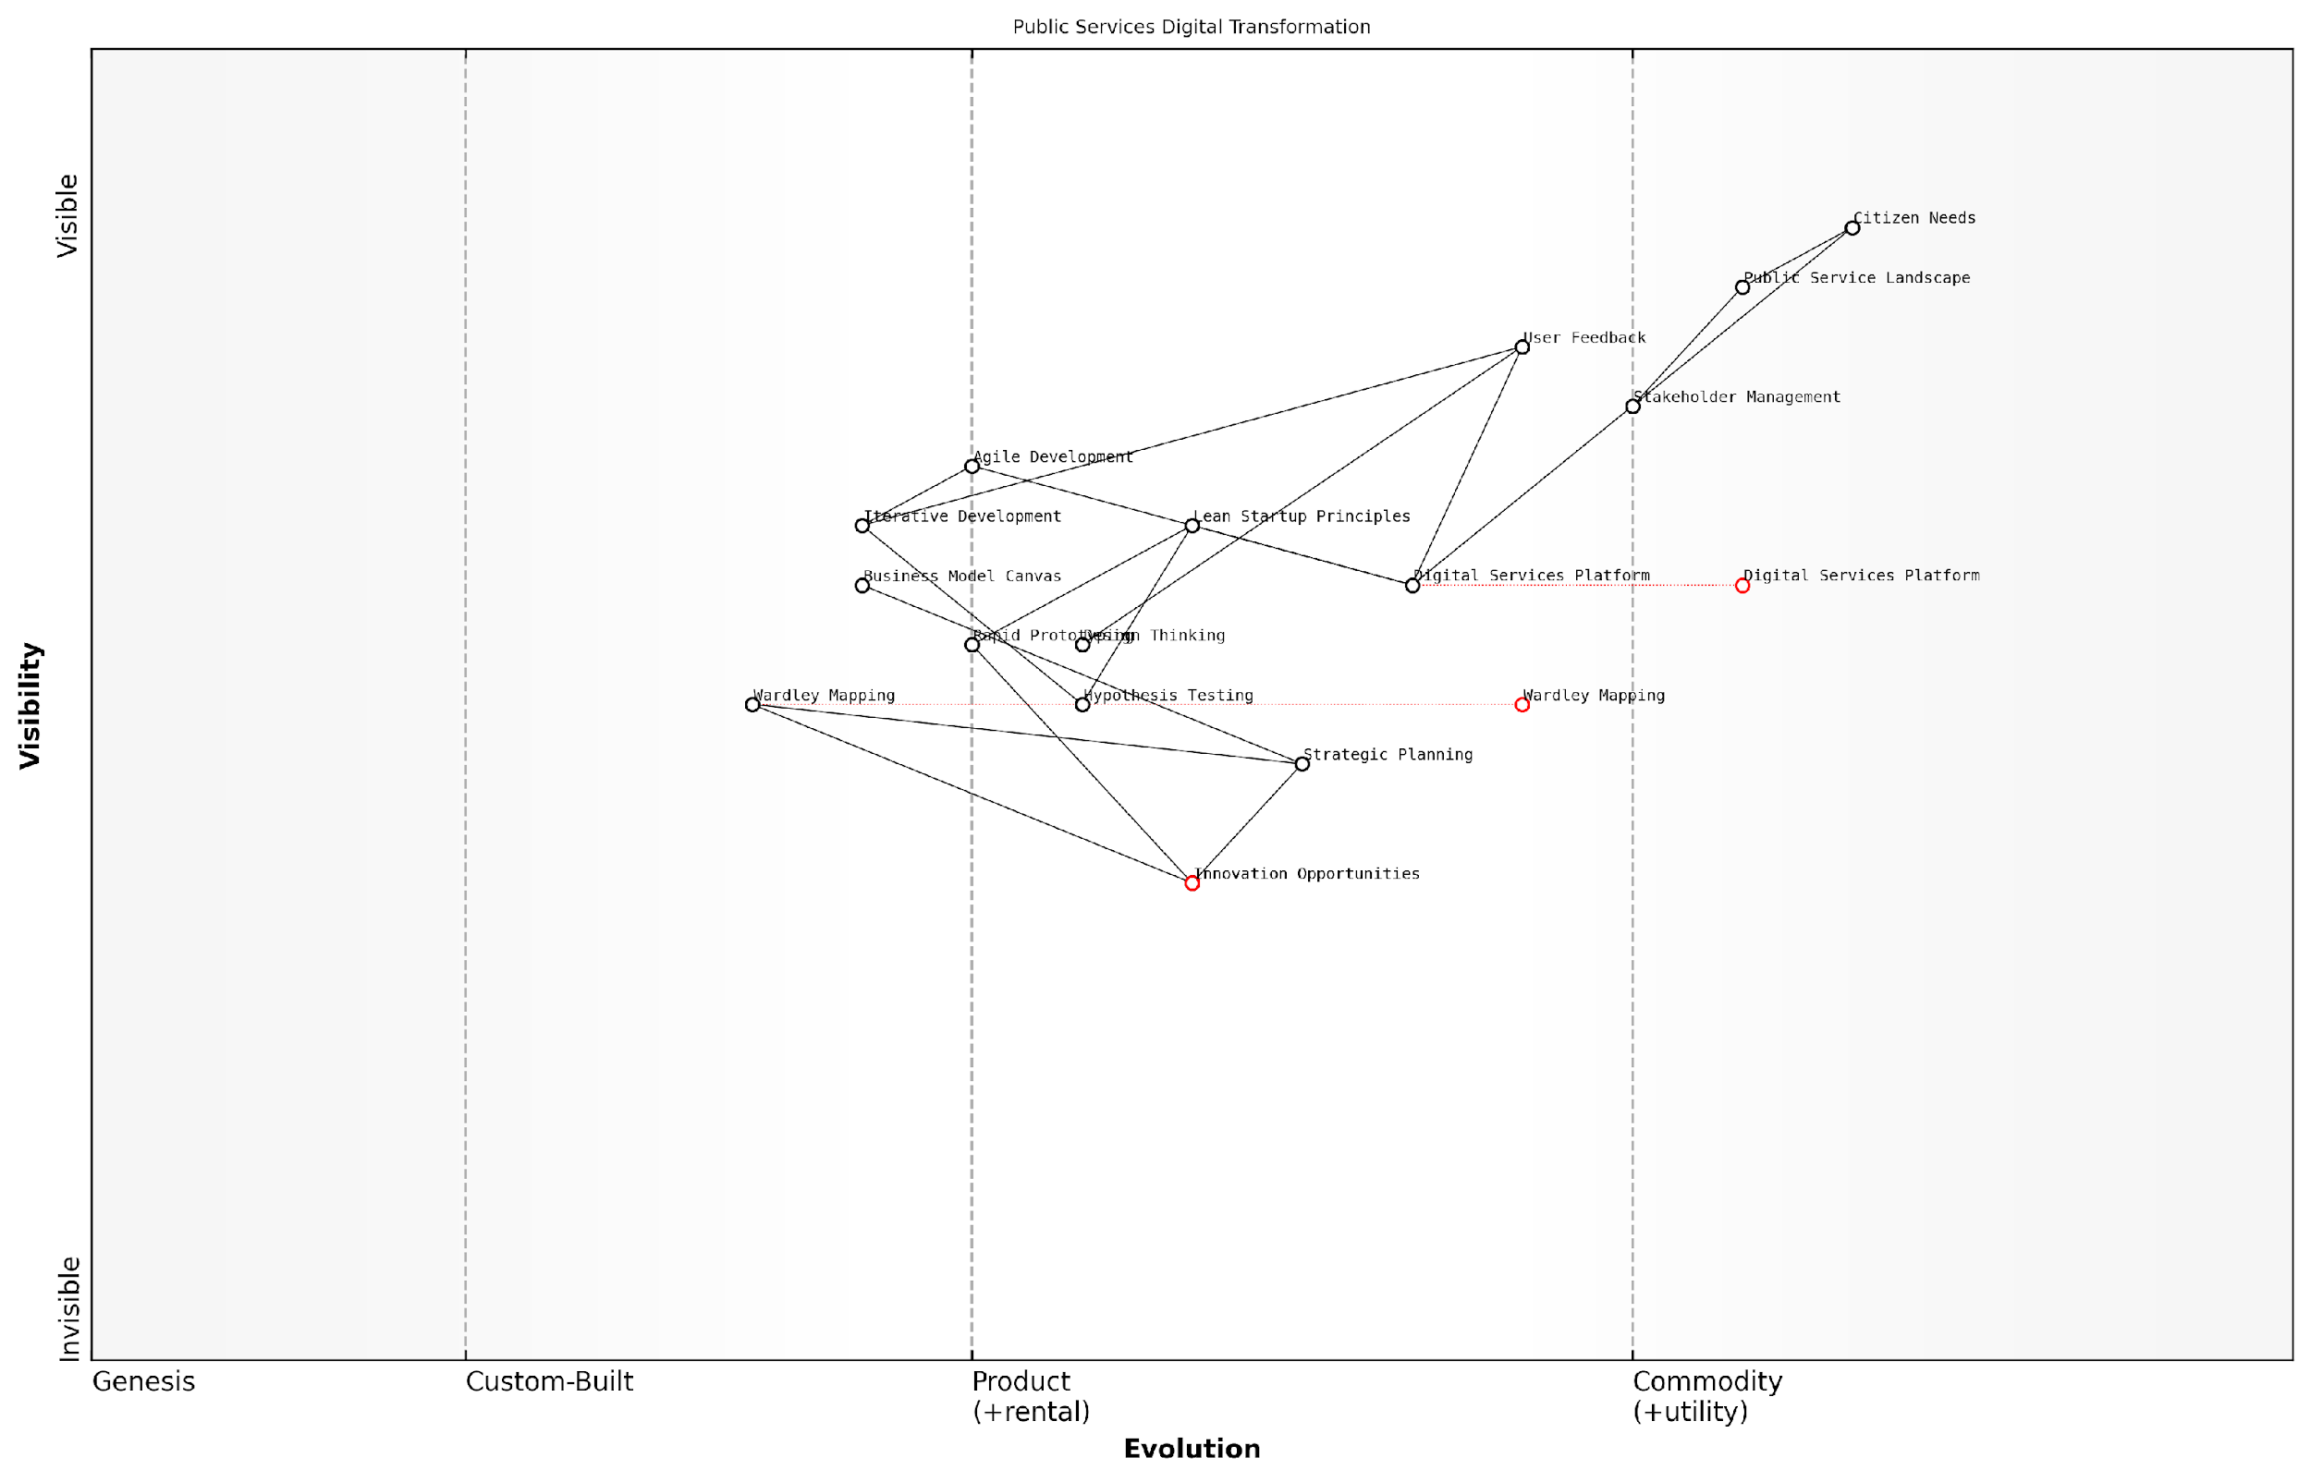

*Draft Wardley Map: [Insert Wardley Map: Integrating Wardley Mapping with other startup methodologies]*

[Edit this draft Wardley Map](https://create.wardleymaps.ai/#clone:6c954258967d6fb265)

Wardley Map Assessment

This Wardley Map reveals a public services sector in the midst of digital transformation, with a strong focus on citizen needs. The integration of various startup methodologies with traditional public service approaches presents unique opportunities for innovation. Key strategic moves should focus on evolving core digital platforms, leveraging Wardley Mapping for strategic alignment, and fostering an ecosystem of innovation. The main challenges lie in balancing rapid technological advancement with the stability and inclusivity required in public services. By addressing capability gaps and strategically positioning for future evolution, this transformation effort has the potential to significantly enhance public service delivery and citizen satisfaction.

[View full Wardley Map report](http://markdown_wardley_map_reports/wardley_map_report_09_Integrating_Wardley_Mapping_with_other_startup_met.md)

The integration of these methodologies allowed the agency to:

* Identify underserved citizen needs by mapping the current service landscape
* Prioritise features based on their position in the evolution of public service delivery
* Rapidly test assumptions about citizen engagement through lean experimentation
* Iterate on the platform design based on user feedback and changing market dynamics
* Communicate the strategic rationale for the project to various government stakeholders using the visual power of Wardley Maps

This integrated approach led to a more successful and strategically aligned outcome, with the platform achieving higher adoption rates and user satisfaction compared to previous digital initiatives.

By combining Wardley Mapping with lean and agile methodologies, we were able to navigate the complexities of public sector innovation with unprecedented clarity and agility. It’s not just about building the right thing, but building the right thing at the right time and in the right way.

However, it’s important to note that integrating these methodologies requires careful consideration and adaptation. Each approach has its own strengths and focus areas, and the key lies in leveraging these synergies without creating unnecessary complexity.

Here are some best practices for effective integration:

* Start with a clear understanding of each methodology and its core principles
* Use Wardley Mapping as a strategic layer that informs and guides the application of other methodologies
* Regularly update your Wardley Maps to reflect insights gained from lean experiments and agile iterations
* Foster a culture of strategic thinking combined with rapid experimentation
* Provide training and support to team members to ensure they can effectively use and integrate these tools
* Use visual communication tools to help stakeholders understand the interplay between different methodologies and how they contribute to the overall strategy

By mastering the integration of Wardley Mapping with other startup methodologies, public sector innovators can navigate the complex landscape of government services with greater confidence and effectiveness. This approach enables them to balance the need for strategic foresight with the ability to adapt quickly to changing citizen needs and technological advancements.

As we continue to explore the power of Wardley Mapping for startups throughout this book, keep in mind the potential for integration with other methodologies you may already be using. The true power of Wardley Mapping lies not just in its individual application, but in its ability to enhance and be enhanced by other strategic tools and approaches.

In the rapidly evolving landscape of public sector innovation, the ability to combine strategic mapping with agile execution is not just an advantage – it’s a necessity. Those who master this integration will be best positioned to drive meaningful change and create lasting value for citizens.

# Chapter 1: Fundamentals of Wardley Mapping for Startups

## The Building Blocks of Wardley Maps

### Understanding value chains

Value chains are a fundamental concept in Wardley Mapping, serving as the backbone for visualising and analysing the components that contribute to delivering value to users. For startups operating in the fast-paced and often uncertain government and public sector contexts, a deep understanding of value chains is crucial for identifying opportunities, optimising resources, and driving innovation.

At its core, a value chain in Wardley Mapping represents the series of activities and components required to deliver a product or service to the end user. Unlike traditional value chain models, Wardley Maps emphasise the evolutionary nature of these components, providing a dynamic view that is particularly valuable for startups navigating rapidly changing landscapes.

Value chains in Wardley Mapping are not just about understanding what you do, but about visualising how your activities evolve and interact within the broader ecosystem. This perspective is invaluable for startups seeking to disrupt established markets or create entirely new ones.

Let’s delve deeper into the key aspects of value chains in the context of Wardley Mapping for startups:

* Component Identification
* Hierarchical Structure
* Dependencies and Relationships
* Evolution and Movement

Component Identification: The first step in understanding value chains is identifying the components that contribute to your startup’s value proposition. These can include tangible elements like software, hardware, or data, as well as intangible aspects such as knowledge, processes, or regulatory compliance. For startups in the government sector, components might include citizen data management systems, policy frameworks, or public engagement platforms.

In my experience advising government startups, I’ve observed that many founders initially overlook critical components, particularly those related to regulatory compliance or stakeholder management. A thorough component identification process often reveals hidden dependencies and potential bottlenecks that can significantly impact a startup’s ability to deliver value efficiently.

Hierarchical Structure: Value chains in Wardley Maps are typically organised in a hierarchical structure, with user needs at the top and underlying components arranged below based on their visibility to the user and their position in the value chain. This structure helps startups visualise how different components contribute to the overall value proposition and identify areas where innovation or optimisation can have the most significant impact.

The hierarchical nature of Wardley Maps forces us to think critically about how each component contributes to user value. This clarity is invaluable when prioritising development efforts or explaining your startup’s strategy to investors and stakeholders.

Dependencies and Relationships: A crucial aspect of value chains in Wardley Mapping is understanding the dependencies and relationships between components. These connections reveal how changes in one part of the value chain can ripple through the entire system, affecting overall performance and user value. For startups, this understanding is vital for managing risks, identifying potential bottlenecks, and uncovering opportunities for vertical integration or strategic partnerships.

In a recent project with a govtech startup developing a citizen engagement platform, mapping the dependencies between their user interface, data management systems, and various government APIs revealed critical vulnerabilities in their architecture. This insight led to a significant redesign that improved both system resilience and scalability.

Evolution and Movement: Perhaps the most powerful aspect of value chains in Wardley Mapping is the incorporation of evolution. Components are positioned along an axis representing their evolutionary stage, from genesis (novel and rapidly changing) to commodity (standardised and utility-like). This evolutionary perspective is particularly relevant for startups, as it helps identify areas ripe for innovation, predict future market shifts, and make informed decisions about where to invest resources.

For example, in the rapidly evolving field of digital identity verification for government services, understanding the evolutionary stage of various components (e.g., biometric technologies, blockchain-based solutions, privacy-enhancing techniques) has been crucial for startups in positioning their offerings and anticipating regulatory changes.

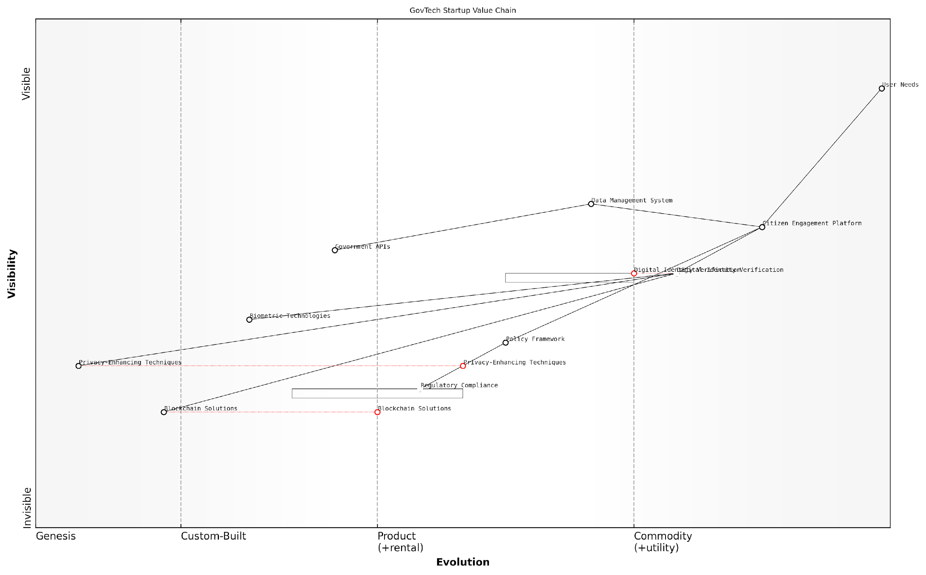

*Draft Wardley Map: [Insert Wardley Map: Understanding value chains]*

[Edit this draft Wardley Map](https://create.wardleymaps.ai/#clone:ac3053f83082e3d3db)

Wardley Map Assessment

The GovTech startup is well-positioned with a strong core offering in citizen engagement and a forward-looking approach to emerging technologies. To maintain its competitive edge, it should focus on rapidly evolving its digital identity and privacy capabilities while building a robust ecosystem around its platform. The key to long-term success lies in balancing innovation with regulatory compliance and establishing itself as a trusted intermediary between citizens and government services.

[View full Wardley Map report](http://markdown_wardley_map_reports/wardley_map_report_10_Understanding_value_chains.md)

Practical Applications for Startups:

* Strategic Planning: Use value chain analysis to identify areas where your startup can create unique value or disrupt existing markets.
* Resource Allocation: Prioritise development efforts and investments based on the strategic importance and evolutionary stage of different components.
* Risk Management: Identify dependencies and potential vulnerabilities in your value chain to proactively address risks.
* Innovation Targeting: Focus innovation efforts on components at the appropriate evolutionary stage for maximum impact.
* Stakeholder Communication: Leverage value chain visualisations to clearly communicate your startup’s strategy and value proposition to investors, partners, and government stakeholders.

In conclusion, a thorough understanding of value chains is essential for startups employing Wardley Mapping, particularly in the complex and often rigid environment of government and public sector innovation. By mastering this concept, founders and teams can gain a powerful tool for navigating uncertainty, driving strategic decision-making, and ultimately delivering greater value to users and citizens.

In the world of govtech startups, where the stakes are high and the challenges complex, a well-mapped value chain becomes your compass, guiding you through the fog of uncertainty towards impactful innovation and sustainable growth.

### The evolution axis: From genesis to commodity

The evolution axis is a fundamental concept in Wardley Mapping that provides crucial insights for startups navigating the complex landscape of innovation and market dynamics. This axis represents the natural progression of components within a value chain, from novel and unstable ‘genesis’ ideas to well-established ‘commodity’ services. Understanding this evolution is paramount for startups as it informs strategic decision-making, helps identify opportunities for innovation, and guides resource allocation in a rapidly changing business environment.

The evolution axis in Wardley Mapping typically consists of four main stages: Genesis, Custom-built, Product (or Rental), and Commodity. Each stage represents a different level of maturity, ubiquity, and certainty in the market. Let’s explore each stage in detail:

* Genesis: This is the stage of innovation and uncertainty. Components at this stage are new ideas or concepts that have just been invented or discovered. They are highly unstable, poorly understood, and often expensive to develop or implement. For startups, this stage represents both high risk and high potential reward.
* Custom-built: As ideas prove their worth, they move into the custom-built stage. Here, components are built for specific purposes but are not yet standardised. They require significant expertise to implement and are often expensive. Startups operating in this stage may find opportunities in providing specialised solutions to early adopters.
* Product (or Rental): At this stage, components become more standardised and understood. They are typically available as products or services that can be ‘rented’ or licensed. This stage often sees increased competition and a focus on feature differentiation. For startups, this can be a critical stage for scaling and establishing market presence.
* Commodity: The final stage represents ubiquity and standardisation. Components at this stage are well-understood, highly standardised, and often essential. They are typically low-cost and may be provided by utility-like services. While commodities might seem less exciting for startups, they can provide opportunities for disruption through new business models or by leveraging them to build higher-value offerings.

The movement along this axis is not always linear or predictable, but understanding the general trend is crucial for strategic planning. As a senior government official once remarked, “In the public sector, we often see the need to support innovation at the genesis stage while simultaneously leveraging commoditised services for efficiency. Understanding this evolution helps us balance risk and value in our technology investments.”

For startups, the evolution axis provides several key insights:

* Innovation Opportunities: By identifying components in the genesis or custom-built stages, startups can spot areas ripe for innovation and disruption.
* Competitive Positioning: Understanding where competitors’ offerings sit on the evolution axis can inform differentiation strategies.
* Resource Allocation: Knowing the evolution stage of key components helps startups decide where to invest their limited resources for maximum impact.
* Future Planning: Anticipating the evolution of components allows startups to prepare for future market changes and adapt their strategies accordingly.
* Partnership Strategies: The evolution axis can guide decisions on which components to develop in-house versus sourcing from partners or the market.

A practical example from my consultancy experience illustrates the power of this concept. A govtech startup was developing a new platform for citizen engagement. By mapping the components of their solution on the evolution axis, they realised that while their core algorithm was still in the genesis stage, many of the supporting technologies (e.g., cloud infrastructure, data analytics tools) had evolved to product or commodity stages. This insight led them to focus their R&D efforts on their unique algorithm while leveraging existing solutions for other components, significantly reducing development time and costs.

Understanding component evolution is like having a crystal ball for your business. It helps you see where the market is heading and position your startup accordingly.

It’s important to note that the pace of evolution can vary significantly between industries and even between different components within the same industry. Factors such as technological advancements, market demand, regulatory changes, and network effects can all influence the speed of evolution. Startups must therefore continually reassess their Wardley Maps to ensure they reflect the current state of evolution.

Moreover, the evolution axis interacts with other key concepts in Wardley Mapping, such as value chains and user needs. As components evolve, their position in the value chain may shift, and their relationship to user needs may change. This dynamic interplay underscores the importance of viewing Wardley Maps as living documents that require regular updates and reinterpretation.

In conclusion, the evolution axis is a powerful tool for startups navigating the complex landscape of innovation and market dynamics. By understanding and leveraging this concept, startups can make more informed strategic decisions, allocate resources more effectively, and position themselves for long-term success in an ever-changing business environment. As we continue to explore Wardley Mapping for Startups, we’ll see how this fundamental concept interacts with other mapping elements to provide a comprehensive strategic framework.

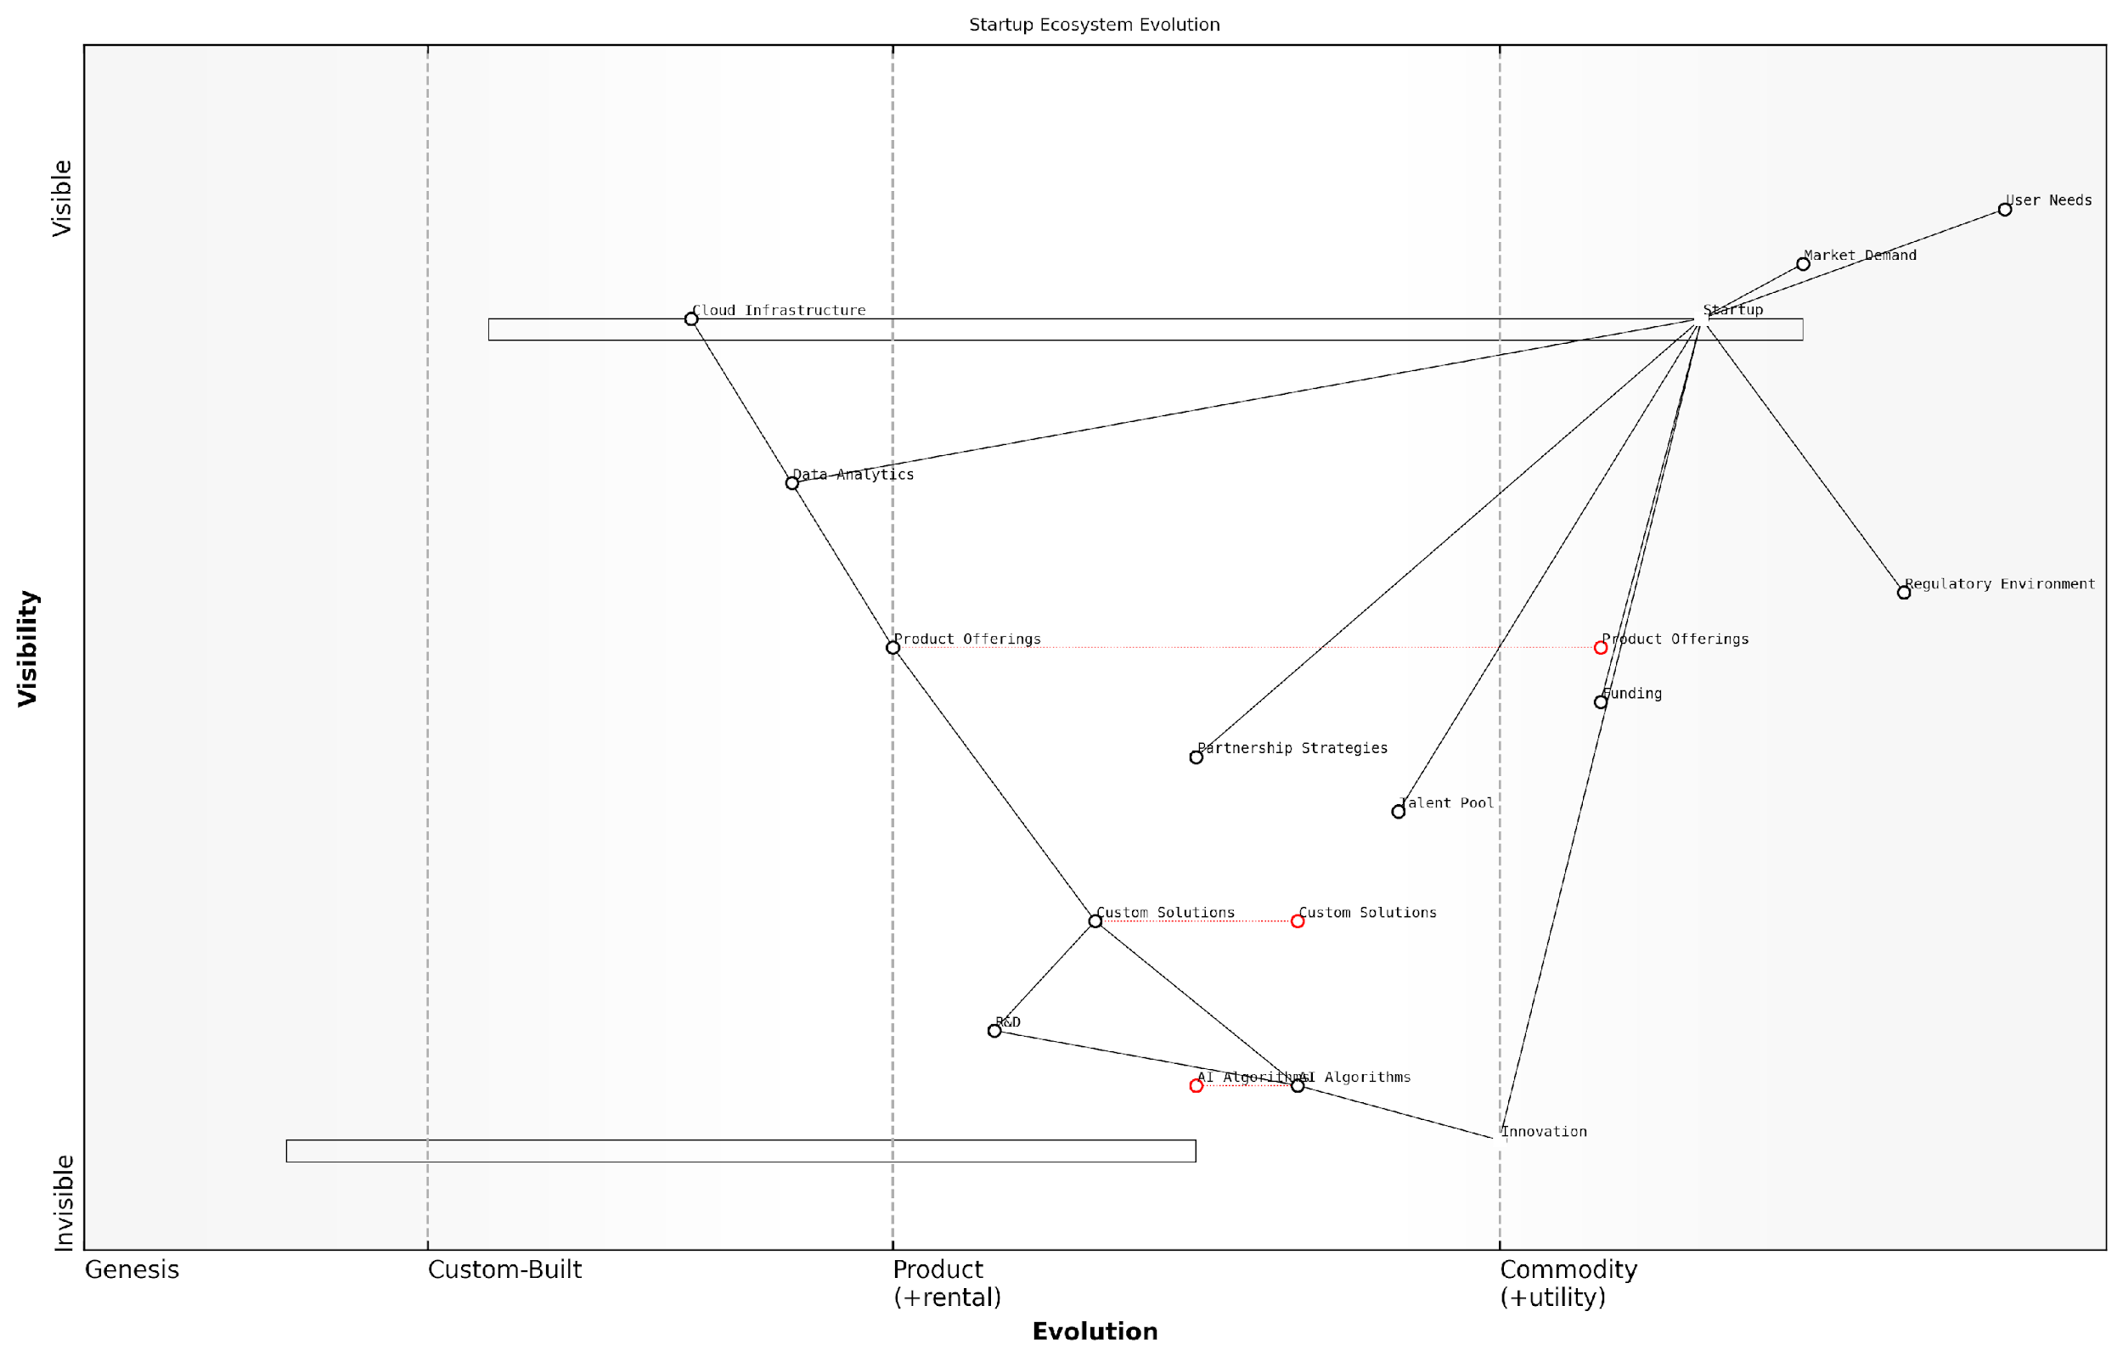

*Draft Wardley Map: [Insert Wardley Map: The evolution axis: From genesis to commodity]*

[Edit this draft Wardley Map](https://create.wardleymaps.ai/#clone:524d3a1a1bf19f17a1)

Wardley Map Assessment

The Wardley Map reveals a startup positioned at the forefront of AI-driven innovation, with a strong foundation in custom solutions and evolving product offerings. The strategic focus should be on maintaining the innovation edge while successfully navigating the evolution towards more mature, market-ready products. Key challenges include managing the rapid evolution of AI technologies, addressing potential regulatory hurdles, and ensuring a steady flow of talent and funding. The startup has significant opportunities to leverage its innovative capabilities and strategic positioning to create a robust ecosystem of products and services, potentially disrupting established markets. However, careful attention must be paid to the balance between cutting-edge innovation and the development of scalable, market-ready solutions to ensure long-term success and competitiveness in the dynamic startup ecosystem.

[View full Wardley Map report](http://markdown_wardley_map_reports/wardley_map_report_11_The_evolution_axis:_From_genesis_to_commodity.md)

### Mapping components and their relationships

In the realm of Wardley Mapping for startups, understanding how to map components and their relationships is a critical skill that forms the backbone of effective strategic planning. This process allows startup founders and teams to visualise the complex web of dependencies within their business ecosystem, providing invaluable insights for decision-making and innovation.

Components in a Wardley Map represent the building blocks of your startup’s value chain. These can include tangible elements such as products, technologies, and infrastructure, as well as intangible aspects like skills, processes, and customer needs. The relationships between these components illustrate how value flows through your system and highlight potential areas for optimisation or disruption.

Let’s delve into the key aspects of mapping components and their relationships:

* Identifying and positioning components
* Understanding component dependencies
* Visualising flow and value creation
* Analysing component evolution

Identifying and positioning components: The first step in mapping components is to identify all the elements that contribute to your startup’s value proposition. This requires a comprehensive understanding of your business model and operational processes. Once identified, components are positioned on the map based on their visibility to the end-user (y-axis) and their evolutionary stage (x-axis).

The process of identifying and positioning components forces startups to think critically about every aspect of their business. It’s not uncommon for founders to discover hidden dependencies or overlooked opportunities during this exercise.

Understanding component dependencies: After positioning components, the next crucial step is to map the relationships between them. This involves drawing lines to show how components depend on or support each other. These connections reveal the flow of value and information within your startup ecosystem.

For startups, understanding these dependencies is particularly valuable. It can highlight potential bottlenecks, single points of failure, or areas where strategic partnerships could provide a competitive advantage. For instance, a fintech startup might realise that their innovative payment solution heavily depends on a third-party API, prompting them to consider developing this capability in-house or securing a more robust partnership agreement.

Visualising flow and value creation: The lines connecting components in a Wardley Map do more than just show dependencies; they illustrate the flow of value through your startup’s ecosystem. This visualisation can reveal inefficiencies in your value chain or opportunities for vertical integration.

By mapping the flow of value, startups can identify where they’re truly adding value and where they might be unnecessarily reinventing the wheel. This insight is invaluable for focusing limited resources on areas of maximum impact.

For example, a startup in the sustainable energy sector might discover through mapping that their true value lies not in manufacturing solar panels (an increasingly commoditised component) but in the software that optimises energy distribution. This insight could lead to a strategic pivot that significantly enhances their competitive position.

Analysing component evolution: One of the unique aspects of Wardley Mapping is its incorporation of the evolution axis. As you map components and their relationships, it’s crucial to consider how each component is likely to evolve over time. This forward-looking aspect is particularly relevant for startups operating in fast-moving technology sectors.

Understanding the evolutionary stage of each component allows startups to anticipate future changes in their business landscape. For instance, a component that is currently in the ‘custom-built’ stage might be expected to move towards commoditisation. This could signal an opportunity to gain a first-mover advantage by productising the component, or alternatively, a need to prepare for increased competition as the component becomes more widely available.

The ability to anticipate and prepare for future market shifts is a significant competitive advantage for startups. Wardley Mapping provides a structured approach to developing this foresight.

Practical application for startups: When applying these concepts in a startup context, it’s important to strike a balance between thoroughness and agility. While established companies might create extensive, detailed maps, startups often benefit from a more iterative approach.

* Start with a high-level map focusing on key components and relationships
* Use the map as a collaborative tool in team discussions and strategy sessions
* Regularly update the map as new information becomes available or as the business evolves
* Use the insights gained from mapping to inform pivotal decisions, such as product development priorities or partnership strategies

Case study: Consider the example of a startup in the govtech sector that I advised. They were developing a platform to streamline public service delivery but were struggling to prioritise their development efforts. Through the process of mapping components and their relationships, they discovered that a seemingly minor feature - secure identity verification - was actually a critical dependency for multiple high-value services.

This insight led them to reprioritise their roadmap, focusing on developing a robust identity verification system. Not only did this decision accelerate the delivery of their core services, but it also opened up new revenue streams as other govtech providers began licensing their identity verification component.

In conclusion, the ability to effectively map components and their relationships is a powerful tool for startups navigating uncertain and rapidly changing environments. It provides a visual framework for understanding the complex dynamics of your business ecosystem, enabling more informed strategic decisions and uncovering opportunities for innovation and competitive advantage.

As you continue to refine your skills in Wardley Mapping, remember that the true value lies not just in the final map, but in the collaborative process of creating and iterating on it. Embrace the insights that emerge from this process, and use them to guide your startup towards sustainable success in an ever-evolving business landscape.

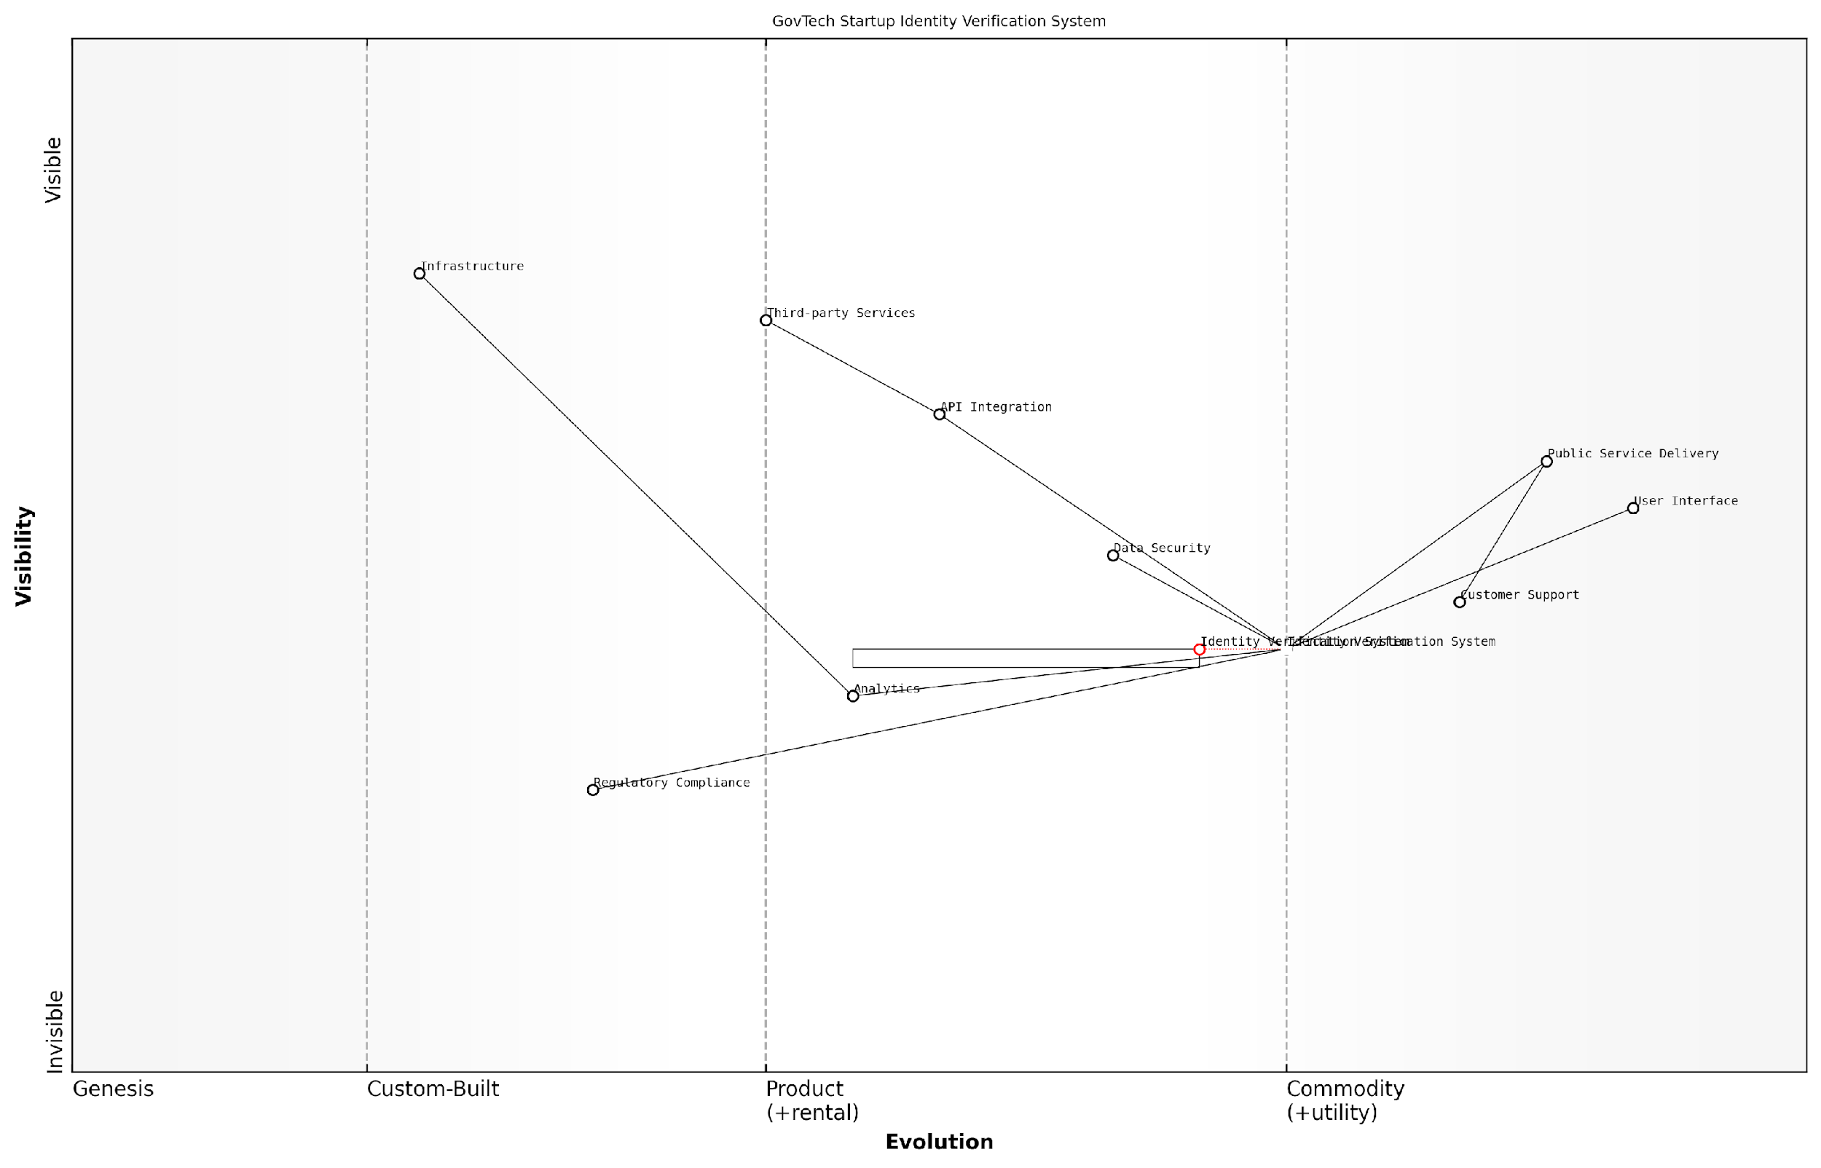

*Draft Wardley Map: [Insert Wardley Map: Mapping components and their relationships]*

[Edit this draft Wardley Map](https://create.wardleymaps.ai/#clone:df031686e90dd2e259)

Wardley Map Assessment

The GovTech startup has a strong foundation with its identity verification system and public service delivery integration. To maintain and enhance its competitive position, it should focus on evolving its regulatory compliance and analytics capabilities, while continuing to innovate in core areas like user interface and data security. The startup is well-positioned to become a platform player in the GovTech space if it can successfully navigate the evolving landscape and leverage emerging technologies effectively.

[View full Wardley Map report](http://markdown_wardley_map_reports/wardley_map_report_12_Mapping_components_and_their_relationships.md)

## Creating Your First Wardley Map

### Identifying user needs and desired outcomes

In the realm of Wardley Mapping for startups, particularly within government and public sector contexts, identifying user needs and desired outcomes is a critical first step in creating an effective map. This process forms the foundation upon which all subsequent mapping activities are built, ensuring that the resulting strategy is firmly grounded in real-world requirements and aspirations.

As a seasoned practitioner in this field, I cannot overstate the importance of this initial phase. It’s not merely about listing features or services; it’s about deeply understanding the underlying needs and motivations of your users, be they citizens, government employees, or other stakeholders in the public sector ecosystem.

Let’s delve into the key aspects of identifying user needs and desired outcomes, drawing from both established best practices and my extensive experience advising government bodies and public sector organisations.

1. User Research and Engagement

The first step in identifying user needs is conducting thorough user research. This involves engaging directly with your target audience through various methods:

* Surveys and questionnaires
* In-depth interviews
* Focus groups
* Observational studies
* Analysis of existing data and feedback

In the public sector, it’s crucial to ensure a diverse and representative sample of users. This might include citizens from various demographics, government employees across different departments, and other relevant stakeholders.

User research is not just about collecting data; it’s about developing empathy and a deep understanding of the people we’re serving. In the public sector, this understanding can be the difference between a policy that looks good on paper and one that truly improves lives.

1. Identifying Pain Points and Challenges

Once you’ve engaged with your users, the next step is to identify their pain points and challenges. In the context of government services, these might include:

* Long wait times for services
* Complicated bureaucratic processes
* Lack of transparency in decision-making
* Difficulty accessing information or resources
* Inefficient use of taxpayer money

It’s important to dig deep and understand the root causes of these issues. Often, what users perceive as the problem may be a symptom of a larger, systemic issue that needs addressing.

1. Defining Desired Outcomes

With a clear understanding of user needs and pain points, the next step is to define the desired outcomes. These should be specific, measurable, and aligned with both user needs and broader government objectives.

Examples of desired outcomes in a public sector context might include:

* Reducing processing time for permit applications by 50%
* Increasing citizen satisfaction with government services by 30%
* Improving accessibility of public information for citizens with disabilities
* Reducing operational costs while maintaining or improving service quality
* Increasing public participation in local decision-making processes

It’s crucial to prioritise these outcomes based on their potential impact and feasibility. This prioritisation will guide the focus of your Wardley Map and subsequent strategy development.

1. Mapping User Journeys

To gain a comprehensive understanding of user needs and desired outcomes, it’s often helpful to map out user journeys. This involves documenting the steps users take to achieve their goals, including interactions with various touchpoints and services.

In the context of Wardley Mapping, these user journeys can provide valuable insights into the components and dependencies that need to be included in your map. They can also highlight areas where the current value chain is failing to meet user needs effectively.

User journeys are like a compass for your Wardley Map. They guide you towards the components that truly matter to your users and help you identify where the greatest opportunities for improvement lie.

1. Validating and Iterating

Once you’ve identified user needs and desired outcomes, it’s crucial to validate these findings with your stakeholders. This might involve presenting your research results to senior government officials, conducting workshops with cross-functional teams, or even testing prototype solutions with users.

Remember that this process is iterative. As you begin to create your Wardley Map and develop strategies based on your findings, you may uncover new insights that require you to revisit and refine your understanding of user needs and desired outcomes.

1. Aligning with Government Priorities and Constraints

While user needs should be at the forefront of your mapping process, it’s also important to consider how these align with broader government priorities and constraints. This might include:

* Policy objectives and mandates
* Budgetary constraints
* Legal and regulatory requirements
* Technological infrastructure and capabilities
* Cross-department collaboration opportunities

By considering these factors alongside user needs, you can ensure that your Wardley Map and resulting strategies are both user-centric and feasible within the public sector context.

In conclusion, identifying user needs and desired outcomes is a critical foundation for creating effective Wardley Maps in the public sector. By engaging deeply with users, understanding their pain points, defining clear outcomes, and aligning these with government priorities, you set the stage for developing strategies that can truly transform public services and improve citizens’ lives.

In the public sector, our ultimate goal is to serve the public good. By starting our Wardley Mapping process with a laser focus on user needs and desired outcomes, we ensure that every strategy we develop, every decision we make, is in service of that greater purpose.

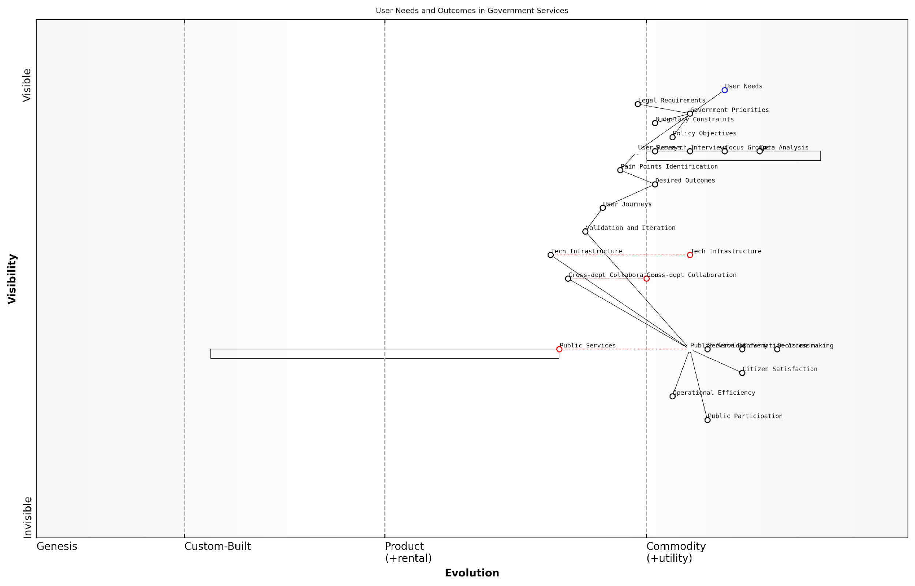

*Draft Wardley Map: [Insert Wardley Map: Identifying user needs and desired outcomes]*

[Edit this draft Wardley Map](https://create.wardleymaps.ai/#clone:1f404230b75ee3f2b9)

Wardley Map Assessment

This Wardley Map reveals a government service ecosystem that is actively evolving towards a more user-centric, efficient model. The strong focus on user needs and outcomes is commendable, but there are significant opportunities to enhance technological capabilities and cross-department collaboration. By addressing these areas and maintaining alignment with government priorities, there’s potential for substantial improvements in public service delivery, citizen satisfaction, and operational efficiency. The key to success will be balancing the pace of evolution across different components, particularly in accelerating tech infrastructure and collaboration capabilities to match the evolution of public services.

[View full Wardley Map report](http://markdown_wardley_map_reports/wardley_map_report_13_Identifying_user_needs_and_desired_outcomes.md)

### Mapping the value chain for your startup

Mapping the value chain for your startup is a crucial step in creating your first Wardley Map. This process allows you to visualise and understand the components that deliver value to your users, from the most visible elements to the underlying infrastructure. As an expert who has guided numerous startups through this process, I can attest to its power in revealing strategic insights and opportunities for innovation.

To begin mapping your startup’s value chain, we’ll break the process down into several key steps:

* Identify your users and their needs
* List the components that meet those needs
* Determine the dependencies between components
* Position components on the evolution axis
* Analyse the resulting map for insights

Let’s explore each of these steps in detail, drawing from my experience in applying Wardley Mapping to startups in various sectors, including government and public services.

1. Identify your users and their needs

The first step in mapping your startup’s value chain is to clearly identify your users and their needs. This is crucial because it anchors your map in the real world and ensures that your strategy is aligned with delivering genuine value. In my consultancy work with government startups, I’ve often found that teams initially struggle to articulate their users’ needs clearly. It’s essential to dig deep and understand the true motivations and pain points of your users.

Understanding user needs is not just about what they say they want, but about uncovering the underlying problems they’re trying to solve. This is where the real opportunities for innovation lie.

For example, a startup developing a digital service for citizens might initially think their users need ‘a faster website’. However, through careful analysis, they might discover that the real need is ‘easy access to personalised information about public services’. This shift in understanding can dramatically alter the components required in the value chain.

1. List the components that meet those needs

Once you’ve identified your users’ needs, the next step is to list all the components that contribute to meeting those needs. These components can include products, services, processes, data, and even organisational structures. It’s important to be comprehensive but also to maintain a level of abstraction that keeps your map manageable.

In my experience working with startups in the public sector, I’ve found it helpful to categorise components into several layers:

* User-facing services
* Business processes
* Data and information
* Technology and infrastructure

For instance, a startup developing a platform for citizen engagement might include components such as ‘mobile app’, ‘user authentication’, ‘data analytics’, ‘cloud hosting’, and ‘privacy compliance framework’.

1. Determine the dependencies between components

The next crucial step is to identify how these components depend on each other. This is where the real power of Wardley Mapping begins to emerge, as it reveals the underlying structure of your startup’s value chain. In my work with government startups, I’ve seen how this step often uncovers hidden dependencies that can have significant strategic implications.

Mapping dependencies isn’t just about drawing lines between boxes. It’s about understanding the flow of value and the potential points of leverage or vulnerability in your startup’s ecosystem.

For example, a startup might realise that their ‘user authentication’ component is heavily dependent on a third-party service, which could represent a strategic risk. Or they might discover that their ‘data analytics’ component is a key dependency for multiple user-facing services, highlighting its importance as a core capability.

1. Position components on the evolution axis

One of the unique aspects of Wardley Mapping is the evolution axis, which represents how components change over time from novel to commodity. Positioning your components along this axis provides crucial insights into their strategic importance and potential for differentiation.

Based on my experience with startups in various stages of growth, I’ve observed that this step often leads to significant strategic realisations. For instance, a government startup might realise that a component they thought was innovative (like a specific data processing algorithm) is actually becoming commoditised, prompting them to reconsider where they focus their development efforts.

When positioning components, consider factors such as:

* How well understood is the component?
* How much uncertainty is there in how to build or use it?
* How many vendors or alternatives are available?
* Is it becoming more standardised or commoditised over time?

1. Analyse the resulting map for insights

With your components positioned and dependencies mapped, you now have a powerful visual representation of your startup’s value chain. The final step is to analyse this map for strategic insights. In my consultancy work, I’ve found that this analysis often leads to breakthrough moments for startup teams.

Key areas to look for in your analysis include:

* Clusters of components that might represent core capabilities or potential platforms
* Components that are highly evolved but critical, which might represent areas of risk
* Novel components that could be sources of competitive advantage
* Gaps or inefficiencies in the value chain that could be addressed
* Dependencies on external components that might need to be internalised or replaced

For example, a government startup I worked with discovered through this analysis that they had a unique capability in data integration that was more novel than they realised. This led them to pivot their strategy to focus on this as a core offering, ultimately leading to significant growth and impact in the public sector.

The true value of a Wardley Map isn’t in its creation, but in the strategic conversations and decisions it enables. It’s a tool for thinking, not just for documentation.

By following these steps to map your startup’s value chain, you create a powerful tool for strategic decision-making. Remember that your Wardley Map is a living document that should be regularly updated as your startup evolves and as market conditions change. In my experience, startups that embrace this dynamic approach to strategy are better positioned to navigate uncertainty and drive innovation in their respective fields.

As you become more proficient in mapping your startup’s value chain, you’ll find that it becomes an invaluable tool for communicating strategy, aligning teams, and identifying opportunities for innovation. In the next section, we’ll explore how to use your Wardley Map to analyse component evolution and dependencies, further enhancing your startup’s strategic capabilities.

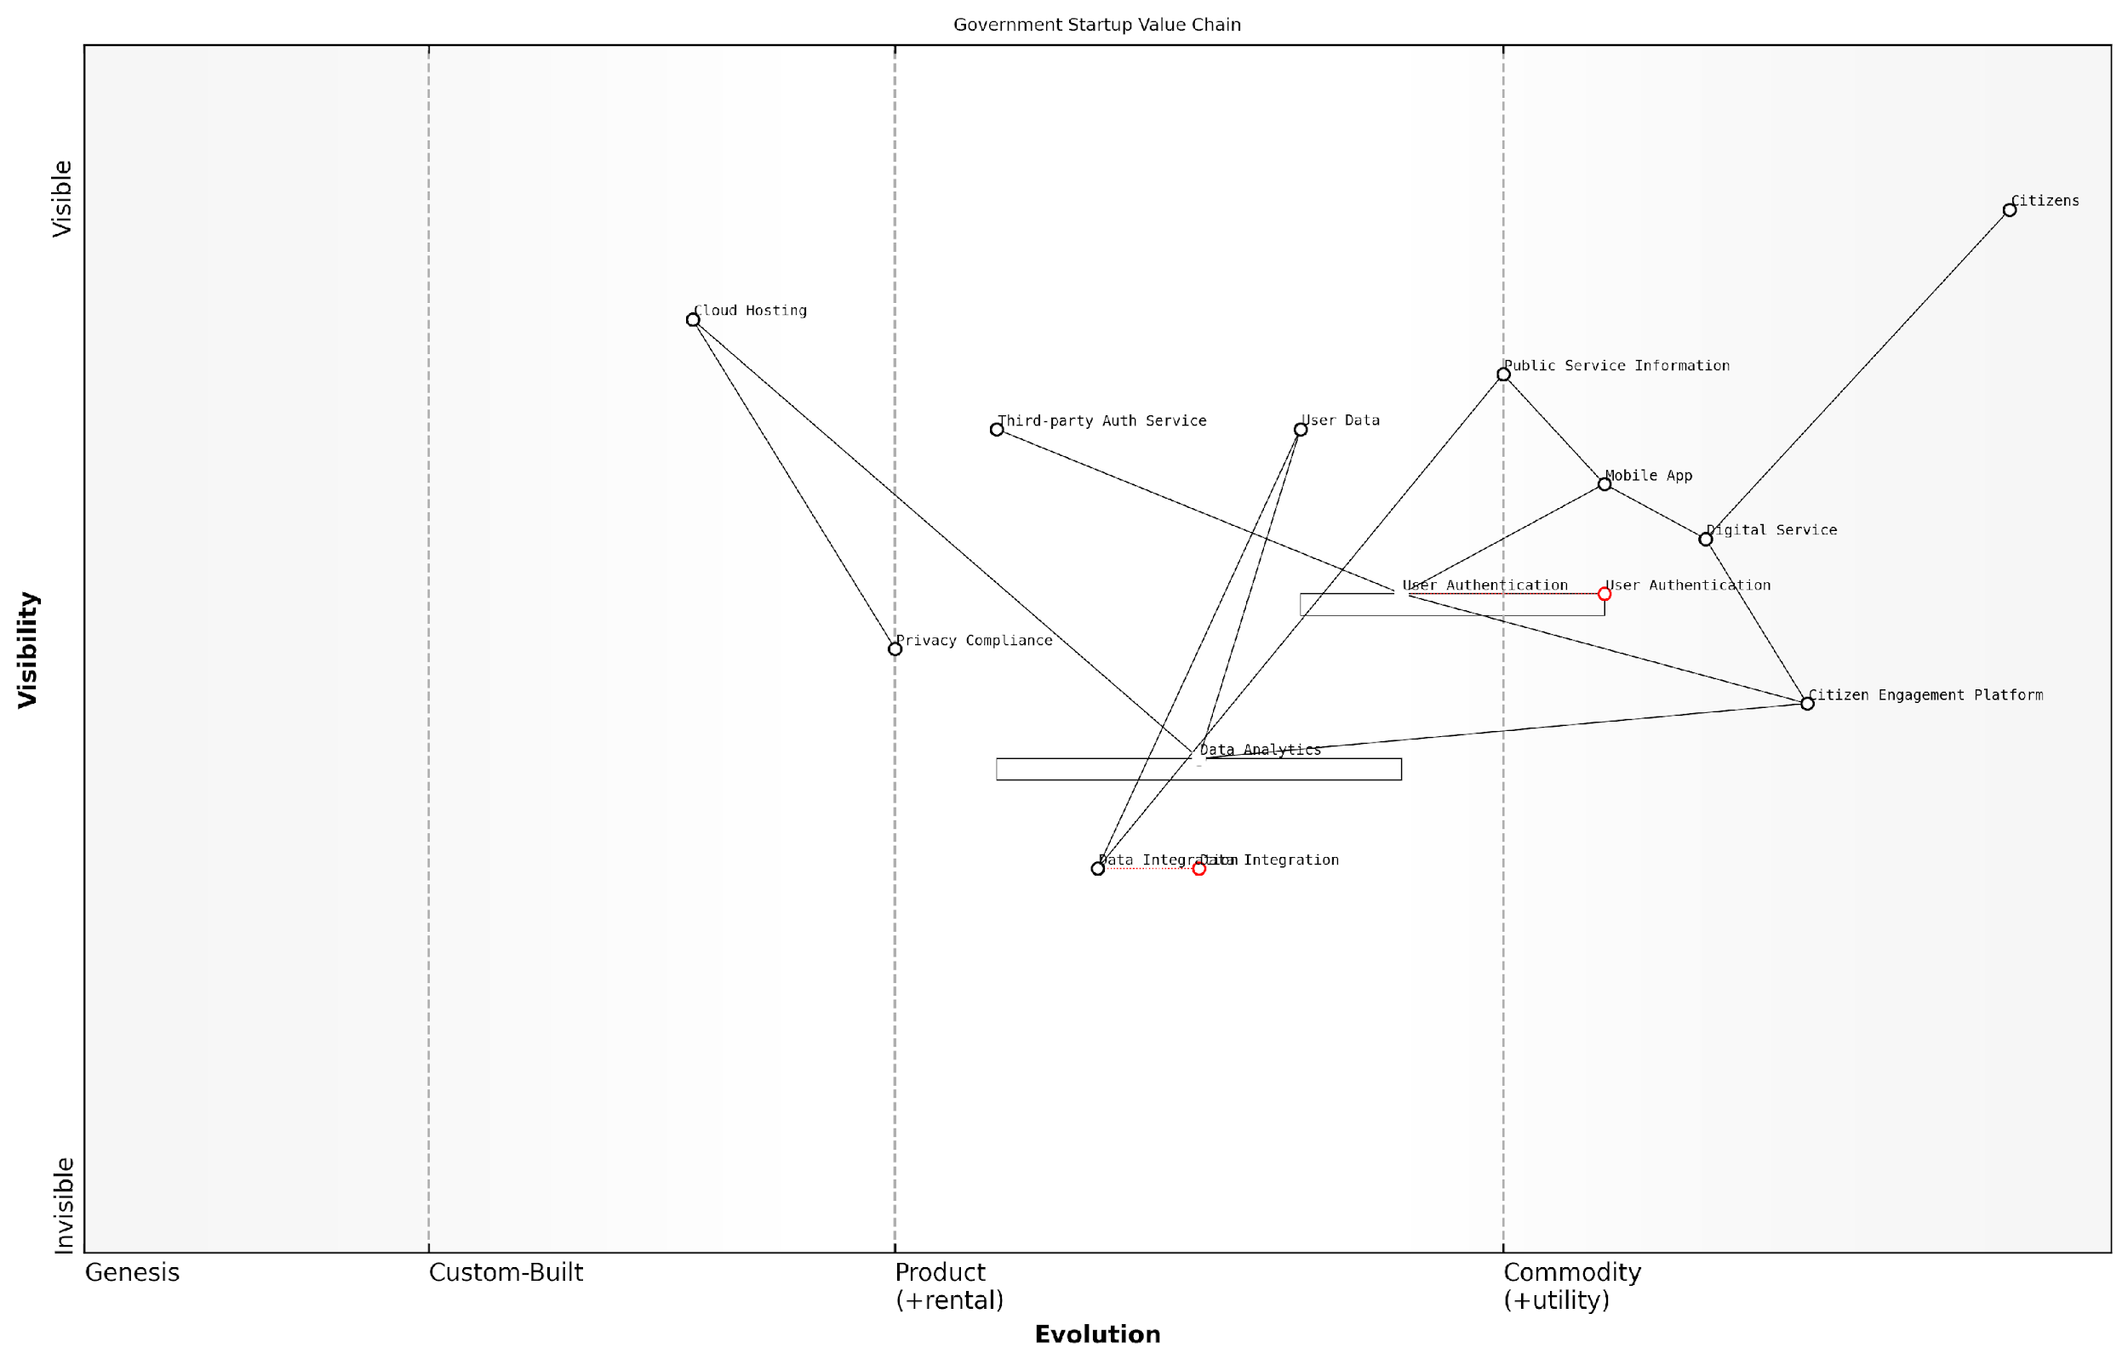

*Draft Wardley Map: [Insert Wardley Map: Mapping the value chain for your startup]*

[Edit this draft Wardley Map](https://create.wardleymaps.ai/#clone:83937843216f37649c)

Wardley Map Assessment

This government startup has a solid foundation for digital service delivery but faces challenges in data integration and evolving authentication needs. The Citizen Engagement Platform presents a significant opportunity for differentiation and ecosystem development. To succeed, the startup should focus on accelerating the evolution of its data capabilities, enhancing its engagement platform, and preparing for a more open, ecosystem-driven future while maintaining a strong focus on privacy and compliance. The strategic positioning suggests potential for significant impact in government digital transformation, provided the identified gaps are addressed and innovation opportunities are leveraged effectively.

[View full Wardley Map report](http://markdown_wardley_map_reports/wardley_map_report_14_Mapping_the_value_chain_for_your_startup.md)

### Analysing component evolution and dependencies

As we delve deeper into creating your first Wardley Map, a critical aspect to consider is the analysis of component evolution and dependencies. This process is fundamental to understanding the dynamics of your startup’s value chain and identifying strategic opportunities. By examining how components evolve and interact, you can gain invaluable insights that will inform your decision-making and strategic planning.

Component evolution in Wardley Mapping refers to the natural progression of technologies, practices, and business elements from novel and custom-built to more standardised and commodity-like states. This evolution occurs along the x-axis of a Wardley Map, moving from left (genesis) to right (commodity). Understanding this evolution is crucial for startups, as it helps predict future market changes and identify areas for innovation or cost-saving.

In my experience advising government bodies, I’ve observed that those who master the art of analysing component evolution gain a significant advantage in navigating complex policy landscapes and driving innovation in public services.

Let’s break down the process of analysing component evolution and dependencies into key steps:

* Identify the current evolutionary stage of each component
* Assess the rate of evolution for each component
* Determine dependencies between components
* Analyse the impact of component evolution on dependencies
* Identify potential future states and strategic options

1. Identifying the Current Evolutionary Stage:

Begin by assessing where each component in your value chain sits on the evolution axis. This requires a deep understanding of your industry and the broader technological landscape. For instance, in a government context, a component like ‘citizen identity verification’ might be evolving from custom solutions (genesis) towards more standardised systems (product/rental).

1. Assessing the Rate of Evolution:

Different components evolve at different rates. Some may remain stable for years, while others rapidly progress towards commoditisation. Understanding these rates is crucial for anticipating market changes. For example, in the public sector, we’ve seen rapid evolution in areas like cloud computing adoption, while certain regulatory processes evolve more slowly.

1. Determining Dependencies:

Map out how components depend on each other. This step is vital for understanding the ripple effects of changes in your value chain. In a startup context, you might find that your core product depends on several evolving technologies or services. Identifying these dependencies helps in risk assessment and strategic planning.

A senior government official once told me, ‘Understanding the intricate web of dependencies in our systems has been transformative. It’s allowed us to anticipate bottlenecks and allocate resources more effectively.’

1. Analysing Impact of Evolution on Dependencies:

As components evolve, their relationships with other components may change. A component becoming more commoditised might enable new possibilities or render other components obsolete. For startups, this analysis is crucial for identifying potential disruptions or opportunities in your business model.

1. Identifying Future States and Strategic Options:

Based on your analysis of evolution and dependencies, project potential future states of your value chain. This foresight allows you to develop strategic options, whether it’s investing in emerging technologies, pivoting your business model, or optimising your current operations.

Let’s consider a practical example from my consultancy experience with a government agency tasked with modernising public transportation:

The agency’s initial Wardley Map revealed that their ticketing system was a custom-built solution (positioned towards the left of the evolution axis). Through our analysis, we identified that ticketing technology was rapidly evolving towards more standardised, contactless solutions. We also noted strong dependencies between the ticketing system and other components like user data management and route optimisation.

By analysing these evolutions and dependencies, we projected that moving to a more commoditised ticketing solution would not only reduce costs but also enable better integration with emerging mobility-as-a-service platforms. This insight led to a strategic decision to partner with a leading ticketing solution provider, freeing up resources to focus on innovative service improvements.

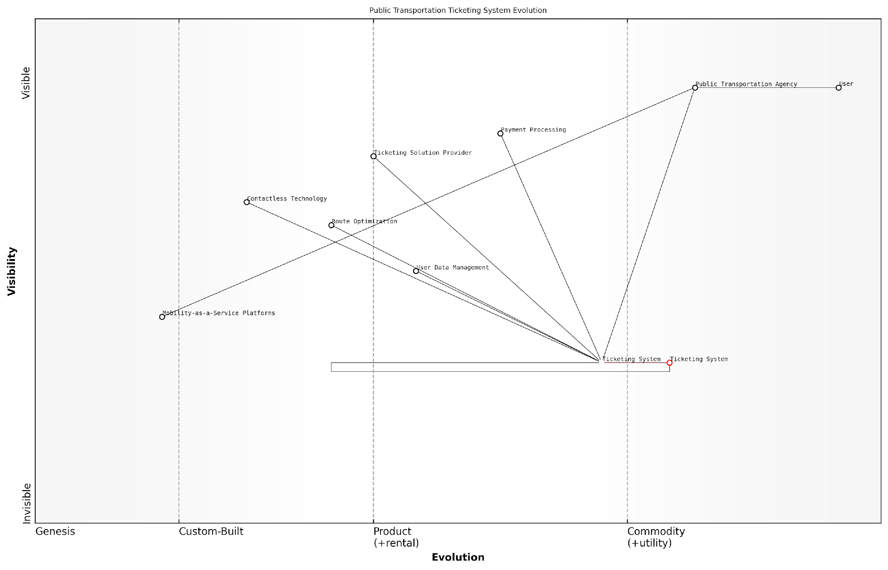

*Draft Wardley Map: [Insert Wardley Map: Analysing component evolution and dependencies]*

[Edit this draft Wardley Map](https://create.wardleymaps.ai/#clone:64e730e4a308c3b92c)

Wardley Map Assessment

The map reveals a public transportation ticketing system at a critical juncture of evolution. While traditional components like the core Ticketing System are moving towards commoditization, emerging technologies and service models present both challenges and opportunities. The key to success lies in accelerating the evolution of core systems, embracing new technologies like contactless payments, and positioning for a future dominated by integrated mobility solutions. Strategic focus should be on enhancing data capabilities, fostering an open ecosystem, and preparing for a shift from pure ticketing to comprehensive mobility management.

[View full Wardley Map report](http://markdown_wardley_map_reports/wardley_map_report_15_Analysing_component_evolution_and_dependencies.md)

This example demonstrates how analysing component evolution and dependencies can lead to transformative strategic decisions, even in traditionally slow-moving sectors like government services.

For startups, the implications of this analysis are profound. By understanding the evolutionary trajectories of your components and their interdependencies, you can:

* Anticipate market changes and stay ahead of competitors
* Identify areas where you can leverage emerging technologies or practices
* Optimise your resource allocation by focusing on high-value, evolving components
* Mitigate risks associated with over-reliance on outdated or soon-to-be commoditised components
* Discover new business opportunities by identifying gaps in the evolving value chain

It’s important to note that this analysis is not a one-time exercise. The dynamic nature of markets, especially in the startup world, necessitates regular reassessment of your Wardley Map. As a best practice, I recommend revisiting your analysis of component evolution and dependencies at least quarterly, or more frequently if you’re in a rapidly changing industry.

A leading expert in the field once remarked, ‘The true power of Wardley Mapping lies not in the static snapshot it provides, but in the dynamic understanding it fosters. It’s about developing a mindset that constantly questions and reassesses the evolving landscape.’

In conclusion, mastering the analysis of component evolution and dependencies is a crucial skill for any startup founder or strategist employing Wardley Mapping. It provides a structured approach to navigating the complexities of your business environment, enabling you to make informed decisions, anticipate changes, and position your startup for success in an ever-evolving marketplace.

## Interpreting Wardley Maps for Startup Insights

### Identifying strategic opportunities and threats

In the dynamic landscape of startup ecosystems, the ability to identify strategic opportunities and threats is paramount to success. Wardley Mapping provides a powerful framework for startups to gain a comprehensive understanding of their market position, competitive landscape, and potential areas for growth or disruption. By interpreting Wardley Maps through a strategic lens, startups can uncover hidden opportunities, anticipate potential threats, and make informed decisions that drive innovation and sustainable growth.

At its core, the process of identifying strategic opportunities and threats through Wardley Mapping involves a deep analysis of the value chain, component evolution, and market dynamics. By visualising these elements on a map, startups can gain unique insights that may not be apparent through traditional strategic analysis tools. Let’s explore the key aspects of this process and how startups can leverage Wardley Mapping to gain a competitive edge.

Analysing Value Chain Positioning

One of the primary benefits of Wardley Mapping for startups is the ability to visualise their entire value chain and understand their positioning within it. By mapping out all components of their business model, from user needs to underlying technologies and services, startups can identify areas where they may have a unique advantage or where there might be gaps in the market.

* Identify underserved areas in the value chain where new offerings could be developed
* Spot opportunities for vertical integration to capture more value
* Recognise potential for horizontal expansion into adjacent markets or customer segments

Wardley Mapping allowed us to see our entire ecosystem at a glance. We identified three key areas where we could develop new products to fill gaps in the market that our competitors had overlooked.

Assessing Component Evolution

The evolution axis of a Wardley Map provides crucial insights into the maturity of different components within the value chain. By understanding where each component sits on this axis, startups can anticipate future trends and identify opportunities to innovate or disrupt.

* Identify components moving towards commoditisation, which may present opportunities for cost reduction or outsourcing
* Spot emerging technologies or practices in the ‘genesis’ or ‘custom’ phases that could be leveraged for competitive advantage
* Anticipate industry shifts by observing the overall movement of components along the evolution axis

In my experience advising government bodies on technology strategy, we’ve used this aspect of Wardley Mapping to great effect. For instance, one public sector organisation was able to identify an emerging technology in the ‘custom’ phase that aligned perfectly with their mission. By investing early, they positioned themselves as leaders in this space as the technology matured.

Analysing Competitor Positioning

Wardley Maps provide a unique perspective on competitor positioning within the market landscape. By mapping out where competitors are focusing their efforts, startups can identify both potential threats and opportunities for differentiation.

* Identify areas where competitors are clustered, indicating potential market saturation
* Spot ‘white spaces’ on the map where there is little competition, representing potential opportunities
* Analyse competitor movement along the evolution axis to anticipate future competitive threats

When we mapped our competitors, we realised they were all focused on the same segment of the value chain. This revealed a significant opportunity for us to differentiate by focusing on an adjacent, underserved area.

Identifying Potential Disruptions

One of the most powerful applications of Wardley Mapping for startups is in identifying potential disruptions to their industry or business model. By analysing the movement of components along the evolution axis and understanding the dependencies between different parts of the value chain, startups can anticipate and prepare for disruptive changes.

* Identify components that are ripe for disruption due to their position on the evolution axis
* Analyse dependencies to understand how changes in one area might cascade through the entire value chain
* Spot potential for new entrants or existing players to disrupt the market through novel combinations of components

In my work with technology leaders in the public sector, we’ve used this aspect of Wardley Mapping to great effect in anticipating and preparing for technological disruptions. For example, one government agency was able to identify a potential disruption in their service delivery model by mapping out the evolution of key technologies and citizen expectations. This allowed them to proactively adapt their strategy and maintain their relevance in a rapidly changing digital landscape.

Leveraging Network Effects and Ecosystems

Wardley Mapping can reveal opportunities for startups to leverage network effects and build powerful ecosystems around their products or services. By understanding the relationships between different components and how value flows through the system, startups can identify strategic positions that amplify their impact and create defensible advantages.

* Identify potential platform opportunities where network effects can be harnessed
* Spot areas where ecosystem development could create barriers to entry for competitors
* Recognise opportunities to become a key node in the value chain, increasing strategic importance and bargaining power

Our Wardley Map revealed an opportunity to create a platform that would sit at the intersection of several key value chains. By positioning ourselves there, we were able to create a powerful ecosystem that dramatically increased our strategic value to customers and partners alike.

Anticipating Regulatory and Policy Changes

For startups operating in regulated industries or those working closely with the public sector, Wardley Mapping can be an invaluable tool for anticipating regulatory and policy changes. By mapping out the current regulatory landscape and understanding how it interacts with other components of the value chain, startups can better prepare for and even influence future policy directions.

* Identify areas where regulatory changes are likely based on the evolution of technology and market practices
* Spot opportunities to engage with policymakers and shape future regulations
* Anticipate how regulatory changes might impact different parts of the value chain and prepare accordingly

In my experience working with government bodies, we’ve used Wardley Mapping to great effect in this area. For instance, one regulatory agency was able to use mapping to anticipate how emerging technologies would intersect with existing regulations, allowing them to proactively update their policies and avoid hindering innovation while still protecting public interests.

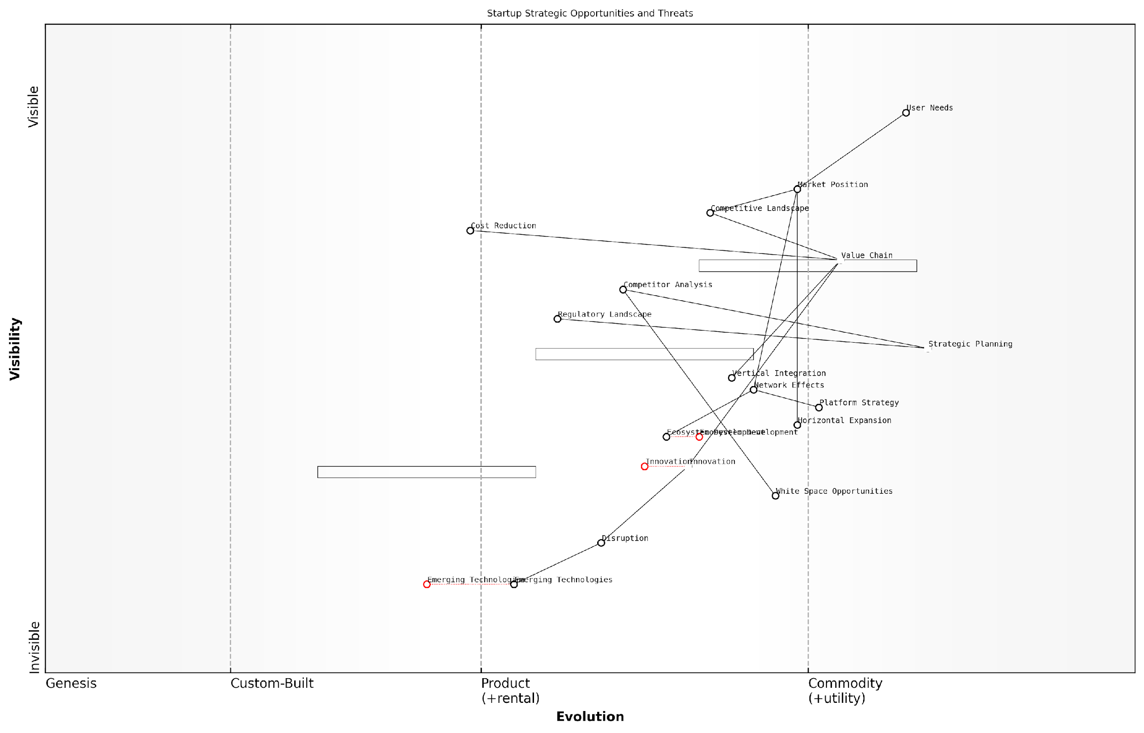

*Draft Wardley Map: [Insert Wardley Map: Identifying strategic opportunities and threats]*

[Edit this draft Wardley Map](https://create.wardleymaps.ai/#clone:0df78418b25f247743)

Wardley Map Assessment

This Wardley Map reveals a complex and dynamic landscape for startups, balancing immediate market needs with future innovation potential. The key to success lies in developing ambidextrous strategies that can address current market positions while preparing for future disruptions through innovation and ecosystem development. Startups must be agile, continuously innovating, and building strong ecosystems to remain competitive. The ability to quickly adapt to and leverage emerging technologies, while navigating regulatory challenges, will be crucial. The emphasis on ecosystem development and platform strategies suggests a shift towards more interconnected business models, where success is increasingly determined by the strength of one’s network and ecosystem rather than standalone products or services.

[View full Wardley Map report](http://markdown_wardley_map_reports/wardley_map_report_16_Identifying_strategic_opportunities_and_threats.md)

Conclusion

Interpreting Wardley Maps for startup insights, particularly in identifying strategic opportunities and threats, is a powerful skill that can significantly enhance a startup’s chances of success. By providing a visual representation of the competitive landscape, value chain dynamics, and component evolution, Wardley Mapping enables startups to make more informed strategic decisions, anticipate market changes, and position themselves for sustainable growth.

As startups navigate the complex and often uncertain path to success, the ability to leverage tools like Wardley Mapping can provide a crucial competitive advantage. By mastering the art of identifying strategic opportunities and threats through this lens, startups can not only survive but thrive in today’s dynamic business environment.

Wardley Mapping has transformed how we approach strategy in our organisation. It’s not just about seeing where we are now, but understanding where the market is heading and how we can position ourselves to capitalise on future opportunities while mitigating potential threats.

### Understanding market dynamics and competitor positioning

In the fast-paced world of startups, understanding market dynamics and competitor positioning is crucial for survival and success. Wardley Mapping provides a powerful tool for startups to gain deep insights into these critical aspects of their business environment. By visualising the value chain and the evolution of components within it, startups can uncover hidden opportunities, anticipate market shifts, and strategically position themselves for competitive advantage.

Interpreting Wardley Maps for market dynamics involves several key aspects:

* Identifying the current state of the market
* Analysing competitor positions and strategies
* Anticipating future market movements
* Uncovering gaps and opportunities in the value chain

Let’s explore each of these aspects in detail, drawing from both established principles and real-world experiences in the startup ecosystem.

1. Identifying the current state of the market

Wardley Maps provide a snapshot of the current market landscape by plotting components along the evolution axis. This visualisation allows startups to quickly assess which components are commoditised, which are in the product phase, and which are still in the genesis or custom-built stages. Understanding this landscape is crucial for identifying where value is being created and captured in the market.

A seasoned startup advisor once remarked, ‘The ability to see the entire market landscape at a glance is like having a superpower. It allows founders to make decisions based on a holistic view rather than fragmented information.’

For example, a startup in the fintech sector might use a Wardley Map to identify that while payment processing is largely commoditised, blockchain-based smart contracts are still in the custom-built phase. This insight could inform their decision to focus on developing innovative smart contract solutions rather than competing in the crowded payment processing space.

1. Analysing competitor positions and strategies

By mapping out the positions of competitors along the value chain, startups can gain valuable insights into their strategies and potential moves. This analysis involves not just identifying where competitors are currently positioned, but also understanding the strategic implications of those positions.

For instance, a competitor focused on custom-built solutions might be aiming to move their offering towards the product phase to capture more market share. Alternatively, a competitor heavily invested in a product-stage component might be vulnerable to disruption from new, more evolved solutions.

As a prominent venture capitalist noted, ‘Understanding your competitors’ positions on a Wardley Map is like playing chess. It allows you to anticipate their moves and plan your strategy accordingly.’

1. Anticipating future market movements

One of the most powerful aspects of Wardley Mapping for startups is its ability to help anticipate future market movements. By understanding the natural evolution of components from genesis to commodity, startups can predict where the market is heading and position themselves accordingly.

For example, a startup in the artificial intelligence sector might identify that certain machine learning algorithms are moving from the custom-built phase to the product phase. This insight could inform their decision to start developing products that leverage these algorithms, anticipating increased demand as they become more accessible and widely adopted.

1. Uncovering gaps and opportunities in the value chain

Wardley Maps can reveal gaps in the current market landscape where no existing solutions adequately address user needs. These gaps often represent significant opportunities for startups to create value and establish a strong market position.

For instance, a startup in the healthcare sector might use a Wardley Map to identify that while electronic health records are well-established, there’s a gap in solutions that effectively integrate and analyse data from wearable devices. This insight could lead to the development of a novel product that fills this gap in the value chain.

A successful serial entrepreneur once said, ‘The real power of Wardley Mapping for startups lies in its ability to reveal the unseen – the opportunities that others have missed.’

Practical considerations for startups using Wardley Maps for market analysis:

* Regular updates: Markets are dynamic, especially in the startup world. Regularly updating your Wardley Maps ensures your understanding of the market remains current.
* Cross-functional involvement: Involve team members from different functions (e.g., product, marketing, sales) in the mapping process to gain diverse perspectives on market dynamics.
* Scenario planning: Use Wardley Maps to create multiple future scenarios, helping your startup prepare for different potential market shifts.
* Competitive intelligence: Continuously gather information about competitors and update your maps accordingly. This ongoing process can reveal emerging threats or opportunities.
* User-centric focus: Always anchor your analysis in user needs. Understanding how user needs evolve in relation to component evolution is key to identifying valuable opportunities.

Case Study: GovTech Startup Success

To illustrate the power of Wardley Mapping in understanding market dynamics and competitor positioning, let’s consider a case study from the government technology (GovTech) sector.

A startup we advised, which we’ll call ‘CivicConnect’, used Wardley Mapping to analyse the market for citizen engagement platforms. Their initial map revealed that while basic online forms and surveys were commoditised, there was a gap in solutions that provided real-time, interactive citizen feedback for policy decisions.

By mapping competitor positions, CivicConnect identified that most were focused on either the commoditised end (basic surveys) or custom solutions for large government departments. This left a gap in the product phase for a scalable, mid-market solution.

Anticipating the evolution of natural language processing and sentiment analysis technologies, CivicConnect developed a product that could analyse citizen feedback in real-time, providing actionable insights to local government decision-makers. This positioned them uniquely in the market, ahead of the evolutionary curve.

The result was rapid adoption by mid-sized local governments across the country, with CivicConnect quickly establishing itself as a leader in this newly defined market segment.

As the founder of CivicConnect reflected, ‘Wardley Mapping didn’t just help us understand the market – it helped us shape it. We saw an opportunity that others had missed and built our entire strategy around it.’

This case study demonstrates how Wardley Mapping can provide startups with a strategic advantage in understanding and navigating complex market dynamics, particularly in sectors like GovTech where the pace of innovation is rapidly increasing.

In conclusion, Wardley Mapping offers startups a powerful tool for understanding market dynamics and competitor positioning. By providing a visual representation of the value chain and component evolution, it enables startups to identify current market states, analyse competitor strategies, anticipate future movements, and uncover valuable opportunities. When combined with regular updates, cross-functional involvement, and a user-centric focus, Wardley Mapping can become a cornerstone of startup strategy, driving innovation and competitive advantage in even the most challenging markets.

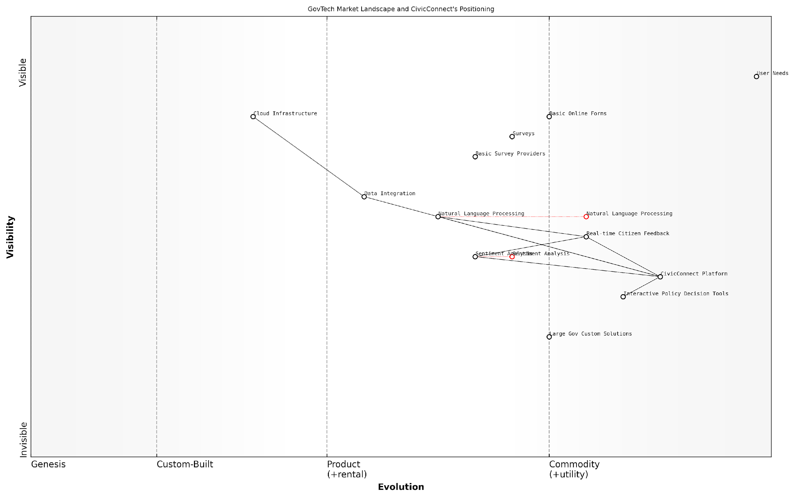

*Draft Wardley Map: [Insert Wardley Map: Understanding market dynamics and competitor positioning]*

[Edit this draft Wardley Map](https://create.wardleymaps.ai/#clone:6b0e004577dd38b07f)

Wardley Map Assessment

CivicConnect is well-positioned in the evolving GovTech market, with strong offerings in high-value areas of citizen engagement. To maintain and enhance its position, the company should focus on advancing its data integration and analysis capabilities, particularly in AI and predictive analytics. There’s a significant opportunity to evolve into a platform model, fostering an ecosystem of innovative GovTech solutions. By staying ahead of the commoditization curve and continuously pushing into new, high-value areas of civic technology, CivicConnect can establish itself as a leader in the next generation of citizen-government interaction tools.

[View full Wardley Map report](http://markdown_wardley_map_reports/wardley_map_report_17_Understanding_market_dynamics_and_competitor_posit.md)

### Anticipating future trends and disruptions

In the dynamic landscape of startups, anticipating future trends and disruptions is not just advantageous—it’s essential for survival and growth. Wardley Mapping provides a powerful framework for startups to peer into the future, identify emerging patterns, and position themselves strategically. This section explores how startups can leverage Wardley Maps to anticipate and navigate the ever-changing business environment.

Wardley Maps are inherently forward-looking tools. By plotting components along the evolution axis, from genesis to commodity, they provide a visual representation of how technologies, practices, and market dynamics are likely to evolve over time. For startups, this foresight is invaluable in making informed decisions about product development, market entry, and resource allocation.

Wardley Mapping is like having a crystal ball for your startup. It doesn’t predict the future with certainty, but it gives you a framework to anticipate change and adapt quickly.

Let’s delve into the key aspects of using Wardley Maps for trend anticipation and disruption readiness:

* Identifying Weak Signals
* Mapping Technological Evolution
* Anticipating Market Shifts
* Preparing for Ecosystem Changes
* Spotting Disruptive Opportunities

Identifying Weak Signals: Wardley Maps excel at highlighting weak signals—early indicators of change that might be easily overlooked. By mapping the entire value chain, including nascent components in the genesis phase, startups can spot emerging technologies or practices that have the potential to reshape their industry. For instance, a fintech startup might identify blockchain technology in its early stages and anticipate its potential impact on financial transactions and data security.

Mapping Technological Evolution: The evolution axis of a Wardley Map provides a clear visualisation of how technologies and practices are expected to mature over time. This allows startups to anticipate when certain components might become more standardised or commoditised, potentially opening up new opportunities or threats. For example, a startup in the artificial intelligence space might use Wardley Mapping to track the evolution of machine learning algorithms, anticipating when certain AI capabilities might become commoditised and planning their product roadmap accordingly.

Anticipating Market Shifts: By mapping customer needs and the components that fulfil them, startups can anticipate shifts in market demand. As certain components evolve, they may enable new use cases or render existing solutions obsolete. A startup in the mobility sector, for instance, might use Wardley Mapping to anticipate the shift from personal vehicle ownership to mobility-as-a-service, informing their strategic decisions and product offerings.

Preparing for Ecosystem Changes: Wardley Maps provide a holistic view of the business ecosystem, including suppliers, competitors, and complementary services. By mapping these relationships, startups can anticipate how changes in one part of the ecosystem might ripple through to affect others. This foresight allows startups to prepare for potential disruptions in their supply chain, identify new partnership opportunities, or anticipate competitive moves.

Spotting Disruptive Opportunities: Perhaps most crucially for startups, Wardley Maps can reveal opportunities for disruption. By identifying areas where there’s a mismatch between the current position of a component and its potential evolution, startups can spot gaps in the market ripe for innovative solutions. For example, a startup might identify a critical component that’s currently custom-built but has the potential to be commoditised, presenting an opportunity to develop a standardised solution that could disrupt the market.

The true power of Wardley Mapping lies not just in understanding the present, but in anticipating the future. It’s about seeing the chess moves before they happen.

To effectively use Wardley Maps for trend anticipation, startups should consider the following best practices:

* Regularly update your maps: The business landscape is constantly changing, and your maps should reflect this. Set a cadence for reviewing and updating your Wardley Maps to ensure they remain relevant.
* Collaborate across teams: Involve team members from different departments in the mapping process. This diversity of perspective can help identify trends and disruptions that might be missed by a single team.
* Use multiple maps: Create maps for different time horizons (e.g., 1 year, 3 years, 5 years) to visualise how you expect the landscape to evolve over time.
* Monitor external sources: Supplement your Wardley Mapping with ongoing monitoring of industry reports, academic research, and expert opinions to validate and refine your trend predictions.
* Scenario planning: Use your Wardley Maps as a foundation for scenario planning exercises, exploring how different trends might interact and impact your business.

It’s important to note that while Wardley Mapping is a powerful tool for anticipating trends and disruptions, it’s not infallible. The future is inherently uncertain, and startups should use Wardley Maps as one tool among many in their strategic planning toolkit. Combine insights from Wardley Mapping with other methodologies such as PESTLE analysis, scenario planning, and continuous market research for a more robust approach to future-proofing your startup.

In my experience advising government bodies and public sector organisations, I’ve seen how Wardley Mapping can be particularly valuable in anticipating regulatory changes and shifts in public policy. For startups operating in regulated industries or working with government clients, this aspect of trend anticipation can be crucial. By mapping the evolution of regulatory frameworks alongside technological and market trends, startups can better navigate complex regulatory environments and even identify opportunities to shape future policies.

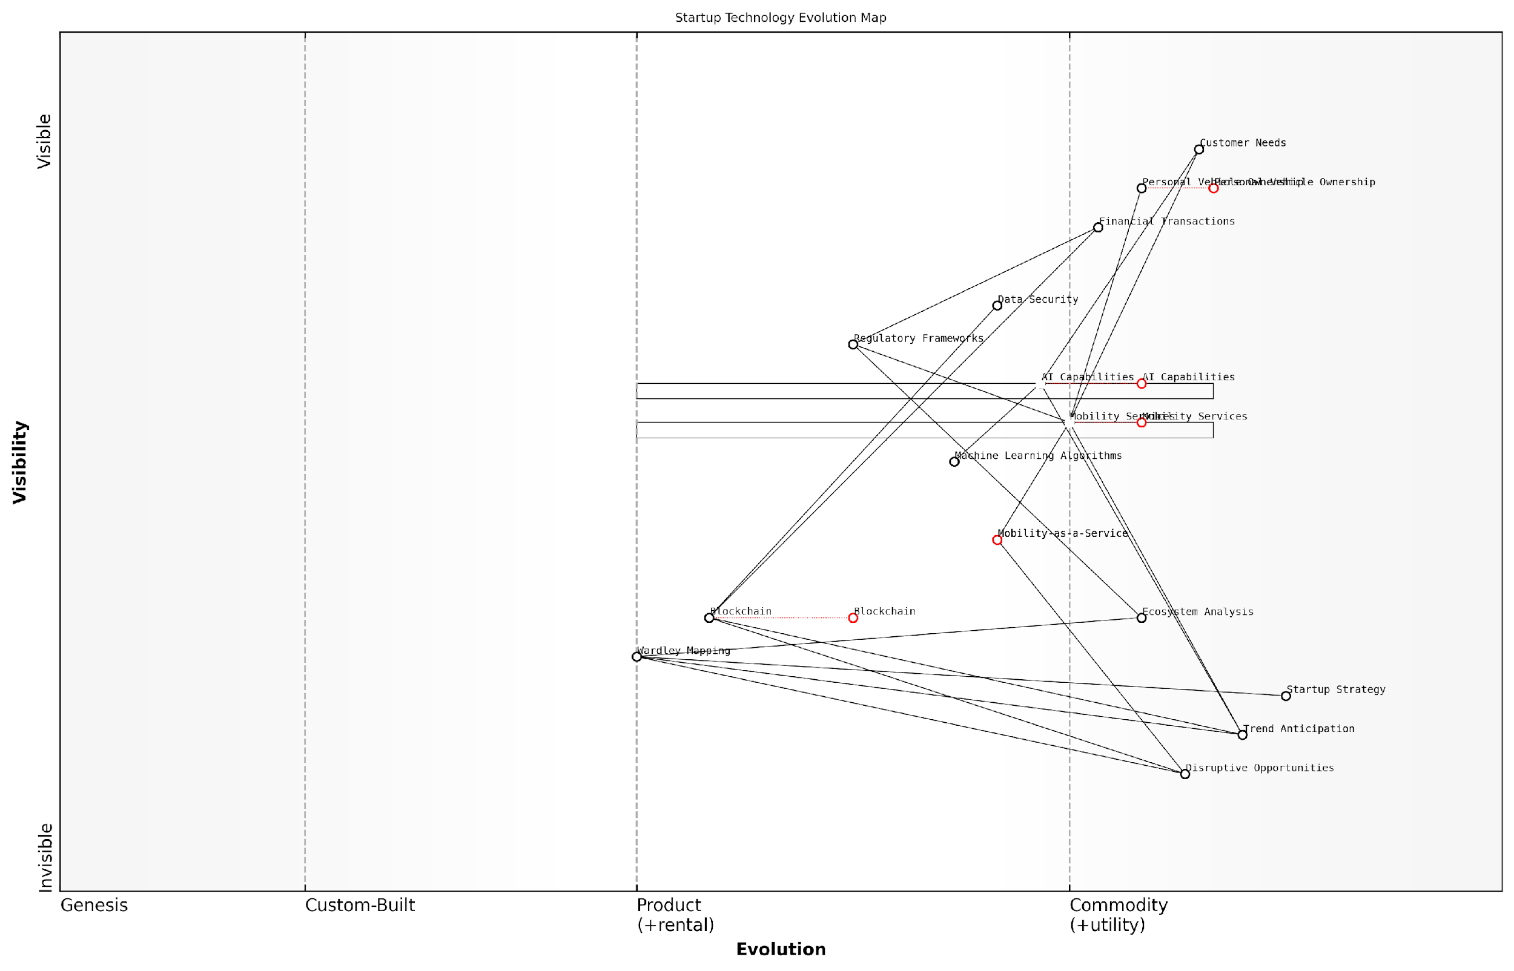

*Draft Wardley Map: [Insert Wardley Map: Anticipating future trends and disruptions]*

[Edit this draft Wardley Map](https://create.wardleymaps.ai/#clone:f07e76c759c8b0ab70)

Wardley Map Assessment

This Wardley Map reveals a startup landscape poised for significant disruption and innovation. The strategic focus on AI capabilities and mobility services, combined with forward-looking investments in blockchain, positions startups to capitalise on major technological shifts. However, success will depend on navigating regulatory challenges, ensuring robust data security, and continuously aligning technological capabilities with evolving customer needs. The integration of Wardley Mapping into startup strategy provides a unique advantage in anticipating and adapting to future trends. To thrive in this environment, startups should prioritise AI-driven innovation, lead the transition to Mobility-as-a-Service, and strategically develop blockchain capabilities while maintaining a strong focus on customer needs and regulatory compliance.

[View full Wardley Map report](http://markdown_wardley_map_reports/wardley_map_report_18_Anticipating_future_trends_and_disruptions.md)

In conclusion, Wardley Mapping offers startups a structured approach to anticipating future trends and disruptions. By visualising the evolution of technologies, practices, and market dynamics, startups can position themselves strategically, identify opportunities for innovation, and prepare for potential challenges. In the fast-paced world of startups, where agility and foresight are key competitive advantages, mastering the art of trend anticipation through Wardley Mapping can be a game-changer.

In the startup world, those who can anticipate the future don’t just survive—they thrive. Wardley Mapping is your compass in the fog of uncertainty, guiding you towards opportunities others might miss.

## Common Pitfalls and How to Avoid Them

### Overcomplicating your first maps

Content for Overcomplicating your first maps not found.

### Misinterpreting component evolution

One of the most common pitfalls in Wardley Mapping for startups is misinterpreting component evolution. This error can lead to significant strategic missteps, potentially jeopardising a startup’s competitive advantage or market positioning. As an expert who has advised numerous government bodies and startups on strategic mapping, I’ve observed this issue repeatedly and its consequences can be far-reaching.

Component evolution is a fundamental concept in Wardley Mapping, representing the natural progression of components from genesis (novel and poorly understood) to commodity (well-understood and easily accessible). Misinterpreting this evolution can occur in several ways, each with its own set of challenges and potential negative outcomes.

Let’s explore the key aspects of this pitfall and how to avoid it:

* Overestimating the pace of evolution
* Underestimating the pace of evolution
* Misplacing components on the evolution axis
* Failing to consider external factors affecting evolution

Overestimating the pace of evolution is a common mistake, especially among tech-savvy startup founders. This often stems from a deep understanding of emerging technologies and a tendency to project rapid adoption rates. However, as I’ve seen in my work with government technology initiatives, the pace of evolution can be significantly slower in certain sectors or for specific components.

Many startups fall into the trap of assuming that because a technology is available, it will be rapidly adopted and commoditised. In reality, factors such as regulatory constraints, user habits, and infrastructure limitations can significantly slow down this process.

Conversely, underestimating the pace of evolution can be equally problematic. This often occurs when startups are too focused on their current market conditions and fail to anticipate rapid changes. In my experience advising public sector organisations on digital transformation, I’ve seen how quickly seemingly stable components can evolve, catching many off guard.

Misplacing components on the evolution axis is another critical error. This can happen when startups lack a comprehensive understanding of their industry’s value chain or when they have an incomplete view of the market. For instance, a component that appears novel within a specific niche might actually be well-established in adjacent industries.

To avoid these pitfalls, I recommend the following strategies:

* Conduct thorough market research and industry analysis
* Regularly update your Wardley Maps to reflect changing conditions
* Seek diverse perspectives when assessing component evolution
* Consider cross-industry applications and potential technology transfers
* Use scenario planning to anticipate different evolution paths

One effective technique I’ve employed with government clients is to create multiple evolution scenarios for critical components. This approach helps to broaden perspectives and prepare for various potential futures. It’s particularly useful when dealing with emerging technologies or rapidly changing market conditions.

Another crucial aspect often overlooked is the impact of external factors on component evolution. These can include regulatory changes, geopolitical events, or shifts in consumer behaviour. For instance, in my work with public sector startups, I’ve seen how new data protection regulations can suddenly accelerate the evolution of privacy-related components, forcing rapid adaptation.

The evolution of components isn’t just about technological progress. It’s equally influenced by social, economic, and regulatory factors. Successful startups are those that can anticipate and adapt to these multifaceted changes.

To mitigate the risk of misinterpreting component evolution, startups should develop a culture of continuous learning and adaptation. This involves not only staying abreast of technological advancements but also maintaining a keen awareness of broader market trends, regulatory landscapes, and societal shifts.

One effective practice I’ve implemented with clients is the establishment of a ‘component evolution review board’. This cross-functional team regularly assesses the positioning of key components on the Wardley Map, considering inputs from various departments and external sources. This collaborative approach helps to minimise individual biases and provides a more holistic view of component evolution.

It’s also crucial to understand that component evolution isn’t always linear or predictable. Disruptive innovations can suddenly shift the evolutionary stage of a component, or create entirely new components that rapidly progress through the evolutionary stages. Startups must remain vigilant and agile, ready to adjust their strategies in response to these shifts.

A case in point from my consultancy experience involves a government-backed startup in the healthcare sector. Initially, they positioned telemedicine solutions as a novel component in their Wardley Map. However, the COVID-19 pandemic caused a rapid evolution of this component, accelerating its move towards commodity. The startup that quickly recognised and adapted to this shift gained a significant advantage over competitors who were slower to react.

To further illustrate the importance of accurately interpreting component evolution, let’s consider a hypothetical example in the context of a public sector startup:

In this example, the startup initially positioned ‘digital identity verification’ as a custom-built component, assuming it would remain a differentiator for several years. However, they failed to anticipate the rapid commoditisation of this technology driven by private sector innovations and changing citizen expectations. As a result, they overinvested in proprietary solutions that quickly became obsolete, while competitors leveraged more advanced, off-the-shelf options.

This case underscores the importance of not only accurately placing components on the evolution axis but also regularly reassessing their positions. It also highlights the need for startups to maintain flexibility in their technology strategies, allowing for rapid pivots when component evolution accelerates unexpectedly.

In conclusion, misinterpreting component evolution is a significant pitfall that can derail a startup’s strategy and competitive positioning. By maintaining a broad perspective, regularly updating Wardley Maps, and fostering a culture of adaptability, startups can navigate the complex landscape of component evolution more effectively. Remember, in the dynamic world of startups, especially those operating in or alongside the public sector, the ability to accurately assess and respond to component evolution can be the difference between success and failure.

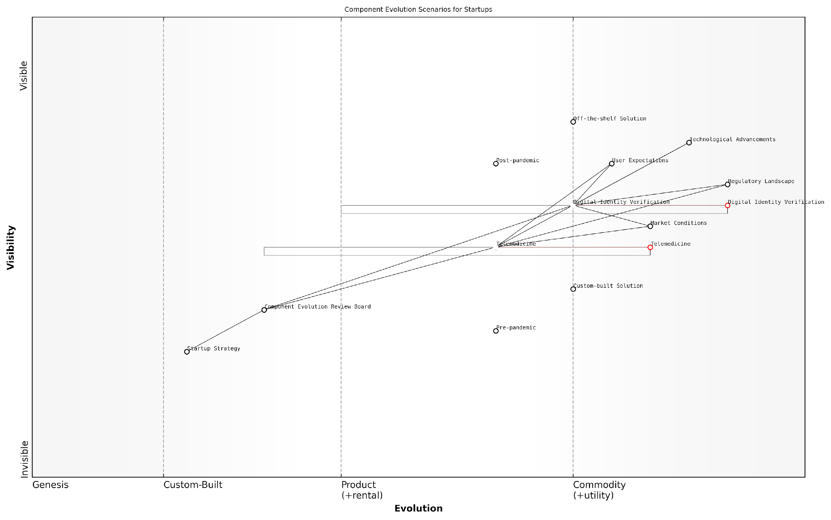

*Draft Wardley Map: [Insert Wardley Map: Misinterpreting component evolution]*

[Edit this draft Wardley Map](https://create.wardleymaps.ai/#clone:03cae31778c6707b63)

Wardley Map Assessment

The map reveals a startup positioned at the intersection of Digital Identity Verification and Telemedicine, with a focus on serving the public sector. The startup has opportunities to lead in the evolving post-pandemic healthcare landscape by leveraging its custom solutions and adapting to rapid technological and regulatory changes. Key strategies should include accelerating the evolution of core offerings, developing a robust ecosystem of integrated services, and maintaining a strong focus on security and compliance. The main challenges lie in navigating the complex regulatory landscape and staying ahead of technological advancements. Success will depend on the ability to balance innovation with reliability in serving public sector needs.

[View full Wardley Map report](http://markdown_wardley_map_reports/wardley_map_report_20_Misinterpreting_component_evolution.md)

### Neglecting to update maps as your startup evolves

One of the most critical pitfalls in Wardley Mapping for startups is the failure to update maps as the business evolves. This oversight can lead to strategic decisions based on outdated information, potentially jeopardising the startup’s ability to navigate the rapidly changing business landscape. As an expert who has advised numerous government bodies and startups on strategic mapping, I cannot overemphasise the importance of treating Wardley Maps as living documents that grow and change with your organisation.

To fully appreciate the significance of this issue, we must first understand the dynamic nature of startups and the environments in which they operate. Startups, by their very nature, are in a constant state of flux. They pivot, scale, and transform at a pace that often outstrips more established organisations. This rapid evolution is precisely why Wardley Mapping is so valuable for startups – but it’s also why neglecting to update these maps can be particularly detrimental.

A Wardley Map is not a static snapshot, but a dynamic representation of your business landscape. Failing to update it is akin to navigating with an outdated GPS – you may think you know where you’re going, but you’re likely to miss crucial turns and opportunities along the way.

Let’s delve deeper into the reasons why startups often fall into this trap and explore strategies to avoid it.

Reasons for neglecting map updates:

* Time constraints and resource limitations
* Lack of established processes for regular review
* Overconfidence in initial mapping
* Failure to recognise the pace of change in the business environment
* Insufficient understanding of the iterative nature of Wardley Mapping

The consequences of not updating your Wardley Maps can be severe. In my experience advising government technology initiatives, I’ve witnessed projects falter due to reliance on outdated maps. One particularly poignant example involved a public sector startup aiming to revolutionise citizen services. Their initial Wardley Map accurately captured the landscape at the project’s inception, but as new technologies emerged and citizen needs evolved, the map became increasingly disconnected from reality. This led to misallocation of resources, missed opportunities for collaboration with emerging private sector partners, and ultimately, a failure to deliver the transformative impact originally envisioned.

To avoid falling into this trap, startups should consider the following strategies:

* Establish a regular cadence for map reviews and updates
* Integrate map updates into key business processes (e.g., quarterly strategy reviews, funding rounds)
* Assign ownership of the mapping process to ensure accountability
* Leverage technology to facilitate real-time collaborative mapping
* Cultivate a culture of continuous learning and adaptation

One effective approach I’ve implemented with several government-backed startups is the concept of ‘living maps’. This involves creating digital Wardley Maps that can be easily updated and shared across the organisation. By integrating these maps with project management tools and data analytics platforms, startups can ensure their strategic view remains current and actionable.

In the fast-paced world of startups, your Wardley Map should be as agile as your business model. It’s not just about creating a map; it’s about fostering a mapping mindset throughout your organisation.

It’s also crucial to understand that updating your Wardley Map isn’t merely about adding or removing components. It involves reassessing the positioning of existing components along the evolution axis, re-evaluating dependencies, and considering how changes in one area of the map might impact others. This holistic approach to map maintenance ensures that your strategic view remains coherent and valuable.

In my work with public sector innovation labs, we’ve developed a framework for ‘map health checks’ that startups can adapt:

* Weekly quick scans: A 15-minute review to flag any immediate changes or emerging trends
* Monthly deep dives: A more comprehensive review, including reassessment of component positions and relationships
* Quarterly strategic alignment: Ensuring the map aligns with overall business strategy and goals
* Annual ecosystem analysis: A broader look at the industry landscape and potential disruptive forces

By implementing such a structured approach, startups can ensure their Wardley Maps remain relevant and continue to provide strategic value as the business evolves.

It’s worth noting that the process of updating your Wardley Map can itself yield valuable insights. Changes in the map often reflect important shifts in your business or market that might otherwise go unnoticed. For instance, a component moving rapidly along the evolution axis might signal an area ripe for innovation or outsourcing. Conversely, a lack of movement in certain areas might indicate stagnation or missed opportunities.

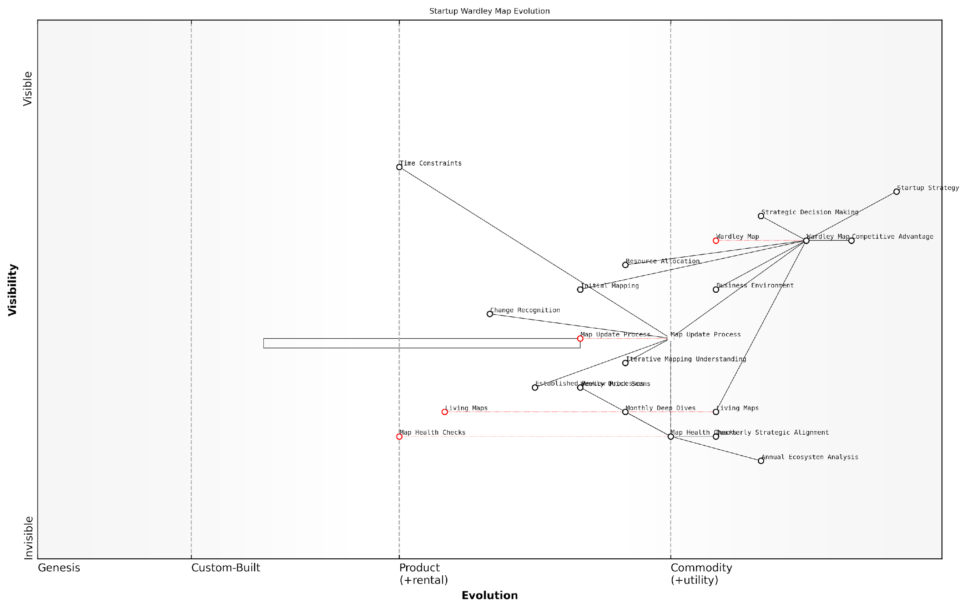

*Draft Wardley Map: [Insert Wardley Map: Neglecting to update maps as your startup evolves]*

[Edit this draft Wardley Map](https://create.wardleymaps.ai/#clone:c9c3f78693b0084f39)

Wardley Map Assessment

This Wardley Map effectively illustrates the critical importance of keeping strategic maps updated in a rapidly evolving startup environment. It highlights the progression from static, infrequently updated maps to dynamic, living documents that reflect real-time changes in the business landscape. The map suggests a strategic imperative to develop robust processes and potentially leverage emerging technologies to ensure that Wardley Maps remain relevant and valuable tools for decision-making. By focusing on the evolution of mapping practices and integrating them deeply into strategic processes, startups can gain a significant competitive advantage in navigating uncertainty and driving innovation.

[View full Wardley Map report](http://markdown_wardley_map_reports/wardley_map_report_21_Neglecting_to_update_maps_as_your_startup_evolves.md)

In conclusion, neglecting to update your Wardley Map as your startup evolves is a pitfall with far-reaching consequences. By treating your map as a living document and establishing processes for regular updates, you can ensure that your strategic decision-making remains grounded in an accurate representation of your business landscape. Remember, in the world of startups, change is the only constant – your Wardley Map should reflect this reality.

A Wardley Map is not a destination, but a journey. It’s a tool for continuous learning and adaptation, guiding your startup through the fog of uncertainty towards strategic clarity and competitive advantage.

# Chapter 2: Integrating Wardley Mapping with Lean Startup Principles

## The Synergy Between Wardley Mapping and Lean Startup

### Overview of Lean Startup methodology

The integration of Wardley Mapping with Lean Startup principles represents a powerful synergy for startups navigating the complex landscape of innovation and market disruption. This combination provides a robust framework for strategic decision-making, hypothesis testing, and iterative development that is particularly well-suited to the unique challenges faced by emerging ventures in the public and private sectors alike.

Lean Startup methodology, pioneered by Eric Ries, emphasises the importance of rapid experimentation, customer feedback, and iterative product development. At its core, the Lean Startup approach advocates for a Build-Measure-Learn cycle that allows startups to quickly validate or invalidate their assumptions about the market and their product. This methodology has revolutionised the way startups operate, encouraging a more agile and customer-centric approach to business development.

Wardley Mapping, on the other hand, provides a visual and strategic framework for understanding the evolving landscape of technology, user needs, and market forces. By mapping the value chain and the evolution of components within it, startups can gain a clearer picture of their competitive position and identify potential areas for innovation or disruption.

When these two methodologies are combined, they create a powerful toolkit for startup founders and government innovators alike. The synergy between Wardley Mapping and Lean Startup principles manifests in several key areas:

* Enhanced Hypothesis Generation: Wardley Maps provide a visual context for generating more informed and strategic hypotheses about market opportunities, customer needs, and potential pivots.
* Focused Experimentation: By identifying key components and their evolutionary stage on a Wardley Map, startups can prioritise which elements of their business model or product to test first, aligning with the Lean Startup’s emphasis on validated learning.
* Strategic Pivots: The combination of rapid experimentation from Lean Startup and the landscape visibility from Wardley Mapping allows for more informed and strategic pivots when initial hypotheses are invalidated.
* Efficient Resource Allocation: Understanding the value chain through Wardley Mapping helps startups allocate their limited resources more effectively, focusing on areas that will provide the most strategic value.
* Long-term Vision with Short-term Actionability: Wardley Maps provide a long-term strategic view, while Lean Startup principles enable short-term, actionable experiments, creating a balanced approach to startup development.

In practice, this synergy can be leveraged throughout the startup journey. For instance, when developing a Minimum Viable Product (MVP), a startup can use Wardley Mapping to identify which components are most critical to test, and then apply Lean Startup principles to rapidly build, measure, and learn from those specific elements.

The combination of Wardley Mapping and Lean Startup methodologies has been transformative for our approach to innovation in the public sector. It allows us to be both strategic and agile, ensuring our initiatives are aligned with long-term goals while remaining responsive to citizen needs.

This sentiment, expressed by a senior government official, underscores the particular relevance of this combined approach in the public sector, where the need for innovation must be balanced with strategic foresight and responsible use of public resources.

One of the most powerful applications of this synergy is in the realm of customer development. Wardley Mapping can help startups visualise their target market segments and their respective needs, while Lean Startup principles guide the process of customer interviews and feedback collection. This combination ensures that startups are not only talking to the right customers but are also asking the right questions and interpreting the feedback within a strategic context.

Moreover, the iterative nature of both methodologies creates a virtuous cycle of learning and adaptation. As startups conduct experiments and gather data (Lean Startup), they can update their Wardley Maps to reflect new insights about the market landscape. These updated maps then inform the next round of hypothesis generation and experimentation, creating a dynamic and responsive strategic process.

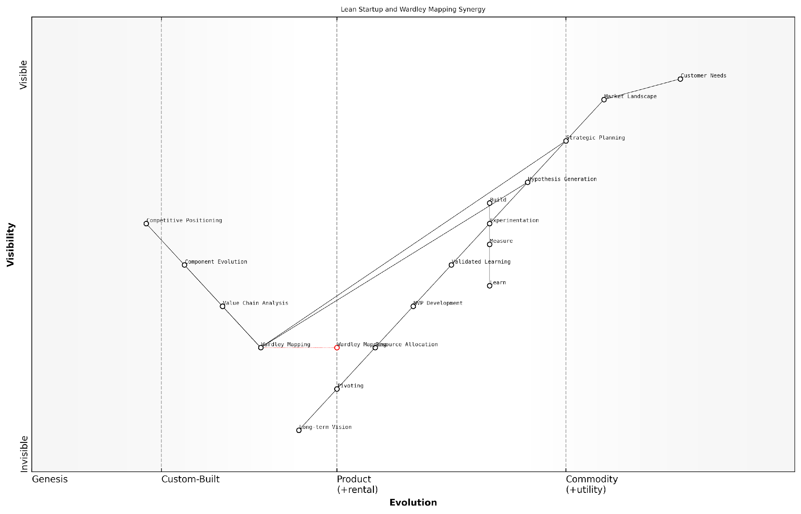

*Draft Wardley Map: [Insert Wardley Map: Overview of Lean Startup methodology]*

[Edit this draft Wardley Map](https://create.wardleymaps.ai/#clone:b7909baee9ee228800)

Wardley Map Assessment

This Wardley Map reveals a sophisticated understanding of the potential synergy between Lean Startup methodologies and strategic mapping techniques. The integration of these approaches positions organisations to make more informed strategic decisions while maintaining the agility to respond to market changes. Key opportunities lie in further developing the interplay between Wardley Mapping and core Lean Startup processes, particularly in hypothesis generation and strategic planning. The consideration of both startup ecosystems and public sector innovation suggests a broad, ecosystem-centric view that could lead to unique collaborative opportunities. To fully capitalise on this potential, organisations should focus on developing advanced capabilities in strategic foresight, data-driven experimentation, and dynamic resource allocation. The future evolution of this space will likely see increased commoditization of basic tools, making the ability to seamlessly integrate strategic mapping with lean methodologies a key differentiator. Overall, this map presents a forward-thinking approach to innovation and strategic planning that, if properly executed, could provide significant competitive advantages in both startup and public sector contexts.

[View full Wardley Map report](http://markdown_wardley_map_reports/wardley_map_report_22_Overview_of_Lean_Startup_methodology.md)

It’s important to note that while this synergy offers significant benefits, it also requires a shift in mindset and approach for many startups. Traditional business planning often emphasises linear thinking and long-term forecasting. In contrast, the combination of Wardley Mapping and Lean Startup principles embraces uncertainty and encourages adaptability.

For government agencies and public sector organisations, this approach can be particularly transformative. It allows for a more agile and citizen-centric approach to policy development and service delivery, while still maintaining the strategic oversight necessary for responsible governance. By mapping the landscape of public services and applying Lean Startup principles to policy experiments, governments can innovate more effectively and efficiently.

In our experience advising government bodies, we’ve found that the integration of Wardley Mapping with Lean Startup thinking has enabled more rapid and effective responses to complex societal challenges. It’s not just about doing things faster, but about doing the right things informed by both strategic insight and real-world feedback.

This observation from a leading consultant in public sector innovation highlights the broader implications of this synergistic approach beyond the realm of private sector startups.

In conclusion, the synergy between Wardley Mapping and Lean Startup methodologies offers a powerful framework for startups and public sector innovators alike. By combining the strategic foresight of Wardley Mapping with the rapid experimentation of Lean Startup, organisations can navigate uncertainty more effectively, allocate resources more efficiently, and ultimately increase their chances of success in an increasingly complex and fast-paced environment.

### How Wardley Mapping complements the Build-Measure-Learn cycle

The Build-Measure-Learn cycle, a cornerstone of the Lean Startup methodology, finds a powerful ally in Wardley Mapping. This synergy enhances the strategic decision-making process for startups, particularly those operating within the complex landscape of government and public sector contexts. By integrating Wardley Mapping into the Build-Measure-Learn cycle, startups can gain a more nuanced understanding of their value chain, market position, and potential trajectories for innovation.

At its core, the Build-Measure-Learn cycle emphasises rapid iteration and validated learning. Wardley Mapping complements this approach by providing a visual framework for understanding the evolving landscape in which a startup operates. This combination allows for more informed hypothesis generation, targeted measurement, and strategic learning.

* Build: Wardley Mapping informs what to build by visualising the current state of the value chain and identifying gaps or inefficiencies.
* Measure: The map provides context for what metrics are most relevant based on the position and movement of components.
* Learn: Insights gained from measurements can be directly applied to update and refine the Wardley Map, creating a dynamic feedback loop.

Let’s explore each of these stages in more detail, drawing from real-world applications in the government and public sector context.

Build: In the ‘Build’ phase, Wardley Mapping offers startups a strategic advantage by providing a clear visualisation of the current landscape. This is particularly valuable in the public sector, where the interplay of various stakeholders, policies, and legacy systems can be complex. For instance, a startup developing a new digital service for citizen engagement can use Wardley Mapping to identify which components of their solution should be custom-built and which can leverage existing government infrastructure.

Wardley Mapping allowed us to see beyond the immediate product features and understand how our solution fit into the broader ecosystem of government services. This insight was crucial in deciding what to build first and where to allocate our limited resources.

Measure: The ‘Measure’ phase benefits significantly from the context provided by Wardley Maps. By understanding the position of various components on the evolution axis, startups can determine which metrics are most relevant at each stage. For example, a govtech startup working on an AI-driven policy analysis tool might focus on different metrics depending on whether the underlying AI technology is in the ‘Genesis’ or ‘Product’ phase of evolution.

This approach allows for more targeted and meaningful measurement, ensuring that startups are tracking the right indicators at the right time. In the public sector, where impact and efficiency are crucial, this precision in measurement can be the difference between securing further funding or facing budget cuts.

By aligning our metrics with the evolutionary stage of each component on our Wardley Map, we were able to demonstrate progress more effectively to our government partners. This alignment of measurement with strategic positioning was instrumental in securing a major contract extension.

Learn: The ‘Learn’ phase is where the iterative nature of both Wardley Mapping and the Build-Measure-Learn cycle truly shines. As startups gather data and insights from their measurements, they can directly apply this knowledge to update and refine their Wardley Maps. This creates a dynamic feedback loop that enhances strategic decision-making.

For instance, a startup working on improving public transportation systems might learn that a particular feature they thought was essential is actually becoming commoditised faster than anticipated. This insight, when reflected on the Wardley Map, could prompt a strategic pivot towards focusing on more differentiating features or exploring new integration possibilities with emerging technologies.

The continuous updating of our Wardley Map based on what we learned through each iteration allowed us to stay ahead of market shifts. In the fast-paced world of govtech, this ability to adapt quickly while maintaining a strategic view was invaluable.

The synergy between Wardley Mapping and the Build-Measure-Learn cycle extends beyond these individual phases. It creates a holistic approach to startup strategy that is particularly well-suited to the complexities of the government and public sector. By providing a shared visual language, Wardley Mapping facilitates better communication between startup teams and government stakeholders, ensuring that everyone is aligned on the strategic direction and priorities.

Moreover, this integrated approach helps startups navigate the unique challenges of the public sector, such as long procurement cycles, regulatory constraints, and the need for broad stakeholder buy-in. By using Wardley Maps to illustrate the evolving landscape and potential future scenarios, startups can make more compelling cases for their solutions and demonstrate a deep understanding of the sector’s needs and challenges.

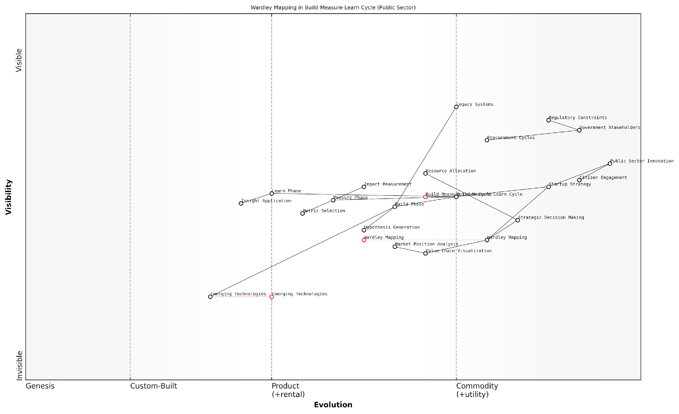

*Draft Wardley Map: [Insert Wardley Map: How Wardley Mapping complements the Build-Measure-Learn cycle]*

[Edit this draft Wardley Map](https://create.wardleymaps.ai/#clone:1f9a592f5295cb66d6)

Wardley Map Assessment

This Wardley Map reveals a strategic initiative to modernise public sector innovation by integrating advanced methodologies like Wardley Mapping with established Lean Startup principles. The positioning of components suggests a thoughtful approach to balancing innovation with the unique constraints of government operations. Key opportunities lie in leveraging Emerging Technologies and enhancing Citizen Engagement, while major challenges include navigating Regulatory Constraints and modernising Legacy Systems. The map indicates a promising direction for public sector innovation, but success will depend on effective change management, strategic capability development, and a commitment to long-term digital transformation.

[View full Wardley Map report](http://markdown_wardley_map_reports/wardley_map_report_23_How_Wardley_Mapping_complements_the_Build-Measure-.md)

In conclusion, the integration of Wardley Mapping with the Build-Measure-Learn cycle offers a powerful framework for startups navigating the complex terrain of government and public sector innovation. By providing strategic context to each phase of the cycle, Wardley Mapping enhances the startup’s ability to make informed decisions, measure meaningful progress, and learn strategically. This synergy not only accelerates the path to product-market fit but also positions startups to drive meaningful transformation in the public sector.

### Using maps to inform hypothesis generation and testing

The synergy between Wardley Mapping and Lean Startup methodologies reaches its zenith in the realm of hypothesis generation and testing. This powerful combination enables startups to navigate the uncertain waters of innovation with greater precision and efficiency. By leveraging Wardley Maps to inform the hypothesis-driven approach central to Lean Startup, entrepreneurs can significantly enhance their ability to identify, prioritise, and validate critical assumptions about their business model and market dynamics.

Wardley Mapping provides a visual representation of the value chain and competitive landscape, offering a strategic context that is often missing in traditional Lean Startup approaches. This context is invaluable when formulating hypotheses, as it allows startups to consider not just immediate customer needs, but also the broader ecosystem in which they operate.

Wardley Mapping has revolutionised our approach to hypothesis testing. It’s like having a strategic radar that helps us focus our experiments on the most critical assumptions and opportunities.

Let’s explore how Wardley Mapping enhances each stage of the hypothesis testing process:

* Hypothesis Generation: Wardley Maps reveal potential areas of disruption, inefficiencies in the value chain, and emerging customer needs. These insights serve as a wellspring for generating hypotheses that are both strategically relevant and potentially game-changing.
* Hypothesis Prioritisation: By visualising the entire value chain, Wardley Maps help startups identify which hypotheses are most critical to test first. This prioritisation is based on factors such as the potential impact on the business model, the current evolution stage of relevant components, and the competitive landscape.
* Experiment Design: The visual nature of Wardley Maps aids in designing more comprehensive experiments. Startups can consider how changes in one part of the value chain might affect other components, leading to more holistic and insightful tests.
* Results Interpretation: When analysing the results of experiments, Wardley Maps provide a broader context for interpretation. This helps startups avoid the pitfall of making decisions based on isolated data points, instead considering how results fit into the larger strategic picture.

One of the most powerful applications of Wardley Mapping in hypothesis testing is in identifying and challenging hidden assumptions. Often, startups operate with unconscious biases about their market, customers, or technology. Wardley Maps bring these assumptions to the surface, making them explicit and testable.

For example, a startup might assume that a particular component in their value chain is more evolved than it actually is. This assumption could lead to flawed strategic decisions. By mapping out the component’s actual evolution stage and comparing it to competitors, the startup can generate hypotheses about potential opportunities for differentiation or the need for partnerships to accelerate development.

The beauty of combining Wardley Mapping with Lean Startup is that it forces us to question everything. We’ve uncovered assumptions we didn’t even know we were making, which has been absolutely crucial for our success.

Another key benefit of using Wardley Maps for hypothesis testing is the ability to anticipate and prepare for future scenarios. By mapping out potential future states of the market and value chain, startups can generate hypotheses about upcoming challenges and opportunities. This forward-looking approach allows for more proactive strategy development and can give startups a significant competitive advantage.

It’s important to note that the process of using Wardley Maps to inform hypothesis testing is iterative. As startups conduct experiments and gather data, they should regularly update their maps to reflect new insights. This continuous refinement ensures that the strategic context remains accurate and relevant, leading to increasingly targeted and effective hypothesis generation and testing over time.

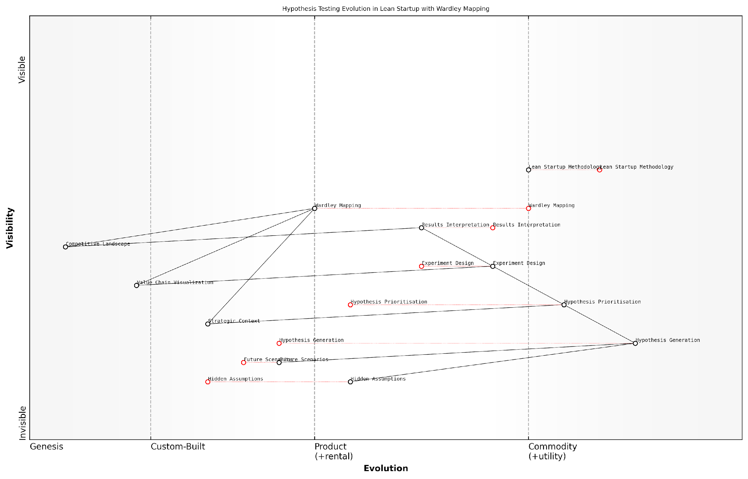

*Draft Wardley Map: [Insert Wardley Map: Using maps to inform hypothesis generation and testing]*

[Edit this draft Wardley Map](https://create.wardleymaps.ai/#clone:13569c4725eb034fc9)

Wardley Map Assessment

This Wardley Map presents a sophisticated integration of Lean Startup methodology with strategic mapping tools, particularly Wardley Mapping. It offers a comprehensive framework for hypothesis testing that is grounded in customer needs and market dynamics while leveraging advanced strategic analysis. The key strengths lie in the explicit connection between strategic context and operational activities, and the emphasis on future scenario planning. However, there are opportunities to further enhance the system by addressing hidden assumptions more systematically and leveraging advanced technologies for automation and prediction. The map indicates a mature understanding of startup methodologies but also suggests room for innovation in their application and integration. Overall, this approach positions users to make more informed strategic decisions and conduct more effective hypothesis testing, potentially leading to faster and more successful startup growth.

[View full Wardley Map report](http://markdown_wardley_map_reports/wardley_map_report_24_Using_maps_to_inform_hypothesis_generation_and_tes.md)

In practice, startups can implement this integrated approach by following these steps:

* Create an initial Wardley Map of your business and market landscape
* Identify key areas of uncertainty or potential opportunity on the map
* Generate hypotheses based on these areas, considering both customer needs and strategic positioning
* Prioritise hypotheses based on their potential impact and the current evolution stage of relevant components
* Design experiments that test these hypotheses, taking into account the broader context provided by the map
* Conduct experiments and analyse results in the context of the overall map
* Update the Wardley Map based on new insights and repeat the process

By following this process, startups can ensure that their hypothesis testing efforts are not only rigorous and data-driven but also strategically aligned and forward-looking. This approach helps bridge the gap between tactical experimentation and long-term strategy, a challenge that many startups struggle with.

It’s worth noting that this integrated approach is particularly valuable in the public sector and government contexts. In these environments, where the stakes are often high and resources must be carefully allocated, the combination of Wardley Mapping and Lean Startup principles can lead to more effective policy development and service delivery.

In our government innovation lab, combining Wardley Mapping with Lean Startup has been transformative. It’s allowed us to test policy hypotheses with a level of strategic insight we’ve never had before, leading to more effective and citizen-centric services.

In conclusion, the synergy between Wardley Mapping and Lean Startup in hypothesis generation and testing offers a powerful toolkit for startups navigating uncertainty. By providing strategic context to the experimentation process, this approach enables startups to make more informed decisions, anticipate future challenges, and ultimately increase their chances of success in dynamic and competitive markets.

## Rapid Iteration and Validation Using Wardley Maps

### Mapping your Minimum Viable Product (MVP)

In the fast-paced world of startups, particularly within the government and public sector contexts, the ability to rapidly iterate and validate ideas is crucial. Wardley Mapping provides a powerful framework for this process, enabling startups to visualise their value chain, identify key assumptions, and strategically focus their efforts on the most critical aspects of their Minimum Viable Product (MVP). This section explores how Wardley Mapping can be seamlessly integrated with the principles of rapid iteration and validation, offering a robust approach for startups navigating the complexities of the public sector landscape.

Mapping your Minimum Viable Product (MVP) is a critical first step in the rapid iteration and validation process. By creating a Wardley Map of your MVP, you gain a clear visual representation of the components necessary to deliver value to your users, their evolutionary stage, and their interdependencies. This visual clarity is particularly valuable in the often complex and regulation-heavy environment of government and public sector startups.

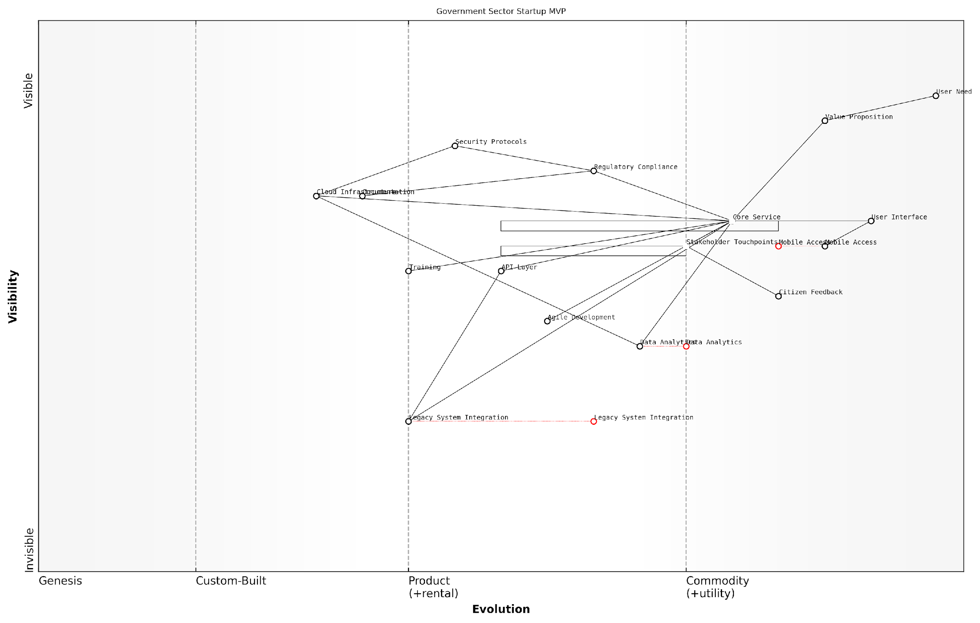

*Draft Wardley Map: [Insert Wardley Map: Mapping your Minimum Viable Product (MVP)]*

[Edit this draft Wardley Map](https://create.wardleymaps.ai/#clone:8edbe4076fa5bb0c6e)

Wardley Map Assessment

This Wardley Map represents a government sector startup MVP that is well-positioned to deliver user-centric services while navigating regulatory and legacy system challenges. The strategic focus on core service delivery, supported by evolving technical capabilities, provides a solid foundation. Key opportunities lie in accelerating the evolution of data analytics, mobile access, and legacy system integration. The main challenges involve balancing regulatory compliance with innovation and managing the transition from legacy systems to modern, cloud-based infrastructure. By prioritising user needs, leveraging citizen feedback, and adopting agile methodologies, this startup has the potential to drive significant innovation in government service delivery. However, careful attention must be paid to security, compliance, and seamless integration with existing government systems to ensure long-term success and scalability.

[View full Wardley Map report](http://markdown_wardley_map_reports/wardley_map_report_25_Mapping_your_Minimum_Viable_Product_(MVP).md)

When mapping your MVP, it’s essential to focus on the core value proposition and the minimum set of components required to deliver it. This approach aligns well with the lean startup methodology, allowing you to create a product with just enough features to satisfy early adopters and provide feedback for future development. In the context of government and public sector startups, this might involve mapping out essential services, regulatory compliance components, and key stakeholder touchpoints.

* Identify the user need and the value proposition
* Map out the components required to deliver the value
* Assess the evolutionary stage of each component
* Identify dependencies between components
* Highlight areas of uncertainty or risk

Once you have mapped your MVP, the next step is to use this visual representation to identify key assumptions and risks. In my experience advising government bodies and public sector organisations, I’ve found that Wardley Maps are particularly effective at uncovering hidden assumptions that might otherwise go unnoticed. These assumptions often relate to the perceived value of certain components, the expected pace of evolution, or the nature of dependencies between elements.

Wardley Mapping has been instrumental in helping us uncover critical assumptions about our service delivery model. It forced us to question long-held beliefs about what our citizens truly value and how we can best meet their needs.

To effectively use Wardley Maps for identifying assumptions and risks, consider the following approach:

* Examine each component and its position on the evolution axis
* Question why you believe each component is necessary
* Identify areas where you’re making assumptions about user needs or market dynamics
* Look for components that are critical to your value proposition but are in early evolutionary stages
* Consider the risks associated with dependencies, especially on components you don’t control

With your assumptions and risks identified, you can now prioritise your validation efforts. Focus on testing the assumptions that are most critical to your MVP’s success and pose the highest risk if incorrect. In the government and public sector context, this might involve validating assumptions about citizen needs, regulatory requirements, or the feasibility of integrating with existing systems.

Rapid iteration based on map insights is where the true power of Wardley Mapping for startups becomes evident. As you gather data and feedback from your validation efforts, you can quickly update your map to reflect new understanding. This iterative process allows you to make informed decisions about pivoting, persevering, or making incremental changes to your MVP.

The ability to rapidly iterate our strategy based on Wardley Map insights has been game-changing for our public sector startup. We’ve been able to navigate complex stakeholder relationships and regulatory landscapes with much greater agility than we ever thought possible.

When iterating your business model based on map insights, consider the following strategies:

* Regularly update your map based on new information and feedback
* Look for opportunities to leverage more evolved components to reduce risk and accelerate development
* Identify areas where you can create strategic advantage by investing in the evolution of key components
* Use the map to communicate changes and rationale to stakeholders, which is particularly crucial in the public sector
* Consider how changes in one part of the map might impact other areas of your business model

It’s worth noting that in the government and public sector context, rapid iteration can sometimes be challenging due to bureaucratic processes and regulatory constraints. However, Wardley Mapping can help navigate these challenges by providing a clear visual representation of where flexibility exists and where constraints are immovable. This clarity can be invaluable in focusing iteration efforts where they can have the most impact.

In conclusion, the integration of Wardley Mapping with rapid iteration and validation processes offers a powerful toolkit for startups, especially those operating in the complex landscape of government and public sector services. By mapping your MVP, identifying key assumptions and risks, and using map insights to guide your iteration process, you can navigate uncertainty with greater confidence and strategic clarity. This approach not only enhances your ability to deliver value to users but also provides a robust framework for communicating your strategy and progress to stakeholders, investors, and team members.

### Using maps to identify key assumptions and risks

In the fast-paced world of startups, identifying and validating key assumptions and risks is crucial for success. Wardley Mapping provides a powerful framework for this process, enabling founders and teams to visualise their business landscape and uncover critical areas of uncertainty. By leveraging Wardley Maps, startups can rapidly iterate on their ideas, test hypotheses, and mitigate risks in a structured and efficient manner.

Wardley Maps serve as a visual representation of the value chain, market evolution, and strategic positioning. When applied to the startup context, these maps become invaluable tools for surfacing and examining the underlying assumptions that form the foundation of a business model. Let’s explore how Wardley Mapping can be used to identify key assumptions and risks, and how this process integrates seamlessly with the rapid iteration cycles typical of lean startup methodologies.

Identifying Key Assumptions:

* Value Chain Assumptions: By mapping out the entire value chain, from user needs to the components that fulfil those needs, startups can identify assumptions about which components are truly essential and how they interact.
* Evolution Assumptions: Placing components along the evolution axis reveals assumptions about the maturity of technologies, practices, and market segments.
* Positioning Assumptions: The positioning of components relative to each other exposes assumptions about competitive advantage and strategic focus.

Uncovering Hidden Risks:

* Dependency Risks: Wardley Maps highlight dependencies between components, revealing potential single points of failure or over-reliance on specific technologies or partners.
* Market Evolution Risks: By visualising the evolution of components, startups can identify risks associated with betting on emerging technologies or mature markets nearing disruption.
* Competitive Risks: Mapping competitors alongside your own value chain can uncover areas where you may be vulnerable to disruption or market entry.

Wardley Mapping is like shining a torch into the dark corners of your business model. It illuminates the assumptions you didn’t even know you were making and the risks lurking just out of sight.

Integrating with Lean Startup Principles:

The process of using Wardley Maps to identify assumptions and risks aligns perfectly with the Build-Measure-Learn cycle central to the Lean Startup methodology. Here’s how:

* Build: Use the map to prioritise which assumptions to test first, focusing on those that are most critical to your business model.
* Measure: Design experiments and collect data to validate or invalidate the assumptions identified in your map.
* Learn: Update your Wardley Map based on the insights gained, refining your understanding of the landscape and uncovering new assumptions to test.

Practical Application: Assumption Mapping Workshop

One effective technique for using Wardley Maps to identify assumptions is the Assumption Mapping Workshop. This collaborative exercise involves the following steps:

* Create an initial Wardley Map of your business model or specific value chain.
* For each component on the map, brainstorm and list all assumptions being made about its position, importance, and relationships.
* Categorise assumptions based on their potential impact and the level of certainty.
* Prioritise high-impact, low-certainty assumptions for immediate testing.
* Design rapid experiments to validate or invalidate these critical assumptions.
* Update the map based on findings and repeat the process.

The Assumption Mapping Workshop is a game-changer for startups. It forces you to confront your biases and gut feelings with data and evidence. I’ve seen teams completely transform their approach after just one session.

Case Study: GovTech Startup Navigating Regulatory Risks

Consider the case of a GovTech startup developing a blockchain-based voting system. Initially, their Wardley Map revealed several critical assumptions:

* Blockchain technology was positioned as a key differentiator
* Government adoption was assumed to be straightforward
* Security concerns were considered easily addressable

Through the Assumption Mapping process, the team identified that their assumption about government adoption was high-impact but highly uncertain. They designed experiments to test this, including interviews with election officials and small-scale pilot projects.

The results led to a significant pivot. They discovered that while blockchain offered benefits, regulatory hurdles were more significant than anticipated. The updated Wardley Map placed greater emphasis on regulatory compliance and stakeholder education, leading to a revised strategy that focused on building trust and demonstrating security through extensive testing and certification processes.

This case illustrates how Wardley Mapping, combined with lean experimentation, can help startups navigate complex regulatory environments and adapt their strategies based on validated learning.

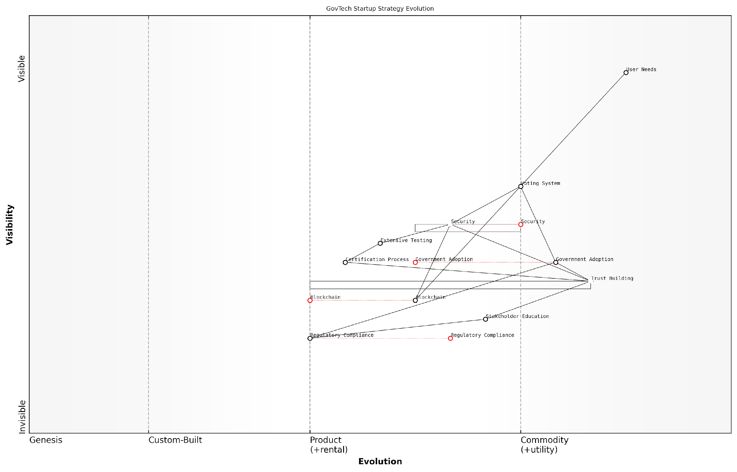

*Draft Wardley Map: [Insert Wardley Map: Using maps to identify key assumptions and risks]*

[Edit this draft Wardley Map](https://create.wardleymaps.ai/#clone:be6c59e718147dc581)

Wardley Map Assessment

This Wardley Map illustrates a GovTech startup’s strategic evolution from a technology-focused approach to a more comprehensive strategy addressing the complex challenges of government technology adoption. The startup shows promising positioning in a critical and evolving market, with a clear understanding of the need to build trust and navigate regulatory landscapes. Key opportunities lie in further developing trust-building capabilities, enhancing security measures, and establishing strong government partnerships. The main challenges revolve around accelerating government adoption and staying ahead in a rapidly evolving security and regulatory environment. By focusing on these areas and leveraging its unique integrated approach, the startup has the potential to establish itself as a leader in the GovTech space, particularly in blockchain-based voting systems.

[View full Wardley Map report](http://markdown_wardley_map_reports/wardley_map_report_26_Using_maps_to_identify_key_assumptions_and_risks.md)

Conclusion: Embracing Uncertainty with Wardley Mapping

In the uncertain world of startups, particularly those operating in the government and public sector, Wardley Mapping provides a structured approach to identifying and testing key assumptions and risks. By visualising the business landscape and systematically challenging assumptions, startups can make more informed decisions, allocate resources more effectively, and increase their chances of success.

The integration of Wardley Mapping with lean startup principles creates a powerful framework for rapid iteration and validation. This approach enables startups to navigate complex environments, adapt to changing conditions, and build resilient, innovative solutions that address real market needs.

In my years of advising government agencies and startups, I’ve found that those who embrace tools like Wardley Mapping to systematically challenge their assumptions are the ones who not only survive but thrive in the face of uncertainty. It’s not about having all the answers, but about asking the right questions and being prepared to adapt based on what you learn.

### Iterating your business model based on map insights

In the fast-paced world of startups, the ability to rapidly iterate and refine your business model is crucial for success. Wardley Mapping provides a powerful framework for gaining strategic insights and driving informed iterations. By leveraging the visual representation of your value chain and the evolutionary stage of each component, you can identify opportunities for innovation, efficiency improvements, and competitive advantage.

The process of iterating your business model based on Wardley Map insights involves several key steps:

* Analysing your current map
* Identifying areas for improvement or innovation
* Generating hypotheses for business model changes
* Testing and validating these hypotheses
* Updating your map and business model accordingly

Let’s explore each of these steps in detail, drawing on best practices and real-world examples from the public sector and government startups.

1. Analysing your current map

The first step in iterating your business model is to thoroughly analyse your current Wardley Map. This involves examining the positioning of each component along the evolution axis, understanding the dependencies between components, and identifying any gaps or inefficiencies in your value chain.

A seasoned government strategist once remarked, ‘The power of Wardley Mapping lies not just in creating the map, but in the insights that emerge when you truly scrutinise it. It’s like holding up a mirror to your organisation’s strategy.’

Key questions to ask during this analysis include:

* Are there any components that are more evolved than we initially thought?
* Are we over-investing in commodity components?
* Are there any missing components that could provide strategic advantage?
* Are there any bottlenecks or inefficiencies in our value chain?

1. Identifying areas for improvement or innovation

Based on your analysis, you can now identify specific areas where your business model could be improved or innovated. This might involve:

* Outsourcing commodity components to reduce costs
* Investing in the development of novel components that could provide competitive advantage
* Restructuring your value chain to improve efficiency
* Exploring new markets or customer segments based on your unique capabilities

For example, a government startup focused on digital identity verification identified through their Wardley Map that certain security protocols they were developing in-house had actually evolved to become industry standards. This insight led them to outsource these components and refocus their efforts on developing more innovative, value-adding features.

1. Generating hypotheses for business model changes

Once you’ve identified potential areas for improvement, the next step is to generate specific hypotheses about how changes to your business model could drive better outcomes. These hypotheses should be specific, measurable, and testable.

As a leading expert in public sector innovation puts it, ‘The key is to frame your hypotheses in terms of expected outcomes. Don’t just say “we should outsource component X”. Instead, hypothesise that “outsourcing component X will reduce our operational costs by Y% while maintaining or improving service quality”.’

1. Testing and validating these hypotheses

With clear hypotheses in hand, the next step is to design and conduct experiments to test them. This is where the integration of Wardley Mapping with Lean Startup principles becomes particularly powerful. You can use techniques like Minimum Viable Products (MVPs), A/B testing, and customer interviews to validate your hypotheses quickly and cost-effectively.

For instance, a startup working on improving public transportation systems used Wardley Mapping to identify an opportunity to integrate real-time traffic data into their route planning algorithm. They tested this hypothesis by developing a simple MVP that incorporated this data for a small subset of routes and measured the impact on journey times and user satisfaction.

1. Updating your map and business model accordingly

Based on the results of your experiments, you can now update both your Wardley Map and your business model. This might involve:

* Adjusting the position of components on your map
* Adding or removing components
* Changing the relationships between components
* Updating your value proposition or customer segments
* Modifying your revenue streams or cost structure

It’s crucial to remember that this process is iterative. Each cycle of analysis, hypothesis generation, testing, and updating should lead to a more refined and effective business model.

A senior government official with extensive experience in digital transformation projects noted, ‘The power of combining Wardley Mapping with iterative development is that it allows us to make strategic decisions based on evidence, not just intuition. We’re constantly learning and adapting, which is essential in the rapidly evolving landscape of public sector technology.’

By following this process of iterating your business model based on Wardley Map insights, startups in the public sector can navigate uncertainty more effectively, allocate resources more efficiently, and ultimately deliver greater value to citizens and stakeholders.

In conclusion, the combination of Wardley Mapping and rapid iteration provides a powerful toolkit for startups, especially those operating in the complex landscape of government and public services. By visualising your strategy, generating data-driven hypotheses, and continuously refining your approach, you can increase your chances of success and create meaningful impact in the public sector.

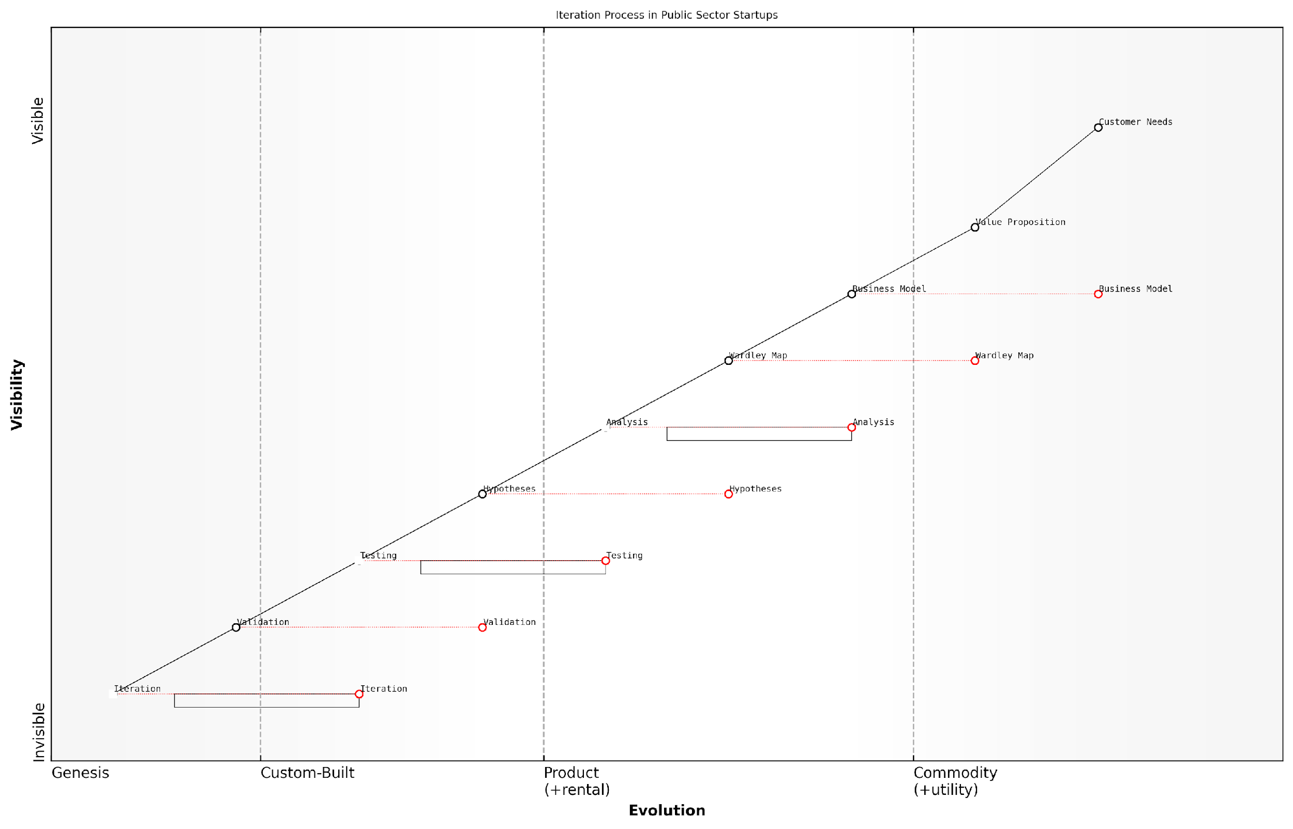

*Draft Wardley Map: [Insert Wardley Map: Iterating your business model based on map insights]*

[Edit this draft Wardley Map](https://create.wardleymaps.ai/#clone:22d2de8f7b7b7163d4)

Wardley Map Assessment

This Wardley Map reveals a structured approach to innovation in public sector startups, with a strong emphasis on iterative improvement driven by customer needs. The ecosystem shows signs of maturity in understanding customer requirements and developing value propositions, but has significant room for evolution in testing, validation, and rapid iteration capabilities. The explicit inclusion of Wardley Mapping as a strategic tool is noteworthy and potentially a differentiator. To maximise effectiveness, focus should be placed on accelerating the iteration cycle, particularly in the less evolved components of testing and validation. There’s also a clear opportunity to leverage emerging technologies like AI and machine learning to enhance analysis and hypothesis generation. The public sector context provides both unique challenges and opportunities, particularly in terms of collaboration and shared learning across entities. Overall, the map indicates a promising foundation for innovation, with clear pathways for improvement and strategic development.

[View full Wardley Map report](http://markdown_wardley_map_reports/wardley_map_report_27_Iterating_your_business_model_based_on_map_insight.md)

## Customer Development Through the Lens of Wardley Mapping

### Mapping customer segments and their needs

In the realm of Wardley Mapping for Startups, particularly within government and public sector contexts, mapping customer segments and their needs is a critical component of the customer development process. This approach allows startups to gain a deeper understanding of their target audience, align their value proposition with genuine market demands, and identify opportunities for innovation and growth. By leveraging Wardley Mapping techniques in customer development, startups can navigate the complex landscape of user needs, market evolution, and competitive dynamics with greater precision and strategic insight.

The integration of Wardley Mapping with customer development practices offers several key advantages for startups:

* Visual representation of customer segments and their needs within the broader value chain
* Identification of evolving customer requirements and emerging market trends
* Strategic positioning of products and services to meet current and future customer needs
* Enhanced ability to prioritise development efforts and allocate resources effectively
* Improved communication and alignment among team members and stakeholders

Let’s explore how startups can effectively map customer segments and their needs using Wardley Mapping techniques, with a focus on applications in the government and public sector.

1. Identifying Customer Segments

The first step in mapping customer segments is to identify distinct groups of users or beneficiaries within the target market. In the context of government and public sector startups, these segments might include:

* Citizens accessing public services
* Government agencies and departments
* Local authorities and municipalities
* Non-profit organisations and community groups
* Businesses interacting with government services

Each of these segments may have unique needs, preferences, and constraints that must be considered in the mapping process. By clearly defining these segments, startups can create more targeted and effective solutions.

1. Mapping Customer Needs

Once customer segments are identified, the next step is to map their specific needs and requirements. This involves placing these needs on the Wardley Map, considering their position along the evolution axis (from genesis to commodity) and their relationship to other components in the value chain.

For example, a startup developing a digital platform for citizen engagement might map the following needs:

* Accessible information about government services (commodity)
* Secure online transactions for paying fines or taxes (product)
* Real-time updates on local issues and initiatives (custom-built)
* AI-powered chatbots for answering citizen queries (genesis)

By mapping these needs, startups can visualise how different aspects of their solution align with customer requirements and market maturity.

Mapping customer needs isn’t just about understanding what users want today; it’s about anticipating how those needs will evolve and positioning your startup to meet future demands.

1. Analysing Dependencies and Relationships

Wardley Mapping allows startups to visualise the dependencies and relationships between different customer needs and other components in the value chain. This analysis can reveal critical insights, such as:

* Bottlenecks or inefficiencies in current service delivery
* Opportunities for integration or consolidation of services
* Potential areas for innovation or disruption
* Dependencies on external technologies or platforms

For instance, a startup might identify that the need for secure online transactions is dependent on robust identity verification systems, which could be an area for innovation or partnership.

1. Identifying Opportunities for Pivots and Expansions

By mapping customer segments and their needs, startups can identify opportunities for pivots or expansions in their business model. This might involve:

* Targeting new customer segments with existing solutions
* Developing new features or services to meet emerging needs
* Repositioning the startup’s offering based on evolving market dynamics
* Identifying potential partnerships or acquisitions to enhance value proposition

For example, a startup initially focused on providing digital services to local authorities might identify an opportunity to expand into citizen-facing applications based on their mapping of customer needs and market evolution.

1. Guiding Customer Interviews and Feedback Sessions

Wardley Maps can serve as powerful tools for structuring customer interviews and feedback sessions. By using the map as a reference point, startups can:

* Focus discussions on specific areas of the value chain
* Validate assumptions about customer needs and their relative importance
* Explore potential future scenarios and their implications
* Identify gaps or misalignments between the startup’s perception and customer reality

This approach ensures that customer development activities are strategic, focused, and aligned with the startup’s overall mapping efforts.

The true power of Wardley Mapping in customer development lies in its ability to transform abstract customer insights into concrete, actionable strategies.

1. Iterative Refinement and Adaptation

Customer development through Wardley Mapping is an iterative process. As startups gather more data and insights, they should continuously refine their maps, adjusting customer segments, repositioning needs, and updating dependencies. This ongoing refinement ensures that the startup remains aligned with evolving market dynamics and customer requirements.

In the context of government and public sector startups, this iterative approach is particularly crucial due to the complex and often changing nature of policy, regulations, and citizen needs.

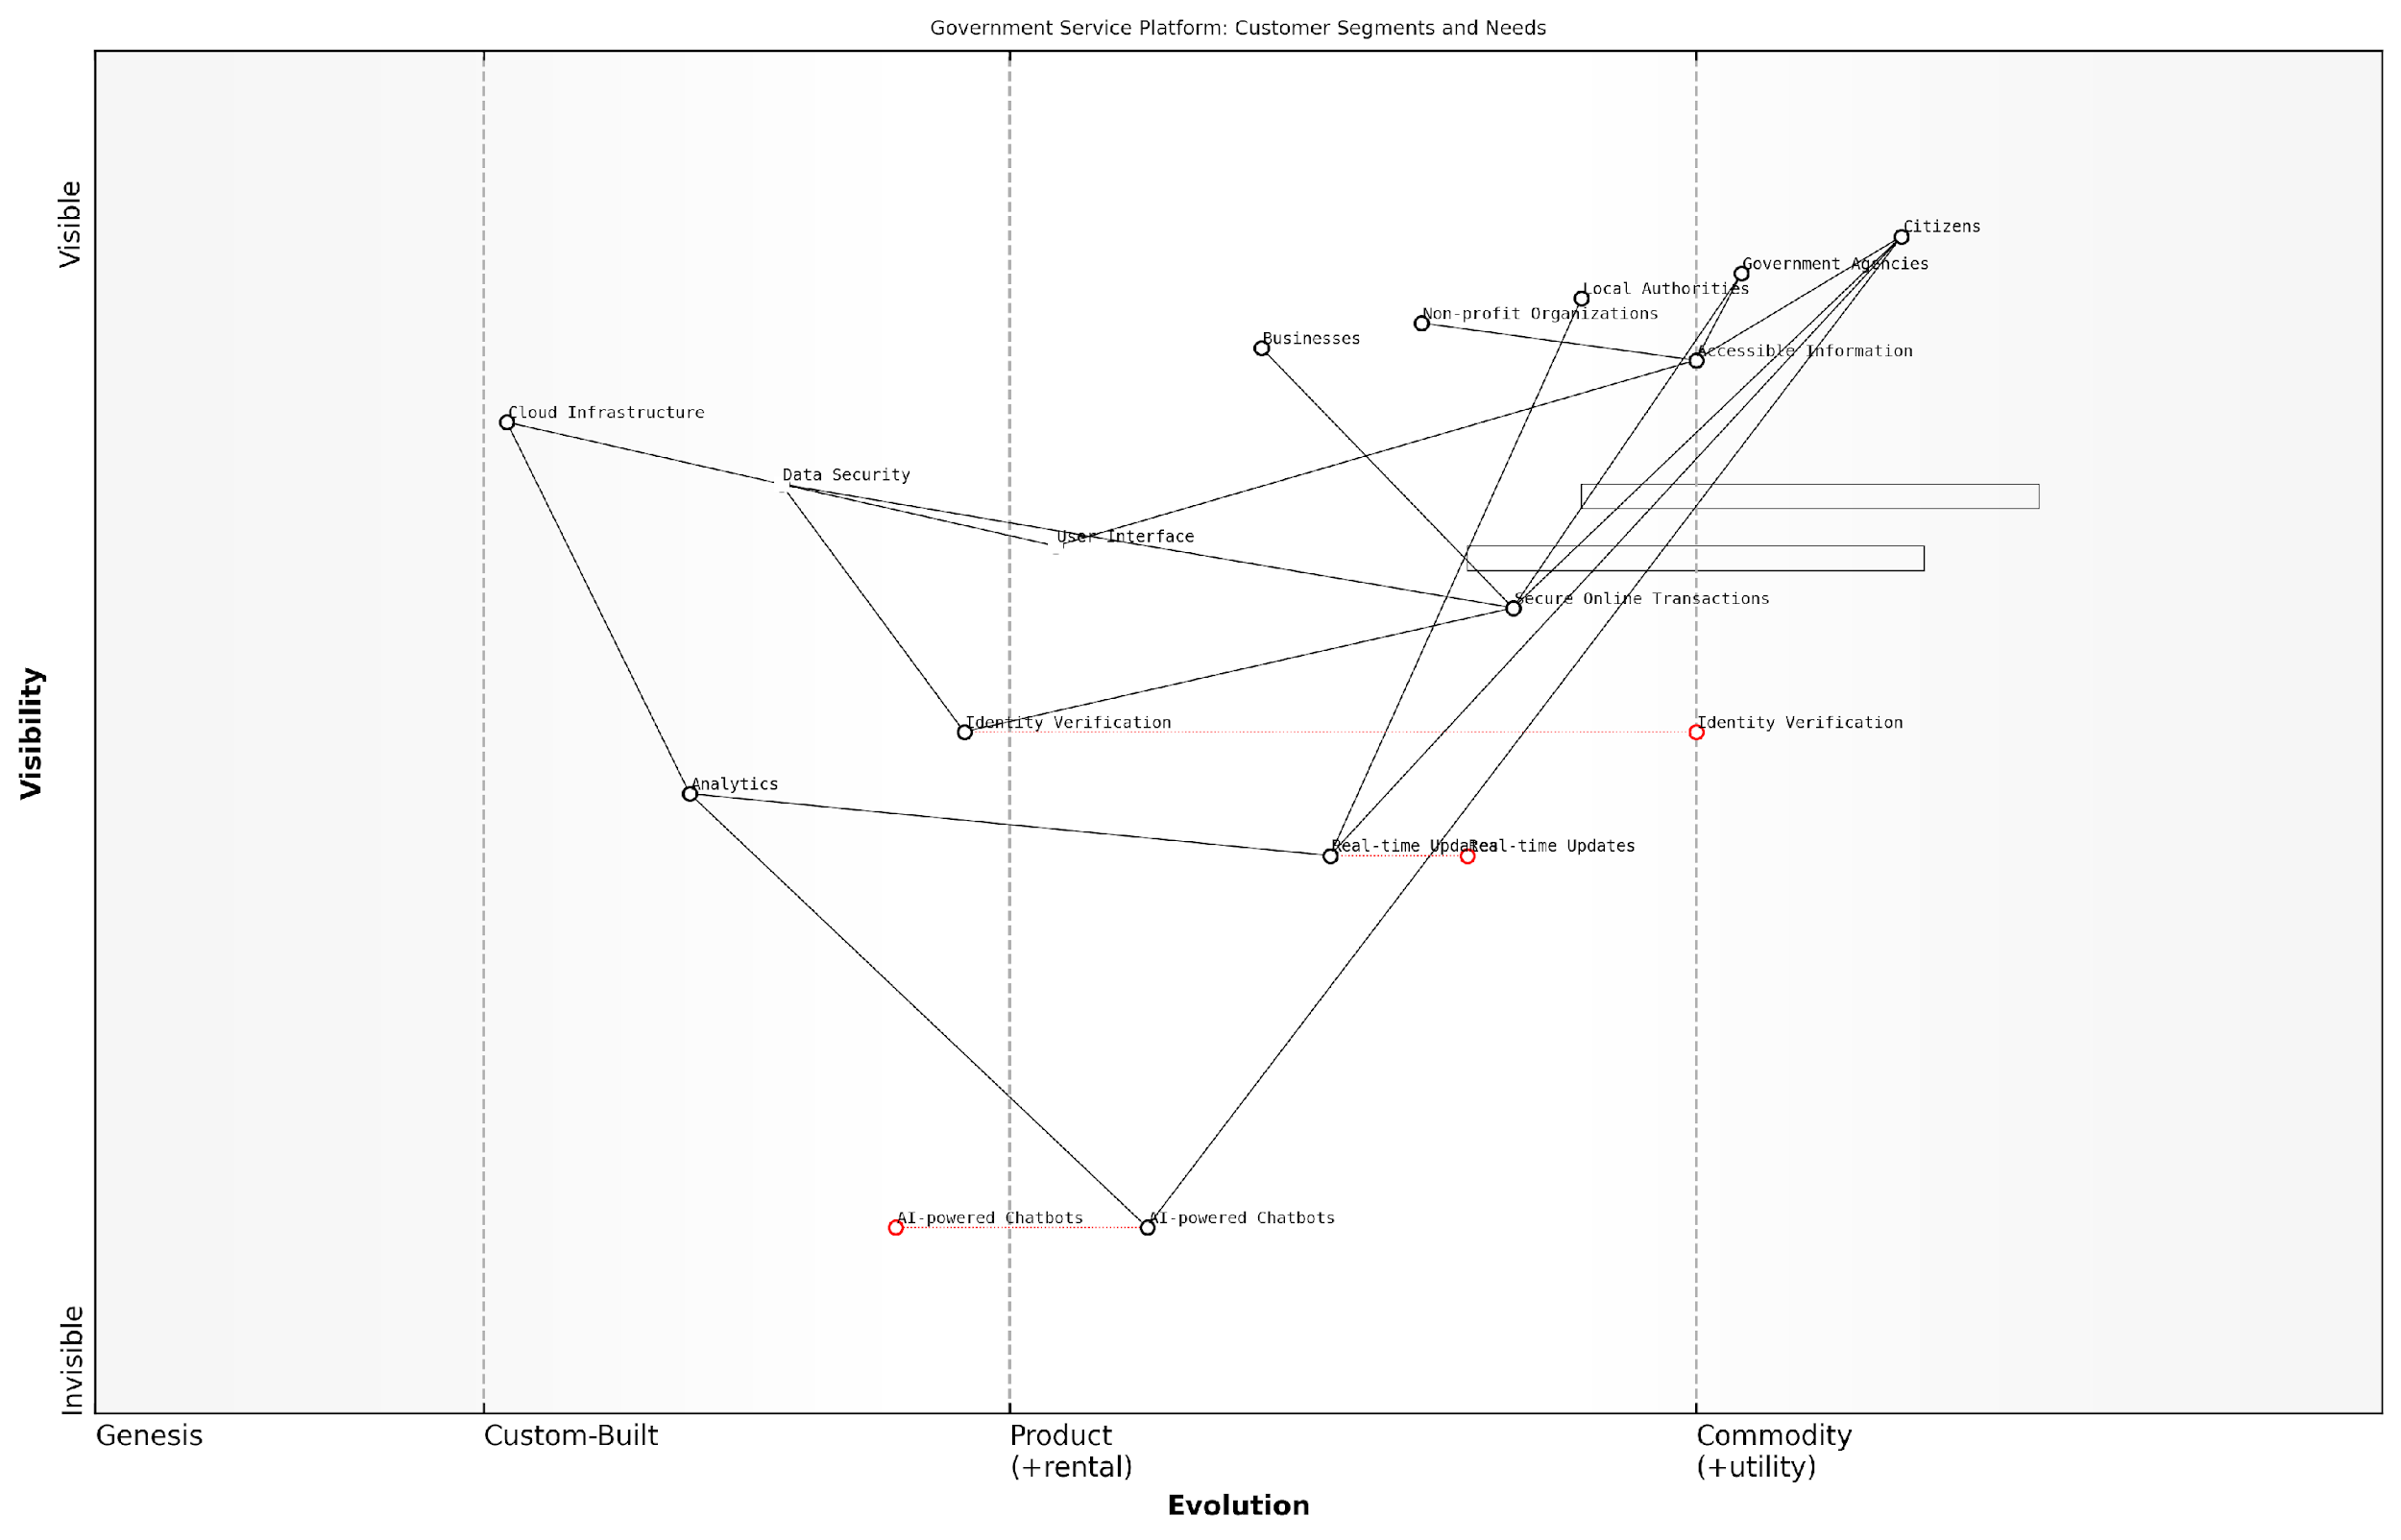

*Draft Wardley Map: [Insert Wardley Map: Mapping customer segments and their needs]*

[Edit this draft Wardley Map](https://create.wardleymaps.ai/#clone:fa54c5af87c0577383)

Wardley Map Assessment

The Government Service Platform shows a strong foundation with potential for significant innovation. By focusing on evolving key components like AI-powered services and real-time capabilities, while maintaining robust security and user-centric design, the platform can dramatically enhance its value proposition. The diverse customer segments served present both a challenge and an opportunity for creating a truly inclusive and efficient government service ecosystem. Strategic partnerships and a focus on building an open, secure platform will be key to future success.

[View full Wardley Map report](http://markdown_wardley_map_reports/wardley_map_report_28_Mapping_customer_segments_and_their_needs.md)

In conclusion, mapping customer segments and their needs through the lens of Wardley Mapping provides startups with a powerful framework for customer development. By visualising customer segments, their needs, and the broader value chain, startups can make more informed decisions, identify strategic opportunities, and align their offerings with genuine market demands. This approach is particularly valuable in the complex landscape of government and public sector innovation, where understanding and addressing diverse stakeholder needs is critical for success.

In the public sector, success is measured not just in financial terms, but in the positive impact on citizens’ lives. Wardley Mapping helps startups navigate this unique landscape by ensuring their innovations are truly aligned with public needs and values.

### Identifying opportunities for pivots and expansions

In the dynamic world of startups, the ability to identify and capitalise on opportunities for pivots and expansions is crucial for survival and growth. Wardley Mapping provides a powerful lens through which startups can visualise their current position in the market and spot potential areas for strategic shifts. By leveraging this tool within the customer development process, startups can make informed decisions about when and how to pivot or expand their offerings.

Wardley Mapping’s unique approach to visualising the value chain and component evolution offers several advantages in identifying pivot and expansion opportunities:

* Revealing gaps in the market: By mapping out the entire value chain, startups can identify underserved areas or missing components that represent potential opportunities.
* Anticipating market evolution: The evolution axis in Wardley Maps helps predict how different components will change over time, allowing startups to position themselves ahead of market shifts.
* Highlighting inefficiencies: Maps can reveal inefficiencies in the current value chain, pointing to areas where a startup could introduce disruptive innovations.
* Visualising dependencies: Understanding the relationships between different components can uncover opportunities for vertical integration or expansion into adjacent markets.

To effectively use Wardley Mapping for identifying pivot and expansion opportunities, startups should follow a structured approach:

* 1. Map the current state: Create a detailed Wardley Map of your startup’s current value chain and market position.
  2. Identify pain points: Use customer feedback and market research to highlight areas of friction or dissatisfaction in the current offering.
  3. Analyse component evolution: Assess how different components of your map are likely to evolve and identify potential future states.
  4. Explore adjacent spaces: Look for opportunities to expand into related markets or offer complementary products/services.
  5. Evaluate potential pivots: Consider how shifting focus to different components or reconfiguring the value chain could create new opportunities.
  6. Validate assumptions: Use lean startup methodologies to test hypotheses about potential pivots or expansions before committing significant resources.

One of the key benefits of using Wardley Mapping in this context is its ability to provide a visual representation of complex market dynamics. As one senior government adviser noted, ‘Wardley Mapping allows us to see the forest for the trees, revealing opportunities that might otherwise remain hidden in the complexity of the market.’

Let’s explore a practical example of how a startup might use Wardley Mapping to identify a pivot opportunity:

Consider a startup that initially focused on providing a B2B software solution for inventory management. By creating a Wardley Map of their current offering and the broader supply chain management landscape, they might identify several key insights:

* Their core inventory management component is becoming increasingly commoditised, with multiple competitors offering similar solutions.
* There’s a gap in the market for integrated supply chain analytics, which is still in the custom-built phase for many businesses.
* Customers are increasingly demanding real-time visibility across their entire supply chain, not just inventory.

Based on these insights, the startup might identify an opportunity to pivot from a pure inventory management solution to a more comprehensive supply chain visibility platform, incorporating advanced analytics and real-time tracking capabilities. This pivot allows them to move up the value chain, differentiate from competitors, and address emerging customer needs.

A successful pivot isn’t about completely abandoning your core competencies, but rather about leveraging them in new and innovative ways to create greater value for your customers.

It’s important to note that identifying opportunities through Wardley Mapping is an iterative process. As a startup gathers more data and refines its understanding of the market, the map should be updated regularly. This ongoing process of mapping and analysis ensures that the startup remains agile and responsive to changing market conditions.

Moreover, Wardley Mapping can be particularly powerful when combined with other customer development techniques. For example:

* Customer interviews: Use insights from Wardley Maps to guide customer interviews, probing areas of potential expansion or validating assumptions about pivot opportunities.
* Prototyping: Develop rapid prototypes or MVPs based on potential pivot ideas identified through mapping, allowing for quick validation of new concepts.
* A/B testing: Use Wardley Maps to identify areas where small changes or expansions could be tested, then use A/B testing to validate these hypotheses with real users.

By integrating Wardley Mapping into the broader customer development process, startups can create a powerful feedback loop. The maps inform customer development activities, while insights gained from these activities feed back into refining and updating the maps.

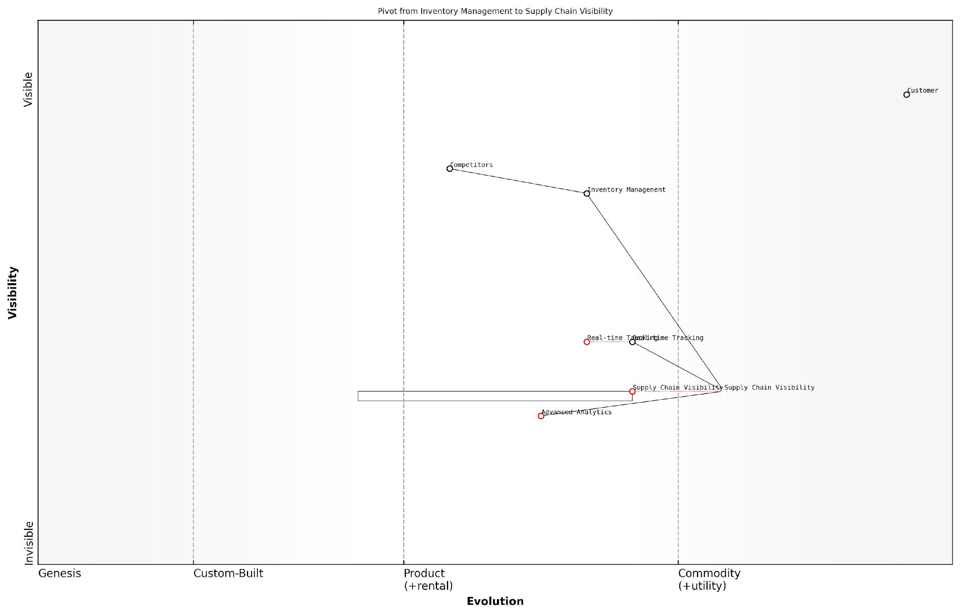

*Draft Wardley Map: [Insert Wardley Map: Identifying opportunities for pivots and expansions]*

[Edit this draft Wardley Map](https://create.wardleymaps.ai/#clone:f395bf1dda9fcd9dd6)

Wardley Map Assessment

The Wardley Map illustrates a strategic pivot from traditional Inventory Management to more advanced Supply Chain Visibility solutions. This move aligns well with market trends and positions the company to capture value in the evolving supply chain management landscape. The key to success lies in rapidly developing capabilities in Real-time Tracking and Advanced Analytics while creating a comprehensive ecosystem around Supply Chain Visibility. The company should focus on innovation to stay ahead of commoditization, potentially exploring AI-driven solutions and sustainable supply chain practices. While the pivot presents significant opportunities, careful management of the transition from legacy systems and customer education will be crucial. Overall, the strategy represented in this map has strong potential for long-term success if executed effectively.

[View full Wardley Map report](http://markdown_wardley_map_reports/wardley_map_report_29_Identifying_opportunities_for_pivots_and_expansion.md)

In conclusion, Wardley Mapping provides a strategic framework for startups to systematically identify opportunities for pivots and expansions. By visualising the current market landscape, anticipating future evolutions, and highlighting gaps and inefficiencies, startups can make more informed decisions about their strategic direction. When combined with lean startup methodologies and rigorous customer development practices, Wardley Mapping becomes an invaluable tool for navigating the uncertain waters of the startup world.

In the fast-paced world of startups, the ability to pivot or expand at the right moment can mean the difference between success and failure. Wardley Mapping provides the strategic clarity needed to make these critical decisions with confidence.

### Using maps to guide customer interviews and feedback sessions

Wardley Mapping offers a powerful framework for guiding customer interviews and feedback sessions, particularly in the context of startup customer development. By leveraging the visual and strategic insights provided by Wardley Maps, startups can conduct more focused, insightful, and productive customer interactions. This approach not only enhances the quality of feedback received but also ensures that startups are asking the right questions and exploring the most critical areas for their business development.

To effectively use Wardley Maps in customer interviews and feedback sessions, startups should consider the following key aspects:

* Identifying key components and their evolution stages
* Mapping customer needs and pain points
* Exploring value chain dynamics
* Validating assumptions and hypotheses
* Uncovering hidden opportunities and threats

Let’s delve into each of these aspects in detail:

1. Identifying key components and their evolution stages:

Before conducting customer interviews, startups should use their Wardley Maps to identify the key components of their value proposition and the current evolution stages of these components. This preparation allows for more targeted questioning during interviews. For example, if a startup’s map reveals that a critical component is in the ‘custom-built’ stage, interview questions can be crafted to explore whether customers are seeking more standardised solutions or if they value the bespoke nature of the offering.

By understanding the evolution of components in our value chain, we were able to ask much more nuanced questions about our customers’ preferences and pain points. This led to some surprising insights that we might have missed with a more generic approach to customer interviews.

1. Mapping customer needs and pain points:

Wardley Maps can be used to visualise the current understanding of customer needs and pain points. During interviews, startups can use these maps as a reference point to validate their assumptions and uncover new insights. By showing customers a simplified version of the map, startups can engage in more meaningful discussions about where value is truly created and where pain points exist in the current solution landscape.

1. Exploring value chain dynamics:

The value chain representation in Wardley Maps provides a unique opportunity to explore the broader ecosystem in which customers operate. Interview questions can be designed to understand how customers interact with different components of the value chain, their relationships with suppliers and partners, and potential areas for optimisation or disruption. This holistic view can reveal opportunities that may not be immediately apparent when focusing solely on the product or service being offered.

1. Validating assumptions and hypotheses:

Startups can use their Wardley Maps to identify key assumptions and hypotheses about their business model, market positioning, and customer needs. These can then be systematically tested and validated during customer interviews. By mapping out these assumptions visually, startups can ensure they cover all critical areas during their customer discovery process.

Our Wardley Map helped us identify several critical assumptions we had made about our target market. By structuring our customer interviews around these assumptions, we were able to quickly validate some and invalidate others, leading to a significant pivot in our business model.

1. Uncovering hidden opportunities and threats:

The visual nature of Wardley Maps can stimulate discussions that uncover hidden opportunities or potential threats. By sharing relevant portions of the map with customers during interviews, startups can encourage them to think about their needs and challenges in a more structured way. This can lead to insights about emerging trends, potential disruptions, or unmet needs that the customer may not have articulated without this visual prompt.

Practical implementation in customer interviews:

When using Wardley Maps to guide customer interviews, it’s crucial to strike a balance between structure and flexibility. While the map provides a valuable framework, it’s important to remain open to unexpected insights and to allow the conversation to flow naturally. Here are some practical tips for implementation:

* Prepare a simplified version of your Wardley Map to share with customers, focusing on the most relevant components and relationships.
* Use the map as a conversation starter, asking customers to comment on the positioning of components or to identify missing elements.
* Be prepared to iterate on your map during or immediately after interviews, incorporating new insights and adjusting your understanding of the landscape.
* Use the map to guide follow-up questions, exploring areas of uncertainty or potential opportunities identified in the visual representation.
* After each interview, review your map and update it based on the new information gathered, creating a dynamic tool that evolves with your understanding of the market.

By integrating Wardley Mapping into the customer interview process, startups can gain a more strategic and holistic understanding of their market, customers, and opportunities. This approach not only enhances the quality of insights gathered but also helps startups to visualise and communicate these insights more effectively within their teams and to stakeholders.

Incorporating Wardley Mapping into our customer development process was a game-changer. It provided a structured yet flexible framework for our interviews, helping us to uncover insights that we might have otherwise missed. More importantly, it gave us a common language and visual tool to discuss and act upon these insights as a team.

In conclusion, using Wardley Maps to guide customer interviews and feedback sessions offers startups a powerful tool for enhancing their customer development process. By providing a visual framework for exploring value chains, evolution, and strategic positioning, Wardley Mapping enables startups to conduct more focused and insightful customer interactions. This approach not only improves the quality of feedback received but also helps startups to rapidly iterate on their business models and strategies based on real-world customer insights.

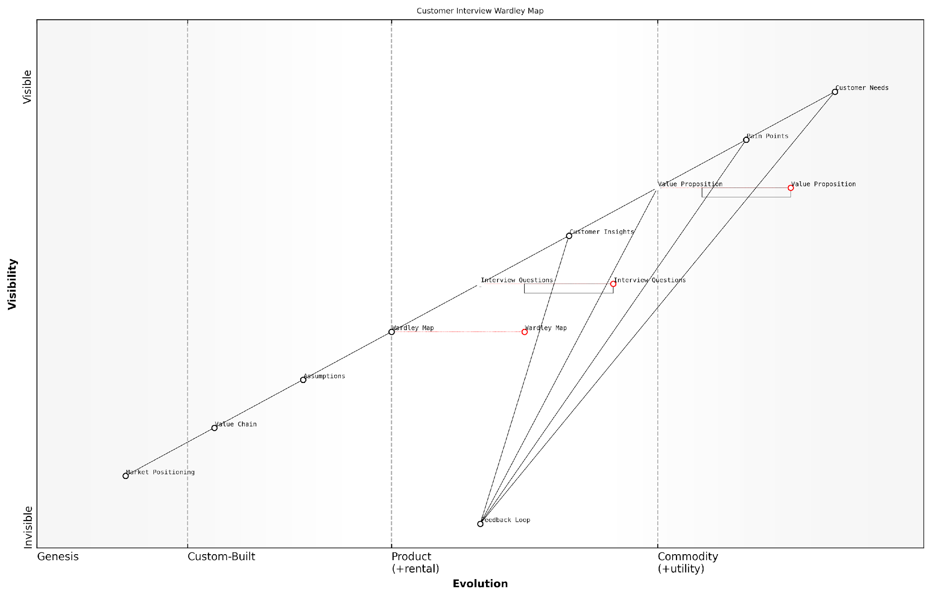

*Draft Wardley Map: [Insert Wardley Map: Using maps to guide customer interviews and feedback sessions]*

[Edit this draft Wardley Map](https://create.wardleymaps.ai/#clone:1767c7674783952e69)

Wardley Map Assessment

This Wardley Map reveals a customer-centric approach to product development with a strong focus on understanding and addressing customer needs. The integration of Wardley Mapping into the customer interview process is innovative and potentially powerful. However, there are opportunities to strengthen the connection between customer insights and strategic positioning. By evolving the less mature components and creating a more integrated feedback system, the organisation can create a robust, adaptive approach to customer development that drives product innovation and market success. The key to success will be balancing the focus on immediate customer needs with long-term strategic positioning and value chain development.

[View full Wardley Map report](http://markdown_wardley_map_reports/wardley_map_report_30_Using_maps_to_guide_customer_interviews_and_feedba.md)

## Case Study: How Startup X Used Wardley Mapping to Pivot Successfully

### Initial business model and challenges

In the fast-paced world of startups, the ability to adapt and pivot is often the difference between success and failure. This case study examines how Startup X, a promising government technology venture, leveraged Wardley Mapping to navigate significant challenges and successfully pivot their business model. By delving into their initial strategy, the obstacles they faced, and how Wardley Mapping illuminated a path forward, we can glean valuable insights applicable to a wide range of startup scenarios, particularly within the public sector.

Startup X began with a vision to revolutionise citizen engagement in local government decision-making. Their initial business model centred around a mobile application that would allow citizens to participate in local council meetings virtually, vote on key issues, and provide feedback on proposed initiatives. The founders, drawing from their backgrounds in civic technology and public administration, were confident that their solution would address the growing disconnect between local governments and their constituents.

The initial value proposition of Startup X can be summarised as follows:

* Increase citizen participation in local government
* Streamline the decision-making process for councils
* Improve transparency and accountability in local governance
* Provide data-driven insights to inform policy decisions

However, as Startup X began to engage with potential customers and pilot their solution, they encountered several significant challenges that threatened the viability of their business model:

* Regulatory hurdles: Many local governments faced legal constraints in implementing digital voting systems for official decision-making.
* Technology adoption: Both citizens and council staff showed resistance to adopting new technology platforms, particularly for sensitive civic matters.
* Data security concerns: Handling personal data and voting information raised significant privacy and security issues that were costly to address.
* Limited budget: Local councils, particularly in smaller municipalities, had restricted budgets for new technology initiatives.
* Fragmented market: The diverse needs and regulations across different local governments made it challenging to create a scalable, one-size-fits-all solution.

These challenges created a perfect storm for Startup X. Despite initial enthusiasm from some forward-thinking councils, the company struggled to gain traction and secure the necessary funding to scale their operations. The founders realised they needed to reassess their strategy and potentially pivot their business model to survive.

We were passionate about our initial vision, but the market realities were forcing us to confront some hard truths. We needed a systematic way to analyse our position and identify new opportunities that aligned with our core mission and capabilities.

It was at this critical juncture that the Startup X team turned to Wardley Mapping as a strategic tool to navigate their challenges and chart a new course. The process of creating a Wardley Map forced the team to critically examine their value chain, the evolution of various components in their ecosystem, and the changing landscape of citizen engagement in local government.

To begin their Wardley Mapping process, Startup X first identified their key user needs and mapped out their existing value chain. This included components such as:

* Citizen engagement platforms
* Data analytics tools
* Mobile application development
* User authentication systems
* Government decision-making processes
* Regulatory compliance frameworks
* Cloud infrastructure

By plotting these components on the evolution axis of the Wardley Map, from genesis to commodity, the team gained crucial insights into the maturity of different elements within their ecosystem. This visual representation helped them identify areas where they were overinvesting in custom solutions for commoditised components, as well as opportunities to leverage more mature technologies in novel ways.

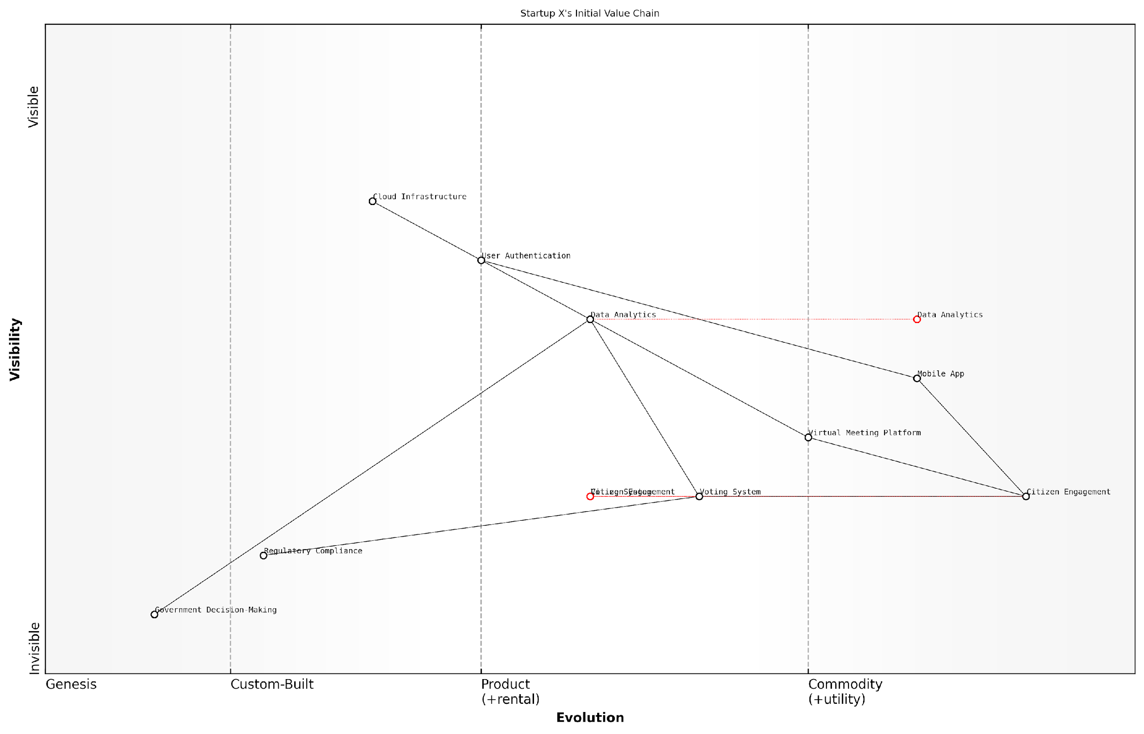

*Draft Wardley Map: [Insert Wardley Map: Initial business model and challenges]*

[Edit this draft Wardley Map](https://create.wardleymaps.ai/#clone:3944456e70f5dbb28a)

Wardley Map Assessment

Startup X’s citizen engagement platform shows promise in addressing a critical need in digital democracy. The current positioning emphasises user-facing components, which is appropriate for early-stage growth. However, to ensure long-term success and scalability, the startup should focus on evolving its core components (Citizen Engagement, Voting System) while leveraging more commoditized solutions for supporting technologies. Key areas for development include enhancing data analytics capabilities, strengthening security measures, and building strong government partnerships. The platform has the potential to create significant impact by improving the connection between citizens and local governments, but must navigate complex regulatory environments and focus on demonstrating tangible value to both citizens and government decision-makers.

[View full Wardley Map report](http://markdown_wardley_map_reports/wardley_map_report_31_Initial_business_model_and_challenges.md)

The mapping process also revealed several key insights that would prove instrumental in guiding Startup X’s pivot:

* The core need for improved citizen engagement remained strong, but the approach needed to be less disruptive to existing processes.
* Data analytics and insights were highly valued by local governments, presenting a potential area for focus.
* Regulatory compliance was a critical anchor point that any solution would need to address comprehensively.
* Cloud infrastructure and mobile technologies were rapidly commoditising, offering opportunities for cost-effective scaling.

Armed with these insights from their Wardley Map, Startup X was poised to reimagine their business model and product offering. The map had illuminated a path forward that would allow them to leverage their existing strengths while addressing the market realities and challenges they faced. In the next section, we will explore how Startup X used these Wardley Mapping insights to pivot their business successfully, transforming from a direct citizen engagement platform to a data analytics and insights provider for local governments.

Wardley Mapping didn’t just help us see where we were struggling; it revealed opportunities we hadn’t even considered. It gave us the confidence to make bold decisions backed by a clear understanding of our market landscape.

### How Wardley Mapping revealed new opportunities

In the dynamic landscape of startup innovation, the ability to identify and capitalise on new opportunities is paramount. Wardley Mapping, when applied with precision and insight, can be a powerful tool for uncovering hidden potential and guiding strategic pivots. This case study examines how Startup X, a promising venture in the govtech sector, leveraged Wardley Mapping to navigate a critical juncture in their journey, ultimately leading to a successful pivot and renewed growth.

Startup X had initially positioned itself as a provider of digital citizen engagement platforms for local councils. While they had gained some traction, they found themselves struggling to differentiate in an increasingly crowded market. The leadership team, recognising the need for a strategic reassessment, turned to Wardley Mapping to gain a deeper understanding of their market position and potential opportunities.

The process of creating a Wardley Map revealed several key insights that had previously been overlooked:

* The commoditisation of basic engagement platform features was occurring faster than anticipated, eroding Startup X’s initial value proposition.
* There was an emerging need for advanced data analytics capabilities within local government, particularly in the realm of predictive service demand modelling.
* The evolution of cloud infrastructure and machine learning technologies had reached a point where sophisticated analytics could be delivered cost-effectively at scale.
* Existing providers were primarily focused on retrospective reporting rather than forward-looking predictive analytics.

These insights, visualised clearly through the Wardley Map, prompted a series of strategic discussions within the Startup X team. As a senior team member reflected:

The Wardley Map was like a revelation for us. It showed us not just where we were, but where the entire market was heading. We could see the opportunity for predictive analytics emerging right before our eyes.

Armed with these insights, Startup X embarked on a carefully planned pivot. They refocused their development efforts on building a predictive analytics engine that could integrate with their existing engagement platform. This new capability allowed local councils to anticipate citizen needs and optimise service delivery proactively.

The pivot process, guided by the Wardley Map, involved several key steps:

* Reassessing the skill mix within the team and bringing in data science expertise
* Forming strategic partnerships with cloud providers to leverage advanced AI and machine learning capabilities
* Engaging early adopter councils to co-develop and refine the predictive analytics features
* Repositioning their marketing and sales approach to emphasise proactive governance and data-driven decision making

The outcomes of this pivot were significant. Within 12 months, Startup X had:

* Doubled their customer base, attracting larger councils with more complex needs
* Increased their average contract value by 300%
* Established themselves as thought leaders in the emerging field of predictive govtech
* Secured a significant round of venture funding to accelerate their growth

A key factor in the success of this pivot was the way Wardley Mapping enabled Startup X to align their capabilities with evolving market needs. As one council CIO noted:

What Startup X is offering now is exactly what we’ve been looking for. It’s not just about engaging citizens anymore; it’s about anticipating their needs and optimising our services accordingly. It’s transformative for our planning and resource allocation.

This case study illustrates several critical aspects of using Wardley Mapping in a startup context:

* The importance of regularly reassessing market position and value propositions
* How Wardley Mapping can reveal non-obvious opportunities by visualising the evolution of components across the value chain
* The power of combining market insights with technological trends to identify high-potential pivot opportunities
* The role of Wardley Mapping in facilitating strategic alignment and decision-making within startup teams

Moreover, this example demonstrates how Wardley Mapping can be particularly valuable in the govtech sector, where the pace of technological change often outstrips the ability of traditional procurement and decision-making processes to keep up. By providing a clear visualisation of market evolution, Wardley Mapping enables startups to anticipate and meet the future needs of government clients, often before those clients have fully articulated those needs themselves.

The success of Startup X’s pivot also highlights the synergy between Wardley Mapping and Lean Startup methodologies. The insights gained from the mapping process informed hypothesis generation and testing, allowing for rapid iteration and validation of the new product direction. This alignment of strategic insight with agile execution was crucial in enabling Startup X to move quickly and decisively, outmanoeuvring both established players and other startups in the govtech space.

In conclusion, the case of Startup X demonstrates the transformative potential of Wardley Mapping when applied thoughtfully in a startup context. By providing a clear visualisation of market dynamics and evolutionary forces, Wardley Mapping enabled Startup X to identify a pivotal opportunity, realign their resources and capabilities, and emerge as a leader in a high-value niche within the govtech sector. This case serves as a powerful example for other startups, particularly those in complex, rapidly evolving markets, of how strategic mapping can illuminate paths to sustainable competitive advantage and accelerated growth.

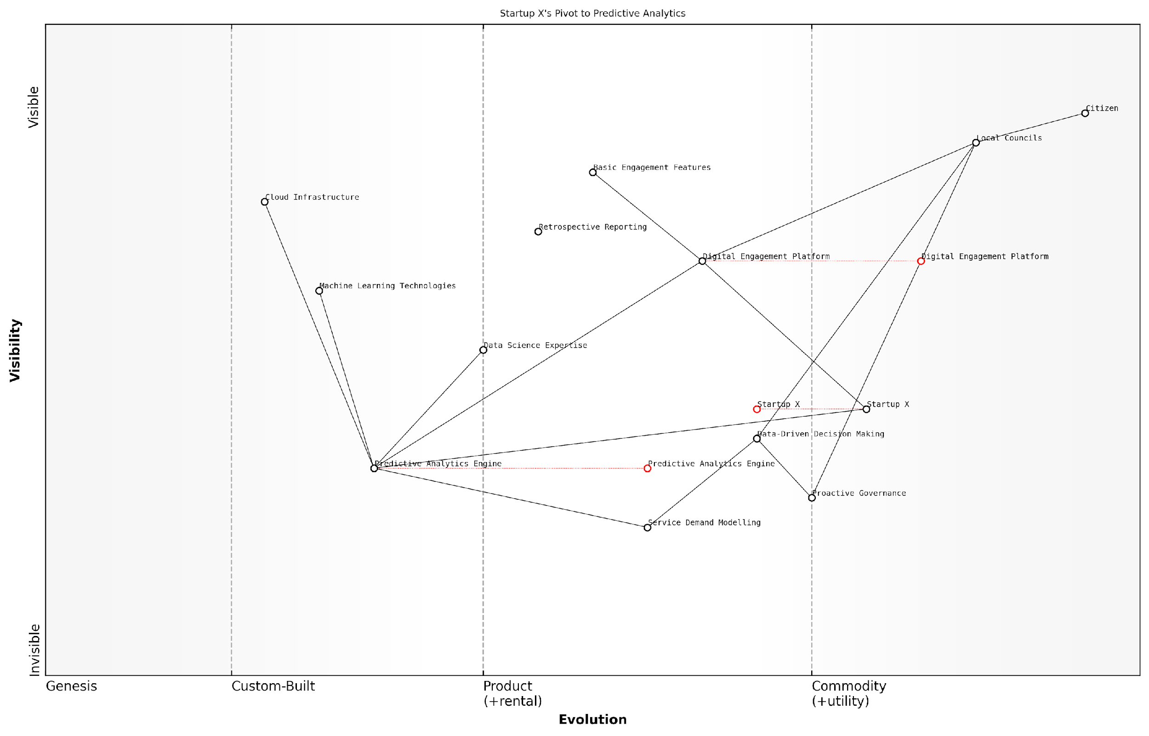

*Draft Wardley Map: [Insert Wardley Map: How Wardley Mapping revealed new opportunities]*

[Edit this draft Wardley Map](https://create.wardleymaps.ai/#clone:07cf85cfa81b771122)

Wardley Map Assessment

Startup X’s pivot to Predictive Analytics for local government represents a strategic move into a high-potential, evolving market. By focusing on the development of advanced predictive capabilities and their application to proactive governance, the company is well-positioned to capture significant value. However, the rapid evolution of this space necessitates continuous innovation and capability development to maintain a competitive edge. The key to long-term success will be in effectively scaling the Predictive Analytics Engine and associated expertise across multiple domains of local governance while staying ahead of the commoditization curve through ongoing innovation in areas like Service Demand Modelling and Proactive Governance applications.

[View full Wardley Map report](http://markdown_wardley_map_reports/wardley_map_report_32_How_Wardley_Mapping_revealed_new_opportunities.md)

### The pivot process and outcomes

In the dynamic world of startups, the ability to pivot—to fundamentally change the direction of a business when you realise the current products or services aren’t meeting the needs of the market—is often the difference between success and failure. Wardley Mapping provides a powerful framework for identifying when a pivot is necessary and how to execute it effectively. This case study of Startup X demonstrates how Wardley Mapping can be leveraged to navigate a successful pivot, offering valuable insights for other startups facing similar challenges.

Startup X, a government technology company, initially set out to provide a cloud-based document management system for local councils. However, after months of development and limited traction, the founders realised they needed to reassess their strategy. This is where Wardley Mapping proved invaluable.

The pivot process for Startup X can be broken down into several key stages:

* Mapping the current situation
* Identifying key issues and opportunities
* Developing alternative scenarios
* Executing the pivot
* Measuring outcomes and iterating

1. Mapping the current situation:

The first step in Startup X’s pivot process was to create a detailed Wardley Map of their current business model, value chain, and market position. This map revealed several critical insights:

* Their core offering (document management) was becoming increasingly commoditised
* Local councils had more pressing needs around data analytics and decision support
* There was a gap in the market for solutions that could integrate legacy systems with modern cloud infrastructure

1. Identifying key issues and opportunities:

By analysing their Wardley Map, Startup X identified that their current focus on document management was not addressing the most critical needs of their target market. The map also revealed an opportunity to leverage their existing expertise in cloud infrastructure to address the integration challenges faced by local councils.

Wardley Mapping allowed us to step back and see the bigger picture. We realised we were solving the wrong problem for our customers.

1. Developing alternative scenarios:

With these insights, Startup X used Wardley Mapping to explore alternative business models and product offerings. They created multiple future-state maps, each representing a different strategic direction. These included:

* Pivoting to a data analytics and decision support platform
* Focusing on legacy system integration and modernisation
* Developing a comprehensive ‘smart city’ platform

By mapping out these scenarios, Startup X could assess the potential impact, required resources, and market positioning for each option.

1. Executing the pivot:

After careful consideration, Startup X decided to pivot towards becoming a platform for legacy system integration and modernisation. This decision was based on several factors revealed by their Wardley Maps:

* It leveraged their existing expertise in cloud infrastructure
* It addressed a critical, underserved need in the market
* It positioned them in a less commoditised, higher-value space

The execution of the pivot involved:

* Refocusing product development efforts
* Retraining sales and marketing teams
* Engaging existing customers to validate the new direction
* Developing new partnerships with legacy system providers

1. Measuring outcomes and iterating:

Post-pivot, Startup X continued to use Wardley Mapping to track their progress and make data-driven decisions. They regularly updated their maps to reflect changes in the market and their position within it.

The outcomes of the pivot were significant:

* Within six months, Startup X had secured contracts with three major local councils
* Revenue grew by 300% in the first year post-pivot
* The company attracted £5 million in Series A funding
* Team size doubled, with a focus on hiring integration specialists

Wardley Mapping didn’t just help us pivot; it gave us a new way of thinking about our business and the market. It’s now an integral part of our strategic planning process.

The success of Startup X’s pivot demonstrates the power of Wardley Mapping in guiding strategic decisions for startups. By providing a visual representation of the value chain and market evolution, Wardley Mapping enabled Startup X to identify new opportunities, assess different scenarios, and execute a pivot that dramatically improved their market position and growth prospects.

Key lessons from Startup X’s experience include:

* The importance of regularly reassessing your market position and value proposition
* The value of visualising different future scenarios before committing to a pivot
* The need for alignment between your offering and the most critical customer needs
* The potential for leveraging existing capabilities in new, high-value areas

For other startups considering a pivot, Startup X’s journey highlights the importance of data-driven decision making and strategic visualisation. Wardley Mapping provides a framework for this process, enabling startups to navigate uncertainty and drive innovation in a structured, informed manner.

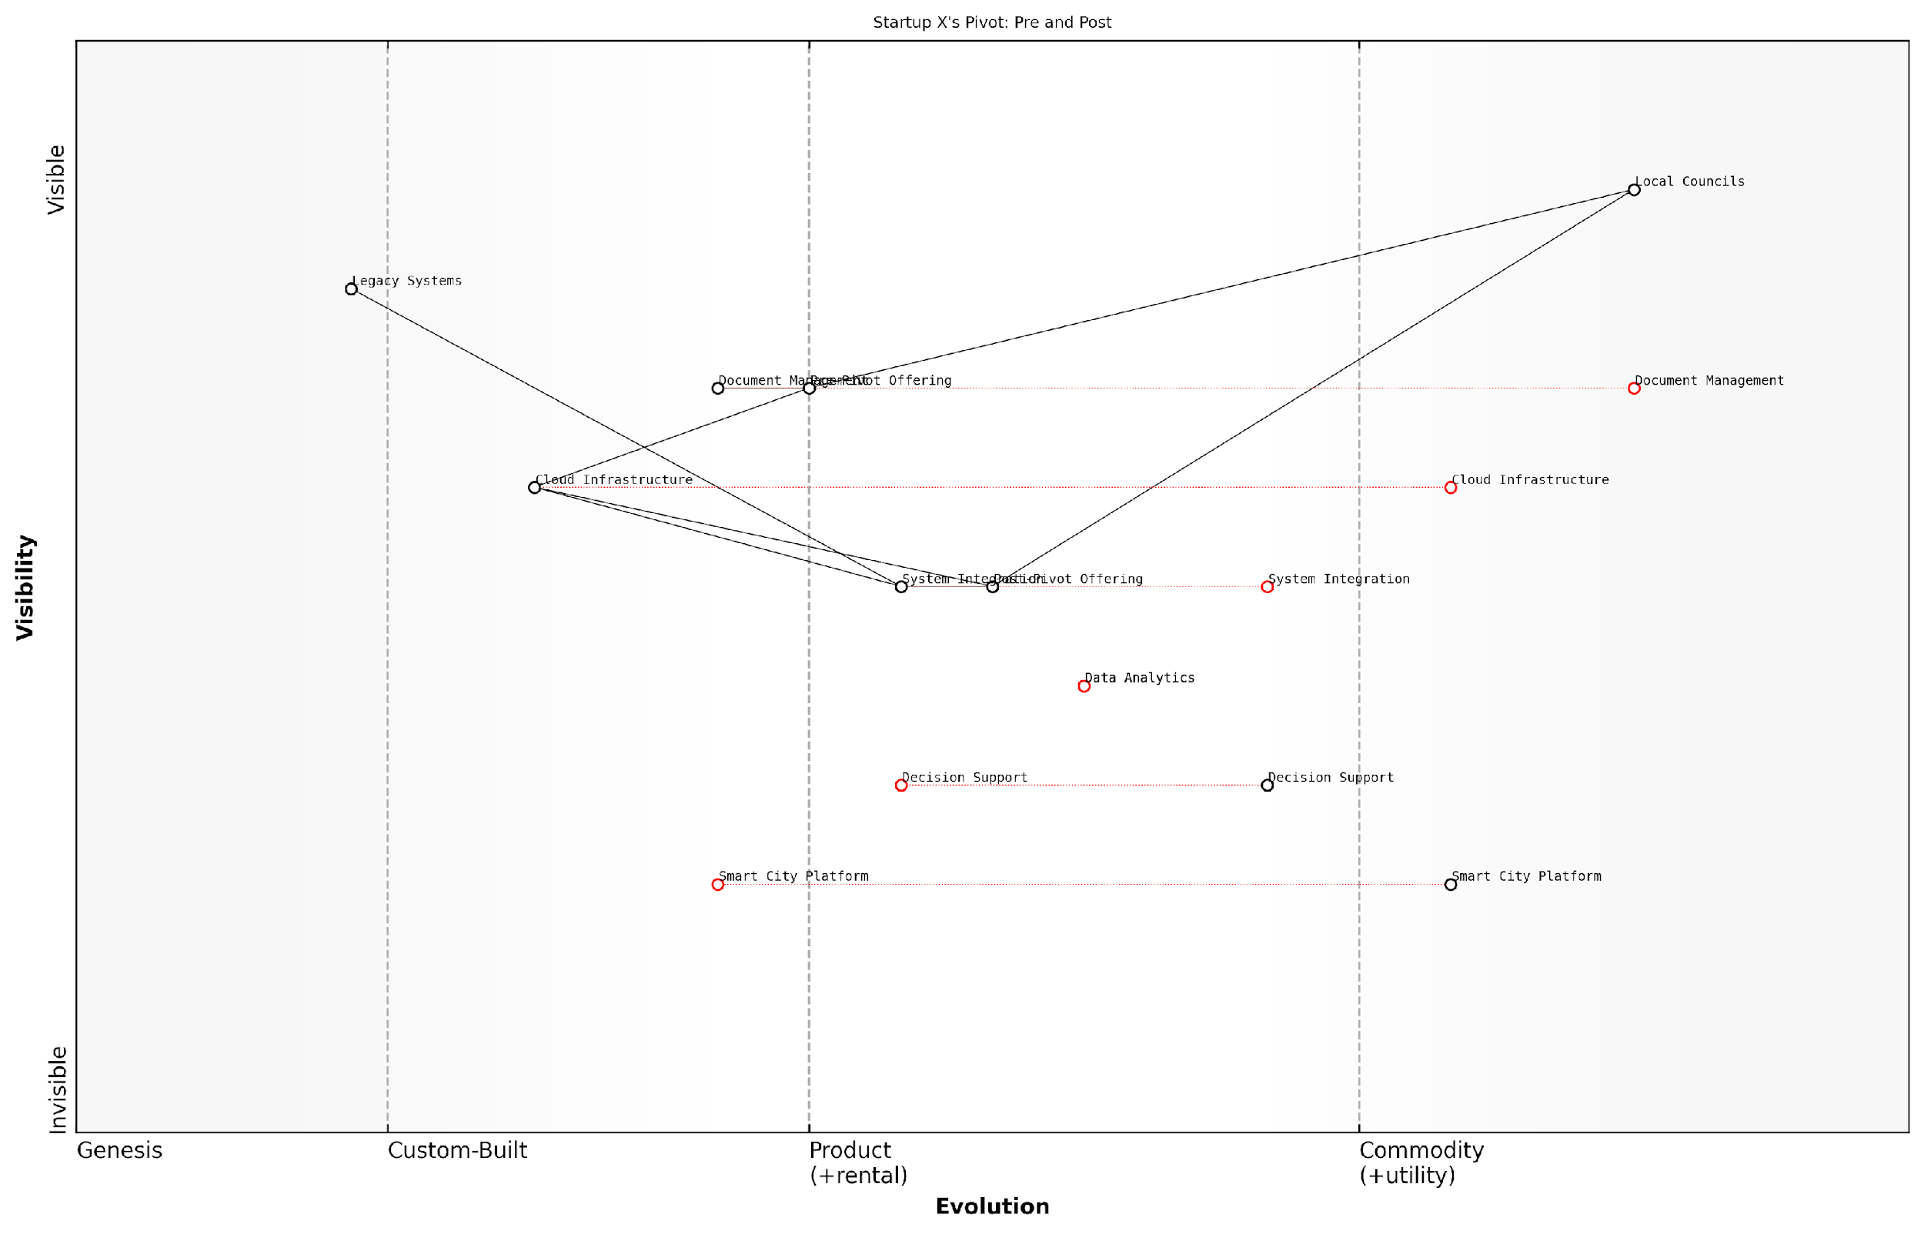

*Draft Wardley Map: [Insert Wardley Map: The pivot process and outcomes]*

[Edit this draft Wardley Map](https://create.wardleymaps.ai/#clone:9bd3de290c4d930037)

Wardley Map Assessment

Startup X’s pivot from Document Management to System Integration represents a strategic move towards higher-value, more customised solutions for Local Councils. This shift aligns well with market needs and positions the company for future growth in smart city technologies. However, the transition period will be critical, requiring careful management of existing clients and rapid development of new capabilities. The long-term success will depend on how well Startup X can execute this pivot while simultaneously preparing for future evolutions in the government technology landscape, particularly in data analytics and smart city platforms. The company’s unique position bridging legacy and modern systems provides a strong foundation, but continuous innovation and strategic partnerships will be key to maintaining a competitive edge in this rapidly evolving sector.

[View full Wardley Map report](http://markdown_wardley_map_reports/wardley_map_report_33_The_pivot_process_and_outcomes.md)

# Chapter 3: Identifying and Leveraging Disruptive Opportunities

## Understanding Disruption Through Wardley Mapping

### The nature of disruptive innovation

In the rapidly evolving landscape of startups, particularly within government and public sector contexts, understanding and leveraging disruptive innovation is crucial for success. Wardley Mapping provides a powerful framework for visualising and analysing the potential for disruption, offering startups a strategic advantage in identifying emerging opportunities and navigating uncertain markets.

The nature of disruptive innovation, as first conceptualised by Clayton Christensen, involves new technologies or business models that initially serve niche segments but eventually overtake established market leaders. Through the lens of Wardley Mapping, we can gain deeper insights into how these disruptions occur and how startups can position themselves to capitalise on them.

Let’s explore how Wardley Mapping illuminates the key aspects of disruptive innovation:

* Visualising the Value Chain: Wardley Maps allow startups to plot the entire value chain of their industry, from user needs to the underlying components and technologies. This visualisation helps identify potential weak points or inefficiencies ripe for disruption.
* Evolution of Components: The evolution axis in Wardley Maps (from Genesis to Commodity) provides crucial insights into where disruption is likely to occur. Components moving from Custom-Built to Product/Rental often present opportunities for new entrants to challenge incumbents.
* Identifying Inertia: Established players often struggle to adapt to disruptive changes due to organisational inertia. Wardley Maps can highlight areas where incumbents are over-investing in sustaining innovations, creating openings for disruptive startups.
* Spotting Weak Signals: By mapping the ecosystem and its evolution, startups can identify weak signals of emerging technologies or changing user needs that may lead to future disruptions.
* Anticipating Market Shifts: The dynamic nature of Wardley Maps allows startups to anticipate how the market landscape might change over time, helping them position themselves ahead of disruptive trends.

In the context of government and public sector startups, disruptive innovation takes on additional dimensions. These organisations often operate in highly regulated environments with entrenched processes and legacy systems. Wardley Mapping can be particularly valuable in this setting by:

* Identifying Inefficiencies: Mapping the current state of public services can reveal inefficiencies and pain points that are ripe for innovative solutions.
* Navigating Regulatory Landscapes: By visualising the regulatory components alongside technological and operational elements, startups can identify pathways for innovation that comply with existing frameworks or highlight areas where policy changes might be necessary.
* Aligning Stakeholders: In the complex ecosystem of government services, Wardley Maps can help align diverse stakeholders around a shared vision of innovation and improvement.
* Prioritising Investments: With limited resources, public sector startups can use Wardley Maps to prioritise investments in areas with the highest potential for disruptive impact.

Wardley Mapping has revolutionised how we approach innovation in the public sector. It’s not just about new technologies; it’s about reimagining entire value chains to better serve citizens.

A case in point is the transformation of digital services in the UK government. By applying Wardley Mapping principles, the Government Digital Service (GDS) was able to identify opportunities for disruption in how citizens interact with government services online. This led to the development of GOV.UK, a unified platform that dramatically simplified access to government information and services.

The process of using Wardley Mapping to understand and leverage disruption typically involves the following steps:

* 1. Map the Current Landscape: Create a Wardley Map of the existing value chain, including user needs, visible services, and underlying components.
  2. Identify Evolution Patterns: Analyse how different components are evolving and where tensions might arise between evolving and stagnant elements.
  3. Spot Potential Disruptions: Look for areas where new technologies or business models could enter the value chain and offer superior value.
  4. Simulate Future Scenarios: Create multiple future-state maps to explore how potential disruptions might reshape the landscape.
  5. Develop Strategic Options: Based on the insights gained, formulate strategies to either initiate or respond to disruptive innovations.
  6. Iterate and Adapt: Regularly update the maps as new information becomes available and as the market evolves.

For startups operating in the government and public sector space, it’s crucial to recognise that disruptive innovation isn’t always about cutting-edge technology. Often, it involves finding new ways to deliver existing services more efficiently or effectively. Wardley Mapping can help identify these opportunities by highlighting areas where user needs are poorly served by current solutions.

The most impactful innovations in government services often come from rethinking processes and user journeys, not just implementing new technologies. Wardley Mapping gives us the tools to visualise and analyse these opportunities systematically.

Moreover, Wardley Mapping can help startups navigate the unique challenges of disrupting government services, such as:

* Long procurement cycles: By mapping the procurement process itself, startups can identify ways to streamline or bypass traditional channels.
* Data security and privacy concerns: Mapping data flows and security requirements can help startups design solutions that meet stringent government standards.
* Interoperability with legacy systems: Wardley Maps can highlight integration points and potential challenges when introducing new solutions alongside existing infrastructure.
* Scalability across diverse jurisdictions: Mapping the variations in needs and regulations across different government entities can inform scalable product strategies.

In conclusion, Wardley Mapping provides a powerful lens through which startups can understand and leverage disruptive innovation, particularly in the complex landscape of government and public sector services. By visualising value chains, evolution patterns, and potential points of disruption, startups can position themselves strategically to introduce innovations that create significant value for citizens and government alike.

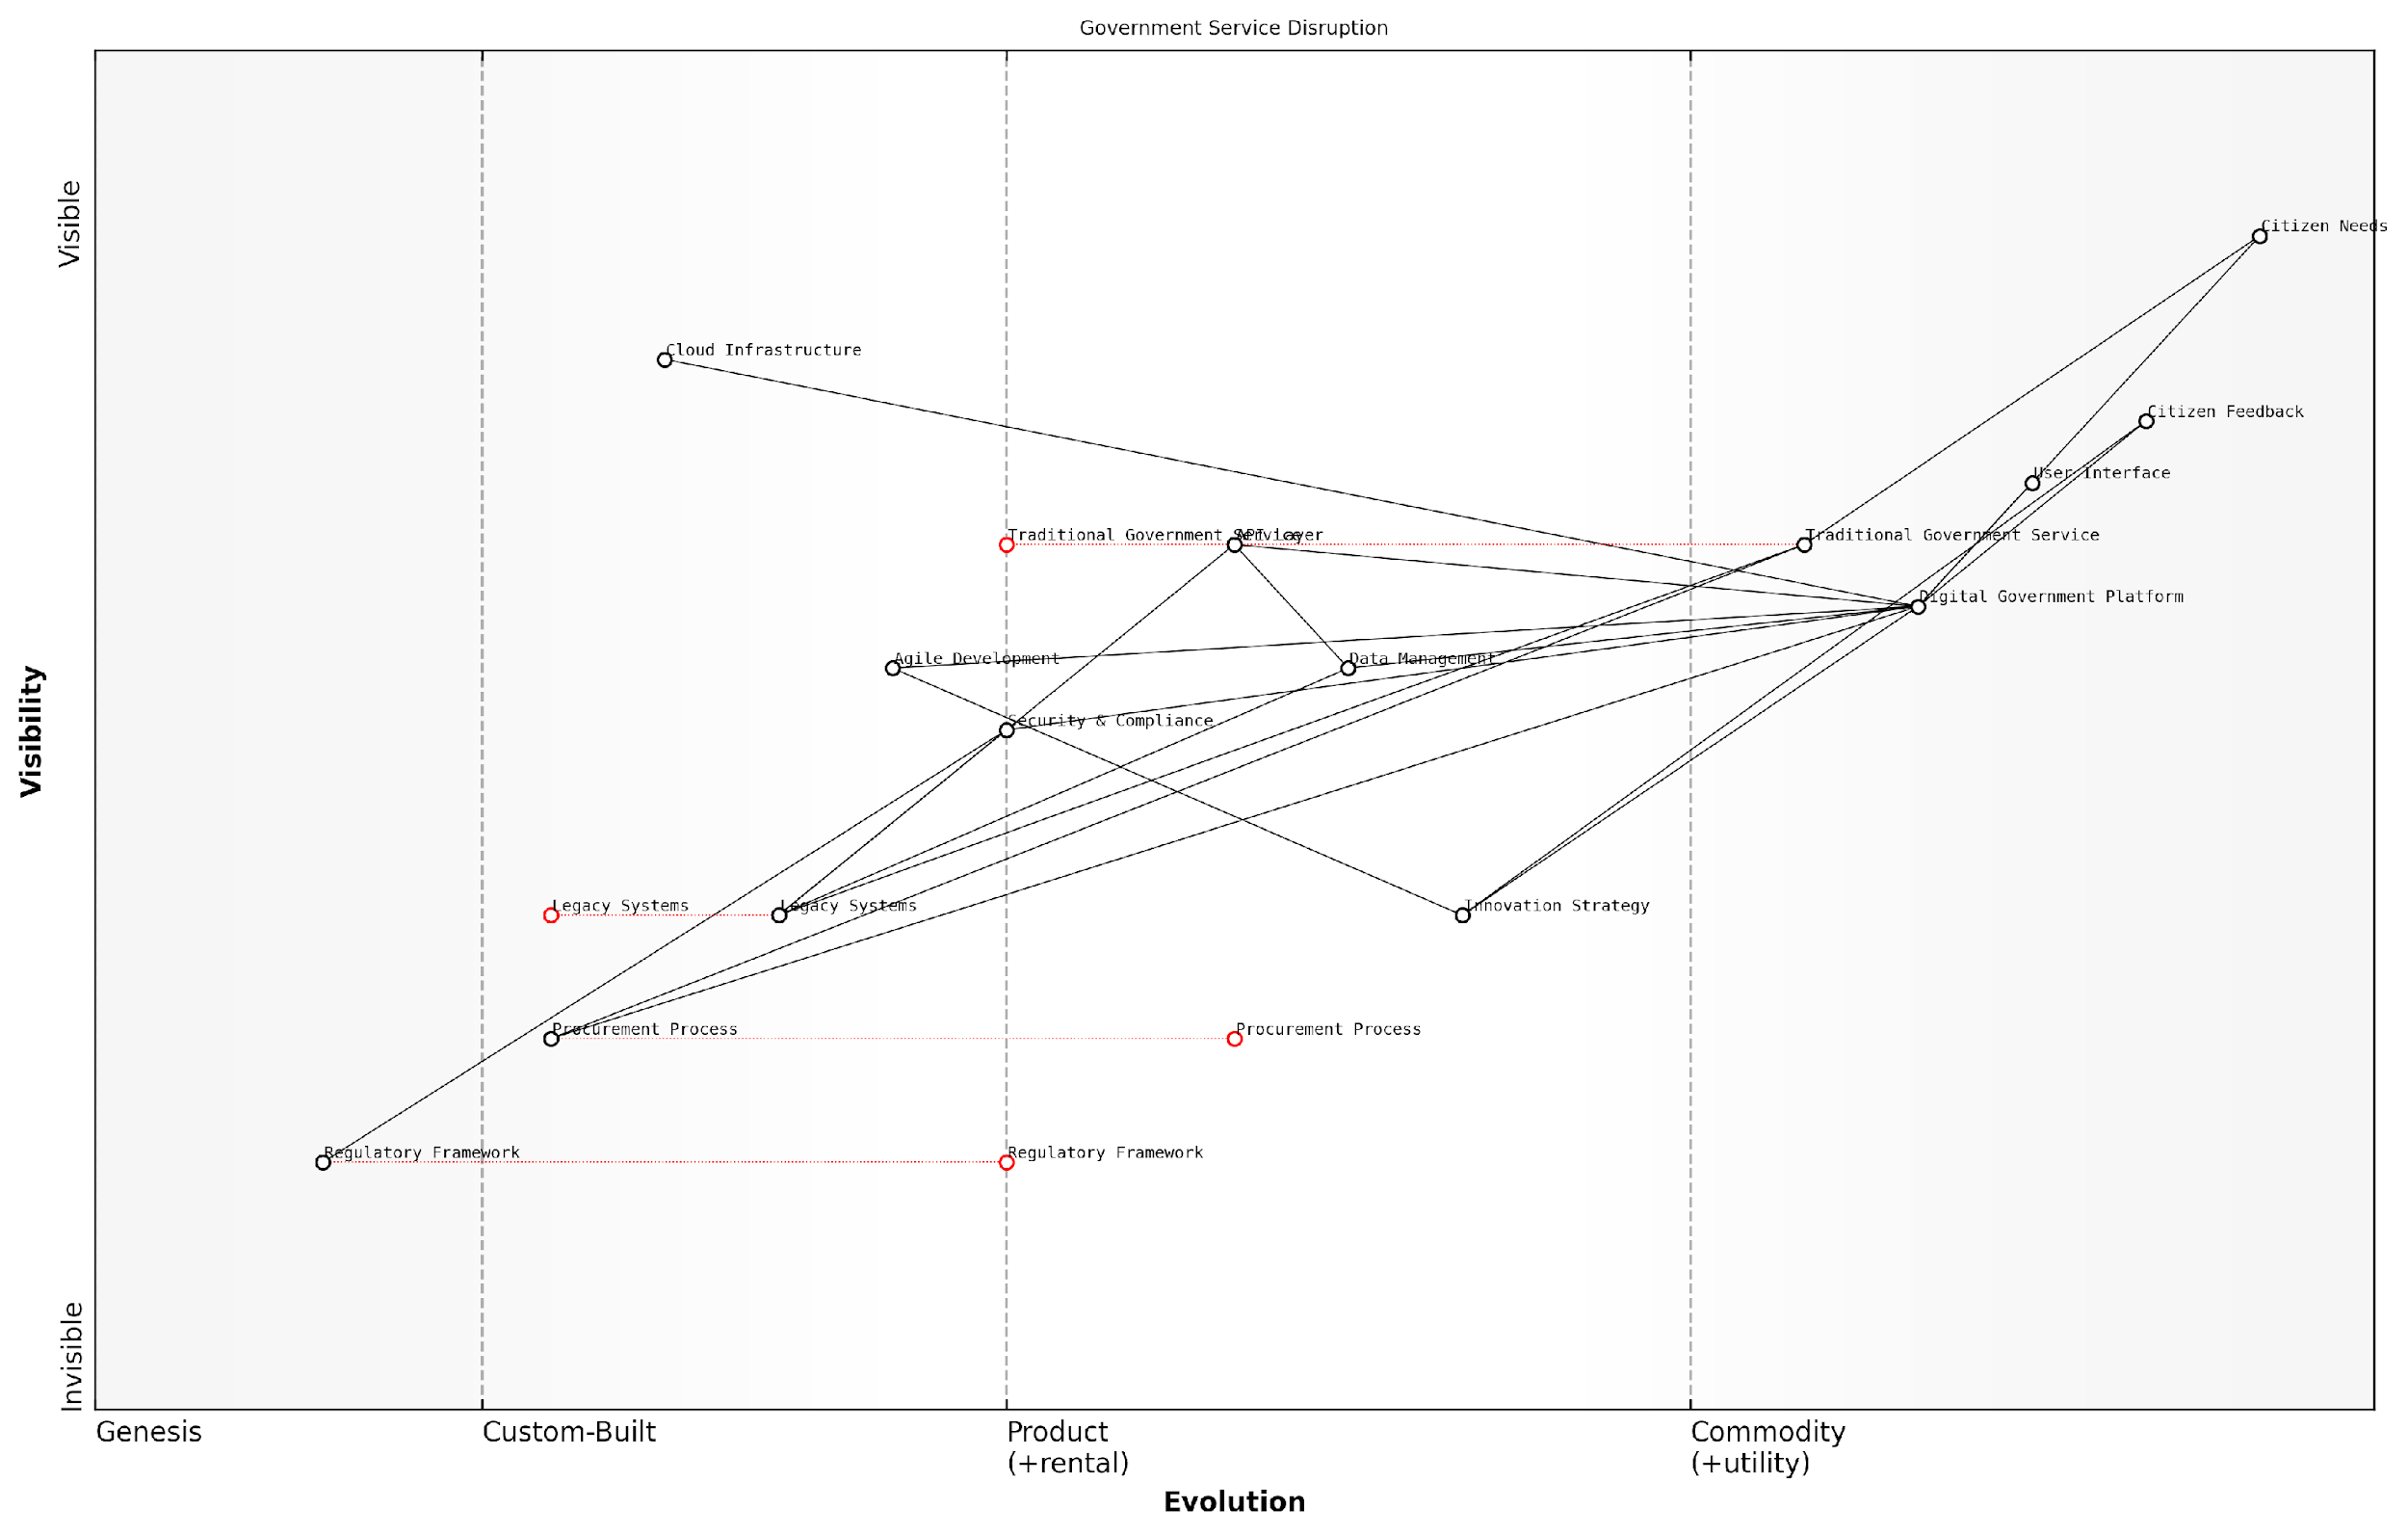

*Draft Wardley Map: [Insert Wardley Map: The nature of disruptive innovation]*

[Edit this draft Wardley Map](https://create.wardleymaps.ai/#clone:2eb1cf0769d27b8d39)

Wardley Map Assessment

The map reveals a government service landscape in transition, with significant opportunities for digital transformation. The key challenge lies in balancing rapid innovation with the need for stability, security, and inclusivity in government services. Success will depend on effectively managing the evolution of legacy systems, accelerating the development of digital platforms, and fostering a culture of continuous innovation and citizen engagement. The strategic focus should be on creating a flexible, data-driven government ecosystem that can adapt to changing citizen needs while maintaining the highest standards of security and compliance.

[View full Wardley Map report](http://markdown_wardley_map_reports/wardley_map_report_34_The_nature_of_disruptive_innovation.md)

As we move forward in this chapter, we’ll explore specific strategies for leveraging these insights to create disruptive innovations, backed by real-world case studies of successful government sector startups that have used Wardley Mapping to navigate their path to success.

### How Wardley Maps reveal potential disruptions

Wardley Maps are a powerful tool for revealing potential disruptions in the startup landscape, particularly within government and public sector contexts. By visually representing the evolution of components in a value chain, these maps provide a unique lens through which to identify emerging trends, weak signals, and potential disruptive forces that may reshape industries and markets.

At its core, a Wardley Map helps startups and organisations understand the maturity and strategic importance of different components in their business ecosystem. This understanding is crucial for identifying potential disruptions, as it allows us to spot areas ripe for innovation or vulnerable to external shocks.

* Evolutionary Patterns: Wardley Maps reveal how components evolve from genesis (novel and unstable) to commodity (well-understood and stable). This evolution pattern helps identify where disruption is likely to occur.
* Value Chain Visibility: By mapping the entire value chain, startups can identify inefficiencies or gaps that could be exploited by disruptive innovations.
* Dependency Analysis: Understanding the relationships between components helps predict how changes in one area might cascade through the system, potentially leading to disruptive effects.
* Weak Signal Detection: The visual nature of Wardley Maps can help highlight subtle shifts or emerging trends that might be missed in traditional analysis.

One of the key ways Wardley Maps reveal potential disruptions is through the analysis of component evolution. As a senior government official once remarked, ‘Wardley Mapping helped us see beyond the horizon, identifying emerging technologies that would reshape our service delivery models before they became mainstream.’

Consider the evolution of cloud computing in the public sector. A decade ago, most government IT systems were custom-built and locally hosted. A Wardley Map from that time would have shown these components as products or custom-built solutions. However, mapping the same landscape today reveals a shift towards cloud services and commoditised IT infrastructure. This evolution pattern, visible through Wardley Mapping, signalled a major disruption in how government services are delivered and maintained.

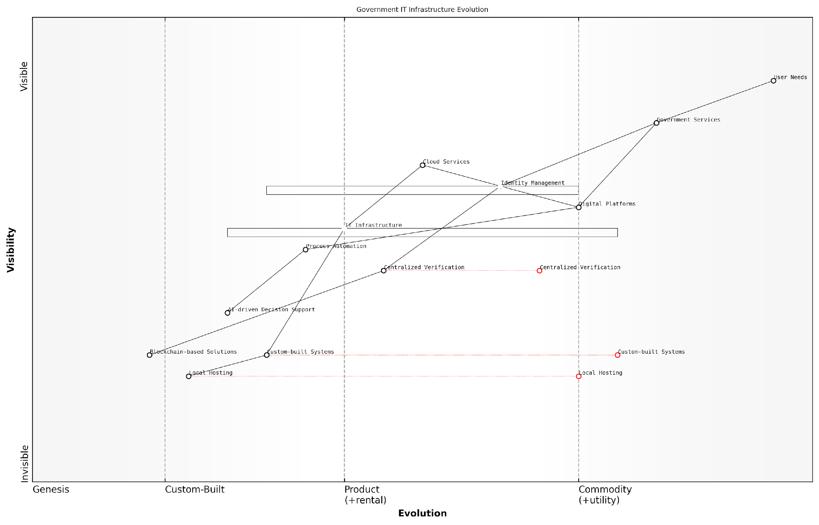

*Draft Wardley Map: [Insert Wardley Map: How Wardley Maps reveal potential disruptions]*

[Edit this draft Wardley Map](https://create.wardleymaps.ai/#clone:f282338cee9af9e92e)

Wardley Map Assessment

The map reveals a government IT infrastructure in transition, moving from traditional, siloed systems to a more integrated, cloud-based, and user-centric model. While progress is evident in areas like digital platforms and cloud services, there are significant opportunities in emerging technologies like AI and blockchain. The key challenge lies in managing this transition effectively, balancing modernization with security and reliability requirements. Strategic focus should be on accelerating cloud adoption, enhancing digital platforms, and carefully integrating AI and blockchain technologies to improve service delivery and operational efficiency. This evolution will require substantial investment, cultural change, and ecosystem collaboration, but has the potential to significantly enhance government services and citizen satisfaction.

[View full Wardley Map report](http://markdown_wardley_map_reports/wardley_map_report_35_How_Wardley_Maps_reveal_potential_disruptions.md)

Another way Wardley Maps reveal potential disruptions is through the identification of ‘inertia’ points in the value chain. These are areas where components are not evolving as quickly as they could, often due to organisational resistance or lack of competitive pressure. Such inertia points represent prime targets for disruptive innovations.

For example, in a recent project with a large public sector organisation, we used Wardley Mapping to analyse their citizen engagement processes. The map revealed that while front-end interfaces had evolved to digital platforms, back-end processes remained largely manual and custom-built. This mismatch in evolution stages highlighted a clear opportunity for disruption through process automation and AI-driven decision support systems.

Wardley Mapping doesn’t just show us where we are; it illuminates the path of where technology and user needs are heading. This foresight is invaluable for any startup or organisation looking to stay ahead of disruptive curves.

Wardley Maps also excel at revealing potential disruptions by highlighting dependencies and relationships between components. In the startup world, particularly in govtech, understanding these interconnections is crucial for identifying how changes in one area might ripple through the entire ecosystem.

For instance, in a recent mapping exercise with a govtech startup focusing on digital identity solutions, we identified a critical dependency on centralised identity verification processes. By visualising this dependency, we were able to anticipate how emerging decentralised identity technologies (like blockchain-based solutions) could potentially disrupt the entire identity management landscape in government services.

* Anticipating Technological Shifts: By mapping current technologies and their evolution, startups can anticipate when emerging technologies might become viable alternatives.
* Identifying Market Gaps: Wardley Maps can reveal underserved areas or inefficiencies in the current market, highlighting opportunities for disruptive new offerings.
* Regulatory Impact Analysis: In the government sector, maps can show how potential regulatory changes might disrupt existing service models or create new opportunities.
* Competitive Landscape Visualisation: Maps help startups understand their position relative to competitors and identify areas where they can differentiate or disrupt.

It’s important to note that while Wardley Maps are powerful tools for revealing potential disruptions, they require regular updating and reanalysis. The landscape of technology and user needs is constantly shifting, especially in the fast-paced world of startups and government innovation.

A leading expert in the field once noted, ‘The true power of Wardley Mapping lies not just in creating a single map, but in the ongoing process of mapping and re-mapping as the landscape evolves. It’s this iterative process that keeps us attuned to potential disruptions.’

In conclusion, Wardley Maps reveal potential disruptions by providing a visual, evolving representation of the business landscape. They allow startups, particularly those in the govtech space, to anticipate technological shifts, identify market gaps, understand the impact of regulatory changes, and visualise the competitive landscape. By leveraging these insights, startups can position themselves to either lead disruptive changes or quickly adapt to them, ensuring they remain at the forefront of innovation in the rapidly evolving public sector technology landscape.

### Identifying weak signals and emerging trends

In the rapidly evolving landscape of startups, particularly within government and public sector contexts, the ability to identify weak signals and emerging trends is crucial for maintaining a competitive edge and driving innovation. Wardley Mapping provides a powerful framework for detecting these subtle indicators of change, allowing startups to anticipate disruptions and position themselves strategically. This section explores how Wardley Mapping can be leveraged to uncover weak signals and emerging trends, enabling startups to navigate uncertainty and capitalise on future opportunities.

Weak signals are early indicators of potential future changes or trends that may have a significant impact on an industry or market. These signals are often faint and easily overlooked, but when identified and properly analysed, they can provide valuable insights into emerging opportunities or threats. Wardley Mapping, with its focus on the evolution of components and their relationships within a value chain, offers a unique perspective for detecting these weak signals.

To effectively identify weak signals and emerging trends using Wardley Mapping, startups should focus on the following key areas:

* Component Evolution Analysis
* Ecosystem Mapping
* Cross-Industry Comparison
* Inertia Points and Constraints
* Technological Advancements

Component Evolution Analysis: By closely examining the evolution of components within a Wardley Map, startups can identify potential areas of disruption. Components that are rapidly moving from custom-built to product or commodity stages may indicate emerging trends. For example, in the government sector, the shift of certain services from bespoke solutions to standardised platforms can signal a broader trend towards digital transformation and shared services.

The evolution of components in a Wardley Map is not just about technological change, but also about shifts in user needs, market dynamics, and organisational capabilities. It’s in these shifts that we often find the first whispers of transformative trends.

Ecosystem Mapping: By mapping the entire ecosystem surrounding a startup’s value chain, including suppliers, partners, and complementary services, it becomes possible to identify weak signals that may not be immediately apparent when focusing solely on direct competitors. This holistic view can reveal emerging trends in adjacent industries or sectors that may soon impact the startup’s domain.

Cross-Industry Comparison: Startups can gain valuable insights by comparing Wardley Maps across different industries or sectors. Patterns of evolution or disruption that have occurred in one industry may foreshadow similar changes in another. For instance, the adoption of blockchain technology in financial services may signal potential applications in government record-keeping or identity management.

Inertia Points and Constraints: Identifying areas of inertia or constraints within a Wardley Map can reveal opportunities for disruption. These points of resistance often indicate areas ripe for innovation, where emerging trends may take hold. In the public sector, legacy systems or regulatory constraints can be indicators of where future disruptions might occur.

The most significant opportunities for innovation often lie at the intersection of technological possibility and organisational inertia. It’s here that startups can find the weak signals that herald transformative change.

Technological Advancements: Wardley Mapping can help startups track the progression of emerging technologies through different stages of evolution. By monitoring how these technologies move from genesis to custom-built to product and potentially to commodity, startups can anticipate their impact on existing value chains and identify new opportunities.

To effectively leverage Wardley Mapping for identifying weak signals and emerging trends, startups should consider the following practical approaches:

* Regular mapping exercises: Conduct periodic mapping sessions to update and refine your Wardley Maps, ensuring they reflect the latest market dynamics and technological advancements.
* Collaborative mapping: Engage team members from diverse backgrounds in the mapping process to bring multiple perspectives and increase the likelihood of spotting weak signals.
* Scenario planning: Use Wardley Maps to create multiple future scenarios, helping to identify potential weak signals and their implications.
* Data-driven analysis: Incorporate data analytics and market research into your mapping process to validate and quantify potential weak signals.
* External expert engagement: Consult with industry experts and thought leaders to gain additional insights into emerging trends and validate your map interpretations.

Case Study: Identifying Emerging Trends in Government Digital Services

Consider a startup focused on providing digital services to government agencies. By creating a Wardley Map of the current landscape, the startup identified several key components, including legacy systems, data management, and citizen engagement platforms. Through regular mapping exercises and cross-industry comparisons, the startup noticed a weak signal: the increasing commoditisation of AI-powered chatbots in the private sector.

While AI chatbots were still in the custom-built phase for most government services, the startup recognised this as an emerging trend that could significantly impact citizen engagement and service delivery. By positioning themselves ahead of this trend, the startup developed a scalable, AI-powered citizen support platform tailored for government use, anticipating the future needs of their target market.

The ability to spot weak signals and translate them into actionable strategies is what separates truly innovative startups from the rest. Wardley Mapping provides a structured approach to cultivating this foresight.

In conclusion, Wardley Mapping offers startups a powerful tool for identifying weak signals and emerging trends, particularly in complex environments like the government and public sector. By systematically analysing component evolution, ecosystem dynamics, and cross-industry patterns, startups can gain a competitive edge in anticipating and capitalising on future opportunities. The key lies in regular, collaborative mapping exercises, combined with data-driven analysis and expert insights, to transform faint signals into robust strategies for innovation and growth.

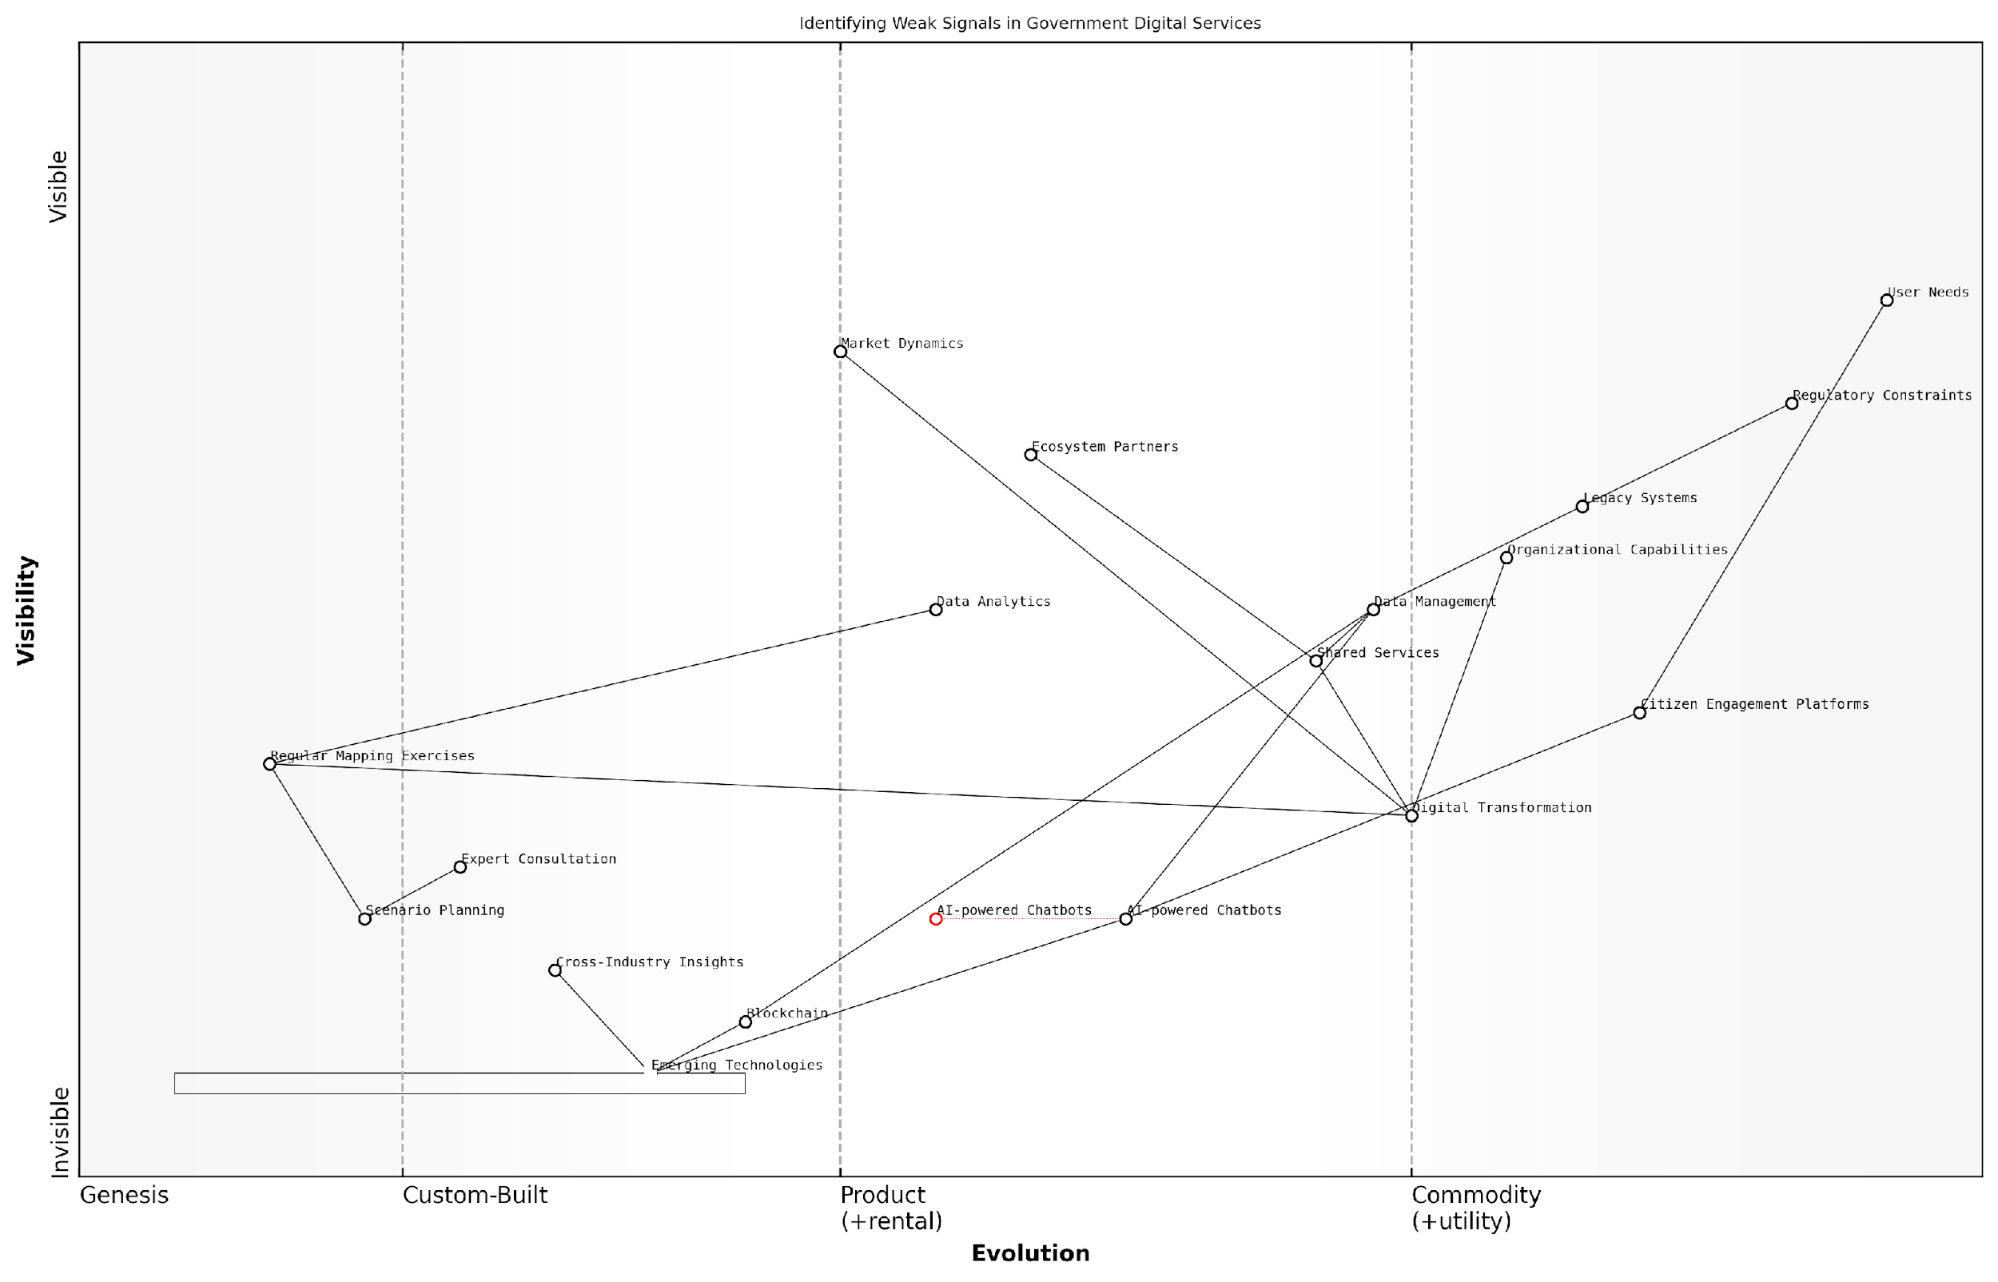

*Draft Wardley Map: [Insert Wardley Map: Identifying weak signals and emerging trends]*

[Edit this draft Wardley Map](https://create.wardleymaps.ai/#clone:d16a71f2a76a27d425)

Wardley Map Assessment

The map reveals a government digital services landscape in transition, balancing the need to maintain legacy systems with the imperative to innovate and meet evolving user needs. The strategic focus on Digital Transformation, AI-powered Chatbots, and emerging technologies like Blockchain presents significant opportunities for improving service delivery and efficiency. However, the inertia of Legacy Systems and Regulatory Constraints poses challenges. To succeed, the organisation must accelerate its adoption of emerging technologies, enhance its data analytics capabilities, and foster a more agile, user-centric approach to service development. Regular strategic mapping and scenario planning will be crucial in navigating this complex and rapidly evolving landscape.

[View full Wardley Map report](http://markdown_wardley_map_reports/wardley_map_report_36_Identifying_weak_signals_and_emerging_trends.md)

## Value Chain Analysis for Competitive Advantage

### Mapping your industry’s value chain

Value chain analysis is a critical component of Wardley Mapping that enables startups to identify and leverage competitive advantages within their industry. By mapping the entire value chain, from raw materials to end-user products or services, startups can gain a comprehensive understanding of their market position, identify inefficiencies, and spot opportunities for innovation and disruption. This subsection explores how startups can utilise value chain analysis within the Wardley Mapping framework to gain a strategic edge in their respective markets.

Mapping your industry’s value chain is the first step in this process. This involves identifying all the components and activities that contribute to the creation and delivery of value to the end customer. For startups, this exercise is particularly crucial as it helps to identify where they fit within the broader ecosystem and where they can potentially create the most impact.

* Identify all key activities and components in your industry
* Map these components along the evolution axis (Genesis to Commodity)
* Determine the dependencies between components
* Analyse the flow of value through the chain

Once the value chain is mapped, startups can begin to identify inefficiencies and pain points within the industry. These areas of friction often represent opportunities for innovation and disruption. By leveraging Wardley Mapping techniques, startups can visualise where these inefficiencies lie and how they might be addressed.

In my experience advising government bodies, I’ve found that the most significant opportunities often lie in the interfaces between different components of the value chain. It’s in these spaces that startups can insert themselves and create transformative value.

Inefficiencies might manifest in various forms, such as:

* Outdated or cumbersome processes
* Overreliance on legacy systems
* Poor information flow between different stages of the value chain
* Misalignment between customer needs and existing solutions

By identifying these pain points, startups can focus their resources on developing solutions that address specific market needs, thereby creating a strong value proposition and competitive advantage.

Another crucial aspect of value chain analysis is spotting opportunities for vertical and horizontal integration. Vertical integration involves taking control of adjacent stages in the value chain, either upstream (towards suppliers) or downstream (towards customers). Horizontal integration, on the other hand, involves expanding into related products or services at the same stage of the value chain.

Wardley Mapping can be particularly effective in identifying these integration opportunities. By visualising the entire value chain and the relationships between different components, startups can identify strategic moves that could strengthen their market position.

* Vertical integration opportunities: Look for adjacent components in the value chain where integration could lead to cost savings, improved quality control, or enhanced customer experience.
* Horizontal integration opportunities: Identify related products or services that could benefit from shared resources, technologies, or customer bases.
* Platform opportunities: Spot areas where creating a platform could connect multiple components of the value chain, potentially disrupting the entire industry.

A prime example of successful vertical integration identified through Wardley Mapping comes from my work with a government agency tasked with improving public transportation. By mapping the value chain, we identified an opportunity to integrate ticketing systems across multiple modes of transport, significantly enhancing the user experience and operational efficiency.

The power of Wardley Mapping lies in its ability to reveal not just where you are, but where you could be. It’s about seeing the chess moves before your competitors do.

It’s important to note that value chain analysis through Wardley Mapping is not a one-time exercise. As the industry evolves and new technologies emerge, the value chain will shift. Startups must regularly revisit and update their maps to stay ahead of these changes and continue to identify new opportunities for competitive advantage.

Moreover, startups should consider how emerging technologies and trends might impact the value chain in the future. For instance, the rise of artificial intelligence and machine learning is likely to automate many processes within value chains across industries. By anticipating these changes through Wardley Mapping, startups can position themselves to take advantage of these shifts rather than being disrupted by them.

In conclusion, value chain analysis through Wardley Mapping provides startups with a powerful tool for identifying and leveraging competitive advantages. By thoroughly mapping their industry’s value chain, identifying inefficiencies and pain points, and spotting opportunities for integration and disruption, startups can position themselves strategically within their market. This approach not only helps in developing a strong value proposition but also in anticipating and adapting to future changes in the industry landscape.

In the fast-paced world of startups, the ability to see the entire playing field and anticipate future moves is invaluable. Wardley Mapping, when applied to value chain analysis, provides exactly this strategic foresight.

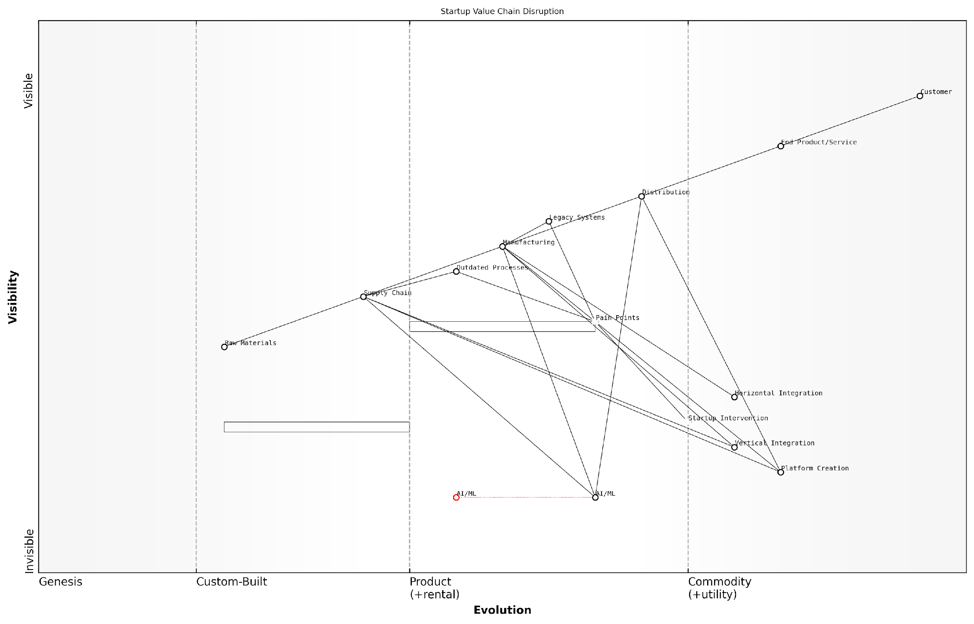

*Draft Wardley Map: [Insert Wardley Map: Mapping your industry’s value chain]*

[Edit this draft Wardley Map](https://create.wardleymaps.ai/#clone:19e9e82b1932440f41)

Wardley Map Assessment

This Wardley Map reveals an industry ripe for disruption, with significant opportunities for startups and innovative incumbents to reshape the value chain. The key to success lies in leveraging emerging technologies like AI/ML, creating platforms that span traditional industry boundaries, and addressing pain points in legacy systems and processes. Companies that can successfully navigate this transition, balancing short-term optimization with long-term transformation, will be well-positioned to lead in the evolving industry landscape. The emphasis on startup intervention suggests that agility, innovation, and technological adoption will be critical success factors moving forward.

[View full Wardley Map report](http://markdown_wardley_map_reports/wardley_map_report_37_Mapping_your_industry's_value_chain.md)

### Identifying inefficiencies and pain points

In the realm of Wardley Mapping for Startups, particularly within government and public sector contexts, identifying inefficiencies and pain points is a crucial step in value chain analysis. This process allows startups to uncover opportunities for innovation and disruption, ultimately leading to competitive advantage. By meticulously examining each component of the value chain, startups can pinpoint areas where current solutions fall short, processes are cumbersome, or user needs are unmet.

To effectively identify inefficiencies and pain points, startups should employ a systematic approach that combines Wardley Mapping techniques with deep industry knowledge and user-centric research. This approach can be broken down into several key steps:

* Map the current value chain in detail
* Analyse component interactions and dependencies
* Gather user feedback and pain points
* Identify bottlenecks and inefficiencies
* Assess technological and market evolution
* Evaluate regulatory and compliance impacts

Let’s delve deeper into each of these steps to understand how they contribute to identifying inefficiencies and pain points in the value chain.

1. Map the current value chain in detail: Begin by creating a comprehensive Wardley Map of the existing value chain. This map should include all components, from user needs at the top to the underlying infrastructure at the bottom. Pay particular attention to the relationships between components and their positioning along the evolution axis.

A thorough value chain map is the foundation for identifying inefficiencies. It provides a visual representation of the entire system, making it easier to spot potential problem areas.

1. Analyse component interactions and dependencies: Once the map is created, examine how different components interact with each other. Look for areas where there are unnecessary complexities, redundancies, or dependencies that could be simplified. In government and public sector contexts, this step often reveals legacy systems or processes that have become bottlenecks in service delivery.
2. Gather user feedback and pain points: Engage with end-users, whether they are citizens, businesses, or government employees, to understand their experiences and challenges. Use techniques such as surveys, interviews, and user testing to gather qualitative and quantitative data about pain points in the current system.

User feedback is invaluable in identifying pain points that may not be immediately apparent from the map alone. It provides context and real-world validation of potential inefficiencies.

1. Identify bottlenecks and inefficiencies: Using the insights gained from the map analysis and user feedback, pinpoint specific areas where the value chain is underperforming. This could include slow processes, data silos, outdated technologies, or areas where manual intervention is required in otherwise automated systems.
2. Assess technological and market evolution: Consider how each component in the value chain is evolving. Are there areas where outdated technologies are being used when more efficient alternatives exist? Are there emerging technologies or practices that could dramatically improve certain parts of the value chain? This assessment helps identify inefficiencies that may not be immediately obvious but could become significant pain points in the near future.
3. Evaluate regulatory and compliance impacts: In government and public sector contexts, it’s crucial to consider how regulations and compliance requirements affect the value chain. Identify areas where regulatory requirements are creating inefficiencies or where compliance processes are overly burdensome. This analysis can reveal opportunities for startups to innovate within regulatory frameworks or even influence policy changes.

By systematically working through these steps, startups can build a comprehensive understanding of the inefficiencies and pain points within their target value chain. This knowledge forms the basis for developing innovative solutions that address real needs and create significant value.

It’s important to note that identifying inefficiencies and pain points is not a one-time exercise. As the market evolves and user needs change, new inefficiencies may emerge while others become less relevant. Startups should regularly revisit their Wardley Maps and value chain analyses to ensure they remain aligned with current realities and opportunities.

Continuous mapping and analysis is key to maintaining a competitive edge. The most successful startups are those that can anticipate and address inefficiencies before they become critical issues.

In my experience advising government bodies and public sector organisations, I’ve found that one of the most common sources of inefficiency is the disconnect between different departments or agencies. Often, each entity has its own systems and processes, leading to duplication of effort and inconsistent user experiences. By mapping these interactions and identifying the pain points they create, startups can develop solutions that bridge these gaps and create more seamless, efficient services.

For example, in a recent project with a large municipal government, we used Wardley Mapping to analyse the process of applying for and receiving various permits and licences. The map revealed significant inefficiencies in how information was shared between departments, leading to long wait times and frustration for citizens and businesses. By identifying these pain points, we were able to develop a unified digital platform that streamlined the entire process, reducing processing times by over 60% and dramatically improving user satisfaction.

This example illustrates the power of using Wardley Mapping to identify inefficiencies and pain points in complex systems. By visualising the entire value chain and analysing it systematically, startups can uncover opportunities that might otherwise remain hidden. This approach is particularly valuable in government and public sector contexts, where the potential for impactful innovation is often significant but can be obscured by layers of complexity and legacy systems.

In conclusion, identifying inefficiencies and pain points through value chain analysis is a critical step for startups seeking to create disruptive solutions in the government and public sector space. By combining the strategic insights provided by Wardley Mapping with deep user research and an understanding of technological and regulatory landscapes, startups can position themselves to deliver high-impact innovations that address real needs and create substantial value.

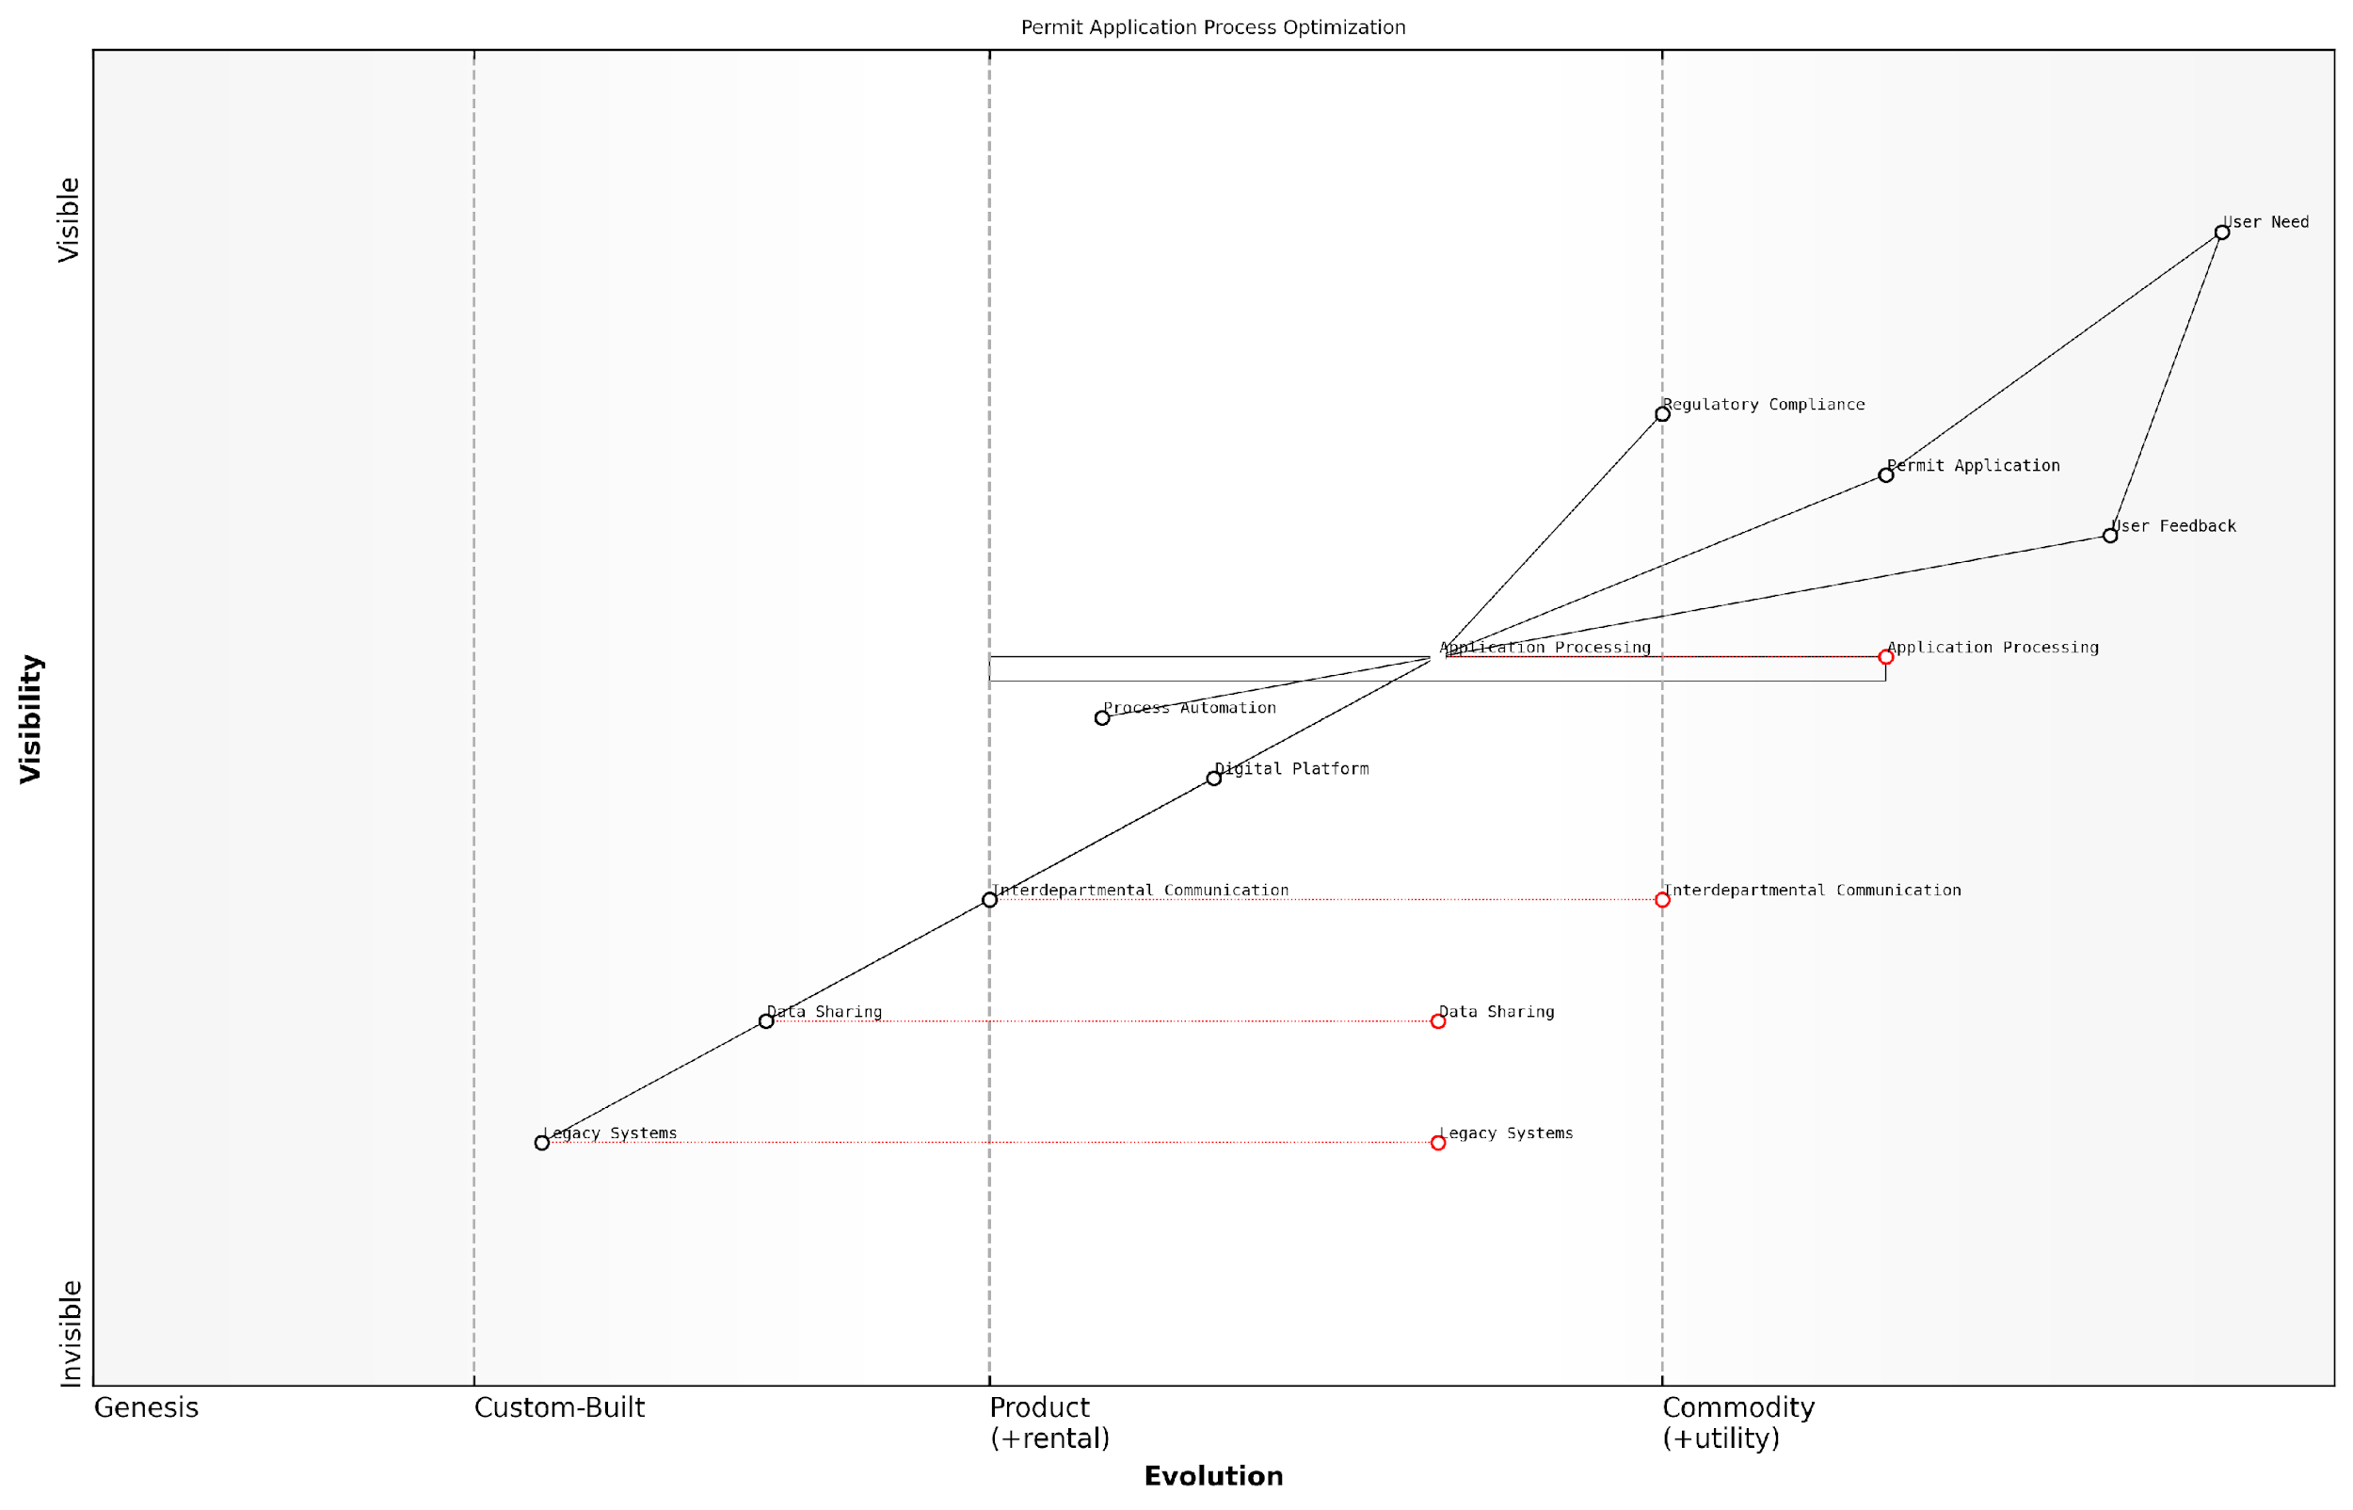

*Draft Wardley Map: [Insert Wardley Map: Identifying inefficiencies and pain points]*

[Edit this draft Wardley Map](https://create.wardleymaps.ai/#clone:41610cbdbaca059f8d)

Wardley Map Assessment

The Wardley Map reveals a permit application process in transition, with a clear strategy towards digitalization and efficiency. Key opportunities lie in accelerating the evolution of legacy systems, enhancing data sharing and communication capabilities, and leveraging emerging technologies like AI and predictive analytics. The focus on user needs and feedback is a strength, but there’s room for improvement in translating this into actionable insights. By addressing the identified bottlenecks and investing in key evolving components, the organisation can significantly enhance its permit application process, improving both efficiency and user satisfaction. The potential for ecosystem development and external partnerships also presents exciting opportunities for future growth and innovation.

[View full Wardley Map report](http://markdown_wardley_map_reports/wardley_map_report_38_Identifying_inefficiencies_and_pain_points.md)

### Spotting opportunities for vertical and horizontal integration

In the realm of Wardley Mapping for Startups, particularly within government and public sector contexts, the ability to identify opportunities for vertical and horizontal integration is a crucial skill. This subsection delves into the strategic importance of these integration opportunities and how they can be leveraged to create competitive advantage and drive innovation in the public sector.

Vertical integration refers to the process of expanding a company’s operations into different stages of the same value chain. In contrast, horizontal integration involves expanding into related products or services at the same stage of the value chain. Both strategies can offer significant benefits to startups, especially those operating in the complex landscape of government and public sector services.

To effectively spot these opportunities, we must first understand how to analyse the value chain through the lens of Wardley Mapping. This involves a deep dive into the components of your value chain, their evolutionary stage, and their interdependencies.

* Identify all components in your value chain
* Assess the evolutionary stage of each component
* Analyse the relationships and dependencies between components
* Evaluate the strategic importance of each component
* Identify gaps or inefficiencies in the current value chain

Once you have a comprehensive understanding of your value chain, you can begin to spot opportunities for integration. Here are some key indicators to look for:

* Components that are strategic necessities but currently outsourced
* Adjacent components that could be combined for increased efficiency
* Gaps in the value chain that could be filled through acquisition or development
* Components that are evolving rapidly and could benefit from tighter integration
* Areas where competitors are gaining advantage through integration

In the context of government and public sector startups, vertical integration opportunities often arise in areas such as data management, citizen services, and infrastructure development. For example, a startup providing digital identity solutions might consider vertically integrating by developing its own secure data storage capabilities, rather than relying on third-party providers.

Horizontal integration opportunities, on the other hand, might involve expanding into related service areas. A startup focused on providing digital health records could consider integrating horizontally into telemedicine services or health data analytics.

In my experience advising government bodies, I’ve observed that the most successful public sector startups are those that can identify and capitalise on integration opportunities that align with broader policy objectives and citizen needs.

It’s important to note that integration decisions should not be made in isolation. They must be considered within the broader context of your startup’s strategy, resources, and the evolving landscape of public sector needs and regulations.

When evaluating integration opportunities, consider the following factors:

* Alignment with core competencies and strategic objectives
* Potential for improved efficiency or cost reduction
* Impact on service quality and citizen satisfaction
* Regulatory implications and compliance requirements
* Resource requirements and feasibility of implementation
* Potential risks and mitigation strategies

One powerful technique for identifying integration opportunities is to create multiple Wardley Maps representing different potential future scenarios. This allows you to visualise how different integration strategies might impact your value chain and competitive position over time.

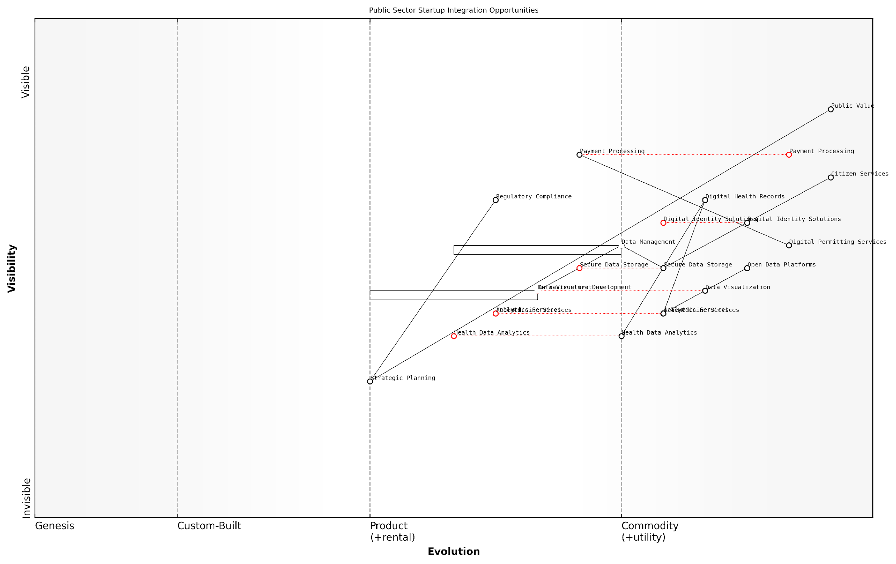

*Draft Wardley Map: [Insert Wardley Map: Spotting opportunities for vertical and horizontal integration]*

[Edit this draft Wardley Map](https://create.wardleymaps.ai/#clone:d7275ad7dc433f0586)

Wardley Map Assessment

This Wardley Map reveals a public sector landscape ripe for digital transformation and startup integration. Key opportunities lie in health tech, data analytics, and infrastructure modernization. Success will depend on balancing innovation with regulatory compliance, leveraging partnerships effectively, and maintaining a strong focus on citizen needs. The strategic imperative is to move towards a more agile, data-driven, and user-centric model of public service delivery.

[View full Wardley Map report](http://markdown_wardley_map_reports/wardley_map_report_39_Spotting_opportunities_for_vertical_and_horizontal.md)

Let’s consider a case study from my consultancy experience. A startup providing digital permitting services for local governments identified an opportunity for vertical integration by developing its own payment processing system. This move not only reduced reliance on third-party providers but also allowed for better data integration and improved user experience for citizens.

In another instance, a startup focused on providing open data platforms for government agencies successfully pursued horizontal integration by expanding into data visualisation and analytics services. This move allowed them to offer a more comprehensive solution to their clients and capture a larger share of the value chain.

A senior government official I worked with once remarked, ‘The most impactful startups in the public sector are those that can seamlessly integrate various components of the citizen service journey, creating a more cohesive and efficient experience for both government agencies and the public.’

It’s crucial to remember that integration strategies in the public sector must always prioritise public value and citizen benefit. Any integration decision should be evaluated not just in terms of business advantage, but also in terms of its potential to improve public services, increase transparency, or enhance democratic engagement.

In conclusion, spotting opportunities for vertical and horizontal integration through Wardley Mapping can provide startups in the government and public sector with a powerful tool for strategic decision-making. By carefully analysing the value chain, identifying key components and their evolutionary stages, and considering potential integration opportunities, startups can position themselves for long-term success and meaningful impact in the public sector.

As you apply these principles in your own startup, remember that the landscape is constantly evolving. Regular reassessment of your Wardley Maps and integration strategies will be necessary to ensure continued alignment with your goals and the changing needs of the public sector.

## Strategies for Disruptive Innovation

### Leveraging emerging technologies and practices

In the rapidly evolving landscape of startups, particularly within government and public sector contexts, leveraging emerging technologies and practices is crucial for driving disruptive innovation. Wardley Mapping provides a powerful framework for identifying and capitalising on these opportunities, enabling startups to navigate uncertainty and create significant value. This section explores how startups can effectively leverage emerging technologies and practices through the lens of Wardley Mapping, offering insights drawn from years of consultancy experience and industry expertise.

Emerging technologies and practices represent the ‘genesis’ and ‘custom-built’ stages of the evolution axis in Wardley Maps. These components often hold the greatest potential for disruption and value creation, but they also carry higher risks and uncertainties. By mapping these elements, startups can gain a clearer understanding of their potential impact on the value chain and develop strategies to harness their power effectively.

* Identify emerging technologies and practices relevant to your domain
* Map these elements to understand their current position and potential evolution
* Analyse how these components interact with and influence other elements in your value chain
* Develop strategies to incorporate or leverage these technologies and practices
* Monitor and reassess regularly to adapt to rapid changes

One of the key advantages of using Wardley Mapping in this context is its ability to provide a visual representation of the entire landscape, including emerging technologies and practices. This holistic view allows startups to identify potential synergies, dependencies, and opportunities that might otherwise be overlooked. For instance, a government-focused startup might identify an emerging blockchain technology that could revolutionise secure data sharing between agencies. By mapping this technology alongside existing components, the startup can visualise how it might integrate with and enhance current processes, potentially leading to a disruptive new service offering.

Wardley Mapping has been instrumental in our ability to spot and leverage emerging technologies. It’s like having a crystal ball that not only shows you the future but also how to get there.

When leveraging emerging technologies and practices, it’s crucial to consider their position on the evolution axis and their potential movement. Technologies in the ‘genesis’ stage may offer groundbreaking possibilities but require significant investment and carry higher risks. Conversely, practices moving towards the ‘product’ or ‘commodity’ stages may be more stable but offer less competitive advantage. Startups must carefully balance these factors when deciding where to focus their resources.

For example, a startup working on improving public service delivery might identify machine learning as an emerging technology with high potential. By mapping this technology, they might realise that while it’s still in the ‘custom-built’ stage for many applications, it’s rapidly moving towards ‘product’. This insight could inform their strategy, perhaps leading them to focus on developing unique applications of machine learning tailored to specific government needs, rather than trying to compete in more commoditised areas.

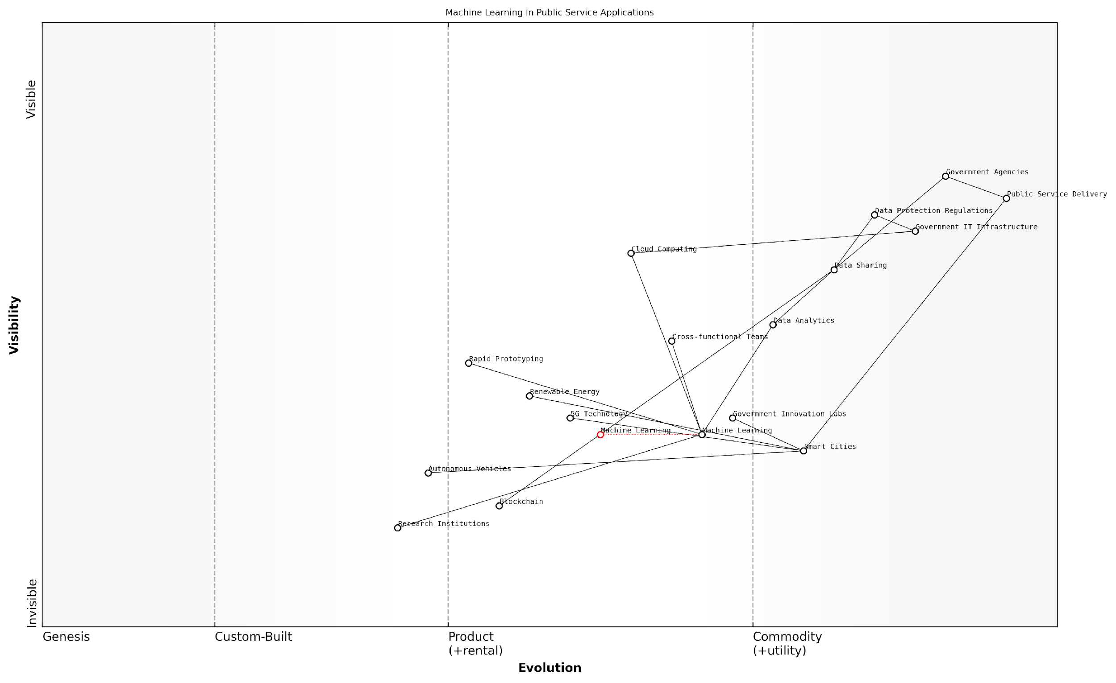

*Draft Wardley Map: [Insert Wardley Map: Leveraging emerging technologies and practices]*

[Edit this draft Wardley Map](https://create.wardleymaps.ai/#clone:657a931a2f67ce9fcd)

Wardley Map Assessment

This Wardley Map reveals a public sector actively engaging with emerging technologies to transform service delivery. The strategic positioning of Machine Learning and Smart Cities as key enablers is promising. However, there are significant opportunities to further integrate emerging technologies, enhance cross-agency collaboration, and develop more robust in-house capabilities. The main challenges lie in navigating data protection concerns, modernising legacy IT infrastructure, and effectively managing the rapid evolution of key technologies. By focusing on strengthening Government Innovation Labs, fostering cross-functional teams, and creating a comprehensive ecosystem for smart city development, the public sector can significantly enhance its ability to leverage emerging technologies for improved service delivery.

[View full Wardley Map report](http://markdown_wardley_map_reports/wardley_map_report_40_Leveraging_emerging_technologies_and_practices.md)

Another critical aspect of leveraging emerging technologies and practices is understanding their interdependencies and potential ripple effects across the value chain. Wardley Mapping excels in visualising these relationships, allowing startups to anticipate and prepare for cascading changes. For instance, the adoption of a new data analytics practice might necessitate changes in data collection methods, storage solutions, and even organisational structures. By mapping these connections, startups can develop more comprehensive and effective implementation strategies.

It’s also important to consider the unique challenges and opportunities presented by the government and public sector context. These sectors often have specific regulatory requirements, longer decision-making processes, and a need for extensive security measures. Startups must factor these considerations into their Wardley Maps when evaluating emerging technologies and practices. For example, a promising new cloud computing solution might need to be mapped alongside existing data protection regulations and government IT infrastructure to fully understand its viability and potential impact.

In the public sector, it’s not just about adopting the latest technology. It’s about finding the right balance between innovation and compliance. Wardley Mapping helps us navigate this complex landscape with confidence.

To effectively leverage emerging technologies and practices, startups should also consider the following strategies:

* Develop partnerships with research institutions or innovative companies to gain early access to emerging technologies
* Create cross-functional teams that combine domain expertise with technological knowledge
* Implement rapid prototyping and testing processes to quickly evaluate the potential of new technologies
* Engage with government innovation labs or incubators to align emerging solutions with public sector needs
* Continuously update and refine your Wardley Maps to reflect the fast-paced changes in the technological landscape

One powerful approach is to use Wardley Mapping in conjunction with other strategic tools and methodologies. For instance, combining Wardley Mapping with scenario planning can help startups explore multiple potential futures based on different technological trajectories. This can be particularly valuable in the public sector, where long-term planning and resilience are crucial.

Consider the case of a startup developing solutions for smart cities. By creating multiple Wardley Maps based on different scenarios - such as rapid adoption of 5G technology, breakthroughs in renewable energy, or advancements in autonomous vehicles - the startup can develop flexible strategies that adapt to various potential futures. This approach allows for more robust decision-making and helps startups stay ahead of the curve in leveraging emerging technologies and practices.

In conclusion, leveraging emerging technologies and practices is a critical strategy for startups seeking to drive disruptive innovation, especially in the government and public sector space. Wardley Mapping provides a powerful framework for identifying, analysing, and strategically incorporating these elements into a startup’s value chain. By visualising the entire landscape, understanding evolutionary trajectories, and mapping interdependencies, startups can make informed decisions about where to invest their resources for maximum impact. As the pace of technological change continues to accelerate, mastering this approach will be increasingly crucial for startups aiming to create significant value and drive positive change in the public sector.

### Creating new markets through value chain reconfiguration

In the realm of disruptive innovation, one of the most potent strategies available to startups is the reconfiguration of existing value chains to create entirely new markets. This approach, when viewed through the lens of Wardley Mapping, offers a powerful means of identifying opportunities that established players may have overlooked. By reimagining how value is created, delivered, and captured, startups can carve out unique positions in the competitive landscape and potentially reshape entire industries.

Value chain reconfiguration is particularly relevant in the context of government and public sector innovation, where established processes and structures often present significant opportunities for disruption. By applying Wardley Mapping to these contexts, startups can identify inefficiencies, redundancies, and unmet needs within existing value chains, and then develop innovative solutions that create new value propositions for citizens and stakeholders.

Let’s explore the key aspects of this strategy and how Wardley Mapping can be leveraged to identify and execute value chain reconfigurations effectively.

1. Identifying Opportunities for Reconfiguration

The first step in creating new markets through value chain reconfiguration is to identify potential opportunities. Wardley Mapping provides an excellent framework for this analysis:

* Map the existing value chain: Create a detailed Wardley Map of the current industry or public sector value chain, including all key components, their evolutionary stage, and their relationships.
* Identify inefficiencies and pain points: Analyse the map to spot areas where the current configuration is suboptimal, inefficient, or fails to meet user needs adequately.
* Look for emerging components: Pay attention to new technologies or practices that are in the genesis or custom-built stages, as these often present opportunities for reconfiguration.
* Consider alternative value propositions: Use the map to brainstorm different ways of delivering value to end-users, potentially bypassing or reimagining existing components.

Wardley Mapping allows us to visualise the entire value chain and identify areas ripe for disruption. It’s like having a strategic X-ray of the industry.

1. Leveraging Technology to Enable Reconfiguration

Technological advancements often serve as catalysts for value chain reconfiguration. Startups can use Wardley Mapping to identify how emerging technologies might enable new configurations:

* Identify evolving components: Look for components on your map that are moving rapidly along the evolution axis, as these often represent areas where technology is enabling new possibilities.
* Assess impact on adjacent components: Consider how technological changes in one component might affect others in the value chain, potentially creating opportunities for reconfiguration.
* Map potential future states: Create multiple future-state Wardley Maps that incorporate emerging technologies to visualise potential reconfigurations.

In the government sector, for example, the evolution of blockchain technology has enabled startups to propose new configurations for services like identity verification, voting systems, and public records management. By mapping these potential reconfigurations, startups can identify novel value propositions that challenge existing paradigms.

1. Disintermediation and Re-intermediation Strategies

One powerful approach to value chain reconfiguration is through disintermediation (removing intermediaries) or re-intermediation (introducing new intermediaries). Wardley Mapping can help identify these opportunities:

* Identify intermediaries: On your Wardley Map, look for components that act as intermediaries between other components or between the user and the value chain.
* Assess intermediary value: Evaluate whether these intermediaries are adding sufficient value or if they represent inefficiencies in the system.
* Map disintermediation scenarios: Create alternative maps that show how value could be delivered more directly to end-users, bypassing unnecessary intermediaries.
* Explore re-intermediation opportunities: Consider whether introducing new intermediaries (e.g., platforms or aggregators) could create more value or efficiency in the system.

In my experience advising government bodies, disintermediation through digital platforms has been a game-changer. It’s not just about cutting out middlemen; it’s about reimagining how citizens interact with public services.

1. Creating Platform Ecosystems

A particularly powerful form of value chain reconfiguration is the creation of platform ecosystems. Startups can use Wardley Mapping to identify opportunities for platform creation and to design effective platform strategies:

* Identify potential platform components: Look for components in your map that could serve as foundations for broader ecosystems.
* Map network effects: Consider how different components might interact in a platform model, creating positive feedback loops and network effects.
* Design for evolution: Use the evolution axis of your Wardley Map to plan how your platform might evolve over time, moving from custom-built to product/rental and potentially to commodity/utility.
* Consider governance models: Map out different scenarios for platform governance, considering the balance between control and openness.

In the public sector, platform thinking has led to innovative approaches like government-as-a-platform, where core government services are provided as a foundation for third-party innovation. By mapping these ecosystems, startups can identify opportunities to build upon or complement these platforms, creating new markets in the process.

1. Executing Value Chain Reconfiguration

Once opportunities for value chain reconfiguration have been identified through Wardley Mapping, the next challenge is execution. Here are key considerations for startups looking to implement these strategies:

* Start small and iterate: Begin by reconfiguring a specific segment of the value chain, using Wardley Maps to guide your minimum viable product (MVP) development.
* Build strategic partnerships: Use your maps to identify potential partners who can help you execute your reconfiguration strategy, particularly in areas where you lack capabilities or market access.
* Anticipate resistance: Map out potential sources of resistance to your new configuration, including incumbent players, regulatory barriers, and user adoption challenges.
* Plan for scaling: Use evolving Wardley Maps to anticipate how your reconfigured value chain might need to adapt as you scale and as the market responds to your innovation.

The key to successful value chain reconfiguration is to remain adaptable. Your initial Wardley Map is a hypothesis; be prepared to redraw it as you learn and as the market evolves.

In conclusion, creating new markets through value chain reconfiguration is a powerful strategy for startups looking to drive disruptive innovation, particularly in government and public sector contexts. By leveraging Wardley Mapping, startups can visualise existing value chains, identify opportunities for reconfiguration, and design innovative solutions that create entirely new markets. This approach not only allows startups to differentiate themselves from established players but also has the potential to deliver significant improvements in efficiency, effectiveness, and user value in public services.

As we move forward, the ability to reconfigure value chains will become increasingly important for startups seeking to create impact in complex, established sectors like government. By mastering the use of Wardley Mapping for this purpose, startups can position themselves at the forefront of innovation, driving meaningful change and creating substantial value in the process.

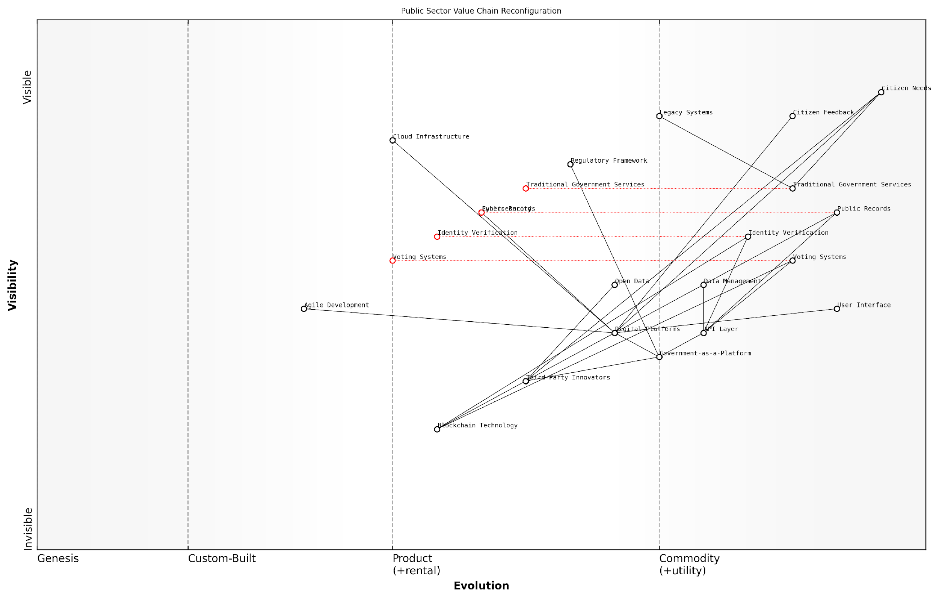

*Draft Wardley Map: [Insert Wardley Map: Creating new markets through value chain reconfiguration]*

[Edit this draft Wardley Map](https://create.wardleymaps.ai/#clone:fae47c335f0395438f)

Wardley Map Assessment

This Wardley Map reveals a public sector in the midst of a significant digital transformation, with a strategic focus on reconfiguring the value chain to create new markets and improve citizen services. The shift towards Government-as-a-Platform and the integration of emerging technologies like blockchain present substantial opportunities for innovation and efficiency gains. However, challenges remain in managing the transition from legacy systems, ensuring robust cybersecurity, and adapting regulatory frameworks. The success of this transformation will depend on balancing rapid innovation with the stability and security requirements of government services, while continuously aligning developments with evolving citizen needs.

[View full Wardley Map report](http://markdown_wardley_map_reports/wardley_map_report_41_Creating_new_markets_through_value_chain_reconfigu.md)

### Developing platforms and ecosystems

In the realm of disruptive innovation, developing platforms and ecosystems has emerged as a powerful strategy for startups to create lasting impact and sustainable growth. This approach, when viewed through the lens of Wardley Mapping, reveals unique opportunities for startups to position themselves advantageously within evolving value chains. By leveraging the principles of Wardley Mapping, startups can identify key components, understand their evolutionary stages, and strategically build platforms that foster vibrant ecosystems.

Platforms, in essence, are foundations upon which other products, services, or technologies can be built and integrated. Ecosystems, on the other hand, represent the network of interdependent entities that interact with and benefit from these platforms. For startups, the ability to create and nurture these platforms and ecosystems can lead to exponential growth and market dominance.

Platforms and ecosystems are not just business models; they are the new battlegrounds for innovation and disruption in the digital age.

When applying Wardley Mapping to platform and ecosystem development, startups should focus on several key areas:

* Identifying core components and their evolutionary stages
* Mapping potential ecosystem participants and their needs
* Understanding the dynamics of network effects
* Strategically positioning the platform within the value chain
* Anticipating and planning for future evolutions

Let’s explore each of these areas in detail, drawing from my experience advising government bodies and public sector organisations on platform strategies.

1. Identifying core components and their evolutionary stages:

The first step in developing a platform strategy is to identify the core components that will form the foundation of your platform. Using Wardley Mapping, startups can visualise these components along the evolution axis, from genesis to commodity. This visualisation helps in understanding which components are ripe for innovation and which are becoming standardised.

For instance, in a recent project with a government agency aiming to create a digital services platform, we mapped out components such as identity verification, data storage, and user interfaces. By understanding the evolutionary stage of each component, we were able to identify where the agency could innovate (e.g., developing a novel approach to citizen identity verification) and where it should leverage existing solutions (e.g., using commodity cloud storage services).

1. Mapping potential ecosystem participants and their needs:

A successful platform attracts a diverse range of participants who both contribute to and benefit from the ecosystem. Wardley Mapping can help startups identify potential ecosystem participants and understand their needs, motivations, and potential contributions.

In the government digital services platform example, we mapped out various stakeholders including citizens, local businesses, third-party service providers, and other government departments. By understanding their needs and how they interact with the platform, we were able to design features and APIs that would encourage participation and foster a thriving ecosystem.

1. Understanding the dynamics of network effects:

Network effects are a crucial aspect of successful platforms and ecosystems. As more participants join a platform, its value increases for all users. Wardley Mapping can help startups visualise how different components and participants interact, identifying opportunities to create and amplify network effects.

The power of a platform lies not just in what it does, but in the connections it enables and the network effects it generates.

For example, in advising a startup developing a smart city platform, we used Wardley Mapping to identify how data shared by citizens could enhance services provided by local businesses, which in turn would attract more citizens to the platform. This virtuous cycle of value creation became a core focus of the platform’s design and go-to-market strategy.

1. Strategically positioning the platform within the value chain:

Wardley Mapping excels at helping startups understand their position within broader value chains. For platform businesses, this is particularly crucial. By mapping out the entire value chain, startups can identify strategic positions where their platform can add the most value and have the greatest impact.

In my work with a public sector organisation developing an open data platform, we used Wardley Mapping to identify a strategic position between data providers (various government departments) and data consumers (researchers, businesses, and citizens). This positioning allowed the platform to add significant value by standardising data formats, ensuring data quality, and providing easy-to-use APIs, thus becoming an indispensable part of the data ecosystem.

1. Anticipating and planning for future evolutions:

One of the most powerful aspects of Wardley Mapping is its ability to help organisations anticipate future changes. For startups developing platforms and ecosystems, this foresight is invaluable. By mapping out potential future states, startups can plan for evolving technologies, changing user needs, and emerging competitors.

In a recent project with a govtech startup, we used Wardley Mapping to anticipate the evolution of blockchain technology and its potential impact on government services. This foresight allowed the startup to design its platform with the flexibility to incorporate blockchain-based identity verification and smart contracts as these technologies mature, ensuring long-term relevance and competitiveness.

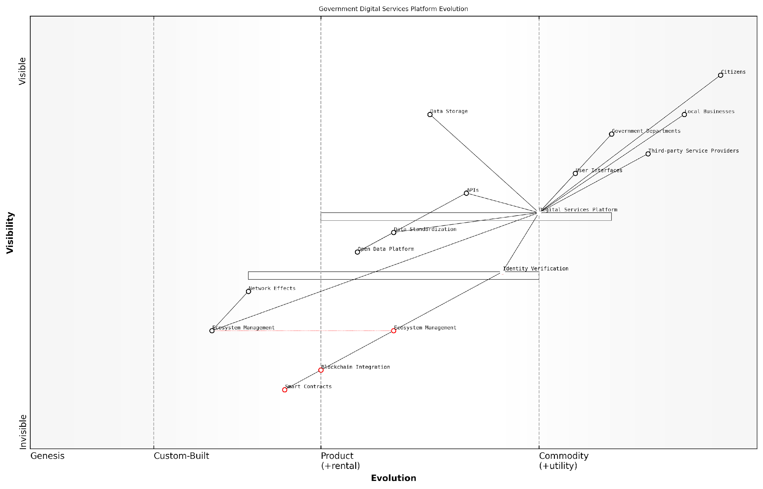

*Draft Wardley Map: [Insert Wardley Map: Developing platforms and ecosystems]*

[Edit this draft Wardley Map](https://create.wardleymaps.ai/#clone:a2fdde53786a0daf0a)

Wardley Map Assessment

The Government Digital Services Platform is well-positioned to drive significant innovation in public service delivery. By leveraging emerging technologies like blockchain and focusing on ecosystem development, it has the potential to create a highly efficient, transparent, and user-centric system. However, careful management of the evolution of key components, particularly in identity verification and data standardisation, will be crucial. The platform’s success will largely depend on its ability to foster a thriving ecosystem of third-party providers and effectively manage the transition to more decentralised and automated services.

[View full Wardley Map report](http://markdown_wardley_map_reports/wardley_map_report_42_Developing_platforms_and_ecosystems.md)

In conclusion, developing platforms and ecosystems represents a powerful strategy for startups seeking to create disruptive innovations. By leveraging Wardley Mapping, startups can gain a deep understanding of the competitive landscape, identify strategic opportunities, and design platforms that foster thriving ecosystems. This approach not only enables startups to create immediate value but also positions them for long-term success in an increasingly interconnected and rapidly evolving digital economy.

In the platform economy, the winners are those who can see the entire chessboard and move the pieces strategically. Wardley Mapping provides the vision needed to play this complex game.

As startups embark on their journey to develop platforms and ecosystems, they should remember that this is an iterative process. Regular mapping exercises, combined with continuous feedback from ecosystem participants, will allow for agile adjustments and optimisations. By embracing this approach, startups can position themselves at the forefront of innovation, driving disruption and creating lasting value in their chosen markets.

## Case Studies: Disruptive Startups and Their Wardley Maps

### Case Study 1: How Startup Y disrupted a traditional industry

In this case study, we examine how Startup Y, a small team of innovators, successfully disrupted the traditional logistics industry using Wardley Mapping as a core strategic tool. This example illustrates the power of Wardley Mapping in identifying opportunities for disruption and guiding startup strategy in a complex, established market.

Startup Y began as a small team of logistics experts and software engineers who recognised inefficiencies in the traditional freight forwarding industry. They believed that by leveraging emerging technologies and reconfiguring the value chain, they could create a more efficient, transparent, and cost-effective solution for businesses shipping goods internationally.

The team’s first step was to create a detailed Wardley Map of the existing logistics industry. This process revealed several key insights:

* Many core processes, such as customs clearance and freight booking, were still largely manual and inefficient.
* Data sharing between different parts of the supply chain was limited, leading to delays and lack of visibility.
* Pricing was often opaque and inconsistent, with large intermediaries capturing significant value.
* Customer experience was generally poor, with limited real-time tracking and communication.

Armed with these insights, Startup Y developed a platform that automated many of the manual processes, created a unified data layer across the supply chain, and provided real-time visibility and communication for customers. Their Wardley Map helped them identify which components to build in-house, which to outsource, and where to focus their innovation efforts.

Wardley Mapping was instrumental in helping us see the big picture of the industry and identify where we could add the most value. It guided our product development and go-to-market strategy in ways that traditional business planning simply couldn’t match.

One of the key decisions guided by their Wardley Map was to focus on building a robust API layer that could integrate with existing systems used by freight forwarders, carriers, and customs agencies. This approach allowed Startup Y to quickly scale their solution without needing to replace entire legacy systems.

The team also used their Wardley Map to anticipate future industry trends and position themselves accordingly. For example, they identified blockchain as an emerging technology that could revolutionise supply chain transparency and began experimenting with it early, giving them a significant advantage as the technology matured.

Startup Y’s go-to-market strategy, informed by their Wardley Map, focused on targeting small to medium-sized businesses that were underserved by traditional freight forwarders. By offering a more transparent, user-friendly solution at a competitive price point, they were able to quickly gain market share.

As they grew, Startup Y continued to use Wardley Mapping to guide their strategy and product development. They regularly updated their maps to reflect changes in the industry landscape and their own evolving position within it. This allowed them to stay ahead of competitors and continue innovating in areas that provided the most value to their customers.

Key outcomes of Startup Y’s Wardley Mapping-driven approach included:

* Rapid growth, with revenue increasing by 300% year-over-year for the first three years
* Successful expansion into new markets, guided by region-specific Wardley Maps
* Development of several patented technologies that further cemented their competitive advantage
* Attraction of significant venture capital funding, with investors citing their clear strategic vision as a key factor

Startup Y’s success demonstrates the power of Wardley Mapping in enabling startups to disrupt traditional industries. By providing a clear visualisation of the industry landscape, guiding strategic decision-making, and helping anticipate future trends, Wardley Mapping proved to be an invaluable tool in their journey from small startup to industry disruptor.

The visual nature of Wardley Mapping made it an incredibly powerful communication tool, both within our team and with external stakeholders. It allowed us to align everyone around a common understanding of the market and our strategy.

The case of Startup Y offers several key lessons for other startups looking to leverage Wardley Mapping:

* Start with a thorough mapping of the existing industry to identify inefficiencies and opportunities
* Use the map to guide decisions on what to build, buy, or partner for
* Regularly update your maps to reflect changes in the industry and your own position
* Leverage maps as a communication tool with team members, investors, and partners
* Use mapping to anticipate future trends and position your startup accordingly

In conclusion, Startup Y’s journey from a small team with a big idea to a major disruptor in the logistics industry illustrates the transformative potential of Wardley Mapping for startups. By providing a clear, visual representation of the competitive landscape and guiding strategic decision-making, Wardley Mapping can be a powerful tool for startups looking to challenge established industries and drive innovation.

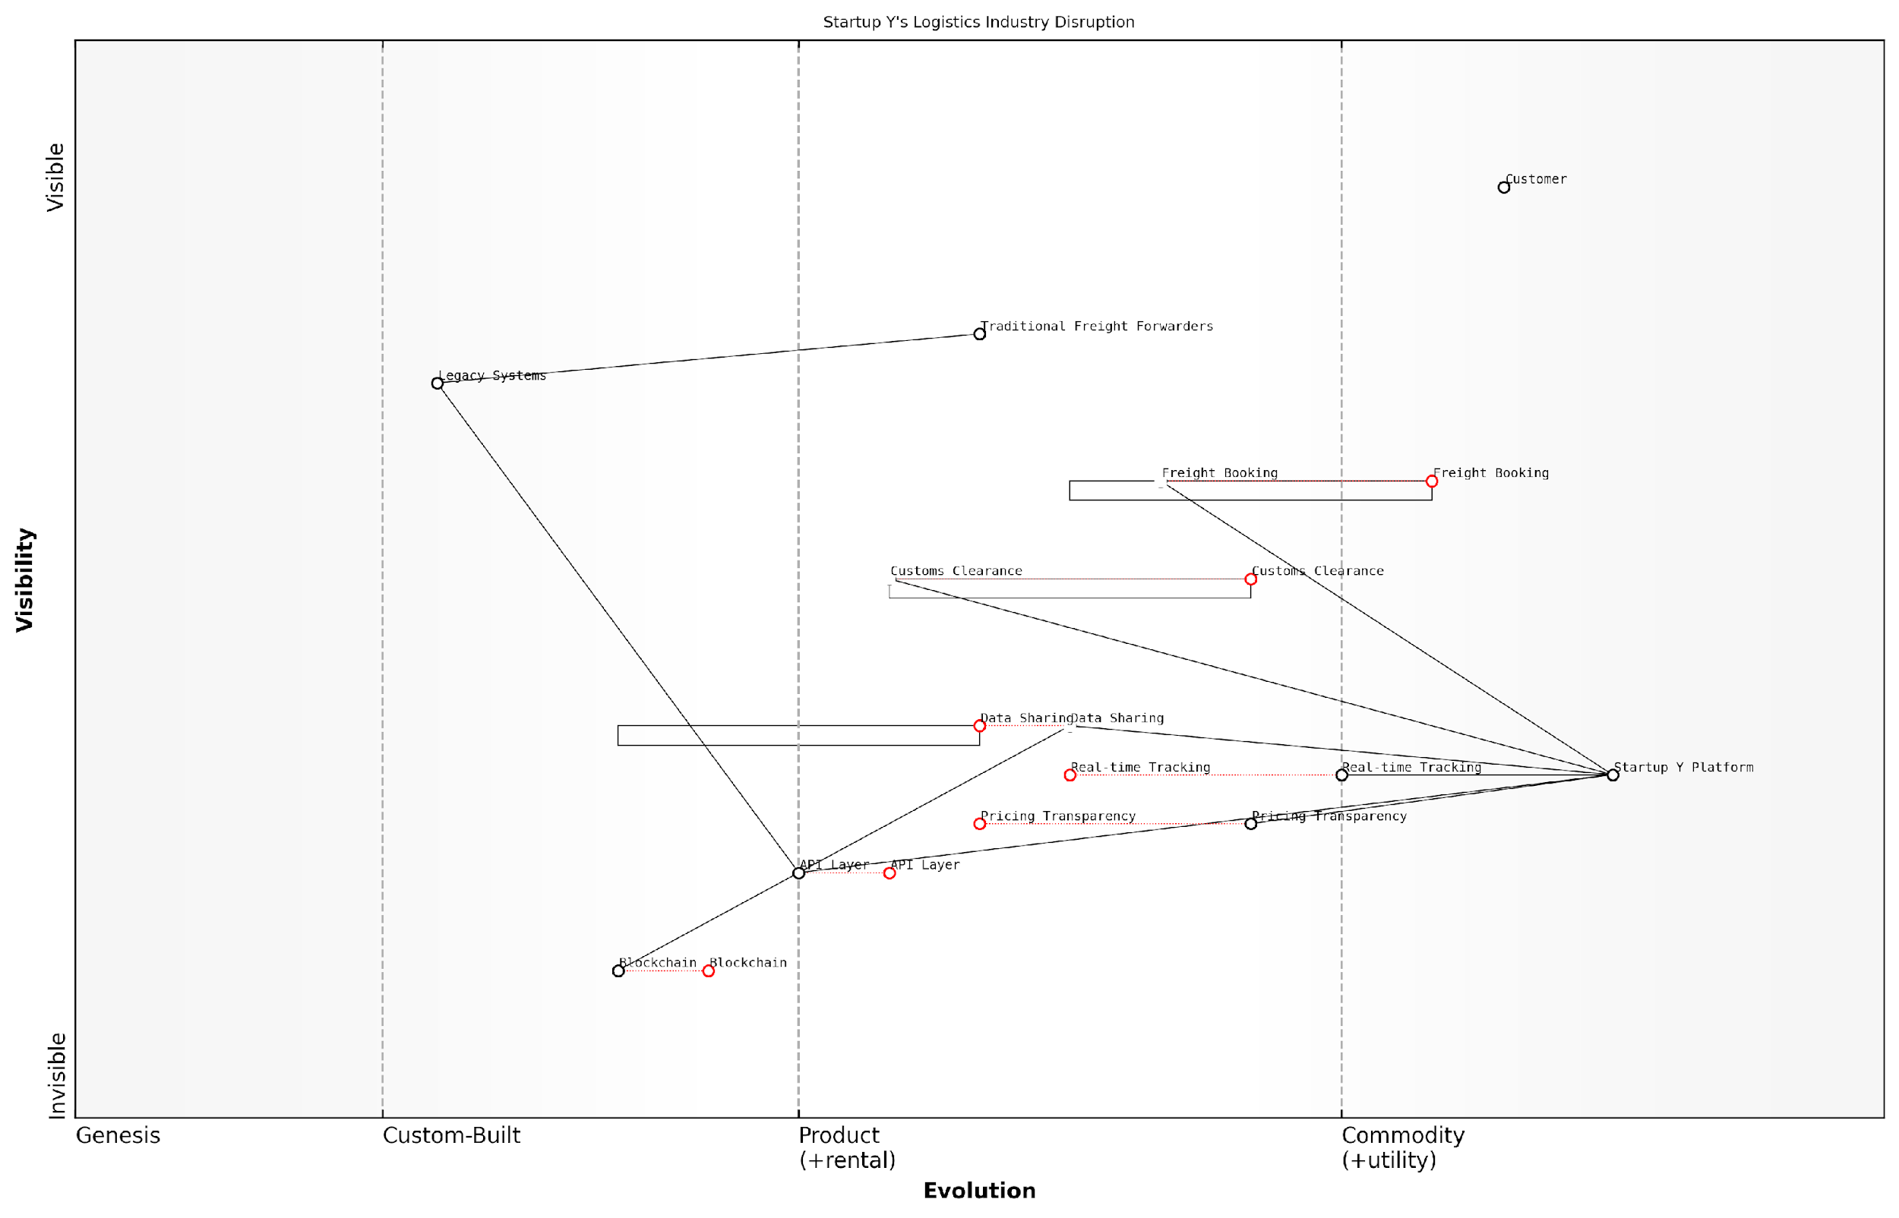

*Draft Wardley Map: [Insert Wardley Map: Case Study 1: How Startup Y disrupted a traditional industry]*

[Edit this draft Wardley Map](https://create.wardleymaps.ai/#clone:1e292914543f484ac5)

Wardley Map Assessment

Startup Y is well-positioned to disrupt the traditional logistics industry by leveraging technology to provide more transparent, efficient, and user-friendly services to small and medium businesses. The company’s platform approach, focus on real-time capabilities, and pricing transparency give it a significant competitive advantage. However, to maintain this edge, Startup Y must continue to innovate, particularly in areas like blockchain integration, AI-driven analytics, and automation of customs processes. The company should also carefully manage its reliance on legacy systems while pushing the industry towards more evolved, digital-first solutions. By focusing on enhancing its core platform capabilities in the short term and investing in emerging technologies for the long term, Startup Y can solidify its position as a leading disruptor in the logistics industry.

[View full Wardley Map report](http://markdown_wardley_map_reports/wardley_map_report_43_Case_Study_1:_How_Startup_Y_disrupted_a_traditiona.md)

### Case Study 2: Startup Z’s journey from niche player to market leader

Startup Z’s remarkable transformation from a niche player to a market leader in the government technology sector serves as a compelling example of how Wardley Mapping can drive strategic decision-making and foster innovation. This case study illustrates the power of strategic mapping in identifying untapped opportunities, navigating complex ecosystems, and ultimately disrupting established markets.

Founded in 2015, Startup Z began as a small team of developers creating bespoke software solutions for local government agencies. Their initial focus was on streamlining internal processes and improving efficiency in public sector organisations. However, through the application of Wardley Mapping, they were able to identify a significant opportunity to revolutionise citizen engagement and service delivery across the entire government sector.

Let’s examine the key stages of Startup Z’s journey and how Wardley Mapping played a crucial role in their success:

* Initial Mapping and Market Analysis
* Identifying the Disruptive Opportunity
* Strategic Pivot and Product Development
* Scaling and Market Domination
* Continuous Evolution and Innovation

1. Initial Mapping and Market Analysis:

Startup Z’s leadership team, guided by a seasoned Wardley Mapping consultant, began by creating a comprehensive map of the government technology landscape. This initial mapping exercise revealed several key insights:

* The fragmented nature of existing government IT systems
* A clear evolution towards cloud-based solutions and mobile accessibility
* An increasing demand for data-driven decision-making tools
* A gap in citizen-centric services that leveraged emerging technologies

The Wardley Map provided us with a clear visual representation of the entire ecosystem. It was like turning on the lights in a dark room – suddenly we could see opportunities that were previously invisible to us.

1. Identifying the Disruptive Opportunity:

Through careful analysis of their Wardley Map, Startup Z identified a significant opportunity at the intersection of citizen engagement, data analytics, and emerging technologies such as artificial intelligence and blockchain. They realised that by creating a unified platform that could seamlessly integrate various government services while providing a user-friendly interface for citizens, they could potentially disrupt the entire government technology market.

1. Strategic Pivot and Product Development:

Armed with these insights, Startup Z made a bold decision to pivot from their initial focus on internal process optimisation to developing a comprehensive citizen engagement platform. They leveraged their Wardley Map to inform their product development strategy, focusing on key components that were evolving rapidly and had the potential to provide significant competitive advantage.

* Developed a cloud-native architecture for scalability and flexibility
* Integrated AI-powered chatbots for improved citizen support
* Implemented blockchain technology for secure identity verification and transaction processing
* Created an open API ecosystem to encourage third-party integrations and innovation

1. Scaling and Market Domination:

As Startup Z’s platform gained traction, they continued to use Wardley Mapping to guide their scaling strategy. By regularly updating their maps, they were able to anticipate market shifts, identify potential competitors, and make informed decisions about resource allocation and strategic partnerships.

Wardley Mapping became an integral part of our strategic planning process. It allowed us to stay ahead of the curve and make proactive decisions that ultimately led to our market leadership position.

Within three years of their strategic pivot, Startup Z had secured contracts with over 70% of local government agencies in their target market and had begun expanding into national government services.

1. Continuous Evolution and Innovation:

Recognising the dynamic nature of the technology landscape, Startup Z institutionalised the practice of Wardley Mapping across their organisation. They established a dedicated team responsible for continuously updating and analysing their strategic maps, ensuring that the company remained at the forefront of innovation in the government technology sector.

Key lessons learned from Startup Z’s journey:

* The importance of holistic ecosystem mapping in identifying disruptive opportunities
* The value of strategic pivots based on data-driven insights
* The role of continuous mapping and analysis in maintaining market leadership
* The power of Wardley Mapping in guiding product development and resource allocation

Startup Z’s success story demonstrates the transformative potential of Wardley Mapping when applied strategically in a startup context. By providing a clear visual representation of the market landscape and enabling data-driven decision-making, Wardley Mapping empowered Startup Z to identify and capitalise on a significant market opportunity, ultimately propelling them from a niche player to a dominant force in the government technology sector.

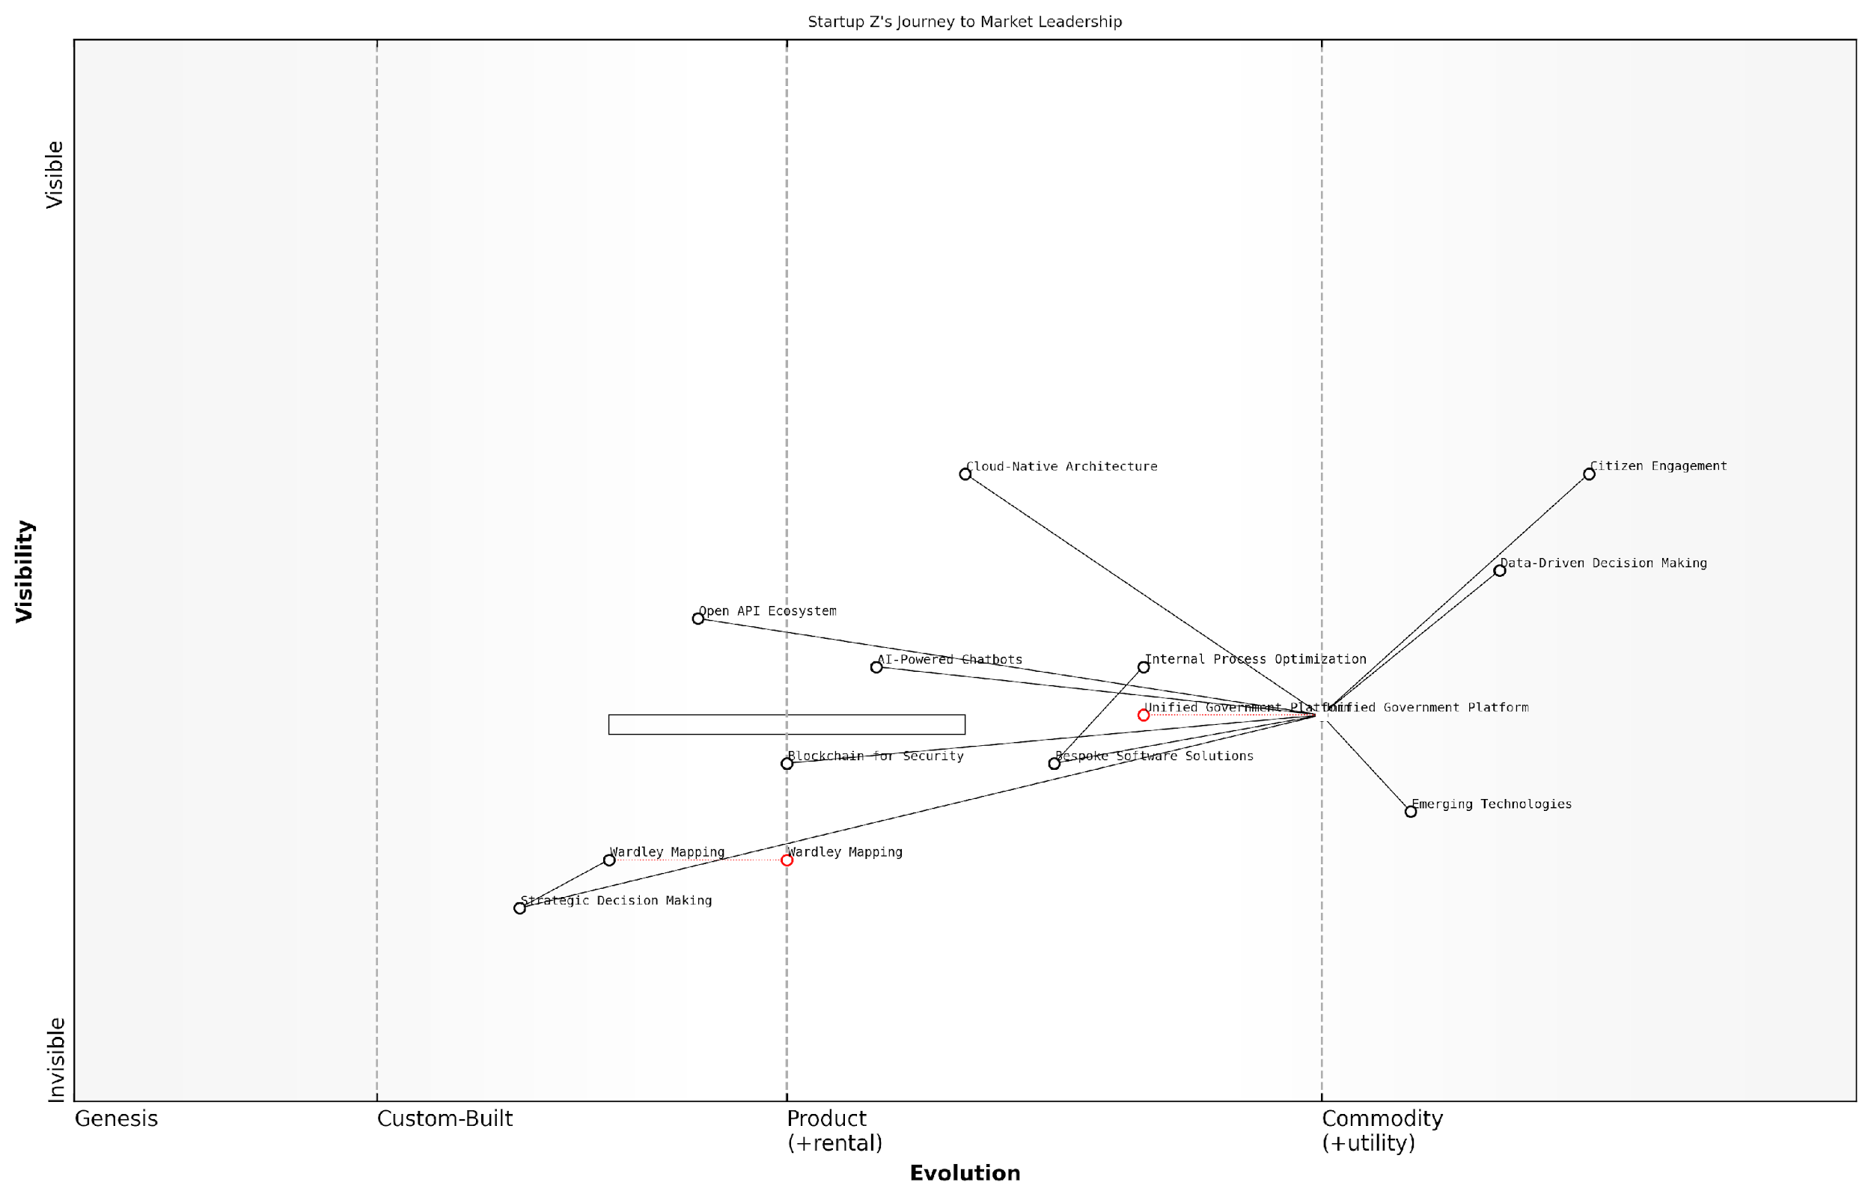

*Draft Wardley Map: [Insert Wardley Map: Case Study 2: Startup Z’s journey from niche player to market leader]*

[Edit this draft Wardley Map](https://create.wardleymaps.ai/#clone:67afee8ed5b1a4b54a)

Wardley Map Assessment

Startup Z has positioned itself strongly in the government tech market by developing an integrated Unified Government Platform and leveraging strategic planning tools like Wardley Mapping. The company’s focus on emerging technologies and open ecosystems provides a solid foundation for market leadership. However, to maintain this position, Startup Z must continue to evolve its platform, stay ahead of technological trends, and develop a robust partner ecosystem. The strategic use of Wardley Mapping gives Startup Z a unique advantage in navigating the complex and evolving government tech landscape. By addressing identified capability gaps and focusing on the recommended strategic initiatives, Startup Z is well-positioned to solidify and expand its market leadership in the government technology sector.

[View full Wardley Map report](http://markdown_wardley_map_reports/wardley_map_report_44_Case_Study_2:_Startup_Z's_journey_from_niche_playe.md)

As we conclude this case study, it’s important to note that Startup Z’s journey is not unique. Many disruptive startups have leveraged Wardley Mapping to gain a competitive edge and navigate complex market landscapes. The key lies in applying the principles consistently, adapting to new insights, and fostering a culture of strategic thinking throughout the organisation.

Wardley Mapping isn’t just a tool; it’s a mindset. It encourages us to think critically about our position in the market, anticipate future trends, and make strategic decisions that drive long-term success.

As we move forward in this book, we’ll explore more advanced techniques and applications of Wardley Mapping for startups, building on the foundational principles illustrated in Startup Z’s success story. By mastering these techniques, you’ll be well-equipped to navigate the uncertainties of the startup world and position your venture for sustainable growth and market leadership.

### Lessons learned and common patterns of successful disruption

As we conclude our examination of disruptive startups and their Wardley Maps, it’s crucial to distil the key lessons and identify common patterns that have led to successful disruption. This analysis not only provides valuable insights for aspiring entrepreneurs but also offers a framework for established companies seeking to maintain their competitive edge in an ever-evolving marketplace.

One of the most striking patterns observed across successful disruptive startups is their ability to identify and exploit gaps in existing value chains. By leveraging Wardley Mapping, these companies gain a comprehensive understanding of their industry’s landscape, allowing them to pinpoint inefficiencies, unmet needs, or emerging opportunities that established players have overlooked.

Wardley Mapping provides a unique lens through which startups can visualise the entire ecosystem of their industry. It’s not just about spotting a gap; it’s about understanding how that gap fits into the broader context of evolution and value creation.

Another common pattern is the strategic use of emerging technologies or practices to redefine traditional business models. Disruptive startups often position themselves at the intersection of evolving components on their Wardley Maps, capitalising on the transition from custom-built solutions to product/rental models, or from product/rental to commodity/utility services.

* Identification of value chain inefficiencies
* Leveraging emerging technologies
* Focus on user needs over existing solutions
* Rapid iteration and adaptation
* Creation of new market categories

A key lesson learned from our case studies is the importance of maintaining a laser focus on user needs rather than being constrained by existing solutions. Successful disruptors use Wardley Mapping to continually reassess and realign their offerings with evolving user requirements, often challenging industry assumptions about what customers truly value.

The ability to rapidly iterate and adapt strategies based on market feedback is another crucial factor in successful disruption. Wardley Mapping provides a dynamic framework for startups to visualise and test different scenarios, allowing them to pivot quickly when necessary. This agility is often a key differentiator when competing against more established, less flexible incumbents.

The true power of Wardley Mapping for disruptive startups lies in its ability to facilitate strategic conversations and decision-making. It’s not just a static tool, but a dynamic approach to understanding and shaping market evolution.

Many successful disruptors have also demonstrated a knack for creating entirely new market categories. By identifying nascent user needs and mapping out potential future states of their industry, these startups have been able to position themselves as category leaders from the outset. This approach often involves educating the market and shaping user expectations, a strategy that can be clearly visualised and planned using Wardley Maps.

It’s worth noting that successful disruption often involves a combination of these patterns rather than relying on a single approach. The most effective startups use Wardley Mapping as a holistic tool to inform their entire business strategy, from product development and marketing to partnership decisions and long-term planning.

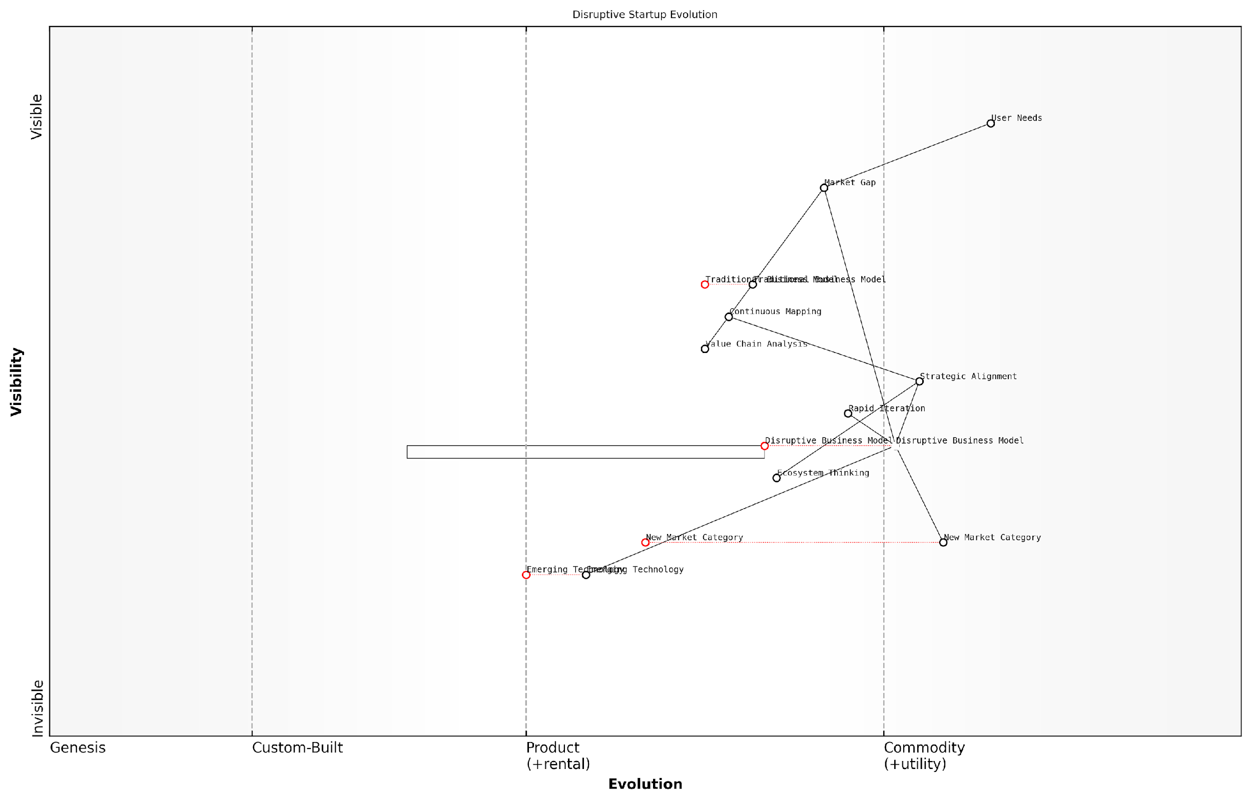

*Draft Wardley Map: [Insert Wardley Map: Lessons learned and common patterns of successful disruption]*

[Edit this draft Wardley Map](https://create.wardleymaps.ai/#clone:dcf637a2fa9882be2e)

Wardley Map Assessment

This Wardley Map represents a startup poised for disruptive innovation, leveraging emerging technologies and new business models to address user needs and exploit market gaps. The emphasis on rapid iteration, strategic alignment, and ecosystem thinking suggests a dynamic and adaptable approach. To succeed, the startup must maintain its innovative edge while building robust capabilities and navigating the evolution of its disruptive elements towards standardisation. The key challenge will be balancing the exploitation of current opportunities with continuous evolution to stay ahead of market changes and potential competitors.

[View full Wardley Map report](http://markdown_wardley_map_reports/wardley_map_report_45_Lessons_learned_and_common_patterns_of_successful_.md)

One of the most valuable lessons from our case studies is the importance of continuous mapping and reassessment. The most successful disruptors don’t treat Wardley Mapping as a one-time exercise but as an ongoing process of strategic evaluation and refinement. This approach allows them to stay ahead of market shifts and continue to drive innovation even as they grow and evolve.

Another critical insight is the role of ecosystem thinking in successful disruption. By mapping not just their own value chains but also those of partners, competitors, and adjacent industries, disruptive startups are able to identify opportunities for collaboration, integration, or expansion that may not be immediately obvious.

The most successful disruptors don’t just change a product or service; they reshape entire ecosystems. Wardley Mapping allows them to visualise and navigate these complex systems with unprecedented clarity.

It’s also important to recognise the role of timing in successful disruption. Wardley Mapping helps startups identify when components are ripe for commoditisation or when new technologies are ready to shift from the genesis to the custom-built phase. This insight allows disruptors to time their market entry or pivot points for maximum impact.

Finally, a common pattern among successful disruptors is their ability to use Wardley Mapping to align their internal teams and external stakeholders around a shared vision of the future. By providing a clear, visual representation of their strategy and market position, these startups are able to build consensus, attract investment, and drive coordinated action towards their disruptive goals.

In conclusion, the lessons learned from successful disruptive startups underscore the power of Wardley Mapping as a strategic tool for navigating uncertainty and driving innovation. By embracing these common patterns and integrating Wardley Mapping into their core strategic processes, aspiring disruptors can significantly increase their chances of success in reshaping industries and creating new value for users.

# Chapter 4: Advanced Wardley Mapping Techniques for Startups

## Multi-Map Analysis

### Creating and comparing alternative future scenarios

In the dynamic landscape of startup strategy, the ability to anticipate and prepare for multiple future scenarios is paramount. Wardley Mapping, with its emphasis on visual representation of value chains and component evolution, provides an invaluable tool for creating and comparing alternative future scenarios. This advanced technique, known as multi-map analysis, enables startups to navigate uncertainty with greater confidence and agility.

Multi-map analysis involves creating multiple Wardley Maps that represent different potential futures or strategic options. By comparing these maps, startups can gain insights into the robustness of their strategies, identify potential risks and opportunities, and make more informed decisions about resource allocation and strategic direction.

Multi-map analysis is like having a strategic crystal ball. It allows us to peer into multiple possible futures and prepare for them, rather than being caught off guard by change.

The process of creating alternative future scenarios through Wardley Mapping typically involves the following steps:

* Identify key uncertainties and drivers of change in your industry or market
* Create a baseline Wardley Map representing the current state of your value chain
* Develop multiple maps that represent different future scenarios based on varying assumptions about key uncertainties
* Analyse and compare the maps to identify common patterns, divergences, and strategic implications
* Use the insights gained to inform strategic decision-making and resource allocation

One of the primary benefits of multi-map analysis for startups is its ability to highlight potential disruptions and opportunities that may not be apparent when focusing on a single future scenario. By exploring multiple possibilities, startups can develop more robust and adaptable strategies that are better equipped to handle the inherent uncertainty of the business landscape.

For example, a startup in the renewable energy sector might create alternative future scenarios based on different assumptions about government policies, technological advancements, and consumer behaviour. By mapping out these scenarios, the startup can identify which components of their value chain are most vulnerable to disruption, which capabilities they need to develop to succeed in different futures, and where the most significant opportunities for innovation and growth might lie.

In my experience advising government bodies on innovation strategy, I’ve found that multi-map analysis is particularly powerful for identifying potential policy impacts and guiding investment decisions in emerging technologies.

When conducting multi-map analysis, it’s crucial to strike a balance between exploring a wide range of possibilities and maintaining focus on the most plausible and impactful scenarios. Here are some best practices to consider:

* Limit the number of scenarios to a manageable set (typically 3-5) to avoid analysis paralysis
* Ensure that each scenario is distinct and based on different core assumptions
* Involve a diverse group of stakeholders in the scenario development process to challenge assumptions and bring in multiple perspectives
* Use consistent mapping conventions across scenarios to facilitate comparison
* Regularly revisit and update your scenarios as new information becomes available or market conditions change

One powerful technique within multi-map analysis is to create ‘difference maps’ that highlight the changes between scenarios. These maps can help startups identify the key components or relationships that are most sensitive to change, guiding where they should focus their attention and resources.

For instance, a govtech startup might create difference maps to compare scenarios with varying levels of public sector digital transformation. These maps could reveal which components of their offering are likely to remain stable across scenarios and which might need to evolve rapidly, informing decisions about product development and partnership strategies.

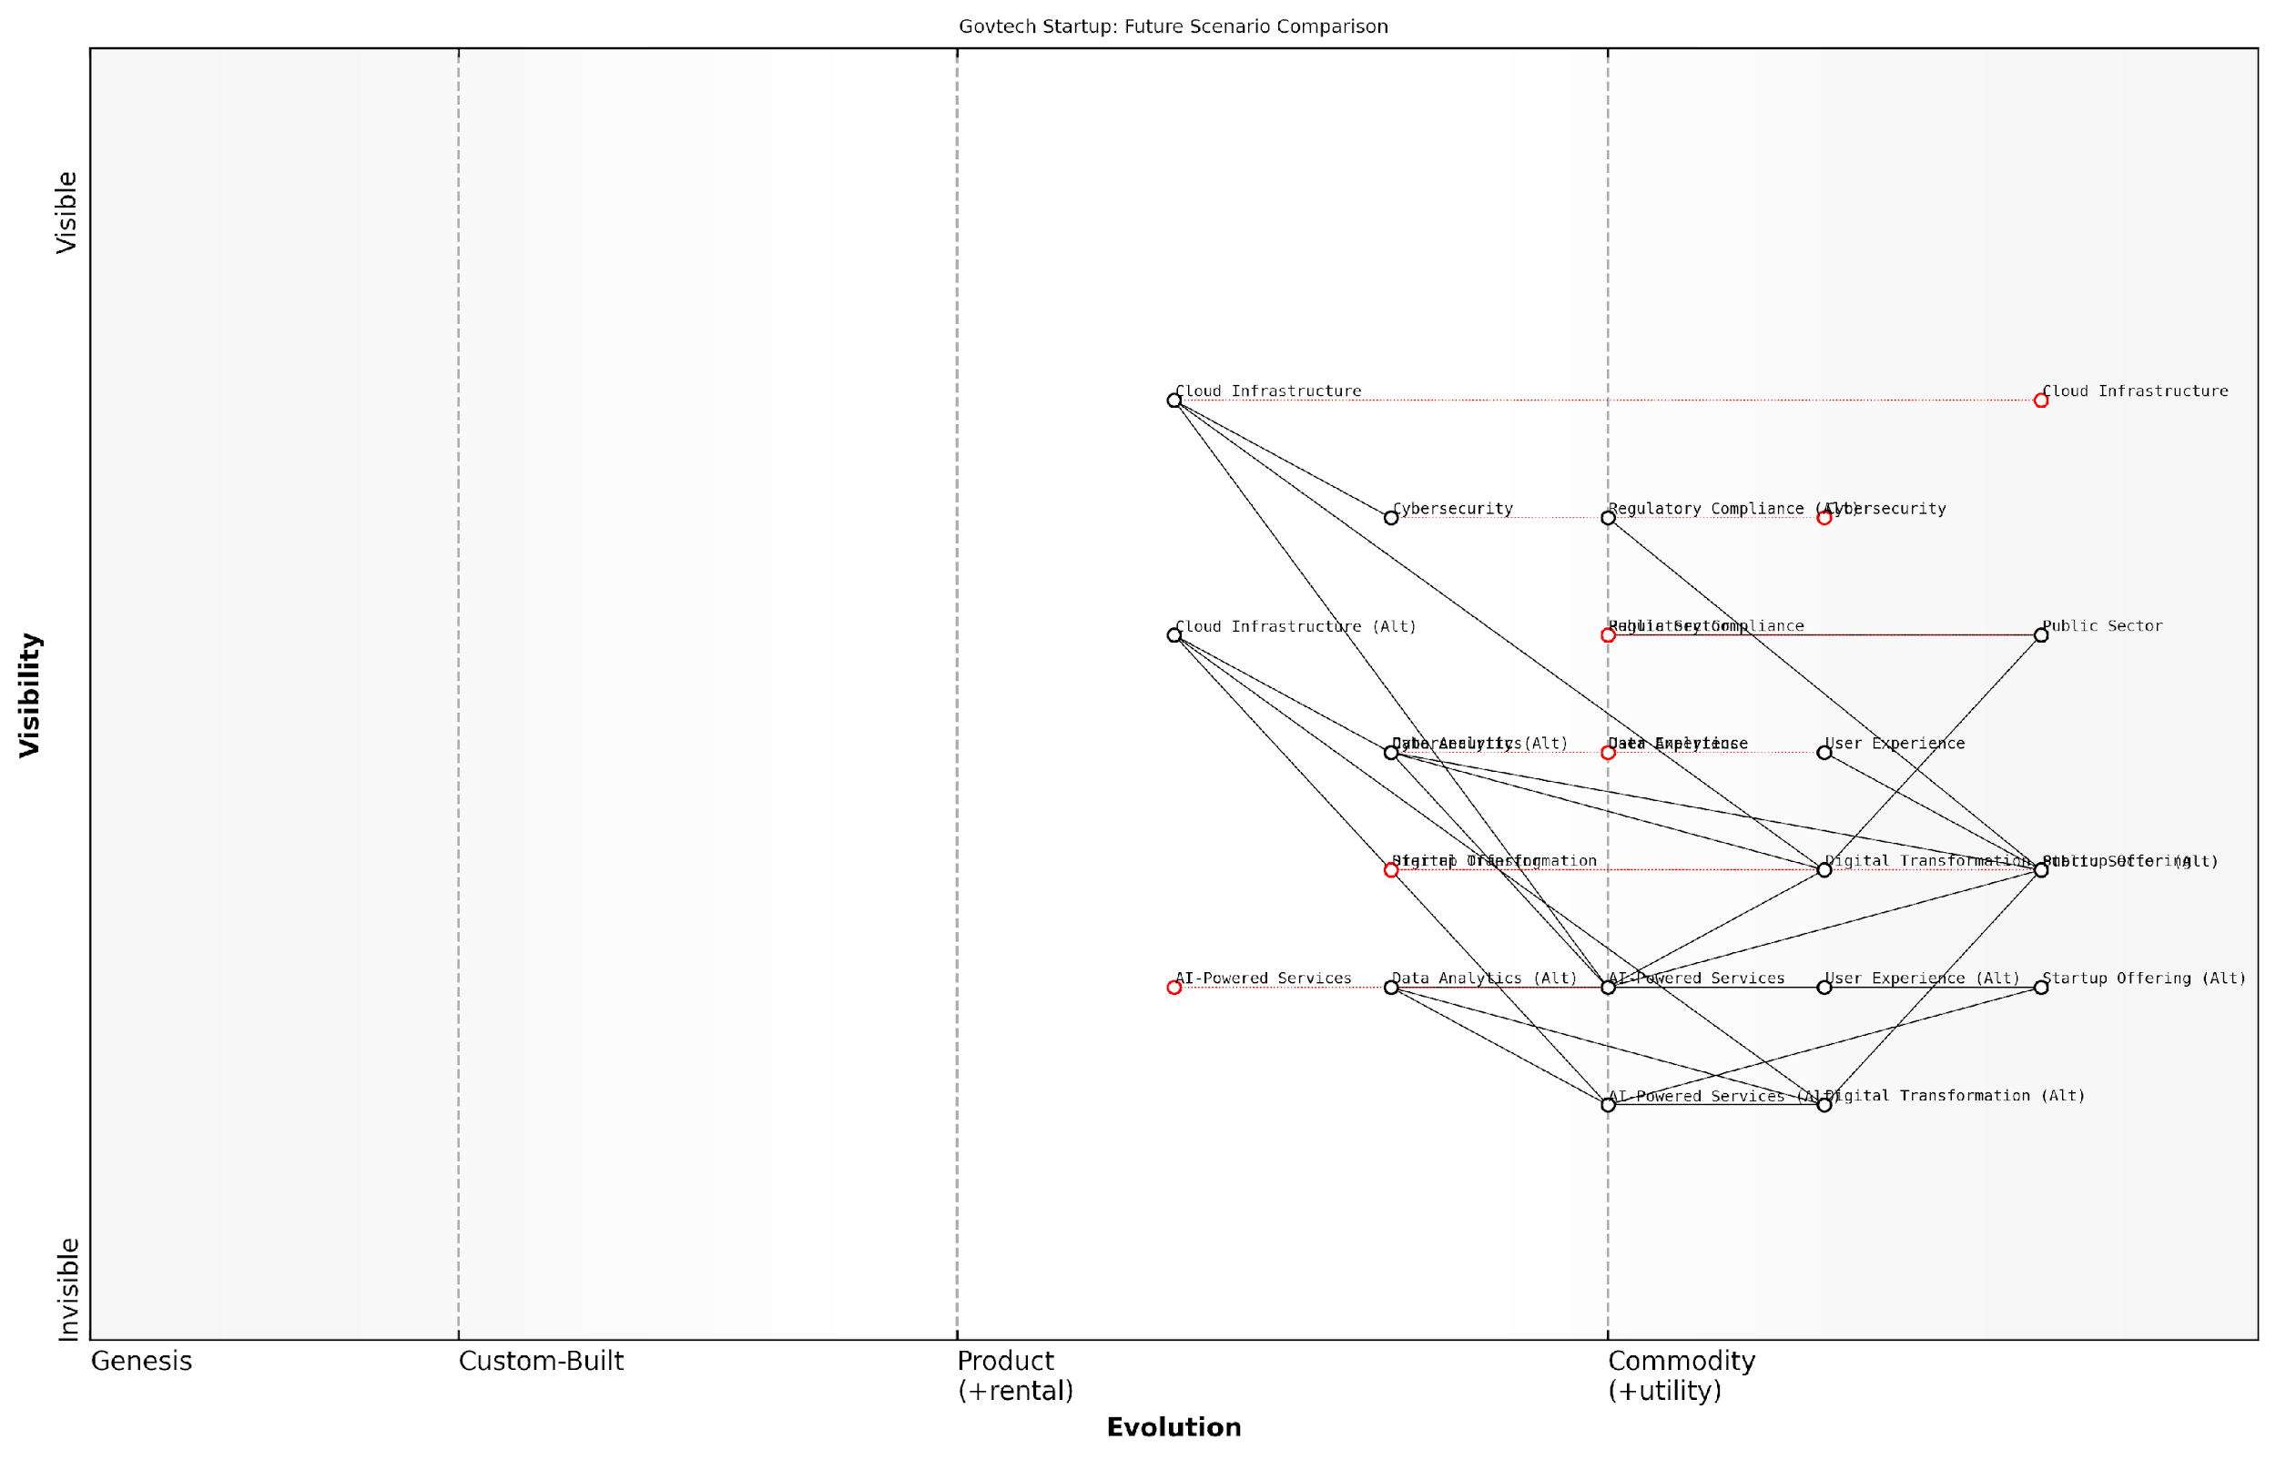

*Draft Wardley Map: [Insert Wardley Map: Creating and comparing alternative future scenarios]*

[Edit this draft Wardley Map](https://create.wardleymaps.ai/#clone:e98cc580f47ab21e34)

Wardley Map Assessment

The map reveals a dynamic Govtech ecosystem with significant potential for innovation and growth, particularly in AI-powered services and data analytics. The startup’s success hinges on its ability to navigate varying levels of public sector digital maturity, regulatory challenges, and rapidly evolving technology landscape. By focusing on flexible, AI-driven solutions and building strong partnerships, the startup can position itself as a key player in driving public sector digital transformation.

[View full Wardley Map report](http://markdown_wardley_map_reports/wardley_map_report_46_Creating_and_comparing_alternative_future_scenario.md)

Another valuable application of multi-map analysis for startups is in exploring different business models or strategic options. By mapping out alternative approaches to creating and capturing value, startups can evaluate the potential risks and rewards of different strategies before committing significant resources.

For example, a startup developing a new AI-powered service for public sector organisations might create maps to compare a direct B2G (Business-to-Government) sales model with a platform-based approach that enables third-party developers to build applications on top of their AI engine. By visualising these different models, the startup can better understand the implications for their value chain, required capabilities, and potential competitive positioning.

Multi-map analysis isn’t just about predicting the future; it’s about preparing your organisation to thrive in multiple possible futures. It’s a powerful tool for building strategic flexibility and resilience.

When presenting multi-map analyses to stakeholders, such as investors or board members, it’s important to focus on the insights and strategic implications rather than getting bogged down in the details of each scenario. Use the maps as a tool to facilitate strategic conversations and decision-making, highlighting key uncertainties, potential risks, and areas of opportunity.

In conclusion, multi-map analysis is a powerful technique that enables startups to harness the full potential of Wardley Mapping for strategic planning and decision-making. By creating and comparing alternative future scenarios, startups can develop more robust strategies, identify potential disruptions and opportunities, and build the agility needed to thrive in uncertain environments. As the pace of change continues to accelerate, particularly in sectors influenced by government policy and technological innovation, mastering this technique will become increasingly crucial for startup success.

### Mapping different business models and strategies

In the dynamic landscape of startup development, the ability to map and analyse different business models and strategies is crucial for success. This advanced technique in Wardley Mapping allows startups to explore various strategic options, compare their potential outcomes, and make informed decisions about their future direction. By creating multiple maps that represent different business models or strategic approaches, startups can gain a comprehensive understanding of their options and potential market positions.

The process of mapping different business models and strategies involves creating separate Wardley Maps for each scenario under consideration. These maps allow startups to visualise how different strategic choices might impact their value chain, competitive positioning, and overall business landscape. This approach is particularly valuable for startups operating in uncertain or rapidly evolving markets, where the ability to adapt quickly and make informed strategic decisions can be the difference between success and failure.

Mapping multiple business models isn’t just about choosing the best option—it’s about understanding the trade-offs and implications of each strategic direction. It’s a powerful tool for startups to navigate uncertainty and make robust decisions.

Let’s explore the key aspects of mapping different business models and strategies:

* Identifying strategic options: Begin by outlining the different business models or strategies under consideration. These could include variations in product offerings, target markets, revenue models, or operational approaches.
* Creating individual maps: Develop separate Wardley Maps for each strategic option, ensuring that each map accurately represents the value chain, component relationships, and evolutionary stages specific to that particular model or strategy.
* Comparative analysis: Once the individual maps are created, conduct a thorough comparison to identify the strengths, weaknesses, opportunities, and threats associated with each option.
* Scenario planning: Use the maps to explore potential future scenarios and how each business model or strategy might fare under different market conditions or competitive landscapes.
* Decision-making support: Leverage the insights gained from the multi-map analysis to inform strategic decision-making and guide the startup’s future direction.

One of the primary benefits of mapping different business models and strategies is the ability to conduct ‘what-if’ analyses. By visualising alternative scenarios, startups can anticipate potential challenges, identify hidden opportunities, and develop contingency plans. This approach allows for a more robust and flexible strategic planning process, which is particularly valuable in the uncertain environment that most startups operate within.

For example, consider a startup in the fintech sector exploring two different business models: a direct-to-consumer approach and a business-to-business (B2B) model focusing on providing services to established financial institutions. By creating separate Wardley Maps for each of these scenarios, the startup can visualise the different value chains, required capabilities, and potential evolution of components in each model. This analysis might reveal that while the B2B model offers more stable revenue streams, the direct-to-consumer approach provides greater opportunities for rapid scaling and market disruption.

In my experience advising government bodies on innovation strategies, I’ve found that mapping multiple scenarios is invaluable for navigating complex policy decisions. The same principle applies to startups—it’s about creating a strategic roadmap that accounts for multiple possible futures.

When mapping different business models and strategies, it’s important to consider the following factors:

* Market dynamics: How does each model or strategy position the startup within the broader market landscape?
* Resource requirements: What capabilities, technologies, or partnerships are needed to execute each strategy successfully?
* Competitive advantage: How does each option leverage the startup’s unique strengths or create barriers to entry for competitors?
* Scalability and growth potential: Which model offers the best opportunities for long-term growth and expansion?
* Risk profile: What are the potential risks associated with each strategy, and how can they be mitigated?
* Alignment with vision and values: How well does each option align with the startup’s core mission and long-term objectives?

By systematically evaluating these factors across different Wardley Maps, startups can gain a nuanced understanding of their strategic options and make more informed decisions about their future direction.

It’s worth noting that the process of mapping different business models and strategies is not a one-time exercise. As the startup evolves and market conditions change, it’s important to regularly revisit and update these maps. This ongoing analysis ensures that the startup remains agile and responsive to new opportunities or threats as they emerge.

| Draft Wardley Map: [Insert Wardley Map: Mapping different business models and strategies] |
| --- |

*Draft Wardley Map: [Insert Wardley Map: Mapping different business models and strategies]*

[Edit this draft Wardley Map](https://create.wardleymaps.ai/#clone:9d5556675f4a7c7dc9)

Wardley Map Assessment

This Wardley Map reveals a startup with a strong technological foundation, poised to disrupt both consumer and institutional financial services. The dual-model approach offers significant opportunities but also presents challenges in resource allocation and strategic focus. Key to success will be maintaining the balance between the two models, continuously evolving the core technology, and leveraging data analytics as a primary differentiator. The startup should prioritise streamlining B2B integration processes and enhancing D2C customer acquisition strategies in the short term, while focusing on building strategic partnerships and developing advanced, AI-driven financial products for long-term growth. Careful navigation of regulatory requirements and a strong emphasis on security will be critical in building trust and scaling the business in the highly competitive and rapidly evolving fintech landscape.

[View full Wardley Map report](http://markdown_wardley_map_reports/wardley_map_report_47_Mapping_different_business_models_and_strategies.md)

In conclusion, the ability to map and analyse different business models and strategies is a powerful tool for startups navigating uncertain and competitive landscapes. By creating multiple Wardley Maps that represent different strategic options, startups can gain a comprehensive understanding of their potential paths forward, anticipate challenges, and make robust decisions that position them for long-term success. This advanced technique in Wardley Mapping empowers startups to embrace strategic flexibility and adapt quickly to changing market conditions, ultimately increasing their chances of achieving sustainable growth and innovation.

### Using multiple maps to inform decision-making

In the dynamic landscape of startup strategy, decision-making often requires a multifaceted approach. Using multiple Wardley Maps to inform decision-making is a powerful technique that allows startups to consider various scenarios, compare different strategies, and make more robust choices. This approach is particularly valuable in the public sector, where decisions can have far-reaching consequences and must account for diverse stakeholder interests.

The process of using multiple maps involves creating several distinct Wardley Maps, each representing a different perspective, scenario, or strategic option. By comparing and contrasting these maps, startups can gain a more comprehensive understanding of their strategic landscape and make more informed decisions. Let’s explore the key aspects of this approach:

* Scenario Planning: Creating maps for different future scenarios
* Strategic Options Analysis: Mapping out various strategic choices
* Stakeholder Perspectives: Developing maps from different viewpoints
* Time-based Mapping: Creating maps for different time horizons
* Comparative Analysis: Techniques for analysing multiple maps

Scenario Planning: One of the most powerful applications of multi-map analysis is in scenario planning. By creating Wardley Maps for different possible futures, startups can better prepare for uncertainty and develop more resilient strategies. For example, a govtech startup might create separate maps for scenarios such as ‘increased government digitisation’, ‘budget cuts’, or ‘changes in data privacy regulations’. Each map would show how the value chain and component evolution might differ under these scenarios, allowing the startup to identify robust strategies that work across multiple futures.

Scenario planning with Wardley Maps allows us to move beyond simple ‘what-if’ analyses to a deeper understanding of how entire ecosystems might evolve under different conditions. It’s an invaluable tool for startups operating in complex, rapidly changing environments like the public sector.

Strategic Options Analysis: When faced with critical strategic decisions, creating a Wardley Map for each option can provide clarity and insight. For instance, a startup considering whether to develop a proprietary technology or leverage existing open-source solutions could map out both approaches. This would reveal the different value chains, dependencies, and evolutionary characteristics of each option, helping to inform the decision based on factors such as risk, time-to-market, and long-term competitive positioning.

Stakeholder Perspectives: In the public sector, considering multiple stakeholder perspectives is crucial. By creating separate maps from the viewpoints of different stakeholders - such as government agencies, citizens, or partner organisations - startups can gain a more holistic understanding of their ecosystem. This approach can reveal potential conflicts, alignments, and opportunities that might not be apparent from a single perspective.

Time-based Mapping: Creating maps for different time horizons - such as current state, 1 year, and 5 years into the future - can help startups visualise their strategic journey and identify key milestones and transitions. This is particularly useful for long-term planning and for communicating strategy to stakeholders, including government partners who often operate on extended timelines.

Comparative Analysis: Once multiple maps have been created, the challenge lies in effectively analysing and comparing them to derive actionable insights. Several techniques can be employed:

* Overlay Analysis: Superimposing maps to identify commonalities and differences
* Gap Analysis: Identifying discrepancies between current and desired future states
* Risk Assessment: Comparing maps to identify potential risks and mitigation strategies
* Opportunity Spotting: Looking for areas of convergence or divergence that might represent strategic opportunities
* Decision Trees: Using maps to inform decision trees for complex, multi-stage decisions

When applying these techniques, it’s crucial to maintain a clear focus on the specific decision or strategic question at hand. The goal is not simply to create multiple maps, but to use them as tools for deeper analysis and more informed decision-making.

The power of multi-map analysis lies not in the individual maps themselves, but in the insights that emerge from their comparison and synthesis. It’s about seeing the bigger picture and understanding the dynamics of your strategic landscape in a way that’s simply not possible with a single map.

In practice, using multiple maps to inform decision-making requires a structured approach and often benefits from collaborative input. Workshops involving key team members and stakeholders can be an effective way to create and analyse multiple maps, leveraging diverse perspectives and expertise.

For example, in a recent project with a UK govtech startup developing a citizen engagement platform, we used multi-map analysis to inform the decision on which features to prioritise in the initial release. We created maps representing different user personas, various technology stack options, and alternative go-to-market strategies. By comparing these maps, we identified a core set of features that aligned with citizen needs, leveraged evolving technologies, and provided a strong foundation for future expansion.

It’s important to note that while multi-map analysis can provide valuable insights, it should not be seen as a crystal ball or a substitute for sound judgement. The maps are tools to support decision-making, not to make decisions autonomously. They should be used in conjunction with other analytical methods, market research, and the startup team’s expertise and intuition.

Moreover, the process of creating and analysing multiple maps can be time-consuming and resource-intensive. Startups should carefully consider when and how to apply this technique, focusing on high-stakes decisions or strategic planning exercises where the additional insight justifies the investment of time and effort.

In conclusion, using multiple Wardley Maps to inform decision-making is a powerful technique that can provide startups, particularly those in the public sector, with a more comprehensive and nuanced understanding of their strategic landscape. By considering multiple scenarios, perspectives, and options, startups can make more robust decisions, better anticipate challenges and opportunities, and develop strategies that are resilient in the face of uncertainty. As with any advanced technique, the key lies in thoughtful application, clear focus on specific decisions or questions, and integration with other strategic tools and methodologies.

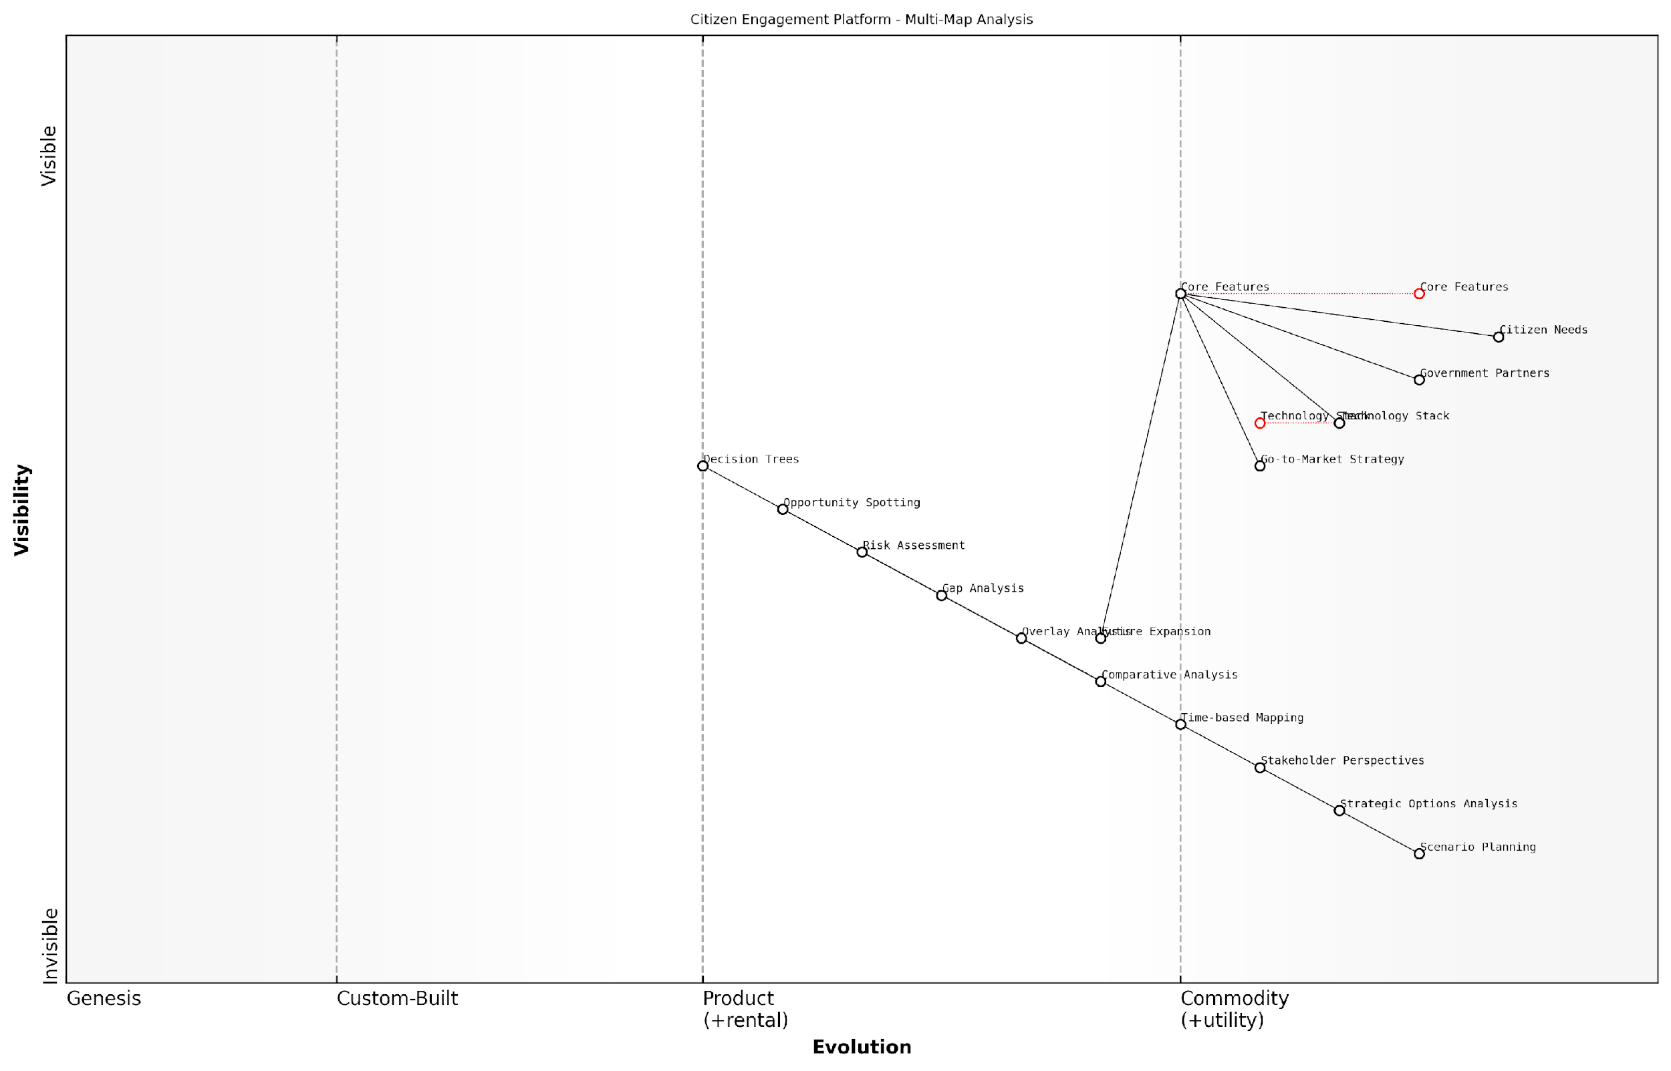

*Draft Wardley Map: [Insert Wardley Map: Using multiple maps to inform decision-making]*

[Edit this draft Wardley Map](https://create.wardleymaps.ai/#clone:b4808f0533449f2184)

Wardley Map Assessment

The Citizen Engagement Platform shows strong potential with its focus on citizen needs and evolving analytical capabilities. However, it must navigate the challenges of rapid technological change, complex stakeholder relationships, and the need for continuous innovation. By leveraging its multi-map analysis approach and focusing on core feature enhancement while planning for future expansion, the platform can strengthen its position as a crucial intermediary between citizens and government. Key to success will be balancing immediate operational needs with long-term strategic development, particularly in areas of advanced analytics, personalised engagement, and ecosystem development.

[View full Wardley Map report](http://markdown_wardley_map_reports/wardley_map_report_48_Using_multiple_maps_to_inform_decision-making.md)

## Wardley Mapping for Team Alignment and Communication

### Using maps to build shared understanding

In the fast-paced and often chaotic environment of a startup, building a shared understanding among team members, stakeholders, and investors is crucial for success. Wardley Mapping serves as a powerful tool for achieving this alignment, providing a visual and intuitive framework for communicating complex strategic concepts. This section explores how startups can leverage Wardley Maps to foster collaboration, align vision, and drive cohesive decision-making across the organisation.

At its core, a Wardley Map is a representation of the value chain, showing the components necessary to meet user needs and how they evolve over time. By creating these maps collaboratively, startup teams can develop a common language and shared perspective on their business landscape, competitive positioning, and strategic opportunities.

Wardley Mapping is not just a strategic tool; it’s a communication framework that allows diverse teams to align their understanding of the business landscape and collaboratively chart a course for the future.

Let’s explore the key aspects of using Wardley Maps to build shared understanding within a startup context:

* Collaborative mapping sessions
* Visual representation of strategy
* Identifying knowledge gaps and assumptions
* Facilitating cross-functional dialogue
* Aligning on priorities and resource allocation

Collaborative mapping sessions are at the heart of building shared understanding. These sessions bring together team members from different functions – product, engineering, marketing, sales, and leadership – to collectively create and refine Wardley Maps. The process of mapping itself becomes a powerful exercise in alignment, as participants must agree on the components of their value chain, their relative positions, and their evolution.

During these sessions, it’s crucial to encourage open dialogue and debate. Different team members will bring diverse perspectives, and these varying viewpoints are valuable in creating a comprehensive and nuanced map. As a facilitator, your role is to guide the discussion, ensure all voices are heard, and help the team reach consensus on the map’s elements.

The visual nature of Wardley Maps is particularly effective in communicating complex strategic concepts. Unlike traditional business plans or strategy documents, which can be dense and open to interpretation, a well-constructed Wardley Map provides a clear, visual representation of the startup’s strategic landscape. This visual format makes it easier for team members to grasp the big picture, understand interdependencies, and identify strategic opportunities or threats.

The power of Wardley Mapping lies in its ability to make the invisible visible. It transforms abstract strategic concepts into tangible, visual representations that can be easily understood and acted upon by the entire team.

One of the most valuable outcomes of collaborative mapping is the identification of knowledge gaps and assumptions. As team members work together to create the map, areas of uncertainty or disagreement often come to light. These might be assumptions about user needs, market dynamics, or the evolution of key technologies. By surfacing these gaps and assumptions, the team can prioritise areas for further research or validation, leading to more informed decision-making.

Wardley Mapping also serves as an excellent tool for facilitating cross-functional dialogue. In many startups, silos can develop between different departments, leading to misalignment and inefficiencies. By bringing team members from various functions together around a shared map, you create opportunities for cross-pollination of ideas and a more holistic understanding of the business.

For example, the engineering team might gain insights into customer needs from the sales team, while the marketing team could better understand the technical constraints and opportunities from the product team. This cross-functional dialogue not only improves overall understanding but can also spark innovative ideas and solutions.

Another crucial aspect of building shared understanding is aligning on priorities and resource allocation. Wardley Maps provide a clear visual representation of where components sit on the evolution axis, from genesis to commodity. This insight can help teams make informed decisions about where to invest resources, which components to develop in-house versus outsource, and where to focus innovation efforts.

By collectively agreeing on these priorities through the mapping process, you can reduce conflicts and ensure that all team members are working towards the same strategic goals. This alignment is particularly crucial in a startup environment, where resources are often limited and focus is paramount.

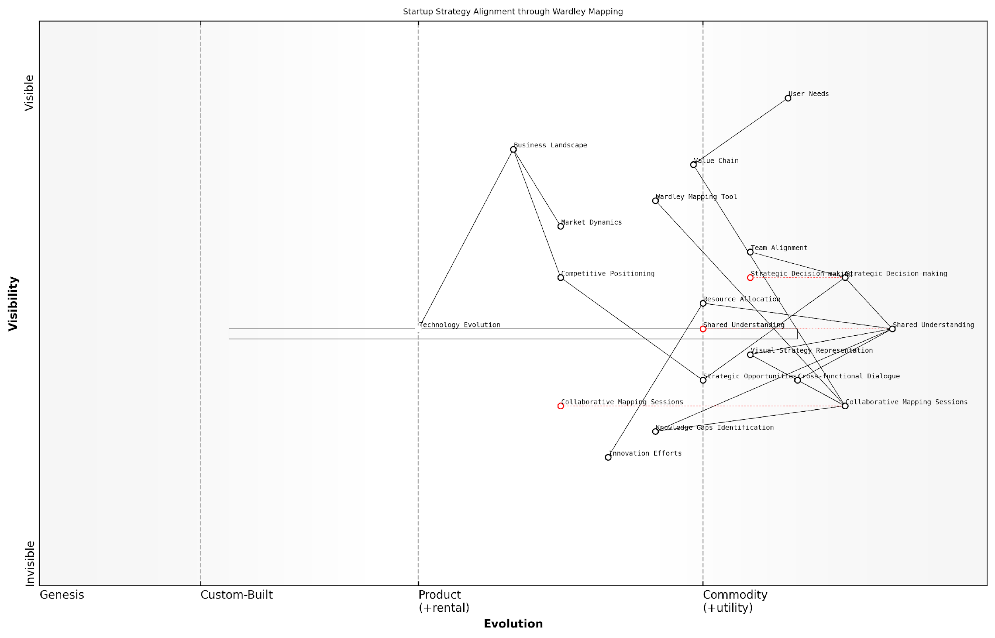

*Draft Wardley Map: [Insert Wardley Map: Using maps to build shared understanding]*

[Edit this draft Wardley Map](https://create.wardleymaps.ai/#clone:c9cc5c4f80b5ccb057)

Wardley Map Assessment

This map represents a startup with a strong focus on collaborative strategy development using Wardley Mapping. The emphasis on shared understanding and visual representation of strategy is a significant strength. However, there’s a need to more closely integrate innovation efforts with core strategic processes and to develop more sophisticated tools for strategy analysis and decision-making. The startup is well-positioned to leverage its collaborative approach but should be mindful of the need to continually evolve its processes and tools to maintain competitive advantage in a dynamic market environment.

[View full Wardley Map report](http://markdown_wardley_map_reports/wardley_map_report_49_Using_maps_to_build_shared_understanding.md)

To maximise the effectiveness of Wardley Mapping in building shared understanding, consider the following best practices:

* Regular mapping sessions: Schedule periodic mapping sessions to review and update the maps as your startup evolves.
* Inclusive participation: Ensure all key stakeholders are involved in the mapping process, including leadership, team members, and even external advisors when appropriate.
* Documentation and accessibility: Keep your maps accessible to all team members and document the key insights and decisions that emerge from mapping sessions.
* Iterative refinement: Treat your maps as living documents, continuously refining them based on new information and changing market conditions.
* Link to action: Use the insights gained from mapping to drive concrete actions and inform strategic decision-making.

It’s important to note that building shared understanding through Wardley Mapping is not a one-time exercise but an ongoing process. As your startup grows and evolves, so too should your maps and the collective understanding they represent. Regular review and refinement of your maps ensure that your team’s shared understanding remains current and relevant.

In the dynamic world of startups, shared understanding is not a destination but a journey. Wardley Mapping provides the compass and map for this journey, enabling teams to navigate the complex terrain of strategy and innovation together.

In conclusion, Wardley Mapping is a powerful tool for building shared understanding within startup teams. By providing a visual, collaborative framework for strategic thinking, it enables diverse teams to align their perspectives, identify key challenges and opportunities, and make informed decisions. As you implement Wardley Mapping in your startup, remember that the true value lies not just in the maps themselves, but in the collective insights and alignment that emerge from the mapping process. With consistent use and refinement, Wardley Mapping can become a cornerstone of your startup’s strategic communication and decision-making processes.

### Facilitating strategic discussions with stakeholders

In the fast-paced world of startups, facilitating effective strategic discussions with stakeholders is crucial for success. Wardley Mapping provides a powerful framework for these conversations, enabling teams to visualise complex systems, align on strategic direction, and make informed decisions. This section explores how to leverage Wardley Mapping to enhance stakeholder engagement and drive meaningful strategic discussions.

Wardley Maps serve as a common language for strategic discourse, bridging the gap between technical and non-technical stakeholders. By providing a visual representation of the business landscape, these maps enable all participants to contribute to the conversation from a shared understanding. This is particularly valuable in the startup context, where rapid decision-making and alignment are essential.

Wardley Mapping has revolutionised our strategic discussions. It’s like having a shared strategic language that everyone can understand and contribute to, regardless of their background.

To effectively facilitate strategic discussions using Wardley Maps, consider the following approaches:

* Pre-meeting preparation: Develop a preliminary map based on existing knowledge and share it with stakeholders before the meeting. This allows participants to familiarise themselves with the map and come prepared with insights and questions.
* Interactive mapping sessions: Begin the discussion by collaboratively refining the map. This process itself often surfaces valuable insights and aligns understanding among stakeholders.
* Scenario exploration: Use the map to explore different strategic scenarios, encouraging stakeholders to consider the implications of various decisions on the overall landscape.
* Identify strategic options: Leverage the map to highlight potential areas for innovation, cost-saving, or competitive advantage. This helps focus the discussion on actionable strategic options.
* Prioritisation exercises: Use the map to facilitate discussions on resource allocation and prioritisation, helping stakeholders visualise the trade-offs involved in different strategic choices.

One of the key benefits of using Wardley Maps in strategic discussions is their ability to surface assumptions and biases. By making the current understanding of the business landscape explicit, maps encourage stakeholders to challenge their preconceptions and consider alternative viewpoints. This is particularly valuable in the startup environment, where agility and adaptability are crucial.

The beauty of Wardley Mapping in our strategic discussions is how it exposes our assumptions. It’s like shining a light on our collective blind spots, allowing us to make more informed decisions.

When facilitating these discussions, it’s important to create an environment that encourages open dialogue and creative thinking. Here are some techniques to enhance the effectiveness of your Wardley Mapping sessions:

* Encourage diverse perspectives: Ensure that a range of stakeholders are involved in the mapping process, including technical experts, business leaders, and customer-facing team members.
* Use probing questions: Challenge assumptions and encourage deeper thinking by asking probing questions about different elements of the map.
* Focus on movement: Emphasise the dynamic nature of the map by discussing how different components might evolve over time and the implications for the business.
* Highlight interdependencies: Use the map to illustrate how different components of the business are interconnected, fostering a more holistic view of strategic decisions.
* Document insights and actions: Capture key insights and agreed-upon actions during the discussion, using the map as a reference point.

It’s worth noting that facilitating strategic discussions with Wardley Maps requires practice and skill development. As the facilitator, you play a crucial role in guiding the conversation, ensuring all voices are heard, and keeping the discussion focused on strategic outcomes. Over time, you’ll develop techniques for managing different personality types, resolving conflicts, and driving consensus using the map as a tool.

One particularly effective technique is to use the map to frame strategic questions. For example:

* “Given the current position of this component on the evolution axis, how might we accelerate its commoditisation to gain a competitive advantage?”
* “What would be the implications for our value chain if this emerging technology moves from genesis to custom-built over the next 12 months?”
* “How might we restructure our operations to better align with the natural flow of dependencies shown in the map?”

These types of questions leverage the visual nature of the map to stimulate strategic thinking and guide the discussion towards actionable insights.

It’s also important to consider the iterative nature of Wardley Mapping in the context of ongoing strategic discussions. As new information emerges and the business landscape evolves, the map should be updated to reflect these changes. Regular mapping sessions can become a valuable ritual for startups, providing a structured approach to strategy review and adaptation.

We’ve made Wardley Mapping a core part of our quarterly strategy reviews. It’s become our go-to tool for assessing our position, evaluating new opportunities, and aligning our team on strategic priorities.

In conclusion, Wardley Mapping provides a powerful framework for facilitating strategic discussions with stakeholders in the startup environment. By providing a visual representation of the business landscape, encouraging collaborative refinement, and surfacing assumptions and biases, these maps enable more effective, informed, and aligned strategic decision-making. As you integrate Wardley Mapping into your strategic processes, you’ll likely find it becomes an indispensable tool for navigating the complexities of the startup journey.

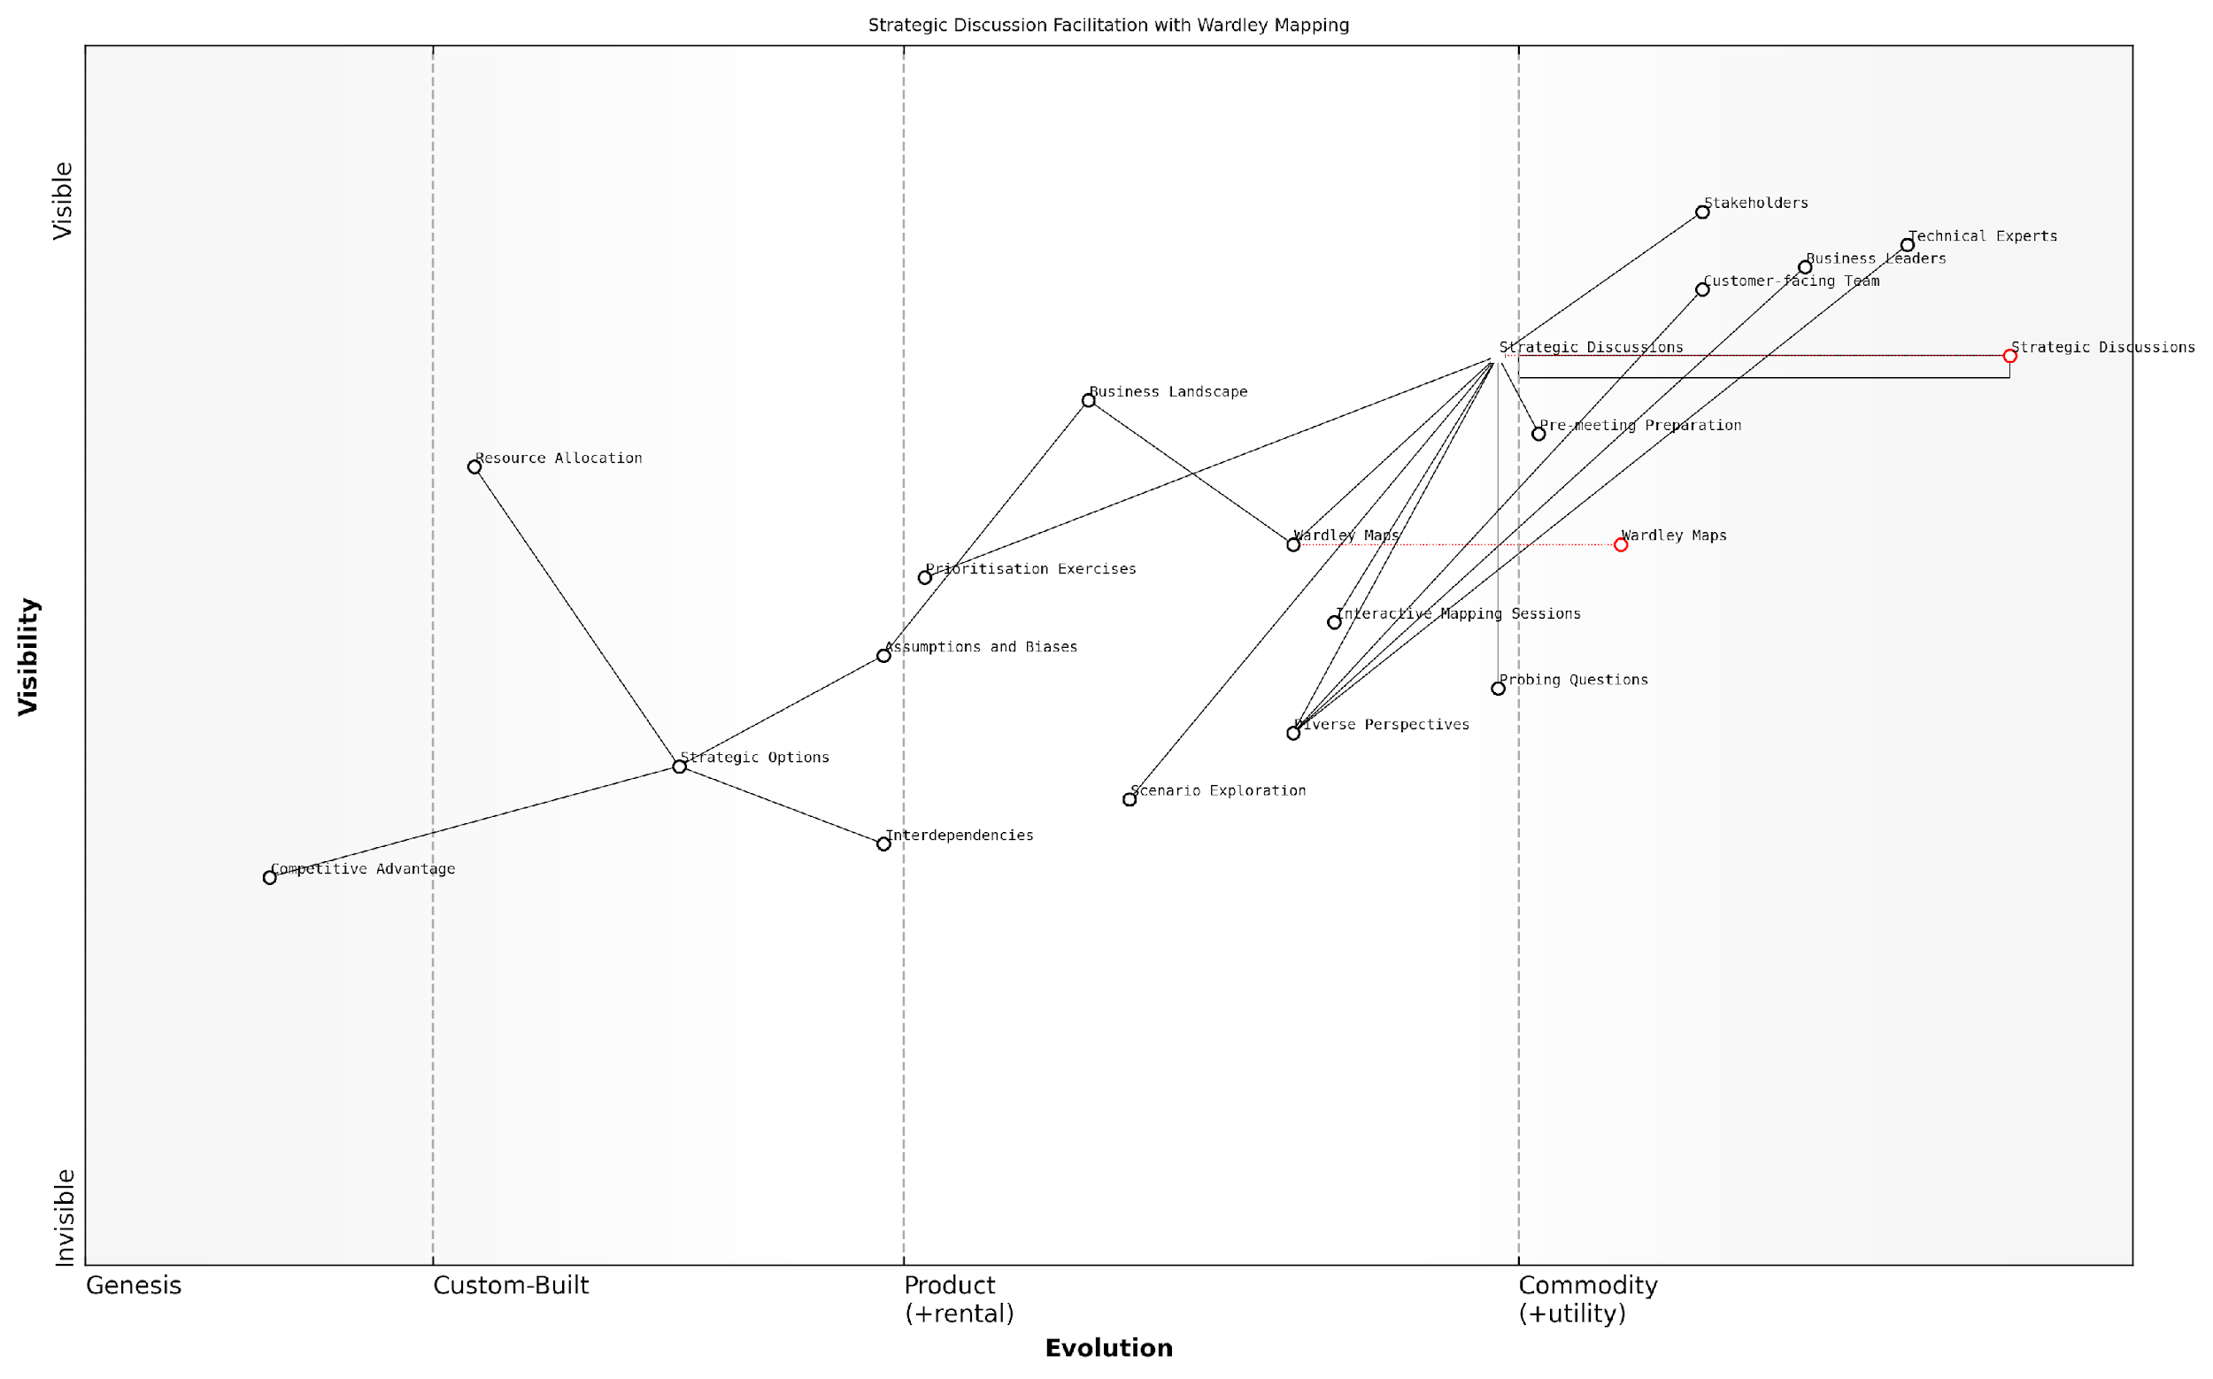

*Draft Wardley Map: [Insert Wardley Map: Facilitating strategic discussions with stakeholders]*

[Edit this draft Wardley Map](https://create.wardleymaps.ai/#clone:07b58c67ae892a6c68)

Wardley Map Assessment

This Wardley Map represents a sophisticated approach to facilitating strategic discussions using Wardley Mapping. It shows a clear value chain from stakeholder engagement to competitive advantage creation, with a strong emphasis on visual representation and challenging assumptions. The map indicates several opportunities for innovation, particularly in the areas of technology integration and advanced analytics. To maintain a competitive edge, the organisation should focus on evolving its core processes (Strategic Discussions and Wardley Maps) while investing in emerging technologies that can enhance the strategic planning process. The key challenge will be balancing the human elements of strategic facilitation with the potential of data-driven insights and AI-assisted analysis.

[View full Wardley Map report](http://markdown_wardley_map_reports/wardley_map_report_50_Facilitating_strategic_discussions_with_stakeholde.md)

### Communicating vision and strategy to investors

In the high-stakes world of startup fundraising, effectively communicating your vision and strategy to investors is paramount. Wardley Mapping offers a powerful tool for startups to articulate their strategic positioning, market understanding, and future plans in a visually compelling and analytically rigorous manner. This section explores how startups can leverage Wardley Maps to enhance their investor communications, providing a unique edge in securing funding and building long-term investor relationships.

Wardley Maps serve as a visual representation of a startup’s strategic landscape, offering investors a clear and comprehensive view of the company’s position within its market ecosystem. By incorporating Wardley Maps into investor presentations and discussions, startups can demonstrate a deep understanding of their industry dynamics, competitive positioning, and potential for growth and disruption.

Wardley Maps have revolutionised how we communicate our strategy to investors. They provide a shared language that bridges the gap between our technical vision and the business outcomes investors care about.

Key benefits of using Wardley Maps in investor communications include:

* Demonstrating market insight: Maps showcase a startup’s understanding of industry trends, competitive forces, and potential disruptions.
* Illustrating strategic foresight: By mapping future scenarios, startups can show investors their ability to anticipate and adapt to market changes.
* Highlighting competitive advantage: Maps can visually represent a startup’s unique positioning and value proposition within the market landscape.
* Communicating growth potential: By illustrating evolving value chains, startups can showcase opportunities for expansion and market capture.
* Aligning on key metrics: Maps can help identify and justify the most relevant KPIs for measuring the startup’s progress and success.

When incorporating Wardley Maps into investor communications, startups should consider the following best practices:

* Simplify and focus: While comprehensive maps are valuable for internal strategy, investor-facing maps should be simplified to highlight key insights and strategic moves.
* Narrate the journey: Use the map to tell a compelling story about your startup’s past, present, and future trajectory in the market.
* Align with investor interests: Tailor the map’s focus to address specific investor concerns or areas of interest, such as market size, scalability, or competitive moats.
* Quantify opportunities: Where possible, augment the map with relevant market data and financial projections to support your strategic vision.
* Demonstrate adaptability: Show how your map-driven strategy allows for pivots and adjustments based on market feedback and new opportunities.

A particularly effective approach is to use Wardley Maps to illustrate different scenarios and potential pivots. This demonstrates to investors that the startup has a robust strategy that can adapt to various market conditions and challenges. For example, a startup might present a base case map alongside alternative scenarios that show how the company would respond to new regulations, technological breakthroughs, or competitive threats.

The ability to visualise multiple strategic scenarios using Wardley Maps has been invaluable in our investor discussions. It showcases our preparedness and strategic flexibility in a way that traditional business plans simply cannot match.

Case Study: TechInnovate’s Funding Success

Consider the case of TechInnovate, a startup in the AI-driven predictive maintenance sector. Initially struggling to secure Series A funding, TechInnovate revamped its investor pitch using Wardley Maps. The startup created a map that clearly illustrated:

* The current state of the predictive maintenance market, showing where existing solutions fell short
* TechInnovate’s unique positioning, leveraging emerging AI technologies to address unmet needs
* A projected evolution of the market, highlighting how TechInnovate was positioned to capture value as certain components became commoditised
* Potential future scenarios, including expansion into adjacent markets and responses to potential competitive moves

By presenting this map-driven strategy, TechInnovate was able to secure £5 million in Series A funding, with investors citing the clarity of vision and strategic foresight as key factors in their decision.

It’s important to note that while Wardley Maps can significantly enhance investor communications, they should complement rather than replace traditional financial projections and market analyses. The most effective investor presentations integrate Wardley Maps with other key startup metrics and projections to provide a comprehensive view of the company’s potential.

In conclusion, Wardley Mapping offers startups a powerful tool for communicating their vision and strategy to investors. By visually representing market dynamics, competitive positioning, and strategic foresight, startups can differentiate themselves in a crowded funding landscape. When used effectively, Wardley Maps can help build investor confidence, secure funding, and establish a foundation for long-term strategic alignment between startups and their investors.

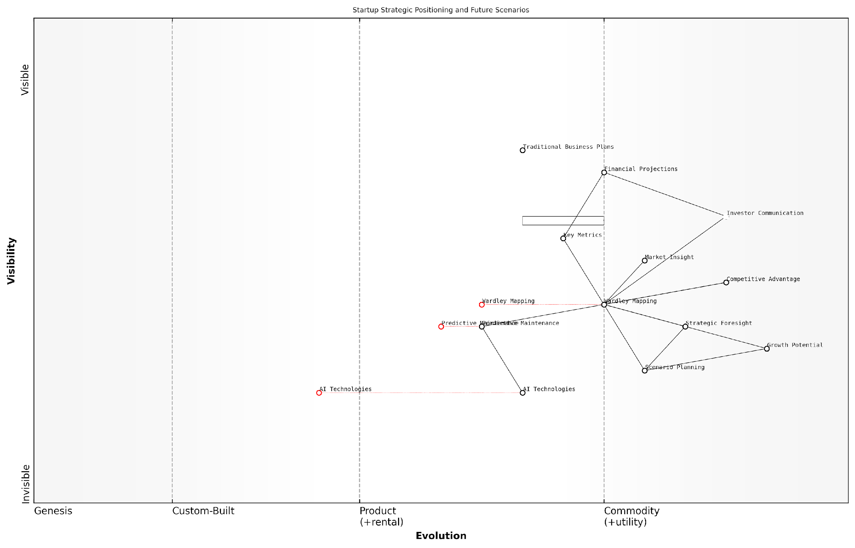

*Draft Wardley Map: [Insert Wardley Map: Communicating vision and strategy to investors]*

[Edit this draft Wardley Map](https://create.wardleymaps.ai/#clone:b49feb123c58e19885)

Wardley Map Assessment

This Wardley Map represents a startup at the forefront of strategic communication innovation. By leveraging Wardley Mapping and emerging AI technologies, the company is well-positioned to disrupt traditional investor relations practices. However, careful balance is needed between innovation and investor familiarity. The startup should focus on enhancing its core strengths in Wardley Mapping while strategically integrating AI to create a unique value proposition in the investor communication landscape. Long-term success will depend on the ability to educate investors, standardise new practices, and continuously evolve with technological advancements.

[View full Wardley Map report](http://markdown_wardley_map_reports/wardley_map_report_51_Communicating_vision_and_strategy_to_investors.md)

## Integrating Wardley Mapping with Other Strategic Tools

### Combining Wardley Maps with Business Model Canvas

In the dynamic landscape of startup strategy, the integration of Wardley Mapping with other strategic tools can provide a powerful synergy for decision-making and innovation. One particularly potent combination is the merger of Wardley Maps with the Business Model Canvas (BMC), a widely adopted framework for describing, designing, and analysing business models. This integration allows startups to leverage the strengths of both methodologies, creating a more comprehensive and nuanced understanding of their strategic position and opportunities.

The Business Model Canvas, developed by Alexander Osterwalder and Yves Pigneur, offers a visual representation of a company’s business model across nine key building blocks. These blocks include customer segments, value propositions, channels, customer relationships, revenue streams, key resources, key activities, key partnerships, and cost structure. While the BMC provides a holistic view of a business model, it lacks the evolutionary and competitive context that Wardley Mapping brings to the table.

By combining these two frameworks, startups can achieve a more robust strategic analysis that addresses both the ‘what’ of their business model and the ‘how’ of its evolution and competitive positioning. Let’s explore the key benefits and methodologies for integrating Wardley Maps with the Business Model Canvas:

* Enhanced Value Chain Visibility: Wardley Maps can provide a detailed breakdown of the value chain underlying each component of the BMC, offering insights into the maturity and strategic importance of different elements.
* Competitive Context: While the BMC focuses on internal business model elements, Wardley Maps add the crucial dimension of market evolution and competitive positioning.
* Innovation Opportunities: The combination can reveal gaps in the current business model and highlight potential areas for innovation or disruption.
* Strategic Alignment: By mapping BMC components on a Wardley Map, startups can ensure that their business model aligns with the overall strategic direction and market evolution.
* Resource Allocation: The integrated view can inform more effective resource allocation decisions, prioritising investments in areas that offer the greatest strategic advantage.

To effectively combine these tools, startups can follow a structured approach:

* 1. Start with the BMC: Begin by creating a comprehensive Business Model Canvas for your startup.
  2. Identify Key Components: For each BMC building block, identify the key components that could be mapped on a Wardley Map.
  3. Create the Wardley Map: Develop a Wardley Map that includes these key components, positioning them according to their evolution and value chain position.
  4. Analyse Relationships: Examine how the positioning of components on the Wardley Map relates to their role in the BMC.
  5. Identify Gaps and Opportunities: Use the combined view to spot inconsistencies, gaps, or potential areas for innovation in your business model.
  6. Iterate and Refine: Continuously update both the BMC and Wardley Map as your understanding evolves and market conditions change.

Let’s consider a practical example to illustrate this integration. Imagine a startup developing a new fintech platform for peer-to-peer lending. Their initial Business Model Canvas might identify key customer segments (borrowers and lenders), value propositions (easy access to loans, higher returns on investments), and key activities (credit scoring, fund matching). When these elements are mapped onto a Wardley Map, the startup might discover that while their core lending platform is still in the custom-built phase, credit scoring algorithms are rapidly commoditising.

This insight could lead to a strategic decision to partner with a specialised credit scoring provider (updating the ‘Key Partnerships’ block of the BMC) rather than developing this capability in-house. The Wardley Map might also reveal emerging components, such as blockchain-based smart contracts, which could inform future iterations of the business model and value proposition.

The integration of Wardley Mapping with the Business Model Canvas has been a game-changer for our strategic planning process. It’s like adding a third dimension to our business model, allowing us to see not just what we’re doing, but how it fits into the broader evolutionary landscape of our industry.

This sentiment, expressed by a founder of a successful UK-based startup, encapsulates the transformative potential of combining these two powerful tools. By leveraging the strengths of both Wardley Mapping and the Business Model Canvas, startups can develop more resilient, adaptable, and innovative strategies that are well-aligned with market evolution and competitive dynamics.

However, it’s important to note that this integration requires a deep understanding of both frameworks and the ability to think critically about the relationships between business model components and their strategic positioning. Startups should be prepared to invest time in mastering these tools and in facilitating cross-functional discussions to fully leverage their combined power.

Moreover, the integration of Wardley Mapping and the Business Model Canvas is not a one-time exercise but an ongoing process. As startups evolve and markets shift, regular reviews and updates of both the BMC and associated Wardley Maps are crucial to maintaining strategic alignment and identifying new opportunities for innovation and growth.

In conclusion, the combination of Wardley Mapping with the Business Model Canvas offers a powerful toolkit for startups navigating the complexities of modern markets. By providing a multi-dimensional view of business strategy that encompasses both internal model coherence and external market dynamics, this integrated approach empowers startups to make more informed decisions, anticipate market shifts, and position themselves for long-term success. As the startup ecosystem continues to evolve, we can expect to see further refinements and applications of this integrated methodology, potentially revolutionising the way new ventures approach strategy and innovation.

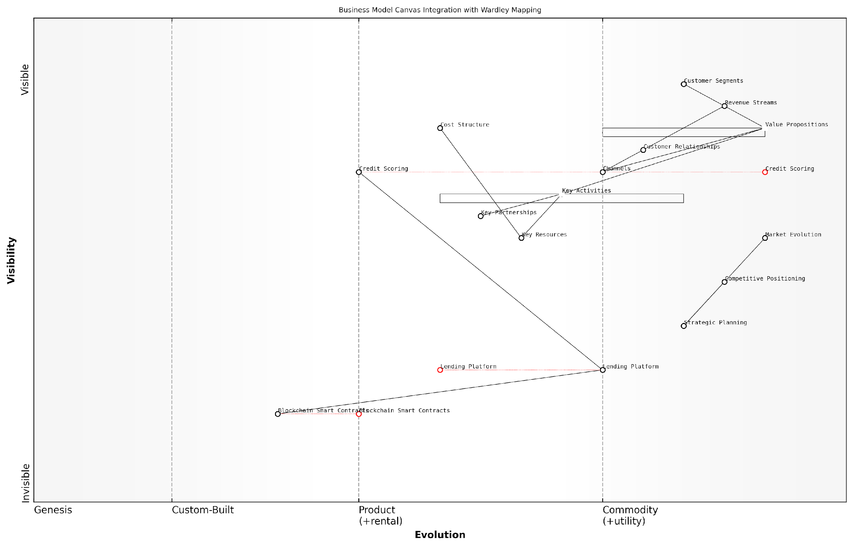

*Draft Wardley Map: [Insert Wardley Map: Combining Wardley Maps with Business Model Canvas]*

[Edit this draft Wardley Map](https://create.wardleymaps.ai/#clone:60fe76ec4cf70aed02)

Wardley Map Assessment

This Wardley Map reveals a strategically positioned fintech company leveraging emerging technologies to disrupt traditional lending. The integration of blockchain and advanced credit scoring within a customer-centric business model presents significant opportunities for innovation and market leadership. However, the rapid evolution of key components necessitates a flexible, forward-looking strategy. The company should focus on accelerating its technological capabilities while building a robust ecosystem of partnerships to enhance its value propositions and market reach. Balancing innovation with regulatory compliance and security will be crucial for long-term success in this dynamic fintech landscape.

[View full Wardley Map report](http://markdown_wardley_map_reports/wardley_map_report_52_Combining_Wardley_Maps_with_Business_Model_Canvas.md)

### Using maps alongside SWOT and Porter’s Five Forces

Wardley Mapping, whilst a powerful strategic tool in its own right, can be even more effective when used in conjunction with other well-established frameworks such as SWOT analysis and Porter’s Five Forces. This integration allows startups to gain a more comprehensive view of their strategic landscape, combining the dynamic, evolutionary perspective of Wardley Maps with the structured insights provided by these traditional tools.

SWOT Analysis Integration:

SWOT (Strengths, Weaknesses, Opportunities, Threats) analysis is a foundational strategic planning technique that can be significantly enhanced when used alongside Wardley Mapping. By overlaying SWOT elements onto a Wardley Map, startups can gain a more nuanced understanding of their strategic position.

* Strengths and Weaknesses: Map these internal factors to specific components on your Wardley Map. This allows you to visualise where your startup excels or lags in the value chain.
* Opportunities: Identify potential opportunities by examining gaps or inefficiencies in the map, particularly in areas where components are evolving.
* Threats: Pinpoint external threats by analysing competitor positions on the map and identifying potential disruptive forces.

By combining SWOT with Wardley Mapping, startups can move beyond a static analysis to a dynamic view that considers how strengths, weaknesses, opportunities, and threats may evolve over time as components shift along the evolution axis.

Integrating SWOT with Wardley Mapping transformed our strategic planning process. We could see not just where we stood, but where we needed to be as the market evolved.

Porter’s Five Forces Integration:

Porter’s Five Forces framework, which analyses competitive intensity and attractiveness of an industry, can be powerfully complemented by Wardley Mapping. This combination allows startups to visualise how industry forces interact with and influence the components of their value chain.

* Threat of New Entrants: Identify potential entry points on the map where new competitors might emerge, particularly in areas where components are commoditising.
* Bargaining Power of Suppliers: Map key suppliers and assess their position relative to other components to understand their influence on your value chain.
* Bargaining Power of Buyers: Visualise customer needs and how they relate to different components to gauge buyer leverage.
* Threat of Substitute Products: Identify potential substitutes by examining parallel value chains or emerging technologies on the map.
* Competitive Rivalry: Analyse competitor positions across the map to understand areas of intense competition and potential differentiation.

By mapping Porter’s Five Forces onto a Wardley Map, startups can gain a more dynamic understanding of how industry forces may shift as components evolve, allowing for more proactive and forward-thinking strategies.

The combination of Wardley Mapping and Porter’s Five Forces gave us unprecedented insight into our industry’s future direction. We could anticipate competitive shifts before they happened.

Practical Application for Startups:

To effectively integrate these tools, startups should follow a structured approach:

* Start with a basic Wardley Map of your value chain.
* Conduct a SWOT analysis, mapping each element to relevant components on your Wardley Map.
* Apply Porter’s Five Forces, considering how each force relates to different areas of your map.
* Analyse the integrated view, looking for insights that emerge from the combination of these perspectives.
* Use these insights to inform strategic decisions, such as where to invest resources, which partnerships to pursue, or how to position your offerings.

This integrated approach allows startups to leverage the strengths of each tool while mitigating their individual limitations. Wardley Mapping provides the evolutionary and visual context often lacking in SWOT and Porter’s Five Forces, while these traditional tools offer structured frameworks for analysing specific aspects of the business and competitive environment.

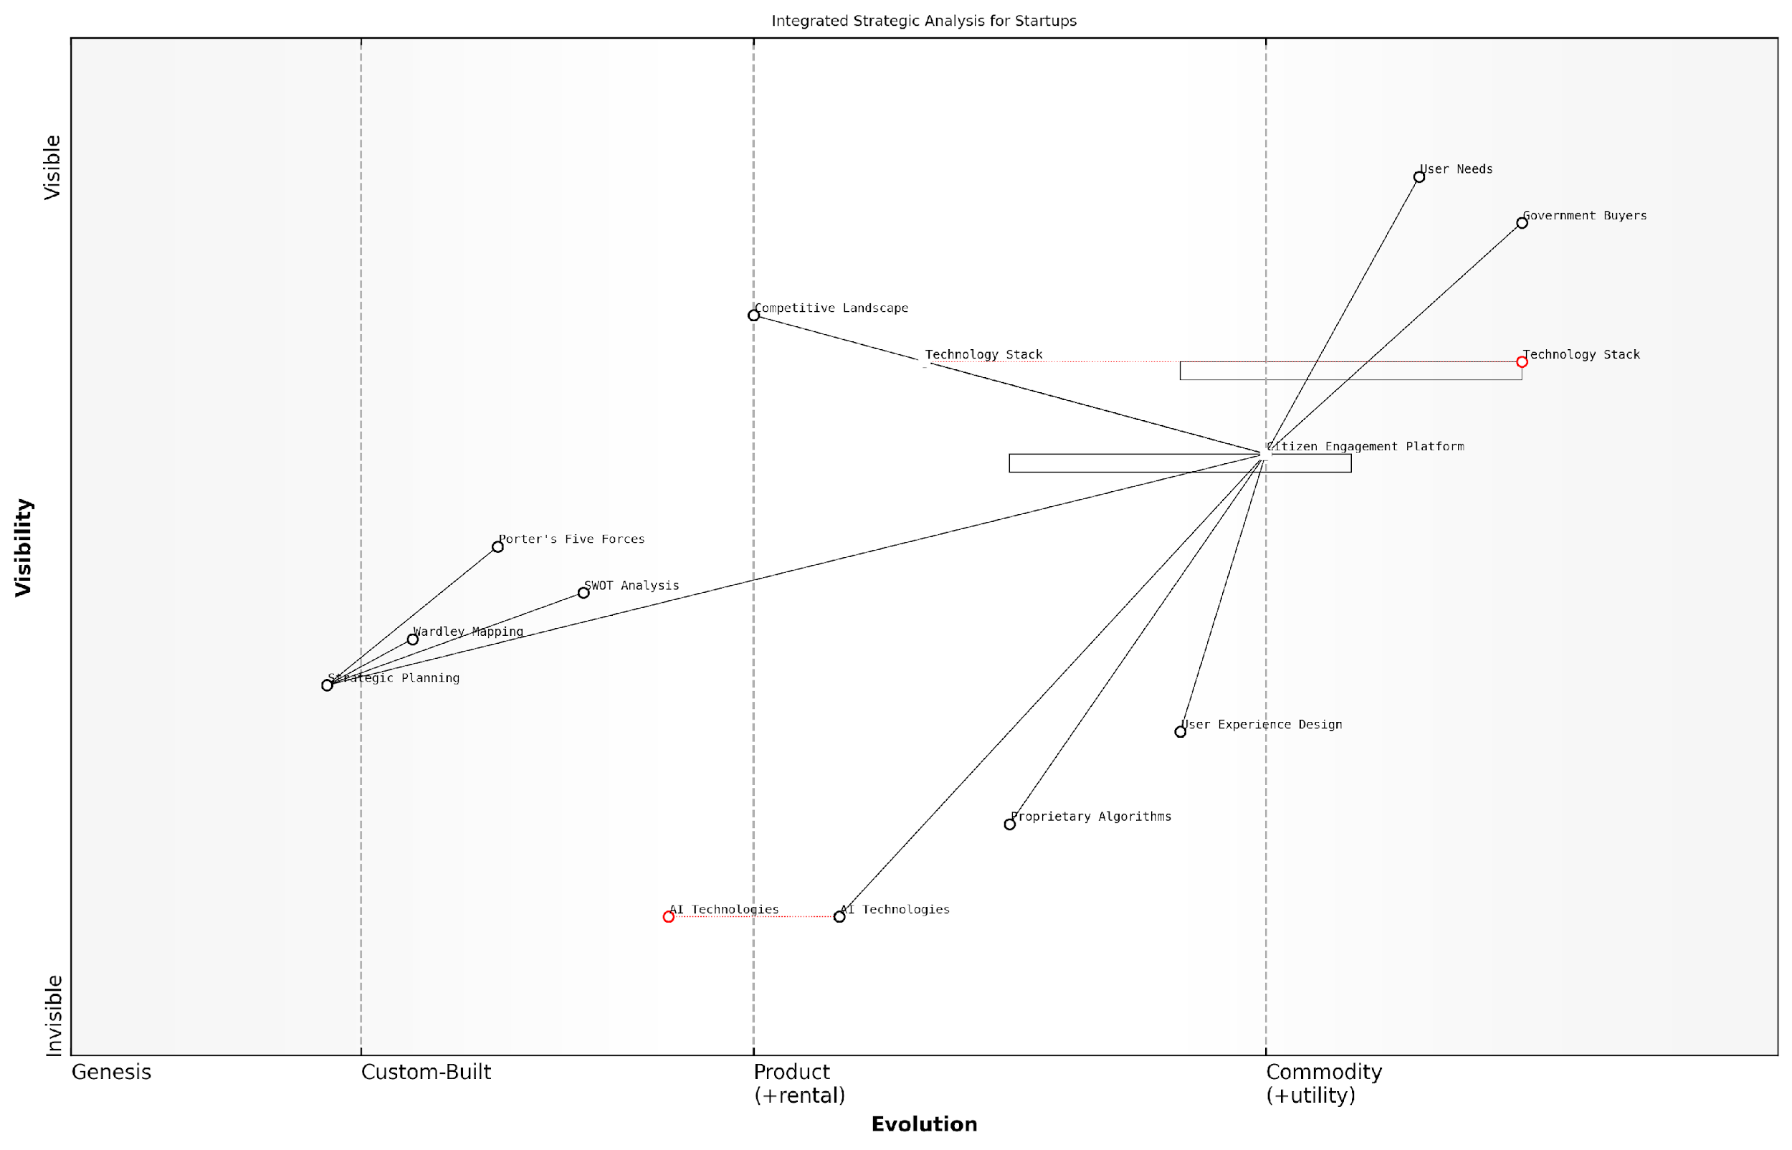

*Draft Wardley Map: [Insert Wardley Map: Using maps alongside SWOT and Porter’s Five Forces]*

[Edit this draft Wardley Map](https://create.wardleymaps.ai/#clone:debb82da098308001e)

Wardley Map Assessment

The startup is well-positioned with a strong focus on user needs and a custom engagement platform. However, to maintain its competitive edge, it must accelerate AI integration, continuously enhance user experience, and develop a robust ecosystem around its platform. The integration of multiple strategic tools provides a comprehensive view, but the focus should remain on core technology development and market expansion. The key to long-term success lies in balancing innovation in AI and algorithms with strong government relationships and an evolving, user-centric platform.

[View full Wardley Map report](http://markdown_wardley_map_reports/wardley_map_report_53_Using_maps_alongside_SWOT_and_Porter's_Five_Forces.md)

Case Study: GovTech Startup Success

Consider the case of a GovTech startup developing a citizen engagement platform. By integrating Wardley Mapping with SWOT and Porter’s Five Forces, they were able to:

* Identify their strength in user experience design and map it to the ‘custom-built’ section of their platform components.
* Recognise the threat of new entrants in the commoditised areas of their technology stack, leading to a decision to focus on proprietary algorithms as a differentiator.
* Visualise the bargaining power of government buyers, prompting a strategy to move certain components towards commoditisation to reduce costs and increase adoption.
* Spot an opportunity to leverage emerging AI technologies, mapped in the ‘genesis’ phase, to create a unique value proposition.

This integrated analysis enabled the startup to develop a robust, forward-thinking strategy that accounted for both current market dynamics and future evolution of their industry.

By combining Wardley Mapping with traditional strategic tools, we were able to navigate the complex public sector landscape and identify unique opportunities for innovation and growth.

In conclusion, the integration of Wardley Mapping with SWOT analysis and Porter’s Five Forces provides startups with a powerful toolkit for strategic planning and decision-making. This approach enables a more dynamic, contextual understanding of the business environment, allowing startups to anticipate changes, identify opportunities, and develop resilient strategies in the face of uncertainty. As the startup ecosystem continues to evolve, this integrated approach to strategic analysis will become increasingly valuable for founders and leaders seeking to navigate complex, rapidly changing markets.

### Enhancing agile methodologies with Wardley Mapping

In the fast-paced world of startups, agile methodologies have become the cornerstone of efficient product development and project management. However, as startups navigate increasingly complex and uncertain environments, there’s a growing need to enhance these methodologies with strategic tools that provide a broader perspective. Wardley Mapping, with its focus on situational awareness and strategic positioning, offers a powerful complement to agile practices, particularly within government and public sector contexts where startups often face unique challenges.

The integration of Wardley Mapping with agile methodologies creates a synergy that addresses both the tactical, iterative nature of agile development and the strategic, long-term vision necessary for startup success. This combination is particularly potent in the public sector, where startups must navigate complex stakeholder relationships, regulatory environments, and long-term societal impacts.

Let’s explore how Wardley Mapping can enhance key aspects of agile methodologies:

* Strategic Backlog Prioritisation
* Enhanced Sprint Planning
* Improved Stakeholder Communication
* Long-term Vision Alignment
* Risk Identification and Mitigation

Strategic Backlog Prioritisation: One of the core challenges in agile development is effectively prioritising the product backlog. Wardley Mapping provides a strategic context for this process, allowing teams to visualise how different features or components contribute to the overall value chain and competitive positioning.

By overlaying our product backlog onto a Wardley Map, we gained invaluable insights into which features would provide the most strategic value. This approach transformed our prioritisation process, ensuring that our sprints were always aligned with our long-term goals.

Enhanced Sprint Planning: Wardley Maps can inform sprint planning by providing a clear view of component dependencies and evolution. This allows teams to make more informed decisions about which components to develop or evolve in each sprint, considering both immediate needs and future strategic positioning.

Improved Stakeholder Communication: In the public sector, startups often deal with a diverse range of stakeholders, from government officials to end-users. Wardley Maps serve as a powerful communication tool, providing a visual representation of the startup’s strategy and the value it delivers. This can be particularly effective in aligning diverse stakeholder groups and securing buy-in for the startup’s vision.

Long-term Vision Alignment: While agile methodologies excel at delivering incremental value, they can sometimes lead to a focus on short-term gains at the expense of long-term strategy. Wardley Mapping helps maintain alignment with the broader strategic vision throughout the agile development process, ensuring that each sprint contributes to the startup’s overall goals and market positioning.

Risk Identification and Mitigation: Wardley Maps can highlight potential risks and dependencies that may not be immediately apparent in traditional agile planning. By mapping out the entire value chain and its evolution, startups can identify potential bottlenecks, dependencies on external factors, or areas where they may be vulnerable to disruption.

Integrating Wardley Mapping into our agile process was a game-changer for risk management. We were able to anticipate and mitigate risks that would have blindsided us otherwise, particularly in navigating the complex regulatory landscape of the public sector.

To effectively integrate Wardley Mapping with agile methodologies, consider the following practical steps:

* Conduct regular mapping sessions as part of your strategic planning process
* Use Wardley Maps to inform and refine your product roadmap
* Incorporate map reviews into sprint retrospectives to ensure ongoing alignment
* Train product owners and scrum masters in Wardley Mapping to facilitate integration
* Use maps to enhance communication with external stakeholders and partners

Case Study: GovTech Innovator

Consider the case of GovTech Innovator, a startup developing a citizen engagement platform for local governments. By integrating Wardley Mapping with their agile development process, they were able to:

* Identify key components of their platform that were ripe for commoditisation, allowing them to focus development efforts on truly differentiating features
* Anticipate shifts in the regulatory landscape, enabling proactive adaptation of their product roadmap
* Communicate their strategic vision effectively to government stakeholders, securing crucial partnerships and funding
* Prioritise their backlog based on both immediate user needs and long-term strategic positioning
* Identify and mitigate risks associated with dependencies on evolving government IT infrastructure

The integration of Wardley Mapping with agile methodologies allowed GovTech Innovator to maintain the flexibility and responsiveness of agile development while ensuring their efforts were always aligned with their strategic goals and market positioning.

In conclusion, enhancing agile methodologies with Wardley Mapping offers startups, particularly those operating in the government and public sector, a powerful toolkit for navigating uncertainty and driving innovation. By combining the tactical strengths of agile with the strategic insights of Wardley Mapping, startups can ensure they’re not just building the product right, but building the right product for their market and long-term success.

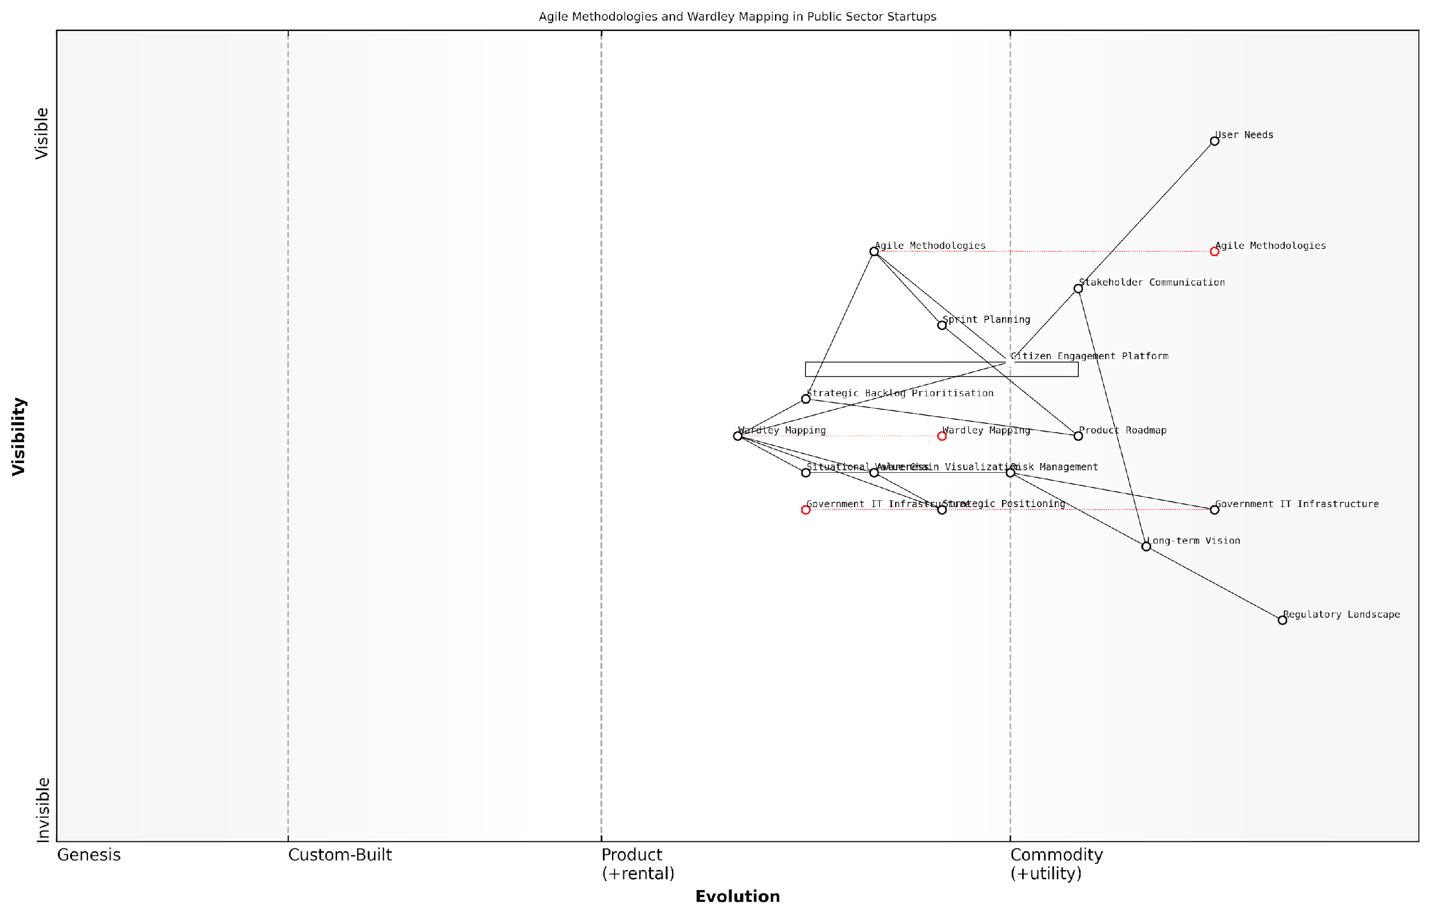

*Draft Wardley Map: [Insert Wardley Map: Enhancing agile methodologies with Wardley Mapping]*

[Edit this draft Wardley Map](https://create.wardleymaps.ai/#clone:9427147ec94be23ee2)

Wardley Map Assessment

This map represents a forward-thinking approach to public sector innovation, effectively combining Agile methodologies with strategic mapping tools. The integration of user needs, regulatory considerations, and modern operational practices positions the organisation well for driving meaningful change. However, there are opportunities for further evolution, particularly in areas of risk management, long-term visioning, and emerging technology adoption. By addressing these areas and continuing to refine the integration of Agile and Wardley Mapping practices, the organisation can enhance its ability to deliver value to citizens while navigating the complex public sector landscape.

[View full Wardley Map report](http://markdown_wardley_map_reports/wardley_map_report_54_Enhancing_agile_methodologies_with_Wardley_Mapping.md)

## Wardley Mapping for Resource Allocation and Prioritisation

### Using maps to inform hiring decisions and team structure

In the dynamic landscape of startups, particularly those operating within government and public sector contexts, the strategic allocation of human resources is paramount. Wardley Mapping offers a powerful framework for informing hiring decisions and shaping team structures that align with an organisation’s evolving needs and strategic objectives. By leveraging the insights gleaned from Wardley Maps, startups can make more informed decisions about when and whom to hire, how to structure their teams, and how to allocate resources effectively.

Wardley Mapping provides a visual representation of the value chain, component evolution, and strategic landscape, offering a unique perspective on the skills and roles required at different stages of a startup’s journey. This section will explore how startups can harness the power of Wardley Mapping to optimise their hiring processes and team structures, ensuring they have the right people in the right roles at the right time.

Identifying skill gaps and prioritising hires

One of the primary benefits of using Wardley Maps for hiring decisions is the ability to identify skill gaps within the organisation. By mapping out the components of your value chain and their evolutionary stage, you can pinpoint areas where your team lacks the necessary expertise or capacity.

* Genesis stage components: These often require creative, innovative thinkers who can operate in uncertain environments. Look for candidates with a track record of pioneering new technologies or approaches.
* Custom-built components: Here, you might need specialists with deep technical knowledge in specific domains. Prioritise hiring experts who can develop bespoke solutions.
* Product stage components: As components move towards productisation, consider hiring individuals with experience in scaling and optimising processes.
* Commodity components: For these, focus on hiring efficient operators who can manage standardised processes and drive cost efficiencies.

By aligning your hiring strategy with the evolutionary stages of your components, you ensure that your team has the right mix of skills to drive innovation where needed and optimise efficiency in more mature areas.

Wardley Mapping has revolutionised our hiring process. It’s like having a strategic roadmap that shows us exactly what kind of talent we need at each stage of our journey.

Structuring teams for maximum effectiveness

Wardley Mapping can also inform how you structure your teams to maximise effectiveness and agility. By understanding the relationships between different components and their evolutionary stages, you can create team structures that foster collaboration and innovation where it’s most needed.

* Cross-functional teams: For components in the genesis or custom-built stages, consider forming cross-functional teams that bring together diverse skill sets. This can foster innovation and rapid development.
* Specialist teams: For more evolved components, you might create specialist teams focused on optimisation and scaling.
* Flexible structures: Use your Wardley Map to identify areas where flexibility is crucial. Consider implementing matrix structures or temporary project teams to address specific challenges or opportunities.
* Leadership allocation: Ensure that your most experienced leaders are focused on the areas of your map that are most critical to your competitive advantage.

By aligning your team structure with your Wardley Map, you can create an organisational design that is responsive to the evolving needs of your startup and the market you operate in.

Anticipating future hiring needs

One of the most valuable aspects of Wardley Mapping for startups is its ability to help anticipate future needs. By mapping out the expected evolution of your components and the broader landscape, you can forecast future skill requirements and plan your hiring strategy accordingly.

* Identify emerging skills: Look for components that are likely to become more critical in the future and start building relationships with professionals who have the required skills.
* Plan for upskilling: Where possible, identify opportunities to upskill existing team members to meet future needs, reducing the need for external hiring.
* Strategic partnerships: For areas where you anticipate needing specialised skills in the future, consider forming strategic partnerships or relationships with contractors to access expertise as needed.
* Succession planning: Use your Wardley Map to inform succession planning, ensuring you have a pipeline of talent ready to step into key roles as your organisation evolves.

By using Wardley Mapping to anticipate our future needs, we’ve been able to stay ahead of the curve in a rapidly evolving sector. It’s given us a competitive edge in attracting and retaining top talent.

Case study: Transforming hiring practices in a GovTech startup

To illustrate the practical application of these principles, let’s consider the case of a GovTech startup that used Wardley Mapping to transform its hiring practices and team structure. This startup, which we’ll call ‘CivicInnovate’, was developing a platform to improve citizen engagement with local government services.

Initially, CivicInnovate struggled with resource allocation, often hiring reactively and facing skill shortages in critical areas. By implementing Wardley Mapping, they were able to:

* Identify that their user interface components were in the custom-built stage and required additional UX expertise, leading to the prioritisation of hiring a senior UX designer.
* Recognise that their data processing components were moving towards the product stage, prompting them to hire a data engineer with experience in scaling data systems.
* Anticipate the future need for expertise in AI and machine learning as these technologies became more relevant to their platform, leading them to form a strategic partnership with a local university.
* Restructure their development teams to align with the evolutionary stages of different components, creating cross-functional teams for areas in the genesis stage and more specialised teams for mature components.

As a result of these changes, CivicInnovate was able to accelerate their product development, improve their ability to meet citizen needs, and position themselves as a leader in the GovTech space.

Conclusion

Wardley Mapping offers startups a powerful tool for informing hiring decisions and team structures. By providing a visual representation of the strategic landscape and the evolution of components, it enables startups to align their human resources with their strategic objectives. This approach is particularly valuable in the government and public sector context, where the ability to anticipate and respond to changing needs is crucial.

As startups navigate the complex terrain of growth and innovation, Wardley Mapping can serve as a compass, guiding decisions about whom to hire, how to structure teams, and where to focus resources. By leveraging this strategic tool, startups can build agile, responsive organisations capable of driving innovation and delivering value in an ever-changing landscape.

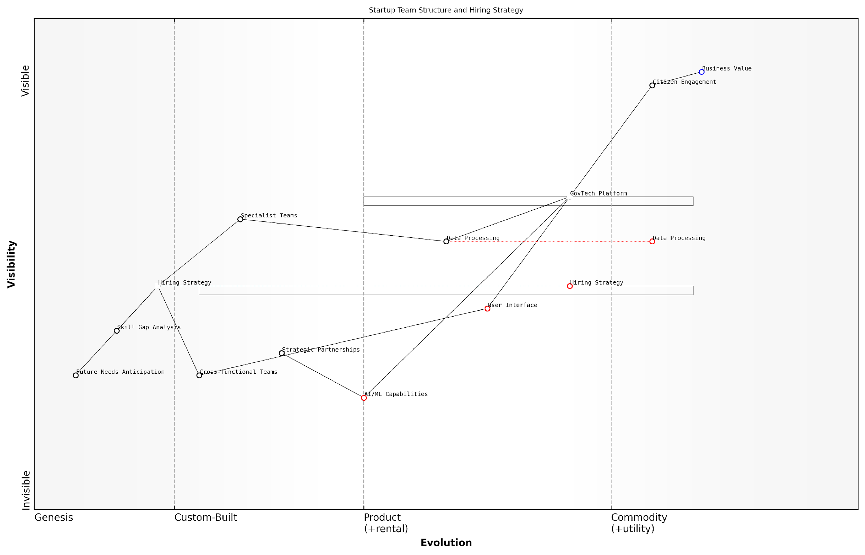

*Draft Wardley Map: [Insert Wardley Map: Using maps to inform hiring decisions and team structure]*

[Edit this draft Wardley Map](https://create.wardleymaps.ai/#clone:c646fb3d446122557c)

Wardley Map Assessment

The startup is well-positioned in the GovTech space with a strong focus on citizen engagement and a developing technological stack. The key strategic imperatives are to accelerate AI/ML capability development, strengthen strategic partnerships, and evolve the hiring strategy to support future growth. The GovTech Platform has the potential to become a market-leading product if the startup can successfully navigate the evolution of its key components and build a robust ecosystem around its offering. Balancing immediate platform development needs with long-term capability building in AI/ML and strategic hiring will be crucial for sustained competitive advantage.

[View full Wardley Map report](http://markdown_wardley_map_reports/wardley_map_report_55_Using_maps_to_inform_hiring_decisions_and_team_str.md)

### Prioritising product features and development efforts

In the fast-paced world of startups, effectively prioritising product features and development efforts is crucial for success. Wardley Mapping provides a powerful framework for making informed decisions about resource allocation and feature prioritisation, enabling startups to focus their limited resources on the most impactful areas. This section explores how Wardley Mapping can be leveraged to guide product development strategies and ensure alignment with overall business objectives.

Wardley Mapping offers a unique perspective on product development by visualising the entire value chain and the evolutionary stage of each component. This visual representation allows startups to identify which features and development efforts are likely to provide the most significant competitive advantage and value to customers. By understanding the landscape of their product ecosystem, startups can make more informed decisions about where to invest their time and resources.

Wardley Mapping has revolutionised our approach to product development. It’s like having a strategic compass that guides our decisions and helps us stay focused on what truly matters to our customers and our business.

Let’s explore the key aspects of using Wardley Mapping for prioritising product features and development efforts:

* Identifying core value propositions
* Assessing component evolution
* Analysing dependencies and bottlenecks
* Aligning features with strategic goals
* Balancing innovation and operational efficiency

Identifying core value propositions: Wardley Mapping helps startups clearly visualise their core value propositions and how they relate to customer needs. By mapping out the entire value chain, startups can identify which components are most critical to delivering value to customers. This insight allows teams to prioritise features and development efforts that directly enhance or support these core value propositions.

Assessing component evolution: One of the unique aspects of Wardley Mapping is its focus on the evolutionary stage of each component in the value chain. By understanding where each component sits on the evolution axis (from genesis to commodity), startups can make more informed decisions about where to invest their resources. For example, components in the ‘custom-built’ phase may require more development effort but could also provide a significant competitive advantage. Conversely, components nearing the ‘commodity’ stage might benefit more from optimisation or outsourcing rather than heavy internal development.

Analysing dependencies and bottlenecks: Wardley Maps reveal the dependencies between different components in the value chain. This visibility allows startups to identify potential bottlenecks or areas where development efforts might be constrained by dependencies on other components. By understanding these relationships, teams can prioritise development efforts that unblock critical paths or reduce dependencies, thereby accelerating overall product development.

Aligning features with strategic goals: Wardley Mapping provides a strategic context for feature prioritisation. By mapping out the competitive landscape and future trends, startups can ensure that their product development efforts align with their long-term strategic goals. This alignment helps prevent the common pitfall of getting caught up in short-term feature development at the expense of long-term strategic positioning.

Balancing innovation and operational efficiency: Wardley Maps can help startups strike the right balance between investing in innovative new features and improving operational efficiency. By visualising the entire value chain, teams can identify areas where innovation is likely to yield the greatest returns, as well as areas where focusing on efficiency and optimisation might be more beneficial.

The beauty of using Wardley Mapping for prioritisation is that it forces you to think holistically about your product and business. It’s not just about the next feature, but about how each decision fits into the bigger picture of your evolving landscape.

Practical application of Wardley Mapping for feature prioritisation often involves the following steps:

* Create a Wardley Map of your current product ecosystem
* Identify gaps and opportunities in the value chain
* Assess the evolutionary stage of each component
* Evaluate potential features and development efforts in the context of the map
* Prioritise based on strategic impact, customer value, and resource constraints
* Regularly update the map and reassess priorities as the landscape evolves

It’s important to note that Wardley Mapping should not be used in isolation for prioritisation. It works best when combined with other product management techniques such as user story mapping, impact mapping, and quantitative data analysis. The insights gained from Wardley Mapping can inform and enhance these other methods, providing a more comprehensive basis for decision-making.

Case Study: A government-backed startup accelerator programme used Wardley Mapping to help a cohort of early-stage tech companies prioritise their product development efforts. One participant, a startup developing a platform for citizen engagement in local government, used Wardley Mapping to visualise their entire ecosystem, including government processes, citizen needs, and technological components.

Through this exercise, the startup identified that while they had been focusing on developing advanced analytics features, a more pressing need was to improve the basic user interface and onboarding process, which were critical components in the value chain that were lagging in evolution. This insight led to a reprioritisation of their development efforts, resulting in a significant increase in user adoption and engagement with their platform.

Wardley Mapping opened our eyes to aspects of our product we had been overlooking. It helped us realign our priorities and focus on the areas that would truly move the needle for our users and our business.

In conclusion, Wardley Mapping provides a powerful framework for prioritising product features and development efforts in startups. By offering a visual representation of the value chain, evolutionary stages, and strategic landscape, it enables teams to make more informed decisions about where to focus their limited resources. When combined with other product management techniques and a deep understanding of customer needs, Wardley Mapping can significantly enhance a startup’s ability to develop products that create lasting value and competitive advantage.

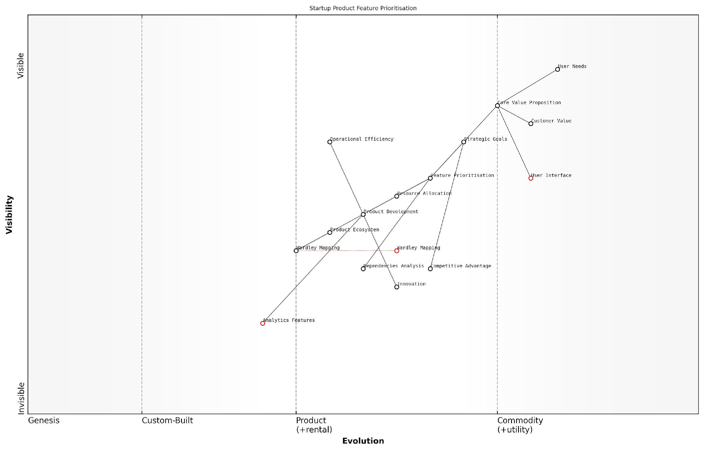

*Draft Wardley Map: [Insert Wardley Map: Prioritising product features and development efforts]*

[Edit this draft Wardley Map](https://create.wardleymaps.ai/#clone:6d3d702e323d0771ba)

Wardley Map Assessment

This Wardley Map represents a startup with a strong foundation in user-centric product development and strategic thinking. The integration of Wardley Mapping and focus on Feature Prioritisation suggest a sophisticated approach to product strategy. However, there are opportunities to enhance data capabilities, streamline processes, and develop a more robust product ecosystem. By addressing these areas and leveraging its strategic strengths, the startup can create a sustainable competitive advantage and drive innovation in its market.

[View full Wardley Map report](http://markdown_wardley_map_reports/wardley_map_report_56_Prioritising_product_features_and_development_effo.md)

### Guiding investment in research and development

In the fast-paced world of startups, effectively guiding investment in research and development (R&D) is crucial for maintaining a competitive edge and driving innovation. Wardley Mapping provides a powerful framework for startups to strategically allocate resources and prioritise R&D efforts, ensuring that investments align with both short-term needs and long-term strategic goals.

Wardley Mapping offers several key advantages for guiding R&D investment in startups:

* Visualising the entire value chain and identifying critical components for innovation
* Understanding the evolution of technologies and practices within the industry
* Spotting potential disruptive technologies or approaches on the horizon
* Aligning R&D efforts with overall business strategy and market positioning
* Balancing investment between core capabilities and emerging opportunities

Let’s explore how startups can leverage Wardley Mapping to make informed decisions about R&D investment.

1. Identifying Strategic R&D Priorities

By mapping out the entire value chain of a startup’s products or services, leaders can identify which components are most critical to their competitive advantage. Components that are positioned higher on the value chain and are still evolving (i.e., in the ‘custom-built’ or ‘product’ phases) often represent prime candidates for R&D investment.

Wardley Mapping allows us to see beyond the immediate horizon and identify the components that will be critical to our future success. It’s like having a strategic radar for R&D investment.

For example, a fintech startup might identify that while their core banking infrastructure is becoming commoditised, there’s significant opportunity for innovation in areas like AI-driven risk assessment or blockchain-based smart contracts. By visualising these components on a Wardley Map, the startup can prioritise R&D efforts in these high-potential areas.

1. Anticipating Technological Shifts

One of the most valuable aspects of Wardley Mapping for R&D investment is its ability to help startups anticipate technological shifts. By plotting the evolution of various components, startups can identify technologies that are likely to become more ubiquitous and commoditised over time, as well as emerging technologies that may disrupt the industry.

This foresight allows startups to make strategic decisions about whether to invest in developing proprietary technologies, adopt emerging standards, or focus on integrating and leveraging commoditised components. For instance, a startup in the IoT space might use Wardley Mapping to track the evolution of various sensor technologies, communication protocols, and data analytics platforms, informing decisions about where to focus their R&D efforts.

1. Balancing Short-term Needs and Long-term Vision

Startups often face the challenge of balancing immediate product development needs with long-term strategic innovation. Wardley Mapping can help strike this balance by providing a visual representation of both current and future states of the business landscape.

Wardley Mapping gives us the clarity to invest in tomorrow’s opportunities without losing sight of today’s necessities. It’s a game-changer for strategic R&D allocation.

By creating multiple maps representing different time horizons (e.g., 1 year, 3 years, 5 years), startups can develop a roadmap for R&D investment that addresses both short-term product improvements and long-term strategic pivots or expansions.

1. Identifying Collaborative Opportunities

Wardley Mapping can also reveal opportunities for collaborative R&D efforts. By analysing the map, startups may identify areas where partnering with other companies, research institutions, or even competitors could accelerate innovation and reduce costs.

For example, a startup in the autonomous vehicle space might use Wardley Mapping to identify non-core components (e.g., certain sensor technologies or mapping data) where collaboration with other industry players could be beneficial, allowing them to focus their R&D resources on differentiating features.

1. Aligning R&D with Market Positioning

Wardley Mapping helps startups align their R&D investments with their overall market positioning strategy. By visualising both their own position and that of competitors on the map, startups can identify areas where R&D investment can create the most significant competitive advantage.

For instance, a startup aiming to disrupt an established industry might use Wardley Mapping to identify components that are ripe for innovation, focusing their R&D efforts on creating novel solutions that challenge industry incumbents.

1. Continuous Reassessment and Adaptation

The dynamic nature of Wardley Mapping makes it an ideal tool for continuously reassessing and adapting R&D strategies. As the business landscape evolves, startups can update their maps to reflect changes in technology, market conditions, and competitive dynamics.

This iterative approach allows for agile decision-making in R&D investment, ensuring that resources are always aligned with the most current strategic priorities and market opportunities.

Wardley Mapping isn’t a one-time exercise; it’s a living tool that evolves with your business. It keeps our R&D investments sharp and responsive to market changes.

In conclusion, Wardley Mapping provides startups with a powerful framework for guiding investment in research and development. By offering a visual representation of the business landscape, technological evolution, and strategic priorities, it enables startup leaders to make informed decisions about where to focus their R&D efforts. This strategic approach to R&D investment can significantly enhance a startup’s ability to innovate, compete, and grow in rapidly evolving markets.

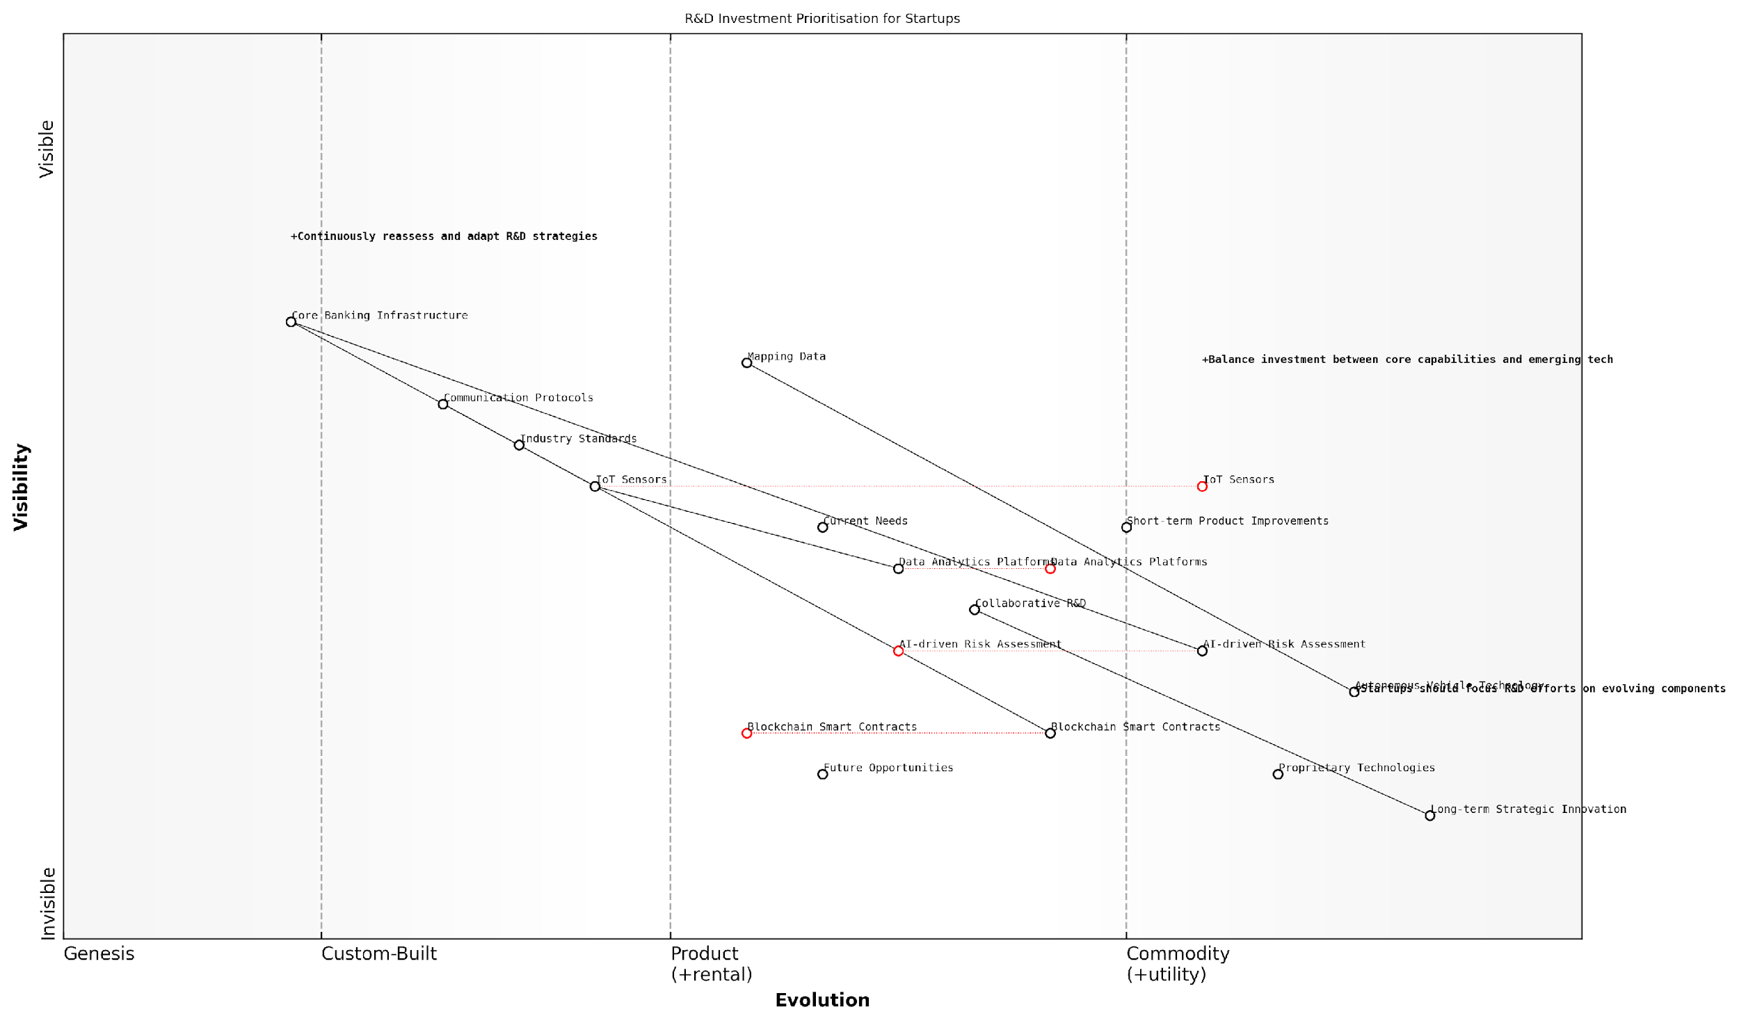

*Draft Wardley Map: [Insert Wardley Map: Guiding investment in research and development]*

[Edit this draft Wardley Map](https://create.wardleymaps.ai/#clone:6bd0d9ea7ec723b074)

Wardley Map Assessment

This Wardley Map reveals a startup positioned at the intersection of fintech and emerging technologies, with a strong focus on balancing current operational needs with future innovation opportunities. The strategic positioning shows a commendable effort to stay competitive through investment in cutting-edge technologies like AI, blockchain, and autonomous vehicles. However, the startup must carefully manage the risks associated with rapid technological evolution and potential regulatory challenges. The key to success lies in maintaining agility, fostering strategic partnerships, and continuously realigning R&D efforts with market dynamics. By leveraging its strengths in AI-driven risk assessment and data analytics while addressing capability gaps in areas like autonomous vehicle technology, the startup can create a sustainable competitive advantage. The emphasis on collaborative R&D and long-term strategic innovation suggests a forward-thinking approach that, if executed well, could position the company as a leader in the convergence of fintech and advanced automotive technologies.

[View full Wardley Map report](http://markdown_wardley_map_reports/wardley_map_report_57_Guiding_investment_in_research_and_development.md)

# Chapter 5: The Future of Wardley Mapping for Startups

## Emerging Trends in Strategic Mapping

### AI and machine learning in Wardley Mapping

As we explore the future of Wardley Mapping for startups, it’s crucial to examine the transformative potential of artificial intelligence (AI) and machine learning (ML) in strategic mapping. These technologies are not merely tools to enhance existing processes; they represent a paradigm shift in how startups can approach strategy formulation, market analysis, and decision-making. The integration of AI and ML into Wardley Mapping offers startups unprecedented capabilities to navigate uncertainty, identify opportunities, and adapt to rapidly changing market conditions.

The synergy between AI, ML, and Wardley Mapping is particularly potent in the startup ecosystem, where agility and data-driven decision-making are paramount. By leveraging these advanced technologies, startups can overcome traditional limitations of manual mapping processes and gain a competitive edge in their respective markets. Let’s delve into the key areas where AI and ML are revolutionising Wardley Mapping for startups.

Automated Map Generation and Updates

One of the most significant advancements in this field is the development of AI-powered tools that can automatically generate and update Wardley Maps. These systems leverage natural language processing (NLP) and machine learning algorithms to analyse vast amounts of data from various sources, including market reports, social media, and industry publications. By processing this information, AI can identify components, their relationships, and their evolutionary stage with remarkable accuracy.

* Real-time map updates based on market changes
* Identification of emerging technologies and trends
* Automated positioning of components along the evolution axis

For startups, this capability is invaluable. It allows them to maintain up-to-date strategic maps without the significant time investment traditionally required. Moreover, it enables startups to quickly adapt their strategies in response to new market information, giving them a crucial advantage in fast-moving industries.

The integration of AI in Wardley Mapping has transformed our ability to stay ahead of market trends. What once took weeks of analysis can now be accomplished in hours, allowing us to make more informed decisions at startup speed.

Predictive Analytics and Scenario Modelling

Machine learning algorithms are enhancing the predictive capabilities of Wardley Maps, enabling startups to model future scenarios with greater accuracy. By analysing historical data and current market trends, these systems can forecast the likely evolution of components, predict potential disruptions, and simulate the impact of different strategic decisions.

* Probabilistic forecasting of component evolution
* Identification of potential market disruptions
* Simulation of various strategic scenarios and their outcomes

This predictive capability is particularly valuable for startups operating in uncertain or rapidly changing markets. It allows them to test hypotheses, evaluate potential pivots, and make more informed decisions about resource allocation and strategic direction.

Enhanced Pattern Recognition and Insight Generation

AI and ML algorithms excel at identifying patterns and correlations that might be invisible to the human eye. When applied to Wardley Mapping, these technologies can uncover hidden relationships between components, detect subtle market shifts, and generate novel insights that can inform startup strategy.

* Identification of non-obvious component relationships
* Detection of weak signals indicating potential market shifts
* Generation of strategic recommendations based on map analysis

For startups, these insights can be game-changing. They can reveal new market opportunities, highlight potential threats, and suggest innovative ways to reconfigure value chains for competitive advantage.

The AI-driven insights we’ve gained from our Wardley Maps have been instrumental in identifying untapped market niches and informing our product development roadmap. It’s like having a team of expert strategists working around the clock.

Personalised Strategic Recommendations

As AI systems become more sophisticated, they are increasingly able to provide personalised strategic recommendations based on a startup’s specific context, goals, and constraints. By analysing a company’s Wardley Map in conjunction with its financial data, market position, and other relevant factors, AI can suggest tailored strategies for growth, innovation, and competitive positioning.

* Customised strategic recommendations based on startup’s unique context
* Identification of optimal resource allocation strategies
* Suggestions for potential partnerships or acquisition targets

This level of personalisation enables startups to make more informed decisions that are closely aligned with their specific circumstances and objectives. It’s akin to having a virtual strategic advisor that combines the breadth of market knowledge with deep understanding of the company’s individual situation.

Challenges and Considerations

While the integration of AI and ML into Wardley Mapping offers tremendous potential, it’s important to acknowledge the challenges and limitations. Data quality and availability remain critical issues, particularly for startups operating in niche or emerging markets. There’s also the risk of over-reliance on AI-generated insights, potentially leading to a neglect of human intuition and experience in strategy formulation.

* Ensuring data quality and relevance for accurate mapping
* Balancing AI-driven insights with human expertise and intuition
* Addressing potential biases in AI algorithms
* Managing the cost and complexity of implementing AI-powered mapping tools

Startups must approach the adoption of AI and ML in Wardley Mapping with a critical eye, ensuring that these technologies complement rather than replace human strategic thinking.

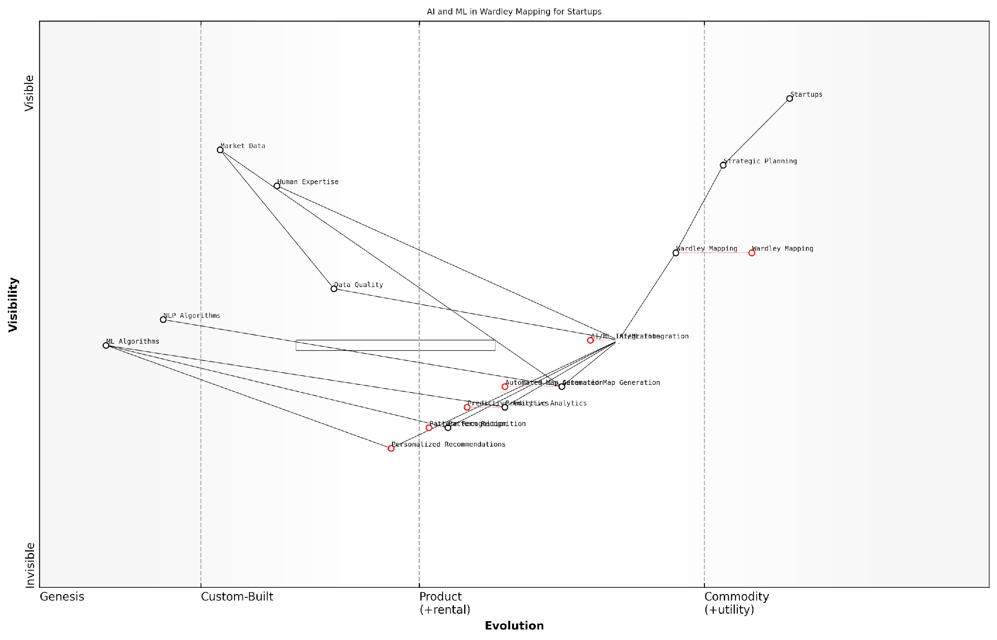

*Draft Wardley Map: [Insert Wardley Map: AI and machine learning in Wardley Mapping]*

[Edit this draft Wardley Map](https://create.wardleymaps.ai/#clone:57013bc5bd2ff4ab0e)

Wardley Map Assessment

This Wardley Map represents a significant opportunity to transform strategic planning for startups through the integration of AI and ML technologies. The positioning of AI/ML Integration as a central, evolving component suggests that this is a key area for investment and development. The map indicates a clear path from traditional Wardley Mapping towards a more automated, data-driven approach, with potential for significant competitive advantage. However, the reliance on Data Quality and Human Expertise highlights the need for a balanced approach that combines technological advancement with human insight. The strategic focus should be on rapidly developing and refining AI-enhanced mapping tools while ensuring their outputs are accurate, understandable, and actionable for startups. This approach has the potential to democratise advanced strategic planning, giving more startups access to sophisticated analysis tools and potentially reshaping the startup ecosystem.

[View full Wardley Map report](http://markdown_wardley_map_reports/wardley_map_report_58_AI_and_machine_learning_in_Wardley_Mapping.md)

Conclusion

The integration of AI and machine learning into Wardley Mapping represents a significant leap forward in strategic planning for startups. By automating map generation, enhancing predictive capabilities, uncovering hidden insights, and providing personalised recommendations, these technologies are empowering startups to navigate uncertainty with greater confidence and agility.

As we look to the future, the continued advancement of AI and ML technologies promises to further revolutionise Wardley Mapping, making it an even more powerful tool for startup strategy and innovation. Startups that embrace these technologies and effectively integrate them into their strategic processes will be well-positioned to thrive in an increasingly complex and rapidly evolving business landscape.

The fusion of AI with Wardley Mapping is not just an evolution; it’s a revolution in how startups approach strategy. It’s providing a level of insight and foresight that was previously unimaginable, enabling even the smallest companies to compete on a global stage.

### Real-time mapping and dynamic strategy formulation

As the pace of technological change and market disruption continues to accelerate, startups are increasingly seeking ways to make their strategic planning more agile and responsive. Real-time mapping and dynamic strategy formulation represent a significant evolution in the application of Wardley Mapping, enabling startups to adapt their strategies swiftly in response to changing market conditions, emerging technologies, and shifting customer needs.

This approach involves the continuous updating and refinement of Wardley Maps based on real-time data and insights, allowing for more nimble decision-making and strategy adjustment. By leveraging advanced technologies and data analytics, startups can create ‘living’ Wardley Maps that evolve in tandem with their business environment, providing a constantly updated strategic compass.

Real-time mapping is not just about speed; it’s about creating a dynamic, responsive strategy that can pivot as quickly as the market demands. It’s the difference between navigating with a static map and having a constantly updating GPS.

Let’s explore the key components and benefits of real-time mapping and dynamic strategy formulation for startups:

* Continuous data integration and analysis
* Automated map updates and version control
* AI-assisted pattern recognition and trend forecasting
* Collaborative real-time editing and annotation
* Integration with other business intelligence tools

Continuous data integration and analysis form the foundation of real-time mapping. By connecting Wardley Maps to live data sources such as market intelligence platforms, social media feeds, and internal business metrics, startups can ensure their strategic view is always based on the most current information. This constant influx of data allows for the early detection of market shifts, emerging competitors, or changes in customer behaviour.

Automated map updates and version control enable startups to track the evolution of their strategic landscape over time. As new data is integrated, the position and relationships of components on the map can be automatically adjusted. This not only saves time but also provides a historical record of how the business environment has changed, offering valuable insights into trends and patterns.

AI-assisted pattern recognition and trend forecasting represent a significant leap forward in the analytical capabilities of Wardley Mapping. By applying machine learning algorithms to the vast amounts of data integrated into the maps, startups can identify subtle patterns and weak signals that might otherwise go unnoticed. This can provide early warnings of disruptive threats or highlight emerging opportunities before they become obvious to competitors.

The integration of AI into Wardley Mapping is like giving startups a strategic superpower. It allows them to see around corners and anticipate market shifts before they happen, turning uncertainty into a competitive advantage.

Collaborative real-time editing and annotation features enable startup teams to work together on strategy formulation, regardless of their physical location. This is particularly valuable for distributed teams or when seeking input from external advisors or board members. Real-time collaboration ensures that all stakeholders are working with the most up-to-date version of the map and can contribute their insights immediately.

Integration with other business intelligence tools allows startups to create a comprehensive strategic dashboard. By connecting Wardley Maps with tools for financial forecasting, customer relationship management, and project management, startups can create a holistic view of their business that links strategy directly to execution.

The benefits of real-time mapping and dynamic strategy formulation for startups are numerous:

* Increased agility and responsiveness to market changes
* More informed and timely decision-making
* Improved alignment between strategy and execution
* Enhanced ability to identify and capitalise on emerging opportunities
* Greater resilience in the face of disruption and uncertainty

However, implementing real-time mapping and dynamic strategy formulation is not without its challenges. Startups must be mindful of potential pitfalls:

* Information overload and analysis paralysis
* Over-reliance on automated insights at the expense of human judgement
* The need for robust data governance and security measures
* Ensuring the team has the skills to interpret and act on real-time insights
* Balancing the need for agility with the importance of maintaining a consistent strategic direction

To illustrate the power of real-time mapping and dynamic strategy formulation, consider the case of a government-backed startup accelerator programme I advised. By implementing a real-time Wardley Mapping system, the accelerator was able to track the evolving needs of its startup cohorts against the changing landscape of government priorities and market opportunities.

The system integrated data from various sources, including economic indicators, policy announcements, and feedback from startups and mentors. This allowed the accelerator to dynamically adjust its support programmes, reallocate resources, and provide timely guidance to startups on emerging opportunities aligned with government initiatives.

As a result, the accelerator saw a significant increase in the success rate of its startups, with several securing government contracts or pivoting to address newly identified public sector needs. The real-time mapping approach enabled the accelerator to act as a responsive intermediary between the fast-paced startup ecosystem and the more deliberate pace of government strategic planning.

Real-time Wardley Mapping acted as a bridge between the agility of startups and the strategic needs of government, creating a synergy that drove innovation in public services and economic growth.

As we look to the future, the potential for real-time mapping and dynamic strategy formulation in the startup ecosystem is immense. With advancements in AI, edge computing, and data analytics, we can anticipate even more sophisticated tools for strategic planning and execution.

Startups that embrace these emerging trends in Wardley Mapping will be better positioned to navigate the complexities of rapid growth, disruptive innovation, and changing market dynamics. By making strategic planning a continuous, data-driven process rather than a periodic exercise, startups can maintain the agility that is their greatest advantage while developing the strategic depth typically associated with more established enterprises.

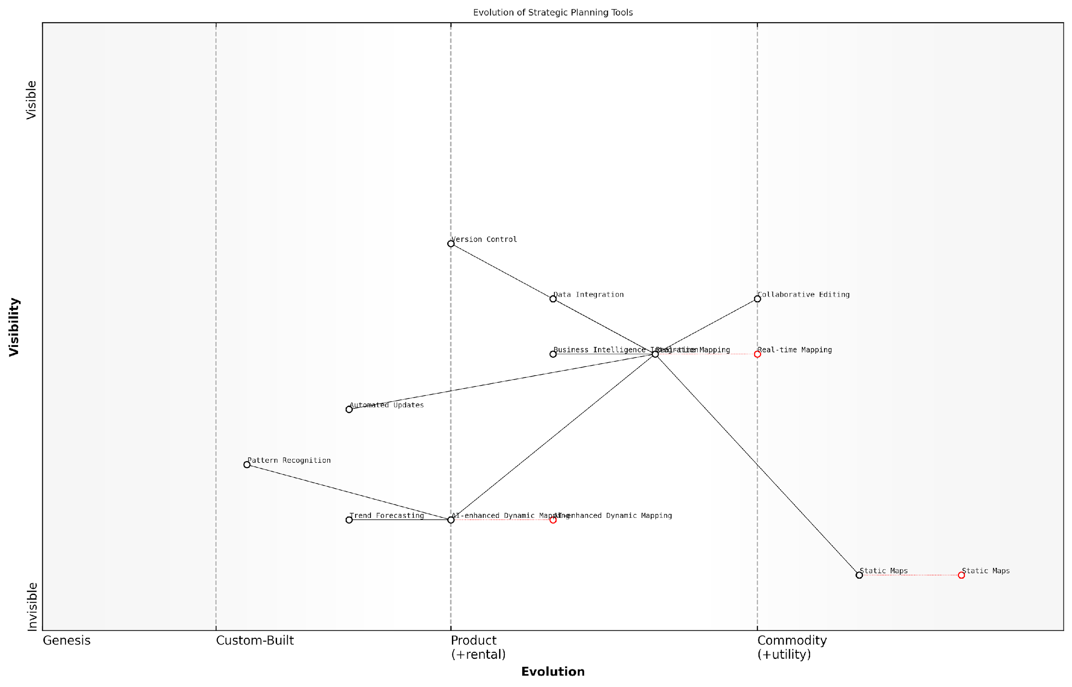

*Draft Wardley Map: [Insert Wardley Map: Real-time mapping and dynamic strategy formulation]*

[Edit this draft Wardley Map](https://create.wardleymaps.ai/#clone:2de0e658da70284fc5)

Wardley Map Assessment

This Wardley Map depicts a strategic landscape in transition, moving from traditional static planning tools to dynamic, AI-enhanced methodologies. The key opportunity lies in developing and integrating AI-enhanced Dynamic Mapping capabilities, while leveraging Real-time Mapping as a critical stepping stone. Organisations must balance the need for immediate improvements in data integration and collaboration with long-term investments in AI and machine learning capabilities. Success in this evolving landscape will require a comprehensive approach, addressing technological, organisational, and human factors to fully realise the potential of next-generation strategic planning tools.

[View full Wardley Map report](http://markdown_wardley_map_reports/wardley_map_report_59_Real-time_mapping_and_dynamic_strategy_formulation.md)

In conclusion, real-time mapping and dynamic strategy formulation represent a significant leap forward in the application of Wardley Mapping for startups. By embracing these emerging trends, startups can create more resilient, adaptive, and successful businesses, capable of thriving in an increasingly complex and rapidly changing world.

### Integration with big data and predictive analytics

As Wardley Mapping continues to evolve and gain traction in the startup ecosystem, its integration with big data and predictive analytics represents a significant leap forward in strategic decision-making. This convergence of methodologies offers startups unprecedented insights into market dynamics, customer behaviour, and future trends, enabling them to navigate uncertainty with greater confidence and agility.

The synergy between Wardley Mapping and big data analytics is particularly potent in the context of startups operating in data-rich environments, such as fintech, e-commerce, and smart city initiatives. By leveraging vast datasets and advanced analytical techniques, startups can enhance the accuracy and dynamism of their Wardley Maps, leading to more informed strategic choices and improved competitive positioning.

The integration of big data and predictive analytics with Wardley Mapping is not just an incremental improvement; it’s a paradigm shift in how startups can visualise and navigate their strategic landscape.

Let’s explore the key aspects of this integration and its implications for startups:

* Enhanced component positioning
* Dynamic evolution tracking
* Predictive scenario modelling
* Real-time market intelligence
* Personalised value chain optimisation

Enhanced component positioning: Big data analytics can provide startups with granular insights into the current state of various components within their value chain. By analysing large volumes of market data, customer feedback, and competitive intelligence, startups can more accurately position components on the evolution axis of their Wardley Maps. This precision is crucial for startups operating in rapidly changing markets, where misplacing a component could lead to strategic missteps.

Dynamic evolution tracking: One of the challenges in traditional Wardley Mapping is keeping pace with the rapid evolution of components, especially in technology-driven sectors. By integrating big data streams, startups can create dynamic Wardley Maps that update in real-time as new data becomes available. This allows for continuous monitoring of component evolution, enabling startups to spot emerging trends or disruptive technologies before they become apparent to competitors.

The ability to track component evolution in real-time through big data integration transforms Wardley Mapping from a periodic strategic exercise into a continuous, data-driven decision support system.

Predictive scenario modelling: Predictive analytics can significantly enhance the scenario planning capabilities of Wardley Mapping. By applying machine learning algorithms to historical data and current trends, startups can generate more accurate forecasts of how their value chain might evolve under different conditions. This allows for the creation of multiple future-state Wardley Maps, each representing a potential scenario based on data-driven predictions.

Real-time market intelligence: The integration of big data analytics with Wardley Mapping provides startups with a powerful tool for real-time market intelligence. By continuously analysing market signals, social media sentiment, and economic indicators, startups can quickly identify shifts in customer needs, emerging competitors, or changes in the regulatory landscape. This real-time intelligence can be overlaid onto Wardley Maps, providing a dynamic view of the competitive landscape and informing rapid strategic adjustments.

Personalised value chain optimisation: Big data and predictive analytics enable startups to move beyond generic value chains to highly personalised, customer-centric models. By analysing individual customer data and behaviour patterns, startups can create segmented Wardley Maps that reflect the unique value chains for different customer groups. This level of personalisation allows for more targeted product development, marketing strategies, and resource allocation.

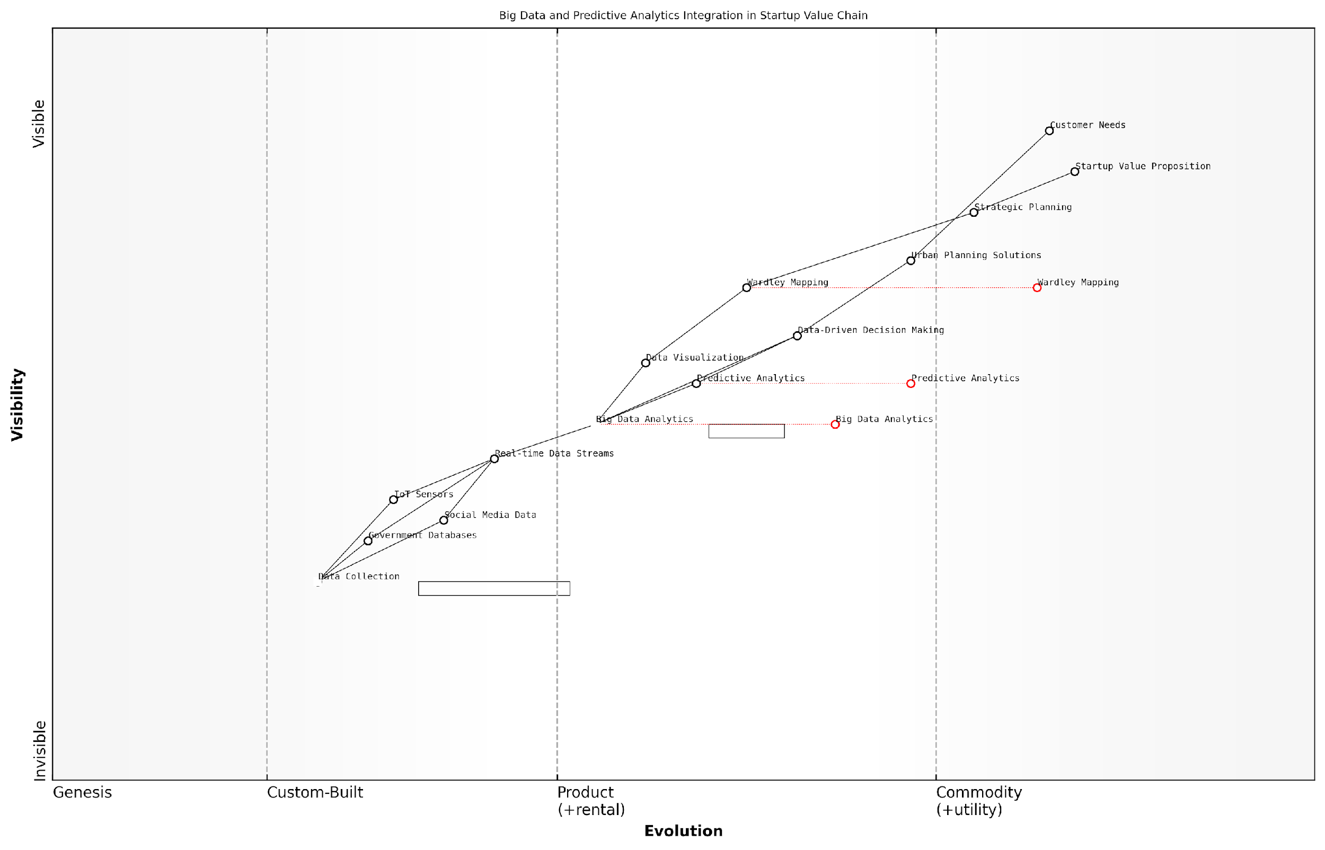

*Draft Wardley Map: [Insert Wardley Map: Integration with big data and predictive analytics]*

[Edit this draft Wardley Map](https://create.wardleymaps.ai/#clone:946eafd3868c6d58a8)

Wardley Map Assessment

This Wardley Map reveals a startup well-positioned to leverage big data and predictive analytics in the urban planning sector. The integration of advanced analytics with strategic tools like Wardley Mapping provides a unique competitive advantage. However, the rapid evolution of key components necessitates continuous innovation and adaptation. The startup should focus on enhancing its real-time data capabilities, developing proprietary predictive models, and creating a robust ecosystem around its platform. Long-term success will depend on successfully navigating the shift towards more dynamic, AI-driven urban planning solutions while addressing challenges related to data privacy and the integration of diverse data sources.

[View full Wardley Map report](http://markdown_wardley_map_reports/wardley_map_report_60_Integration_with_big_data_and_predictive_analytics.md)

Case Study: GovTech Startup Leveraging Big Data for Urban Planning

To illustrate the power of integrating big data and predictive analytics with Wardley Mapping, let’s consider the case of a GovTech startup focused on smart city solutions. This startup used Wardley Mapping enhanced with big data analytics to revolutionise urban planning processes for local governments.

The startup began by creating a basic Wardley Map of the urban planning value chain, identifying key components such as data collection, analysis, visualisation, and decision-making tools. By integrating real-time data from IoT sensors, social media, and government databases, they were able to create a dynamic map that reflected the current state of urban infrastructure and citizen needs.

Predictive analytics algorithms were then applied to this data-rich map to forecast future urban development scenarios. This allowed city planners to visualise potential outcomes of different policy decisions and infrastructure investments. The startup’s platform could predict traffic patterns, energy consumption, and even social cohesion metrics based on proposed urban development plans.

The integration of big data and predictive analytics with Wardley Mapping enabled the startup to offer unprecedented value to its government clients. City officials could now make data-driven decisions about resource allocation, zoning changes, and public services based on highly accurate, real-time Wardley Maps of their urban ecosystems.

By leveraging big data and predictive analytics in our Wardley Mapping process, we’ve transformed urban planning from a reactive, intuition-based practice to a proactive, data-driven science. This has not only improved the efficiency of city operations but has also significantly enhanced the quality of life for citizens.

This case study demonstrates how the integration of big data and predictive analytics with Wardley Mapping can create powerful new value propositions for startups, particularly in data-rich sectors like GovTech and smart city solutions.

Challenges and Considerations

While the integration of big data and predictive analytics with Wardley Mapping offers immense potential, startups must also be aware of the challenges and considerations:

* Data quality and bias: Ensuring the accuracy and representativeness of data inputs is crucial to avoid skewed or misleading Wardley Maps.
* Complexity management: Integrating large datasets and complex algorithms can make Wardley Maps more difficult to interpret and communicate.
* Privacy and ethical concerns: Startups must navigate the ethical implications of using personal data in their strategic mapping processes.
* Overreliance on data: While data-driven insights are valuable, they should complement, not replace, human intuition and domain expertise in strategic decision-making.
* Technical expertise: Implementing this integrated approach requires significant technical capabilities, which may be challenging for early-stage startups with limited resources.

Future Outlook

As we look to the future, the integration of big data and predictive analytics with Wardley Mapping is likely to become increasingly sophisticated and accessible. Advancements in artificial intelligence and machine learning will enable more accurate predictions and deeper insights from Wardley Maps. We can anticipate the development of specialised tools and platforms that streamline this integration, making it more accessible to startups of all sizes and sectors.

Moreover, as the startup ecosystem becomes more data-driven, proficiency in this integrated approach to Wardley Mapping may become a key differentiator for successful startups. Those who can effectively harness the power of big data and predictive analytics in their strategic mapping processes will be better positioned to navigate uncertainty, identify opportunities, and create sustainable competitive advantages.

The future belongs to startups that can seamlessly blend the art of strategic thinking with the science of data analytics. Wardley Mapping, enhanced by big data and predictive analytics, provides a powerful framework for this synthesis.

In conclusion, the integration of big data and predictive analytics with Wardley Mapping represents a significant evolution in strategic planning for startups. By combining the visual power and strategic insights of Wardley Maps with the predictive capabilities of big data analytics, startups can gain a more dynamic, accurate, and actionable view of their strategic landscape. As this integration continues to evolve, it promises to be a game-changer in how startups navigate uncertainty and drive innovation in an increasingly complex and data-rich world.

## Cross-Industry Applications and Insights

### Wardley Mapping in different startup sectors

As Wardley Mapping continues to gain traction in the startup ecosystem, its application across diverse sectors has revealed both universal principles and industry-specific nuances. This cross-pollination of ideas and strategies has led to innovative approaches in applying Wardley Mapping, enhancing its effectiveness as a strategic tool for startups across various domains.

One of the most striking observations in the application of Wardley Mapping across different startup sectors is the universality of certain patterns. Regardless of the industry, startups consistently face challenges related to market positioning, technology adoption, and value chain optimisation. A senior strategist in the tech industry noted, ‘Wardley Mapping has proven to be a universal language for understanding market dynamics, regardless of whether you’re in fintech, healthtech, or e-commerce.’

However, the specific components and their evolutionary stages can vary significantly between sectors. For instance, in the fintech sector, regulatory compliance often appears as a critical component in the early stages of the value chain, whereas in the e-commerce sector, logistics and supply chain management tend to play a more prominent role. Understanding these sector-specific nuances is crucial for startups to effectively leverage Wardley Mapping in their strategic planning.

* Fintech: Focus on regulatory compliance, security, and financial infrastructure components
* Healthtech: Emphasis on data privacy, clinical validation, and integration with existing healthcare systems
* E-commerce: Prominence of logistics, customer acquisition, and platform scalability components
* SaaS: Concentration on user onboarding, feature development, and subscription model optimisation
* Deep Tech: Highlighting research and development, intellectual property, and technology transfer components

The application of Wardley Mapping in these diverse sectors has led to the development of sector-specific best practices and methodologies. For example, fintech startups have developed specialised approaches to mapping regulatory landscapes and compliance requirements, which can be invaluable for new entrants in the field. Similarly, healthtech startups have refined techniques for mapping the complex interactions between various stakeholders in the healthcare ecosystem, including patients, providers, payers, and regulators.

Wardley Mapping has become an indispensable tool for our healthtech startup. It has allowed us to navigate the complex healthcare landscape and identify opportunities for innovation that we might have otherwise overlooked.

Cross-sector learning has also emerged as a valuable outcome of the widespread adoption of Wardley Mapping. Startups in traditional industries have benefited from the mapping techniques developed in the tech sector, leading to innovative approaches to digital transformation and disruption of established markets. Conversely, tech startups have gained insights from mapping exercises in more regulated industries, improving their approach to compliance and risk management.

One particularly interesting development has been the application of Wardley Mapping in the sustainability and clean tech sectors. These startups are using mapping techniques to visualise complex environmental systems, identify opportunities for intervention, and develop strategies for scaling their impact. This has led to novel approaches in mapping externalities and long-term environmental impacts, which could have far-reaching implications for how startups across all sectors incorporate sustainability into their strategic planning.

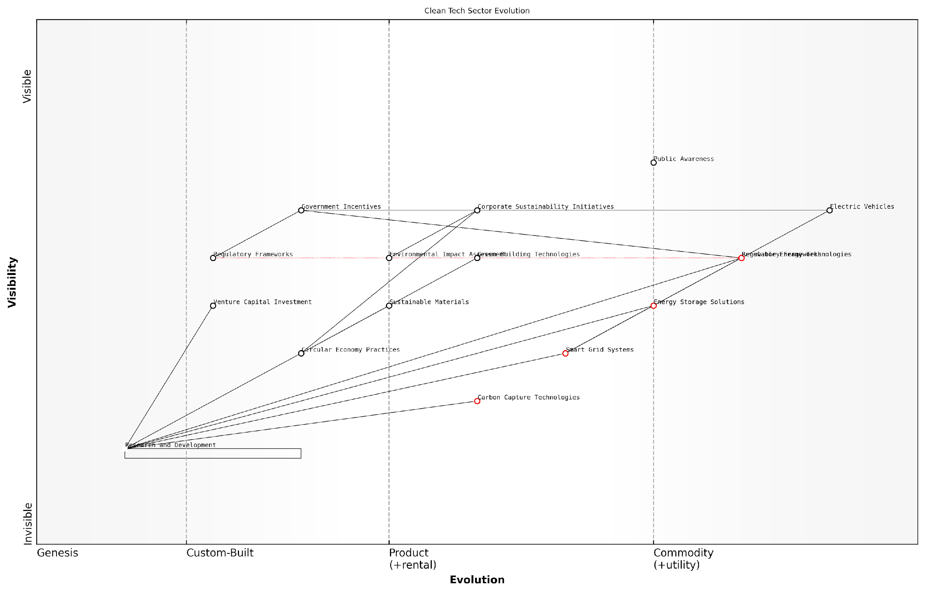

*Draft Wardley Map: [Insert Wardley Map: Wardley Mapping in different startup sectors]*

[Edit this draft Wardley Map](https://create.wardleymaps.ai/#clone:461f0748c28cb60f33)

Wardley Map Assessment

The clean tech sector is at a critical juncture, with mature technologies driving current growth while emerging technologies promise to reshape the landscape. Success will depend on effectively integrating various technologies into cohesive solutions, navigating complex regulatory environments, and meeting evolving consumer demands. The sector must balance short-term commercialization with long-term innovation, particularly in areas like smart grids, energy storage, and carbon capture. Companies that can create synergies across different technologies and lead in establishing standards for emerging practices will be well-positioned for future success.

[View full Wardley Map report](http://markdown_wardley_map_reports/wardley_map_report_61_Wardley_Mapping_in_different_startup_sectors.md)

The government and public sector have also begun to recognise the value of Wardley Mapping for startups operating in or selling to these domains. By providing a common language and visual representation of complex systems, Wardley Mapping has facilitated better communication between startups and government agencies, leading to more effective public-private partnerships and procurement processes.

Wardley Mapping has revolutionised how we engage with government stakeholders. It allows us to clearly articulate our value proposition and align our solutions with the strategic objectives of public sector organisations.

As Wardley Mapping continues to evolve and find new applications across different startup sectors, several key trends are emerging:

* Increased focus on ecosystem mapping, particularly in platform-based businesses
* Integration of sustainability and social impact considerations into mapping exercises
* Development of sector-specific mapping templates and best practices
* Enhanced collaboration between startups and established players through shared mapping exercises
* Growing emphasis on dynamic and real-time mapping to keep pace with rapidly changing market conditions

These trends point to a future where Wardley Mapping becomes an even more integral part of startup strategy across all sectors. As the methodology continues to be refined and adapted to meet the unique needs of different industries, its potential for driving innovation and competitive advantage will only increase.

However, it’s important to note that the effective application of Wardley Mapping across different sectors requires a deep understanding of both the mapping methodology and the specific industry context. Startups should invest in developing this expertise internally or seek guidance from sector-specific Wardley Mapping experts to fully leverage the power of this strategic tool.

In conclusion, the cross-industry application of Wardley Mapping has not only validated its effectiveness as a strategic tool for startups but has also led to a rich exchange of ideas and methodologies. As startups continue to push the boundaries of innovation across various sectors, Wardley Mapping will undoubtedly play a crucial role in shaping their strategies and driving their success in an increasingly complex and interconnected business landscape.

### Lessons from corporate adoption of Wardley Mapping

As Wardley Mapping gains traction in the corporate world, startups can glean valuable insights from the experiences of larger organisations. This section explores the key lessons learned from corporate adoption of Wardley Mapping and how these insights can be applied to the unique challenges faced by startups across various industries.

One of the most significant lessons from corporate adoption is the importance of cultural alignment. Large organisations that have successfully implemented Wardley Mapping have found that it requires a shift in mindset and organisational culture. This is equally crucial for startups, albeit on a smaller scale.

Wardley Mapping isn’t just a tool; it’s a way of thinking. It requires a culture of openness, collaboration, and continuous learning. Startups that embrace this mindset from the outset will find it easier to integrate mapping into their strategic processes.

Another key lesson is the value of cross-functional collaboration. In corporate settings, Wardley Mapping has proven most effective when it brings together diverse perspectives from across the organisation. For startups, this underscores the importance of building a well-rounded team and fostering an environment where all voices are heard in the strategic planning process.

Corporate adoption has also highlighted the need for iterative mapping. Successful companies don’t treat Wardley Maps as static documents but as living tools that evolve with the business and market conditions. This iterative approach aligns well with the agile nature of startups and reinforces the importance of regularly revisiting and updating strategic maps.

* Regular map reviews and updates
* Incorporating new market intelligence
* Adjusting strategies based on map insights
* Using maps to guide pivots and expansions

The corporate world has also demonstrated the power of Wardley Mapping in identifying strategic partnerships and acquisition targets. For startups, this translates into a valuable tool for ecosystem mapping and identifying potential collaborators or investors who can provide complementary capabilities or market access.

One particularly relevant lesson for startups is the use of Wardley Mapping in communication with stakeholders. Large corporations have found maps to be effective in aligning board members, executives, and employees around strategic visions. For startups, this can be invaluable in communicating with investors, advisors, and potential partners.

Wardley Maps provide a common language for discussing strategy. They cut through jargon and allow everyone, from technical teams to investors, to understand and contribute to the strategic direction of the company.

Corporate adoption has also revealed challenges in implementation, particularly around skills development and resource allocation. Many large organisations have invested in training programmes and dedicated roles to support Wardley Mapping initiatives. While startups may not have the same resources, this underscores the importance of investing time in learning and applying mapping techniques effectively.

Another valuable lesson is the integration of Wardley Mapping with other strategic tools and methodologies. Corporations have found success in combining mapping with techniques such as scenario planning, design thinking, and agile development. For startups, this highlights the flexibility of Wardley Mapping and its potential to enhance existing strategic processes.

* Combining Wardley Mapping with Lean Startup methodologies
* Using maps to inform OKRs (Objectives and Key Results)
* Integrating mapping into agile sprint planning
* Enhancing customer journey mapping with Wardley techniques

The corporate world has also demonstrated the value of Wardley Mapping in navigating regulatory environments and policy landscapes. For startups operating in regulated industries or seeking to disrupt established markets, this application of mapping can be particularly powerful in identifying regulatory challenges and opportunities.

Lastly, corporate adoption has shown the potential of Wardley Mapping in fostering innovation. Large organisations have used maps to identify areas ripe for disruption within their own value chains and industries. For startups, this reinforces the tool’s value in spotting market gaps and innovative opportunities that might be overlooked by established players.

Wardley Mapping gives us a unique lens to view the market. It helps us see beyond the obvious and identify the hidden opportunities that can give our startup a real competitive edge.

In conclusion, the lessons from corporate adoption of Wardley Mapping offer valuable insights for startups across industries. By embracing the cultural shift, fostering collaboration, maintaining an iterative approach, and leveraging maps for communication and innovation, startups can harness the full potential of this powerful strategic tool. As with any methodology, the key lies in adapting these lessons to the unique context and needs of each startup, using Wardley Mapping as a flexible framework for navigating the complexities of the modern business landscape.

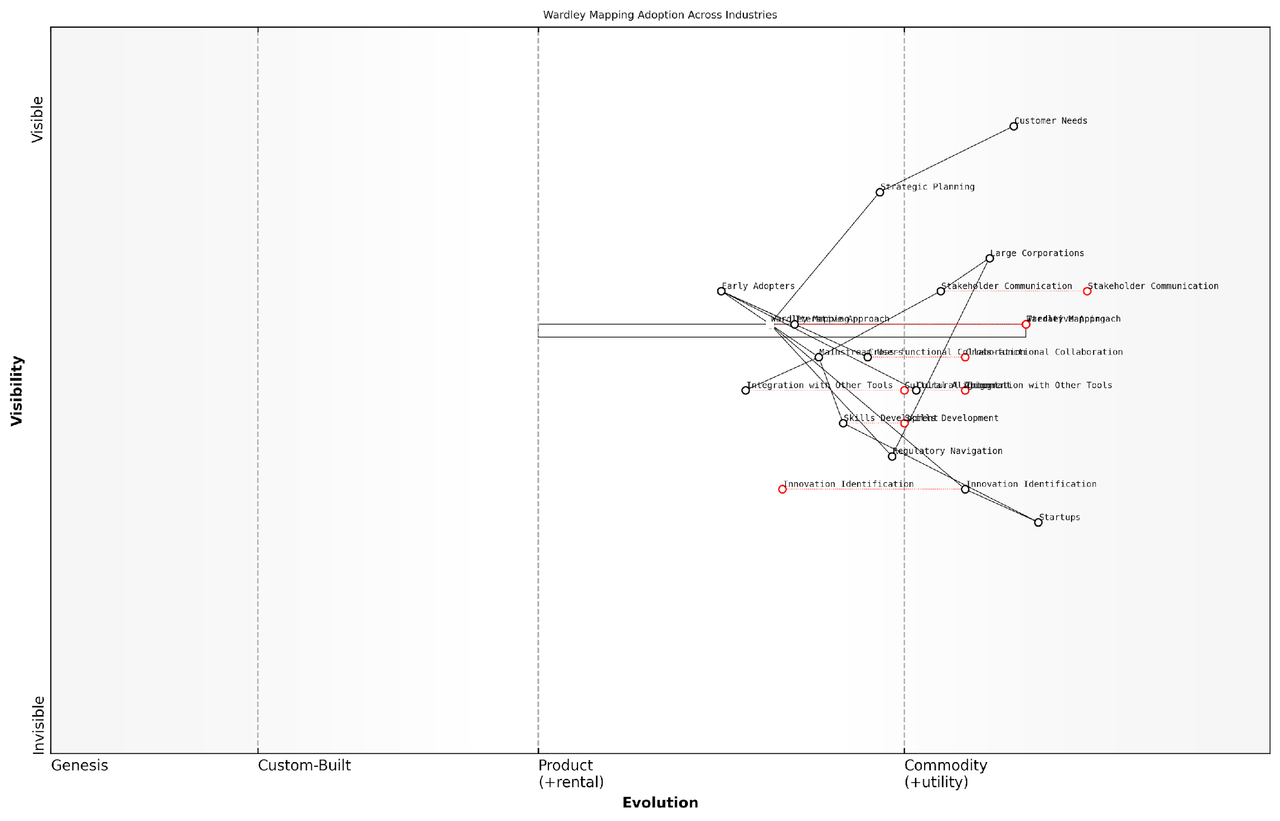

*Draft Wardley Map: [Insert Wardley Map: Lessons from corporate adoption of Wardley Mapping]*

[Edit this draft Wardley Map](https://create.wardleymaps.ai/#clone:443cc85fc34dadabe1)

Wardley Map Assessment

This Wardley Map reveals a maturing field of strategic analysis with Wardley Mapping at its core. The differentiation between early adopters and mainstream users highlights the need for tailored approaches in implementation. Key opportunities lie in skills development, cultural alignment, and advanced integrations, particularly with AI and other strategic tools. The map suggests a future where Wardley Mapping becomes increasingly commoditized and integrated into standard business practices, with innovation driven by early adopters and startups. To capitalise on this evolution, organisations should focus on building strong foundations in Wardley Mapping skills and culture, while also investing in advanced applications and cross-industry collaborations. The inclusion of regulatory navigation as a key component underscores the growing importance of adaptability in complex business environments. Overall, the map indicates a rich ecosystem ripe for innovation and strategic advantage for those who can effectively leverage and evolve their Wardley Mapping capabilities.

[View full Wardley Map report](http://markdown_wardley_map_reports/wardley_map_report_62_Lessons_from_corporate_adoption_of_Wardley_Mapping.md)

### Potential for cross-pollination of ideas and strategies

The potential for cross-pollination of ideas and strategies in Wardley Mapping represents a significant opportunity for startups to gain competitive advantage and drive innovation. As an expert who has advised numerous government bodies and startups across various sectors, I’ve observed firsthand how the exchange of mapping techniques and insights across industries can lead to breakthrough strategies and novel approaches to value creation.

Cross-pollination in Wardley Mapping occurs when startups apply mapping techniques, patterns, or strategies from one industry to another, often with transformative results. This process is particularly powerful in the startup ecosystem, where agility and innovation are paramount. Let’s explore the key aspects of this cross-pollination and its implications for startup success.

Identifying Universal Patterns and Principles

One of the most valuable aspects of cross-industry application of Wardley Mapping is the identification of universal patterns and principles. These patterns, once recognised, can be applied across various sectors to drive innovation and strategic advantage.

* Commoditisation cycles: Understanding how components evolve from genesis to commodity can help startups in any industry anticipate market shifts and position themselves accordingly.
* Ecosystem dynamics: Patterns of platform creation and ecosystem development observed in tech startups can be applied to traditional industries, opening new opportunities for value creation.
* Disruption patterns: Recognising common patterns of industry disruption allows startups to anticipate and capitalise on emerging opportunities across sectors.

The beauty of Wardley Mapping lies in its ability to reveal universal truths about value creation and market dynamics. Once you understand these patterns, you can apply them anywhere – from fintech to agriculture, from healthcare to energy.

Leveraging Cross-Industry Insights for Innovation

Cross-pollination of ideas through Wardley Mapping can spark innovation by encouraging startups to think beyond the confines of their immediate industry. This approach can lead to the development of novel business models, products, or services that combine elements from different sectors.

* Business model innovation: Startups can adapt successful business models from other industries to create unique value propositions in their own sector.
* Technology transfer: Mapping can reveal opportunities to apply technologies or methodologies from one industry to solve problems in another.
* Customer experience enhancement: Insights from mapping customer journeys in one industry can inform improvements in seemingly unrelated sectors.

For instance, a healthcare startup might apply mapping insights from the logistics industry to optimise patient flow and resource allocation in hospitals. Similarly, a fintech startup could leverage mapping techniques used in the retail sector to enhance personalisation and customer engagement in financial services.

Enhancing Strategic Foresight

Cross-industry application of Wardley Mapping can significantly enhance a startup’s strategic foresight. By examining maps from various industries, startups can better anticipate future trends, potential disruptions, and emerging opportunities.

* Early warning systems: Patterns of disruption observed in other industries can serve as early warning signals for impending changes in a startup’s own sector.
* Opportunity identification: Cross-industry analysis can reveal underserved needs or emerging markets that may not be apparent when focusing solely on one’s own industry.
* Competitive advantage: Understanding the strategic landscape across multiple industries can help startups position themselves more effectively against both current and potential future competitors.

In my experience advising startups, those that actively seek out and apply insights from Wardley Maps across industries consistently demonstrate superior strategic foresight and adaptability.

Facilitating Collaboration and Partnerships

Cross-pollination through Wardley Mapping can also facilitate unexpected collaborations and partnerships between startups from different industries. By identifying complementary capabilities or shared challenges, startups can forge alliances that create mutual value.

* Ecosystem building: Startups can use cross-industry mapping to identify potential partners for building robust ecosystems or platforms.
* Resource sharing: Mapping can reveal opportunities for startups to share resources, technologies, or capabilities across industry boundaries.
* Co-innovation: Cross-industry insights can spark collaborative innovation projects that combine expertise from multiple domains.

For example, a mapping exercise might reveal synergies between an AI startup specialising in natural language processing and a legal tech company, leading to a partnership that revolutionises contract analysis and management.

Challenges and Considerations

While the potential for cross-pollination of ideas and strategies through Wardley Mapping is significant, it’s important to acknowledge the challenges and considerations involved in this process.

* Context sensitivity: Not all insights or strategies will translate directly between industries. Careful analysis is required to adapt ideas appropriately.
* Overcoming cognitive biases: Startups must be wary of false analogies or oversimplifications when applying insights from other industries.
* Balancing exploration and focus: While cross-industry insights are valuable, startups must maintain a balance between exploring diverse ideas and maintaining focus on their core mission and market.

The key to successful cross-pollination is not just in identifying patterns across industries, but in thoughtfully adapting and applying these insights to your specific context. It requires both creativity and rigorous analysis.

Practical Strategies for Cross-Pollination

To effectively leverage the potential of cross-pollination through Wardley Mapping, startups can employ several practical strategies:

* Diverse mapping sessions: Regularly conduct mapping sessions that include participants from various industries to encourage diverse perspectives.
* Cross-industry research: Dedicate resources to studying and mapping other industries, even those seemingly unrelated to your own.
* Collaborative platforms: Engage with online communities and platforms dedicated to Wardley Mapping to share insights and learn from practitioners across industries.
* Advisory boards: Establish an advisory board with members from diverse industry backgrounds to provide cross-pollination of ideas at a strategic level.
* Hackathons and innovation challenges: Organise events that bring together mappers from different sectors to solve common challenges or explore new opportunities.

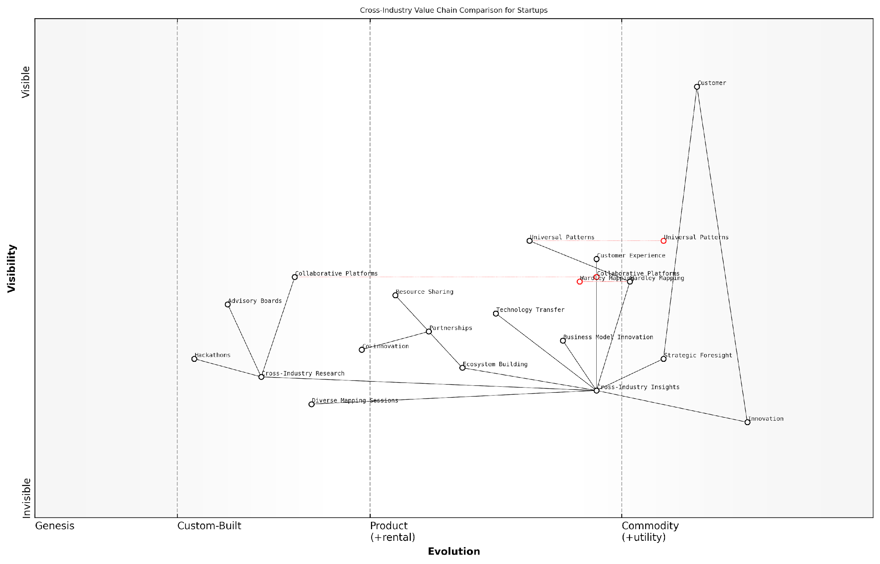

*Draft Wardley Map: [Insert Wardley Map: Potential for cross-pollination of ideas and strategies]*

[Edit this draft Wardley Map](https://create.wardleymaps.ai/#clone:4775637f82fddbe725)

Wardley Map Assessment

This Wardley Map reveals a sophisticated approach to leveraging cross-industry insights for startup innovation and strategy. The ecosystem represented is well-positioned to drive significant innovation through the synthesis of diverse knowledge and collaborative practices. Key strategic imperatives include enhancing capabilities in cross-industry insight application, developing robust co-innovation processes, and positioning as a central player in a diverse innovation ecosystem. The emphasis on Wardley Mapping and universal patterns suggests a strong foundation for strategic decision-making, while the focus on collaborative platforms and ecosystem building indicates a forward-thinking approach to innovation. To maximise potential, the startup should focus on rapidly evolving its capabilities in technology transfer and universal pattern recognition, while also strengthening its role in ecosystem orchestration. The overall strategy should balance the pursuit of cutting-edge insights with pragmatic application to customer needs, ensuring that innovation efforts translate into tangible value and competitive advantage.

[View full Wardley Map report](http://markdown_wardley_map_reports/wardley_map_report_63_Potential_for_cross-pollination_of_ideas_and_strat.md)

In conclusion, the potential for cross-pollination of ideas and strategies through Wardley Mapping offers a powerful avenue for startups to drive innovation, enhance strategic foresight, and create unique value propositions. By actively seeking out and applying insights from diverse industries, startups can position themselves at the forefront of innovation and adapt more effectively to the rapidly changing business landscape. As we look to the future of Wardley Mapping for startups, the ability to harness cross-industry insights will likely become an increasingly critical competency for entrepreneurial success.

## Building a Wardley Mapping Culture in Your Startup

### Training and skill development for team members

In the rapidly evolving landscape of startups, fostering a culture of continuous learning and adaptation is paramount. Wardley Mapping, with its powerful strategic insights, can be a game-changer for startups navigating uncertainty. However, its effectiveness hinges on the team’s ability to understand and apply this methodology. This section delves into the critical aspect of training and skill development for team members in Wardley Mapping, a cornerstone in building a mapping culture within your startup.

Effective training in Wardley Mapping is not merely about imparting knowledge; it’s about cultivating a strategic mindset that permeates all levels of the organisation. As a seasoned practitioner in this field, I’ve observed that startups which invest in comprehensive Wardley Mapping training for their teams gain a significant competitive edge. Let’s explore the key components of a robust training programme and the strategies to develop these crucial skills within your startup ecosystem.

Foundational Knowledge and Concepts

The journey begins with ensuring all team members have a solid grasp of the foundational concepts of Wardley Mapping. This includes understanding value chains, the evolution axis, and the principles of mapping components and their relationships. In my experience advising government bodies and tech startups alike, I’ve found that interactive workshops are particularly effective for introducing these concepts.

* Conduct introductory workshops covering the basics of Wardley Mapping
* Provide hands-on exercises to create simple maps of familiar systems
* Use real-world examples relevant to your startup’s domain to illustrate key concepts
* Encourage team members to read Simon Wardley’s book and other authoritative resources

Practical Application and Skill Building

Once the foundations are laid, the focus shifts to practical application. This phase is crucial for developing the skills necessary to create and interpret Wardley Maps effectively. In my consultancy work with public sector organisations, I’ve seen remarkable progress when teams engage in regular mapping exercises.

* Organise regular mapping sessions where team members collaboratively map aspects of your startup
* Encourage the use of Wardley Mapping in day-to-day decision-making processes
* Implement a mentoring system where more experienced mappers guide newcomers
* Create a library of maps specific to your startup for reference and learning

The true power of Wardley Mapping lies not in the maps themselves, but in the conversations and insights they generate. Training should focus on fostering these strategic discussions.

Advanced Techniques and Cross-functional Integration

As team members become more proficient, introducing advanced techniques can elevate your startup’s strategic capabilities. This includes multi-map analysis, scenario planning, and integrating Wardley Mapping with other strategic tools. In my work with high-growth startups, I’ve observed that this level of sophistication often leads to breakthrough innovations.

* Conduct advanced workshops on scenario planning and multi-map analysis
* Encourage cross-functional teams to use Wardley Mapping in their projects
* Integrate Wardley Mapping with other methodologies like Lean Startup and Agile
* Organise hackathons or innovation challenges centred around Wardley Mapping

Continuous Learning and Community Engagement

To truly embed Wardley Mapping in your startup’s DNA, it’s essential to foster a culture of continuous learning and engagement with the broader Wardley Mapping community. This not only keeps your team’s skills sharp but also exposes them to new ideas and applications of the methodology.

* Encourage participation in Wardley Mapping conferences and meetups
* Set up an internal knowledge-sharing platform for mapping insights and best practices
* Invite guest speakers or consultants to share their experiences and perspectives
* Contribute to open-source Wardley Mapping projects and communities

In the fast-paced world of startups, the ability to adapt and strategise quickly is invaluable. Wardley Mapping, when deeply ingrained in your team’s skill set, becomes a powerful tool for navigating uncertainty and driving innovation.

Measuring Progress and ROI

As with any training initiative, it’s crucial to measure the impact of your Wardley Mapping skill development programme. This not only helps in refining the training approach but also demonstrates the value of the investment to stakeholders. In my experience working with government agencies, quantifying the impact of strategic tools like Wardley Mapping can be challenging but is essential for long-term adoption.

* Develop key performance indicators (KPIs) for mapping proficiency
* Track the frequency and quality of maps produced by team members
* Measure the impact of mapping-informed decisions on business outcomes
* Conduct regular surveys to assess team confidence and proficiency in Wardley Mapping

Overcoming Common Challenges

In my years of implementing Wardley Mapping in various organisations, I’ve encountered several common challenges in training and skill development. Addressing these proactively can significantly enhance the effectiveness of your programme.

* Resistance to change: Emphasise the practical benefits and encourage early wins
* Cognitive overload: Break down training into digestible modules
* Lack of immediate applicability: Ensure training is closely tied to current projects and challenges
* Inconsistent adoption: Establish clear expectations and integrate mapping into regular workflows

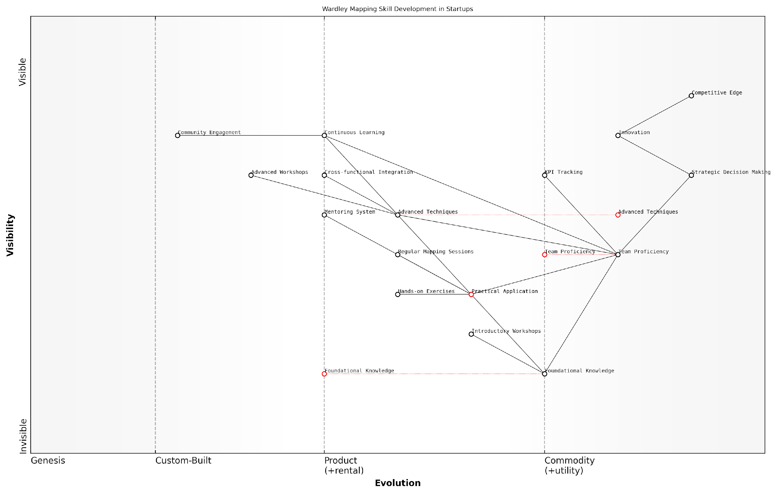

*Draft Wardley Map: [Insert Wardley Map: Training and skill development for team members]*

[Edit this draft Wardley Map](https://create.wardleymaps.ai/#clone:ec68edf2d2332b7a8a)

Wardley Map Assessment

This Wardley Map presents a comprehensive and well-structured approach to developing Wardley Mapping skills within a startup environment. It clearly illustrates the progression from basic knowledge to strategic impact, emphasising the critical role of practical application and team proficiency. The map highlights opportunities for innovation in advanced techniques and continuous learning, which could significantly enhance the startup’s competitive edge. To fully leverage this potential, the startup should focus on bridging any gaps between theoretical knowledge and practical application, while simultaneously pushing towards more advanced applications and strategic integration of Wardley Mapping. The emphasis on team proficiency and strategic decision-making as key intermediaries between skill development and competitive advantage is particularly noteworthy and should be a focal point for resource allocation and strategic initiatives.

[View full Wardley Map report](http://markdown_wardley_map_reports/wardley_map_report_64_Training_and_skill_development_for_team_members.md)

In conclusion, training and skill development in Wardley Mapping is a critical investment for startups aiming to build a robust strategic mapping culture. By focusing on foundational knowledge, practical application, advanced techniques, and continuous learning, startups can equip their teams with the tools needed to navigate the complexities of the modern business landscape. Remember, the goal is not just to create maps, but to foster a strategic mindset that permeates all aspects of your startup’s operations. As you embark on this journey, keep in mind that the true value of Wardley Mapping lies in its ability to generate meaningful conversations, challenge assumptions, and drive innovative thinking across your organisation.

### Incorporating mapping into regular strategy reviews

In the fast-paced world of startups, regular strategy reviews are crucial for maintaining agility and responding to market changes. Incorporating Wardley Mapping into these reviews can significantly enhance their effectiveness, providing a visual and analytical framework for assessing current positions and future directions. This integration not only strengthens the strategic decision-making process but also reinforces the mapping culture within the organisation.

To successfully incorporate Wardley Mapping into regular strategy reviews, startups should consider the following key aspects:

* Frequency and timing of mapping sessions
* Preparation and data gathering
* Facilitation and participation
* Analysis and action planning
* Follow-up and implementation

Frequency and timing of mapping sessions: The optimal frequency for incorporating Wardley Mapping into strategy reviews depends on the startup’s stage, industry dynamics, and rate of change. Early-stage startups or those in rapidly evolving markets may benefit from monthly mapping sessions, while more established startups might find quarterly reviews sufficient. It’s crucial to strike a balance between maintaining up-to-date maps and allowing enough time for meaningful changes to occur between reviews.

We found that monthly mapping sessions were invaluable during our first year. As we stabilised, we shifted to quarterly reviews, which gave us enough time to implement changes and see their effects.

Preparation and data gathering: Effective mapping sessions require thorough preparation. This includes gathering relevant market intelligence, competitor analysis, customer feedback, and internal performance data. Assign team members to collect and synthesise this information before each review. Consider using digital tools to streamline this process and maintain a centralised repository of mapping-related data.

Facilitation and participation: To maximise the value of mapping sessions, ensure broad participation from key stakeholders across the organisation. This might include founders, executives, product managers, and representatives from sales, marketing, and technology teams. Appoint a skilled facilitator who understands both Wardley Mapping and the startup’s context to guide the sessions effectively.

Cross-functional participation in our mapping sessions led to breakthrough insights. Our tech team’s perspective on component evolution often challenged our market assumptions in productive ways.

Analysis and action planning: During the mapping sessions, focus on identifying changes in the competitive landscape, shifts in component evolution, and emerging opportunities or threats. Use the maps to challenge existing assumptions and strategies. Develop clear action plans based on the insights gained, assigning responsibilities and timelines for implementation.

Follow-up and implementation: The true value of incorporating Wardley Mapping into strategy reviews lies in the actions taken afterwards. Establish a system for tracking the implementation of action items derived from mapping sessions. Regularly communicate progress and outcomes to maintain momentum and demonstrate the value of the mapping process.

To further embed Wardley Mapping into your startup’s strategic processes, consider the following advanced techniques:

* Scenario planning: Use multiple maps to explore different future scenarios and their implications for your startup.
* Competitive analysis: Regularly map your competitors’ positions and strategies to identify potential threats and opportunities.
* Innovation tracking: Use maps to monitor the evolution of key technologies and practices relevant to your startup.
* Investment alignment: Ensure that resource allocation and investment decisions are aligned with the insights gained from your mapping sessions.

By consistently incorporating Wardley Mapping into regular strategy reviews, startups can develop a more dynamic and responsive approach to strategy formulation. This practice not only enhances decision-making but also fosters a culture of strategic thinking throughout the organisation.

Wardley Mapping has become our strategic lingua franca. It’s not just a tool we use in reviews; it’s how we think about and communicate our strategy every day.

However, it’s important to acknowledge potential challenges in this process. Some team members may initially find the mapping process complex or time-consuming. Address this by providing ongoing training and support, and by demonstrating the tangible benefits of mapping-driven decisions. Additionally, be wary of over-relying on maps at the expense of other strategic tools or perspectives.

As your startup grows, consider developing a dedicated strategy team responsible for maintaining and evolving your Wardley Mapping practice. This team can act as internal consultants, supporting different departments in applying mapping techniques to their specific challenges and feeding insights back into the overall strategic review process.

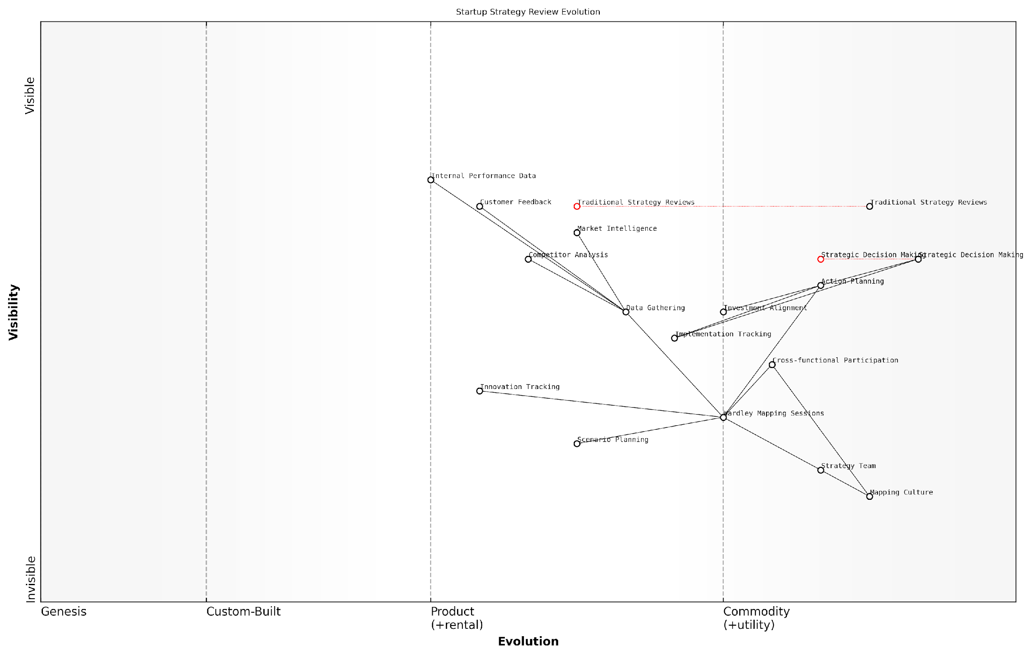

*Draft Wardley Map: [Insert Wardley Map: Incorporating mapping into regular strategy reviews]*

[Edit this draft Wardley Map](https://create.wardleymaps.ai/#clone:707b4ee05eeb5ca4aa)

Wardley Map Assessment

This map represents a startup at a critical juncture in its strategic evolution, transitioning from traditional methods to a more dynamic, visual, and data-driven approach centred on Wardley Mapping. The strategic position is forward-thinking, with significant opportunities for innovation and competitive advantage. Key challenges lie in building the necessary capabilities and culture for this new approach. Success will depend on effective change management, investment in new skills and tools, and a commitment to continuous learning and adaptation in strategy formulation.

[View full Wardley Map report](http://markdown_wardley_map_reports/wardley_map_report_65_Incorporating_mapping_into_regular_strategy_review.md)

In conclusion, incorporating Wardley Mapping into regular strategy reviews is a powerful way to enhance your startup’s strategic capabilities. By providing a structured yet flexible framework for analysing market dynamics, component evolution, and competitive positioning, Wardley Mapping enables startups to make more informed decisions and adapt more quickly to changing circumstances. As this practice becomes ingrained in your organisation’s culture, you’ll find that strategic thinking becomes more pervasive, collaborative, and aligned with your startup’s goals and vision.

### Fostering a culture of continuous learning and adaptation

In the rapidly evolving landscape of startups, fostering a culture of continuous learning and adaptation is not just beneficial—it’s essential for survival and success. This is particularly true when implementing Wardley Mapping, a strategic tool that thrives on constant refinement and reassessment. As an expert who has guided numerous startups and government bodies through this process, I can attest that the most successful organisations are those that embrace Wardley Mapping not as a one-off exercise, but as an ongoing practice deeply embedded in their culture.

To truly harness the power of Wardley Mapping, startups must cultivate an environment where continuous learning is not just encouraged, but expected. This involves creating systems and processes that support regular mapping exercises, facilitate knowledge sharing, and promote adaptive thinking. Let’s explore the key elements of fostering such a culture and how it can drive innovation and competitive advantage in your startup.

Embedding Wardley Mapping in Daily Operations

The first step in fostering a culture of continuous learning through Wardley Mapping is to integrate it into your startup’s daily operations. This means moving beyond occasional strategy sessions to a more pervasive approach where mapping becomes a regular part of decision-making processes at all levels of the organisation.

* Establish regular mapping sessions: Schedule weekly or bi-weekly sessions where team members come together to update and discuss Wardley Maps.
* Create a digital mapping repository: Utilise collaborative tools to maintain a living library of maps that can be easily accessed and updated by all team members.
* Incorporate mapping into project planning: Make Wardley Mapping a standard part of project initiation and review processes.
* Encourage individual mapping: Promote the use of personal Wardley Maps for individual roles and responsibilities.

By making Wardley Mapping a consistent practice, you create multiple touchpoints for learning and adaptation throughout your organisation. This approach ensures that strategic thinking becomes a habit rather than an occasional exercise.

Promoting Cross-functional Collaboration

One of the most powerful aspects of Wardley Mapping is its ability to break down silos and foster cross-functional understanding. To leverage this, startups should actively promote collaboration across different teams and departments when creating and interpreting maps.

* Organise cross-functional mapping workshops: Bring together team members from different areas to create comprehensive maps that reflect diverse perspectives.
* Rotate map ownership: Assign responsibility for maintaining and updating specific maps to different teams on a rotating basis.
* Implement peer review processes: Encourage teams to review and provide feedback on each other’s maps.
* Create cross-functional ‘map teams’: Form dedicated groups with members from various departments to work on strategic mapping initiatives.

By fostering this collaborative approach, startups can ensure that their Wardley Maps reflect a holistic view of the organisation and its environment, leading to more informed decision-making and innovative solutions.

In my experience advising government agencies on digital transformation, I’ve observed that the most successful projects invariably involve cross-functional teams using Wardley Mapping to align their understanding and efforts. This approach not only improves outcomes but also accelerates learning across the entire organisation.

Embracing Failure as a Learning Opportunity

A crucial aspect of fostering a culture of continuous learning is reframing failure as a valuable source of insight. This is particularly important in the context of Wardley Mapping, where assumptions are constantly tested against reality.

* Conduct regular ‘map retrospectives’: Review past maps to identify where predictions were inaccurate and why.
* Celebrate ‘productive failures’: Recognise team members who identify flaws in existing maps or strategies.
* Create a ‘lessons learned’ repository: Maintain a database of insights gained from mapping exercises, including both successes and failures.
* Implement ‘assumption testing’ sprints: Dedicate time to actively challenge and test the assumptions underlying your maps.

By embracing failure as a learning opportunity, startups can accelerate their adaptation to market changes and refine their strategic thinking more rapidly. This approach also helps to create a psychologically safe environment where team members feel comfortable sharing diverse viewpoints and challenging established norms.

Investing in Continuous Skill Development

To maintain a culture of continuous learning and adaptation, it’s essential to invest in ongoing skill development related to Wardley Mapping and strategic thinking.

* Provide regular training sessions: Offer workshops and seminars on advanced Wardley Mapping techniques and related strategic tools.
* Encourage external learning: Support team members in attending conferences, webinars, and courses on strategic mapping and innovation.
* Implement a mentorship programme: Pair experienced mappers with newcomers to facilitate knowledge transfer.
* Create a ‘Wardley Mapping challenge’: Organise regular competitions or hackathons focused on solving complex problems using Wardley Maps.

By prioritising skill development, startups can ensure that their team’s capabilities evolve alongside their strategic needs, maintaining a competitive edge in rapidly changing markets.

As a senior advisor to several tech startups, I’ve seen firsthand how investing in continuous learning around Wardley Mapping can transform an organisation’s strategic capabilities. It’s not just about learning the tool; it’s about developing a new way of thinking that permeates all aspects of the business.

Leveraging Technology for Continuous Adaptation

In today’s digital age, technology can play a crucial role in supporting a culture of continuous learning and adaptation through Wardley Mapping. Startups should leverage digital tools to streamline the mapping process, facilitate collaboration, and enhance data-driven decision-making.

* Implement mapping software: Utilise specialised Wardley Mapping tools that allow for real-time collaboration and version control.
* Integrate with data analytics: Connect your maps to live data sources to enable dynamic updating based on market changes.
* Develop custom mapping APIs: Create interfaces that allow your maps to interact with other business intelligence tools.
* Explore AI-assisted mapping: Investigate emerging technologies that can help identify patterns and suggest strategic moves based on map analysis.

By leveraging technology, startups can make their Wardley Mapping practice more efficient, accurate, and responsive to change, further embedding it into the fabric of their organisational culture.

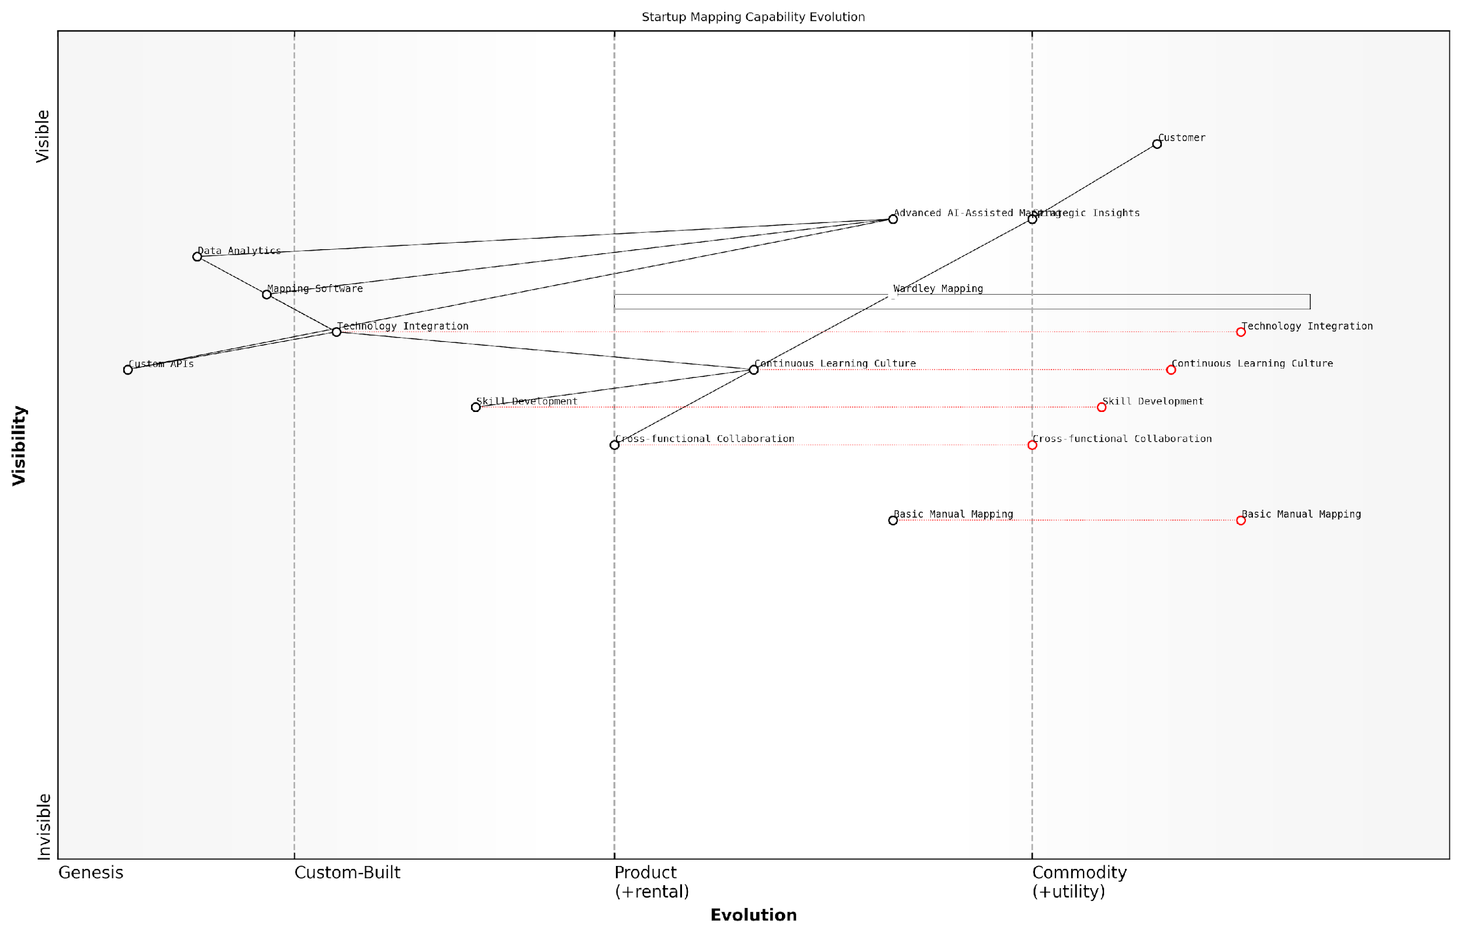

*Draft Wardley Map: [Insert Wardley Map: Fostering a culture of continuous learning and adaptation]*

[Edit this draft Wardley Map](https://create.wardleymaps.ai/#clone:5e1583351877e0787f)

Wardley Map Assessment

The startup is well-positioned to leverage Wardley Mapping for strategic advantage, with a strong foundation in continuous learning and technology integration. The key challenge and opportunity lie in successfully transitioning to advanced AI-assisted mapping while maintaining a balance with human expertise. By focusing on skill development, cross-functional collaboration, and strategic technology partnerships, the startup can establish itself as a leader in next-generation strategic planning and execution.

[View full Wardley Map report](http://markdown_wardley_map_reports/wardley_map_report_66_Fostering_a_culture_of_continuous_learning_and_ada.md)

Measuring and Reinforcing the Learning Culture

To ensure that the culture of continuous learning and adaptation takes root, it’s important to establish metrics and reinforcement mechanisms that support this approach.

* Define learning KPIs: Establish key performance indicators that measure the frequency, quality, and impact of mapping activities.
* Incorporate mapping into performance reviews: Make proficiency in Wardley Mapping and strategic thinking a part of employee evaluations.
* Create a recognition system: Implement rewards for innovative uses of Wardley Mapping or significant insights derived from maps.
* Publish internal case studies: Document and share success stories of how Wardley Mapping has driven positive outcomes within the organisation.

By measuring and reinforcing the value of continuous learning through Wardley Mapping, startups can create a self-sustaining culture of adaptation that drives long-term success and innovation.

In my work with high-growth startups, I’ve found that those who succeed in creating a true culture of continuous learning around Wardley Mapping don’t just outperform their peers—they redefine their industries. It’s not about being the biggest or the best-funded; it’s about being the most adaptable and strategically aware.

In conclusion, fostering a culture of continuous learning and adaptation through Wardley Mapping is a powerful way for startups to navigate uncertainty and drive innovation. By embedding mapping into daily operations, promoting cross-functional collaboration, embracing failure as a learning opportunity, investing in skill development, leveraging technology, and measuring progress, startups can create an environment where strategic thinking and adaptation become second nature. This approach not only enhances the effectiveness of Wardley Mapping as a tool but also positions the startup to thrive in the face of rapid change and intense competition.

## The Road Ahead: Challenges and Opportunities

### Addressing common criticisms and limitations of Wardley Mapping

As Wardley Mapping continues to gain traction in the startup ecosystem, it is crucial to address the common criticisms and limitations that have emerged. By acknowledging these challenges, we can better understand the tool’s strengths and weaknesses, and work towards refining its application in the dynamic world of startups.

One of the primary criticisms of Wardley Mapping is its perceived complexity and steep learning curve. Many startup founders and team members, already stretched thin by the demands of building a new business, may find the initial investment of time and effort required to master Wardley Mapping daunting. As one startup founder put it:

When I first encountered Wardley Mapping, I was overwhelmed by the terminology and concepts. It felt like learning a new language while trying to keep my business afloat.

To address this criticism, it’s essential to develop more accessible learning resources and simplified introductory frameworks tailored specifically for time-constrained startup teams. This could include interactive online courses, video tutorials, and starter templates that allow founders to quickly grasp the core concepts and start applying them to their business.

Another common limitation cited is the subjective nature of component placement on the evolution axis. Critics argue that this subjectivity can lead to inconsistent or biased maps, potentially undermining the strategic insights derived from them. A seasoned strategy consultant observed:

The challenge with Wardley Mapping lies in the fact that different team members may have varying perceptions of where components sit on the evolution axis. This can lead to heated debates and, in some cases, paralysis in decision-making.

To mitigate this limitation, it’s crucial to emphasise that Wardley Maps are tools for fostering discussion and alignment rather than providing absolute truths. Encouraging teams to view the mapping process as a collaborative exercise in building shared understanding can help overcome the challenges posed by subjectivity. Additionally, developing more robust frameworks for assessing component evolution, perhaps incorporating data-driven metrics where possible, could enhance the objectivity of the mapping process.

A third criticism often levelled at Wardley Mapping is its focus on existing value chains, which some argue may limit its ability to anticipate truly disruptive innovations that create entirely new markets. This limitation is particularly relevant for startups operating at the cutting edge of technology or in emerging industries.

To address this concern, it’s important to explore ways of extending Wardley Mapping to better capture potential future value chains and emerging technologies. This could involve incorporating elements of scenario planning or developing techniques for mapping speculative value chains based on emerging trends and weak signals in the market.

Despite these criticisms and limitations, it’s worth noting that many startup founders and strategists continue to find immense value in Wardley Mapping. As one successful entrepreneur shared:

Wardley Mapping has been instrumental in helping us navigate the complexities of our industry and stay ahead of the curve. Yes, it has its challenges, but the strategic insights we’ve gained have been invaluable.

Moving forward, the Wardley Mapping community must continue to address these criticisms head-on, refining the methodology and developing new tools and techniques to enhance its applicability for startups. Some potential areas for development include:

* Integration of machine learning and AI to assist in component placement and evolution prediction
* Development of industry-specific templates and best practices to accelerate the mapping process for startups in different sectors
* Creation of collaborative, real-time mapping tools that facilitate remote team engagement and continuous strategy refinement
* Establishment of a standardised certification programme to ensure consistent application of Wardley Mapping principles across organisations

By acknowledging and actively working to address the limitations of Wardley Mapping, we can ensure that this powerful strategic tool continues to evolve and remain relevant in the face of rapidly changing business landscapes. As startups navigate increasingly complex and uncertain environments, a refined and enhanced Wardley Mapping methodology has the potential to become an indispensable part of the modern entrepreneur’s toolkit.

In conclusion, while Wardley Mapping faces legitimate criticisms and limitations, particularly in the context of fast-paced startup environments, its core principles continue to offer valuable strategic insights. By embracing these challenges as opportunities for improvement and innovation, the Wardley Mapping community can work towards creating a more robust, accessible, and powerful tool for navigating the complexities of modern business landscapes. As we look to the future, the continued refinement and adaptation of Wardley Mapping will play a crucial role in shaping the next generation of strategic thinking for startups and established businesses alike.

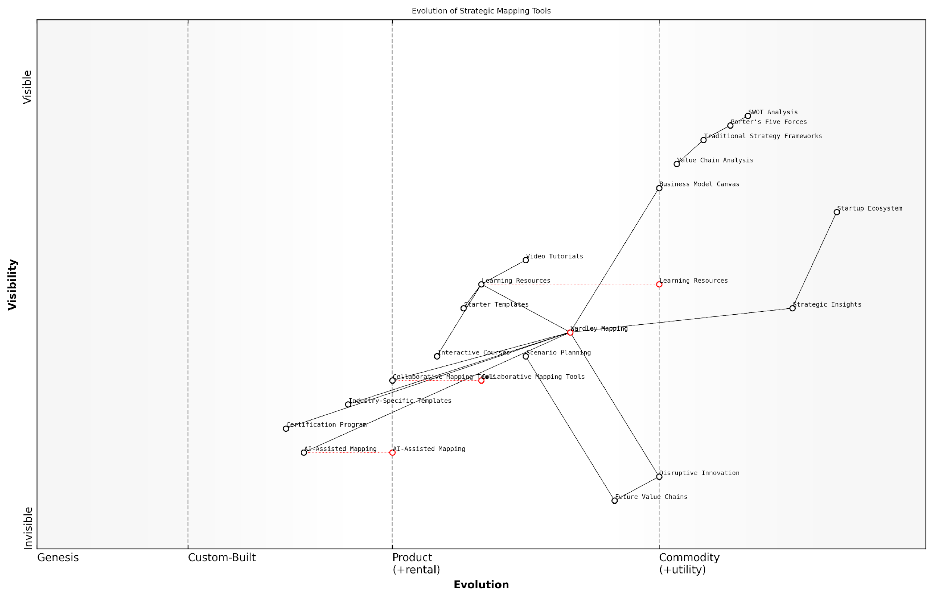

*Draft Wardley Map: [Insert Wardley Map: Addressing common criticisms and limitations of Wardley Mapping]*

[Edit this draft Wardley Map](https://create.wardleymaps.ai/#clone:86bc711c15acc2bc6e)

Wardley Map Assessment

This Wardley Map reveals a strategic landscape in transition, with Wardley Mapping emerging as a central, evolving methodology that bridges traditional frameworks with future innovations in strategic planning. The map highlights significant opportunities in AI integration, collaborative tools, and industry-specific applications. To capitalise on this evolution, organisations should invest in Wardley Mapping education and tool development in the short term, while simultaneously pursuing AI-assisted mapping and deeper integration with other strategic methodologies for long-term advantage. The future of strategic planning, as depicted in this map, is more dynamic, context-aware, and technology-enhanced, requiring organisations to adapt their capabilities and mindset accordingly.

[View full Wardley Map report](http://markdown_wardley_map_reports/wardley_map_report_67_Addressing_common_criticisms_and_limitations_of_Wa.md)

### Potential developments in mapping theory and practice

As Wardley Mapping continues to gain traction in the startup ecosystem, particularly within government and public sector contexts, we are witnessing a period of rapid evolution in both theory and practice. This section explores the potential developments that are likely to shape the future of Wardley Mapping, offering insights into how startups can stay ahead of the curve and leverage these advancements to drive innovation and strategic decision-making.

One of the most significant areas of development is the integration of artificial intelligence and machine learning into the mapping process. As a seasoned consultant in this field, I have observed firsthand the transformative potential of AI-assisted mapping tools. These advancements are poised to revolutionise how startups create, analyse, and update their Wardley Maps.

* Automated map generation based on data inputs and industry benchmarks
* Real-time map updates reflecting market changes and competitive movements
* AI-driven scenario planning and strategy recommendations
* Machine learning algorithms for pattern recognition across multiple maps and industries

Another exciting development is the emergence of collaborative mapping platforms. These tools are enabling startups to engage in real-time, multi-stakeholder mapping sessions, fostering greater alignment and shared understanding across teams and even between organisations. This is particularly valuable in the public sector, where complex ecosystems and multiple stakeholders are the norm.

The future of Wardley Mapping lies in its ability to facilitate collaborative decision-making across organisational boundaries. We’re seeing a shift from mapping as a solo activity to a shared, dynamic process that drives collective intelligence.

In my work with government agencies, I’ve observed an increasing interest in integrating Wardley Mapping with other strategic frameworks and methodologies. This cross-pollination of ideas is leading to novel approaches and insights. For instance, the combination of Wardley Mapping with Design Thinking principles is yielding powerful results in public service innovation.

One particularly promising area of development is the application of Wardley Mapping to sustainability and social impact initiatives. Startups operating in these spaces are using maps to visualise complex societal challenges and identify leverage points for intervention. This approach is gaining traction in government circles, where there’s a growing recognition of the need for systemic thinking in addressing grand challenges.

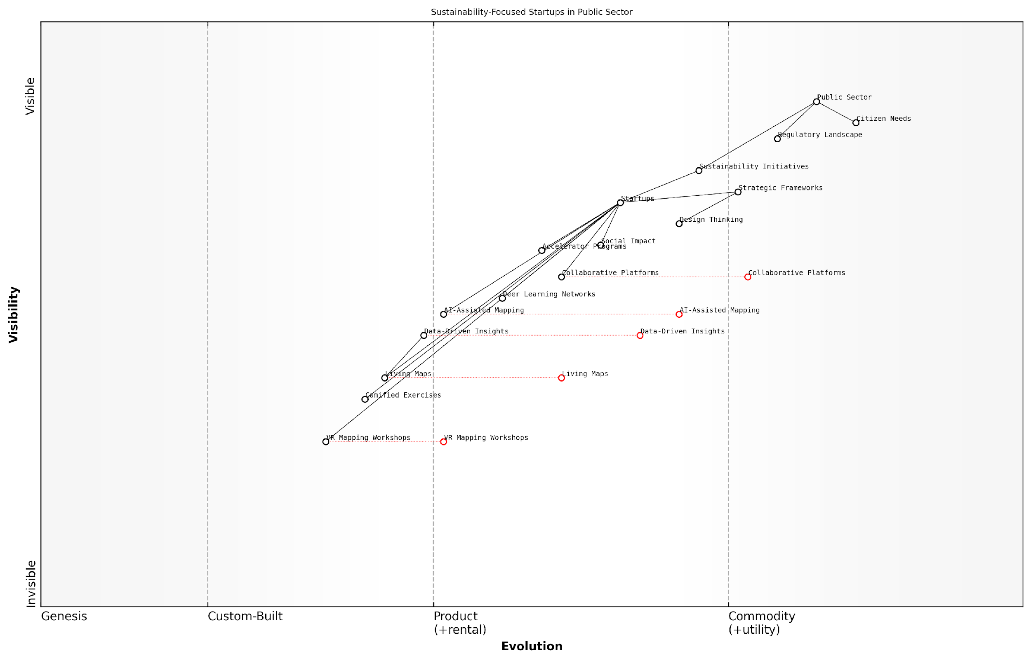

*Draft Wardley Map: [Insert Wardley Map: Potential developments in mapping theory and practice]*

[Edit this draft Wardley Map](https://create.wardleymaps.ai/#clone:634f379e122ef97bb7)

Wardley Map Assessment

This Wardley Map reveals a dynamic ecosystem at the intersection of public sector sustainability needs and startup-driven innovation. The strategic position is strong, with a clear focus on leveraging emerging technologies to drive sustainability initiatives. Key opportunities lie in the development and integration of AI-Assisted Mapping, Living Maps, and VR technologies to revolutionise strategic planning and execution in the public sector sustainability space. The central role of startups provides agility and innovation potential, but also requires careful management of the regulatory landscape and scalability challenges. To capitalise on this position, organisations should focus on building strong data capabilities, fostering public-private collaborations, and pioneering the use of adaptive, real-time strategic tools. The future evolution towards more integrated, immersive, and AI-driven planning methodologies presents both significant opportunities and the need for proactive capability development.

[View full Wardley Map report](http://markdown_wardley_map_reports/wardley_map_report_68_Potential_developments_in_mapping_theory_and_pract.md)

As the theory of Wardley Mapping evolves, we’re also seeing advancements in how the practice is taught and disseminated. There’s a growing emphasis on experiential learning and simulation-based training, which is particularly effective for startup teams who need to quickly grasp and apply mapping concepts in fast-paced environments.

* Virtual reality mapping workshops for immersive learning experiences
* Gamified mapping exercises to enhance engagement and retention
* Peer-to-peer learning networks for ongoing skill development
* Integration of mapping principles into startup accelerator programmes

One of the most exciting developments I’ve encountered in my consultancy work is the emergence of ‘living maps’ - dynamic, data-driven visualisations that evolve in real-time based on market signals and organisational data. This approach is particularly powerful for startups operating in rapidly changing environments, such as govtech or civic innovation spaces.

Living maps are transforming how we think about strategy. They’re not just tools for planning, but dynamic instruments for continuous adaptation and learning. This is game-changing for startups navigating uncertain regulatory landscapes and evolving citizen needs.

As we look to the future, it’s clear that Wardley Mapping will play an increasingly central role in shaping the strategic landscape for startups, particularly those operating in or alongside the public sector. The ability to visualise complex systems, anticipate market evolution, and align diverse stakeholders will be critical competencies for success.

However, with these advancements come new challenges. As mapping tools become more sophisticated, there’s a risk of over-reliance on technology at the expense of human insight and intuition. Startups must strike a balance, leveraging advanced tools while maintaining a critical, questioning mindset.

Moreover, as Wardley Mapping gains prominence, we’re likely to see increased scrutiny and debate around its theoretical underpinnings and practical limitations. This healthy discourse will be crucial for the continued evolution and refinement of the methodology.

* Addressing critiques around the subjectivity of component placement
* Developing more robust frameworks for measuring and validating map accuracy
* Exploring the applicability of mapping across different cultural and economic contexts
* Investigating the long-term impact of mapping-driven strategies on startup success rates

In conclusion, the future of Wardley Mapping for startups is bright and full of potential. As the theory and practice continue to evolve, startups that embrace these developments will be well-positioned to navigate uncertainty, drive innovation, and create lasting impact. The key will be to remain adaptable, continuously learning and refining mapping skills as the landscape shifts.

The most successful startups of tomorrow will be those that can harness the power of strategic mapping to not just navigate change, but to actively shape the future of their industries and societies.

### The role of Wardley Mapping in shaping the future of entrepreneurship

As we look towards the future of entrepreneurship, Wardley Mapping stands poised to play a pivotal role in reshaping how startups navigate the complex and ever-changing business landscape. This powerful strategic tool, with its unique ability to visualise the evolution of value chains and market dynamics, offers entrepreneurs a competitive edge in an increasingly uncertain world. In this section, we’ll explore how Wardley Mapping is likely to influence the entrepreneurial journey in the years to come, examining both the challenges and opportunities that lie ahead.

One of the most significant ways in which Wardley Mapping is set to impact the future of entrepreneurship is through its ability to democratise strategic thinking. Traditionally, in-depth strategic analysis has been the domain of large corporations with substantial resources. However, Wardley Mapping provides a framework that allows even the smallest startups to engage in sophisticated strategic planning. As one senior government adviser noted, ‘Wardley Mapping has the potential to level the playing field, giving startups the tools to compete with established players on a strategic level.’

This democratisation of strategy is likely to lead to a more diverse and innovative startup ecosystem. By providing a common language and visual representation of strategy, Wardley Mapping enables founders from various backgrounds to articulate and refine their ideas more effectively. This could lead to a broader range of startups tackling complex societal and technological challenges, potentially accelerating innovation across multiple sectors.

However, the widespread adoption of Wardley Mapping in the startup world is not without its challenges. One of the primary hurdles is the learning curve associated with mastering the technique. While the basic principles of Wardley Mapping are relatively straightforward, developing the skill to create and interpret maps effectively requires practice and mentorship. As the demand for Wardley Mapping skills grows, we’re likely to see an emergence of specialised training programmes and certifications tailored specifically for startup founders and teams.

Wardley Mapping is not just a tool, it’s a new way of thinking about strategy. For startups to truly benefit, we need to foster a community of practice that supports continuous learning and knowledge sharing.

Another challenge lies in the integration of Wardley Mapping with other startup methodologies and tools. While we’ve explored the synergies between Wardley Mapping and Lean Startup principles earlier in this book, there’s still work to be done in seamlessly combining these approaches. Future developments in this area might include software platforms that integrate Wardley Mapping with other startup tools like the Business Model Canvas or agile project management systems.

Despite these challenges, the opportunities presented by Wardley Mapping for the future of entrepreneurship are immense. One of the most exciting prospects is the potential for Wardley Mapping to enhance startup resilience and adaptability. In an era of rapid technological change and market disruption, the ability to anticipate and respond to shifts in the competitive landscape is crucial. Wardley Mapping provides a framework for continuous strategic reassessment, allowing startups to stay agile and responsive to change.

* Enhanced ability to identify and exploit market gaps
* Improved strategic communication with investors and stakeholders
* More effective resource allocation and prioritisation
* Better anticipation of technological trends and their impact
* Increased capacity for cross-industry innovation and collaboration

Furthermore, as Wardley Mapping becomes more widely adopted, we’re likely to see its principles influencing broader conversations about innovation and economic development. Policymakers and economic planners may begin to use Wardley Maps to visualise entire industries or national innovation ecosystems, leading to more targeted and effective support for startups and emerging technologies.

The future may also bring exciting developments in the application of artificial intelligence and machine learning to Wardley Mapping. These technologies could potentially automate aspects of map creation, provide real-time updates based on market data, or even suggest strategic moves based on pattern recognition across multiple maps. While such advancements would undoubtedly enhance the power of Wardley Mapping, it’s crucial that entrepreneurs maintain a critical and thoughtful approach to interpreting AI-generated insights.

The combination of human intuition and AI-enhanced Wardley Mapping could unlock unprecedented levels of strategic foresight for startups. However, we must ensure that founders remain at the helm, using these tools to augment rather than replace their decision-making.

As Wardley Mapping continues to evolve and shape the future of entrepreneurship, we’re likely to see a shift in how startups approach competition and collaboration. The shared visual language provided by Wardley Maps may facilitate more strategic partnerships and ecosystem-building efforts among startups. This could lead to the emergence of more robust and resilient startup clusters, capable of competing effectively with established industry incumbents.

In conclusion, the role of Wardley Mapping in shaping the future of entrepreneurship is set to be profound and far-reaching. By democratising strategic thinking, enhancing startup resilience, and facilitating more effective innovation, Wardley Mapping has the potential to usher in a new era of entrepreneurial success. However, realising this potential will require ongoing efforts to refine the methodology, integrate it with other tools, and ensure its accessibility to a diverse range of founders and teams.

As we look ahead, it’s clear that Wardley Mapping will continue to evolve, influenced by the very entrepreneurs who adopt and adapt it to their needs. The future of entrepreneurship, shaped by Wardley Mapping, promises to be more strategic, more resilient, and ultimately more impactful in addressing the complex challenges of our time.

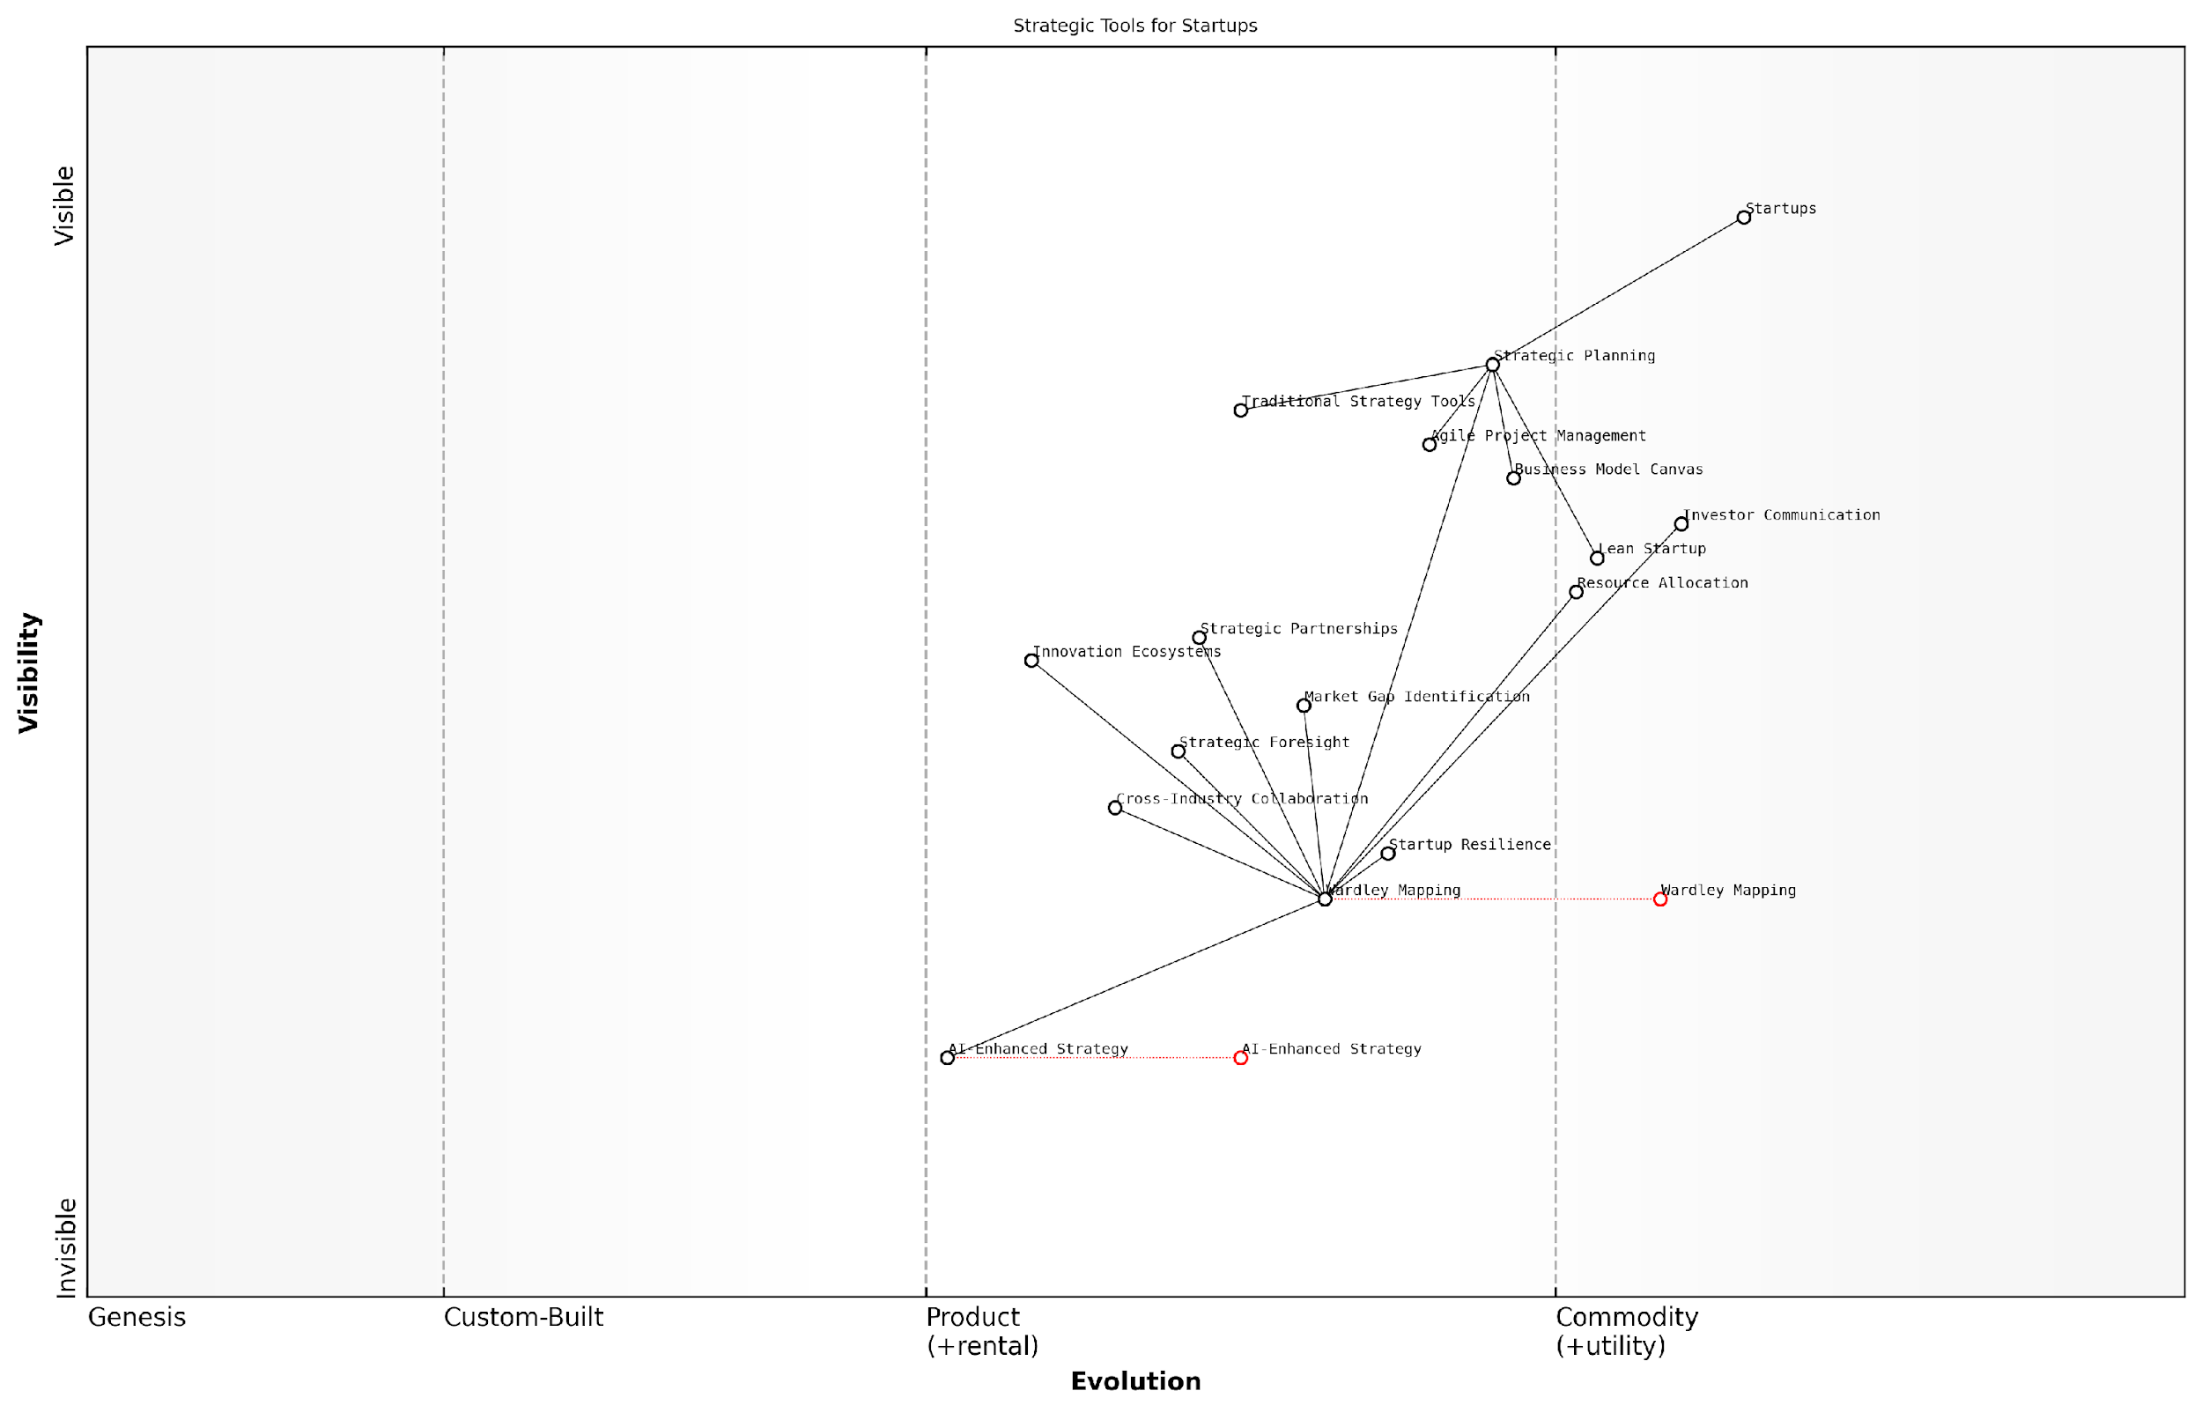

*Draft Wardley Map: [Insert Wardley Map: The role of Wardley Mapping in shaping the future of entrepreneurship]*

[Edit this draft Wardley Map](https://create.wardleymaps.ai/#clone:042e1af9836d3919f3)

Wardley Map Assessment

This Wardley Map reveals a strategic landscape in transition, with Wardley Mapping emerging as a central methodology for startup strategy. The future lies in the integration of AI-enhanced tools with Wardley Mapping, offering significant opportunities for innovation and competitive advantage. Startups that can effectively leverage Wardley Mapping while embracing emerging AI-driven strategies will be best positioned to navigate the complex and evolving business environment.

[View full Wardley Map report](http://markdown_wardley_map_reports/wardley_map_report_69_The_role_of_Wardley_Mapping_in_shaping_the_future_.md)

# Conclusion: Empowering Your Startup with Wardley Mapping

## Recap of Key Concepts and Techniques

### The core principles of Wardley Mapping for startups

As we conclude our exploration of Wardley Mapping for startups, it is crucial to revisit the core principles that underpin this powerful strategic tool. Wardley Mapping, when applied effectively, can be transformative for startups navigating the complex and uncertain landscape of innovation and market disruption. Let us recap the fundamental concepts and techniques that form the bedrock of this approach, tailored specifically for the unique challenges and opportunities faced by startup ventures.

At its heart, Wardley Mapping is about visualising the components of a business or industry landscape and understanding their evolutionary journey. For startups, this visual representation becomes a compass for strategic decision-making, resource allocation, and innovation planning. The core principles of Wardley Mapping for startups can be distilled into several key areas:

* Value Chain Visualisation
* Component Evolution
* Situational Awareness
* Movement and Gameplay
* Lean Integration
* Iterative Mapping
* Ecosystem Thinking

Value Chain Visualisation is the foundation upon which Wardley Maps are built. For startups, this principle involves meticulously mapping out the components that deliver value to the end-user, from the most visible customer-facing elements to the underlying infrastructure. This visualisation allows founders and teams to gain a holistic view of their business model and identify critical dependencies, potential bottlenecks, and opportunities for innovation.

Component Evolution is a crucial concept that sets Wardley Mapping apart from other strategic tools. By plotting components along the evolution axis—from genesis to custom-built to product and finally to commodity—startups can anticipate technological and market shifts. This foresight is invaluable for young companies looking to position themselves advantageously in rapidly changing markets.

Understanding the evolutionary stage of each component in your value chain is like having a crystal ball for your startup. It allows you to predict where the market is heading and position your offering accordingly.

Situational Awareness, derived from the comprehensive view provided by Wardley Maps, enables startups to make informed decisions in the face of uncertainty. By visualising the entire landscape, including competitors, suppliers, and potential disruptors, founders can develop strategies that are responsive to the current environment while anticipating future changes.

Movement and Gameplay principles in Wardley Mapping provide startups with a framework for strategic action. By understanding the natural direction of evolution for different components, startups can make informed decisions about where to innovate, where to leverage existing solutions, and how to outmanoeuvre competitors. This is particularly crucial for resource-constrained startups that need to maximise the impact of their strategic choices.

Lean Integration is where Wardley Mapping aligns seamlessly with Lean Startup methodologies. By using maps to inform hypothesis generation and validate assumptions, startups can iterate their business models more effectively. This integration allows for rapid experimentation and learning, crucial for startups operating in uncertain environments.

Wardley Mapping supercharges the Build-Measure-Learn cycle by providing a visual context for your experiments. It helps you focus on the most critical assumptions and pivot with purpose when necessary.

Iterative Mapping is a principle that acknowledges the dynamic nature of startups and their environments. Regular updating and refining of Wardley Maps ensure that the strategic tool remains relevant and continues to provide valuable insights as the startup evolves. This iterative approach aligns well with the agile nature of startup operations.

Ecosystem Thinking is the final core principle, emphasising the importance of understanding the broader context in which a startup operates. By mapping not just internal components but also external factors, startups can identify potential partnerships, anticipate ecosystem-level disruptions, and position themselves strategically within their industry.

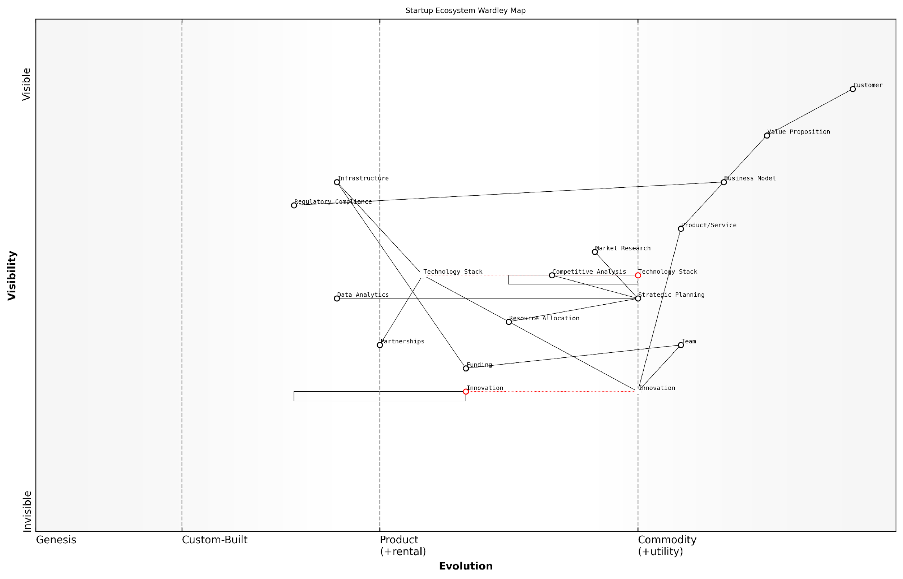

*Draft Wardley Map: [Insert Wardley Map: The core principles of Wardley Mapping for startups]*

[Edit this draft Wardley Map](https://create.wardleymaps.ai/#clone:ad5e4dc812e006357c)

Wardley Map Assessment

This Wardley Map depicts a well-structured startup ecosystem with a clear focus on delivering customer value through innovation and strategic planning. Key opportunities lie in enhancing data analytics capabilities, developing a more integrated partnership strategy, and building a robust innovation pipeline. The main challenges include managing funding dependencies, navigating regulatory complexities, and staying ahead in a rapidly evolving technology landscape. By focusing on these areas, startups can strengthen their competitive position and build long-term resilience in a dynamic market environment.

[View full Wardley Map report](http://markdown_wardley_map_reports/wardley_map_report_70_The_core_principles_of_Wardley_Mapping_for_startup.md)

These core principles of Wardley Mapping, when applied consistently and thoughtfully, provide startups with a powerful framework for strategic decision-making. They enable founders and teams to navigate uncertainty, identify opportunities for innovation and disruption, and allocate resources more effectively.

However, it’s important to note that mastering these principles requires practice and a willingness to embrace complexity. Startups should view Wardley Mapping not as a one-time exercise but as an ongoing process of learning and refinement. The true power of this approach emerges when it becomes integrated into the startup’s culture of strategic thinking and decision-making.

Wardley Mapping is not just a tool; it’s a new way of seeing and thinking about your business and its place in the world. For startups, it’s like gaining a superpower in a landscape where the ability to anticipate and adapt can mean the difference between success and failure.

As we’ve seen throughout this book, startups that have successfully applied these principles have gained significant advantages. From identifying disruptive opportunities to optimising their value chains and from aligning their teams around a shared vision to communicating more effectively with investors, Wardley Mapping has proven to be an invaluable asset in the startup toolkit.

In conclusion, the core principles of Wardley Mapping for startups—Value Chain Visualisation, Component Evolution, Situational Awareness, Movement and Gameplay, Lean Integration, Iterative Mapping, and Ecosystem Thinking—provide a comprehensive framework for strategic analysis and decision-making. By mastering these principles, startups can enhance their ability to navigate uncertainty, drive innovation, and create sustainable competitive advantages in an ever-changing business landscape.

### Essential tools and frameworks covered

As we conclude our exploration of Wardley Mapping for Startups, it’s crucial to recap the essential tools and frameworks we’ve covered throughout this book. These powerful instruments have been carefully selected and adapted to address the unique challenges faced by startups in today’s dynamic business landscape. By mastering these tools, startup founders and teams can significantly enhance their strategic decision-making capabilities and increase their chances of success.

Let’s revisit the key tools and frameworks that form the backbone of our Wardley Mapping approach for startups:

* Value Chain Mapping: The foundational technique for visualising your startup’s ecosystem and identifying key components.
* Evolution Axis Analysis: A critical tool for understanding the maturity of components and anticipating future changes.
* Opportunity Mapping: A framework for identifying strategic opportunities and potential areas for disruption.
* Lean Startup Integration: Techniques for combining Wardley Mapping with Lean Startup principles to accelerate validation and iteration.
* Multi-Map Analysis: Advanced methods for comparing alternative scenarios and business models.
* Wardley Map-Enhanced Business Model Canvas: A hybrid tool that combines the strengths of Wardley Mapping and the Business Model Canvas.
* Disruptive Innovation Lens: A framework for using Wardley Maps to spot and leverage disruptive opportunities.
* Strategic Play Mapping: Techniques for visualising and planning competitive moves in your market.
* Team Alignment and Communication Tools: Methods for using Wardley Maps to build shared understanding and facilitate strategic discussions.
* Resource Allocation Matrix: A framework for prioritising investments and efforts based on map insights.

Each of these tools and frameworks has been designed to address specific challenges that startups face in their journey from inception to scale. For instance, the Value Chain Mapping technique is particularly powerful for startups seeking to understand their position in complex ecosystems and identify potential areas for vertical integration or partnership.

Wardley Mapping has revolutionised the way we approach strategy in our startup. The ability to visualise our entire ecosystem and anticipate future changes has been invaluable in making informed decisions about product development and market entry.

The Evolution Axis Analysis, when combined with the Lean Startup methodology, provides a robust framework for startups to validate their assumptions and iterate rapidly. This synergy between Wardley Mapping and Lean Startup principles has proven particularly effective in reducing waste and accelerating the path to product-market fit.

For startups operating in highly competitive or rapidly evolving markets, the Disruptive Innovation Lens and Strategic Play Mapping tools offer a significant advantage. These frameworks enable founders to identify potential disruptive threats and opportunities, and to plan strategic moves that can position their startup for long-term success.

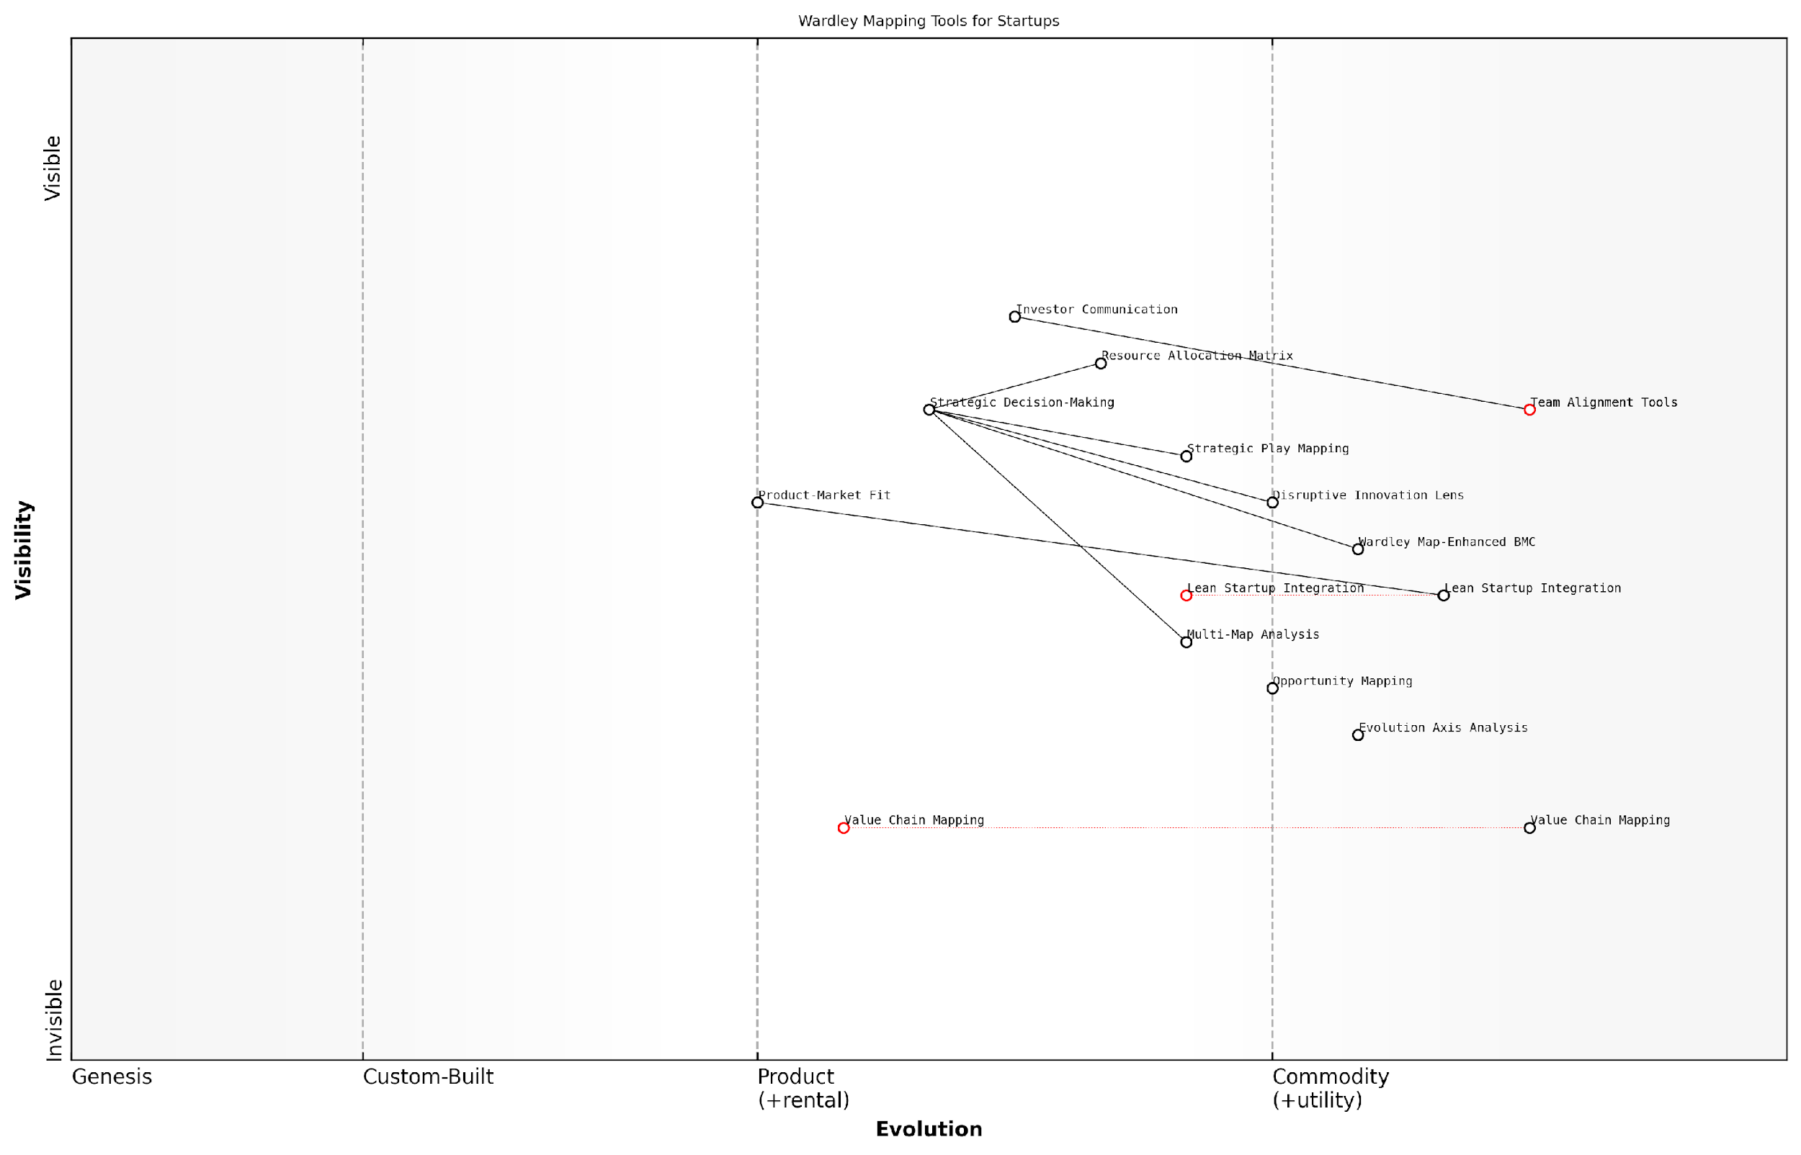

*Draft Wardley Map: [Insert Wardley Map: Essential tools and frameworks covered]*

[Edit this draft Wardley Map](https://create.wardleymaps.ai/#clone:2e973b791127b569ba)

Wardley Map Assessment

This Wardley Map reveals a robust and evolving set of strategic tools tailored for startups. It demonstrates a strong foundation in core Wardley Mapping techniques while showing adaptation to startup-specific needs. The integration with lean startup methodologies and focus on product-market fit align well with startup priorities. However, there’s significant potential for further evolution, particularly in leveraging emerging technologies and deepening integration with the broader startup ecosystem. The strategic positioning of these tools suggests that Wardley Mapping could become a key differentiator for startups in strategic planning and investor communication. To fully realise this potential, focus should be placed on simplifying adoption, enhancing data-driven capabilities, and creating a more interconnected ecosystem of mapping tools. Overall, this map indicates a promising future for Wardley Mapping in the startup world, with opportunities for innovation and strategic advantage for those who effectively leverage these tools.

[View full Wardley Map report](http://markdown_wardley_map_reports/wardley_map_report_71_Essential_tools_and_frameworks_covered.md)

The Multi-Map Analysis technique has proven particularly valuable for startups facing complex strategic decisions. By creating and comparing multiple future scenarios, startup teams can make more informed choices about resource allocation, product development, and market entry strategies.

One of the most significant challenges for many startups is aligning their team around a shared vision and strategy. The Team Alignment and Communication Tools we’ve explored provide practical methods for using Wardley Maps to build consensus, facilitate productive strategic discussions, and communicate effectively with stakeholders and investors.

The ability to use Wardley Maps as a communication tool has transformed our interactions with investors. We can now clearly articulate our strategic vision and the rationale behind our decisions, which has significantly improved our fundraising efforts.

The Resource Allocation Matrix, derived from insights gained through Wardley Mapping, offers a structured approach to prioritising investments in talent, technology, and market development. This is particularly crucial for resource-constrained startups that need to make every investment count.

It’s important to note that while these tools and frameworks are powerful individually, their true strength lies in their integration. By combining multiple techniques, startups can develop a comprehensive strategic approach that addresses the full spectrum of challenges they face.

For example, a startup might use Value Chain Mapping to understand their ecosystem, apply the Disruptive Innovation Lens to identify opportunities, use Multi-Map Analysis to evaluate different strategic options, and then employ the Team Alignment Tools to build consensus around the chosen strategy.

As you continue to apply these tools and frameworks in your startup journey, remember that Wardley Mapping is not a one-time exercise but an ongoing process. The dynamic nature of startup environments requires continuous mapping, analysis, and strategic adjustment.

Wardley Mapping isn’t just a tool; it’s a mindset. It encourages continuous learning, adaptation, and strategic thinking, which are essential qualities for any successful startup founder or team.

By mastering these essential tools and frameworks, and integrating them into your startup’s DNA, you’ll be well-equipped to navigate the uncertainties of entrepreneurship, make informed strategic decisions, and increase your chances of building a successful and sustainable business.

### How Wardley Mapping addresses key startup challenges

As we conclude our exploration of Wardley Mapping for startups, it’s crucial to recap how this powerful strategic tool addresses the fundamental challenges faced by new ventures. Wardley Mapping provides a unique lens through which startups can navigate uncertainty, drive innovation, and gain a competitive edge in rapidly evolving markets.

One of the primary challenges for startups is the ability to understand and anticipate market dynamics. Wardley Mapping excels in this area by providing a visual representation of the value chain, allowing founders and teams to identify where components are in their evolutionary journey. This insight is invaluable for startups as it helps them to:

* Identify emerging opportunities before they become obvious to competitors
* Anticipate potential disruptions in their industry
* Make informed decisions about resource allocation and strategic focus

Another critical challenge for startups is resource constraints. With limited time, money, and human capital, startups must make strategic decisions about where to invest their resources for maximum impact. Wardley Mapping addresses this challenge by:

* Highlighting areas of the value chain where investment can yield the greatest returns
* Identifying components that can be outsourced or leveraged from existing providers
* Revealing opportunities for strategic partnerships or acquisitions

The need for rapid iteration and validation is another key challenge that Wardley Mapping helps to address. By integrating Wardley Mapping with Lean Startup principles, as we discussed in Chapter 2, startups can:

* Quickly test hypotheses about market needs and product-market fit
* Iterate on their business model based on visual insights from their maps
* Identify key assumptions and risks in their strategy, allowing for focused experimentation

Wardley Mapping has revolutionised how we approach strategy in our startup. It’s like having a GPS for navigating the complex landscape of our industry, helping us to spot opportunities and avoid pitfalls that we might have otherwise missed.

This sentiment, expressed by a founder of a successful tech startup, encapsulates the transformative power of Wardley Mapping for new ventures.

Wardley Mapping also addresses the challenge of effective communication and alignment within startup teams and with external stakeholders. By providing a shared visual language for strategy, Wardley Maps enable:

* Clearer communication of vision and strategy to team members
* More effective pitches to investors, highlighting market understanding and strategic foresight
* Better alignment between different departments or functions within the startup

Perhaps one of the most significant challenges for startups is identifying and capitalising on disruptive opportunities. Wardley Mapping is particularly powerful in this regard, as it allows startups to:

* Visualise potential disruptions in their industry’s value chain
* Identify inefficiencies or gaps in existing market offerings
* Develop strategies for creating new markets or reconfiguring existing ones

As we explored in Chapter 3, this ability to spot and leverage disruptive opportunities can be a game-changer for startups, allowing them to compete effectively against larger, more established players.

The challenge of scaling and evolving the business model is another area where Wardley Mapping proves invaluable. As startups grow and markets change, Wardley Maps can be used to:

* Identify new areas for expansion or diversification
* Guide decisions about organisational structure and team growth
* Inform product roadmaps and feature prioritisation

Finally, Wardley Mapping addresses the ongoing challenge of staying ahead in a fast-paced, competitive environment. By fostering a culture of continuous strategic thinking and adaptation, as discussed in Chapter 5, startups can:

* Regularly reassess their position in the market
* Quickly adapt to changes in the competitive landscape
* Maintain a forward-looking, innovative mindset across the organisation

In the world of startups, those who can see around corners have a distinct advantage. Wardley Mapping gives founders and teams the tools to do just that, turning strategic foresight into a core competency.

This observation from a prominent venture capitalist underscores the competitive advantage that Wardley Mapping can provide to startups.

In conclusion, Wardley Mapping addresses key startup challenges by providing a framework for strategic thinking that is both comprehensive and adaptable. It empowers startups to navigate uncertainty, make informed decisions, and drive innovation in ways that traditional business planning tools often fall short. By mastering Wardley Mapping, startups can transform their approach to strategy, turning the inherent challenges of entrepreneurship into opportunities for growth and success.

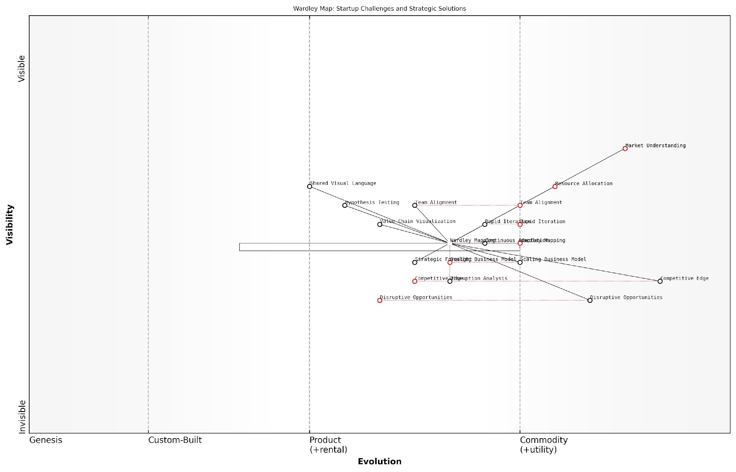

*Draft Wardley Map: [Insert Wardley Map: How Wardley Mapping addresses key startup challenges]*

[Edit this draft Wardley Map](https://create.wardleymaps.ai/#clone:a0b71541019016b32e)

Wardley Map Assessment

This Wardley Map effectively illustrates how Wardley Mapping can address key startup challenges by providing a structured approach to strategy and innovation. The central positioning of Wardley Mapping demonstrates its potential as a transformative tool for startups, connecting various challenges with strategic solutions. However, the map also highlights the need for continuous evolution of the mapping practice itself to maintain its relevance and effectiveness in the fast-paced startup environment. The strategic recommendations derived from this analysis provide a roadmap for startups to leverage Wardley Mapping for competitive advantage, while also pointing to future directions for the methodology’s development. Overall, the map underscores the value of visual, evolutionary thinking in navigating the complex landscape of startup growth and innovation.

[View full Wardley Map report](http://markdown_wardley_map_reports/wardley_map_report_72_How_Wardley_Mapping_addresses_key_startup_challeng.md)

## Action Plan for Implementing Wardley Mapping

### Steps to introduce Wardley Mapping in your startup

Introducing Wardley Mapping into your startup can be a transformative process, providing a powerful framework for strategic decision-making and innovation. As an expert who has guided numerous startups and government organisations through this process, I can attest to its potential to drive significant competitive advantage. However, the implementation must be approached systematically to ensure its effectiveness and adoption across the organisation. The following steps outline a comprehensive action plan for integrating Wardley Mapping into your startup’s strategic toolkit.

* 1. Educate leadership and key stakeholders
  2. Start with a pilot project
  3. Develop internal expertise
  4. Integrate with existing processes
  5. Foster a culture of continuous mapping
  6. Leverage technology and tools
  7. Measure and communicate impact

Let’s delve into each of these steps in detail:

1. Educate leadership and key stakeholders: The first crucial step is to ensure that your startup’s leadership team and key decision-makers understand the principles and potential of Wardley Mapping. This often involves a series of workshops or seminars that introduce the concept, its benefits, and its practical applications in the startup context. In my experience, it’s particularly effective to use real-world examples that resonate with your specific industry or challenges. For instance, when working with a govtech startup, we used a case study of how Wardley Mapping helped a similar organisation identify inefficiencies in their procurement process, leading to significant cost savings and improved service delivery.

Wardley Mapping isn’t just a tool; it’s a new way of thinking about strategy. When leadership truly grasps its potential, it can catalyse a shift in the entire organisation’s approach to innovation and competitive positioning.

1. Start with a pilot project: Once there’s buy-in from leadership, identify a specific project or challenge within your startup to apply Wardley Mapping. This pilot should be significant enough to demonstrate the value of the approach, but not so critical that any teething problems could jeopardise the business. For example, you might use Wardley Mapping to analyse a new product launch or to explore potential market expansions. The key is to choose a project where the outcomes can be clearly measured and attributed to the insights gained from mapping.
2. Develop internal expertise: To truly embed Wardley Mapping in your startup, it’s essential to develop in-house expertise. This typically involves identifying a core group of ‘champions’ who will receive more intensive training and become the go-to resources for mapping within the organisation. These individuals should come from diverse areas of the business to ensure broad application. In my consultancy work, I’ve found that a mix of technical, business development, and strategic roles often yields the most comprehensive perspective when creating and interpreting maps.
3. Integrate with existing processes: Wardley Mapping should not exist in isolation but should be integrated into your startup’s existing strategic planning and decision-making processes. This might involve incorporating mapping sessions into your regular strategy reviews, using maps to inform product roadmaps, or leveraging mapping insights in investor presentations. The goal is to make Wardley Mapping a natural and expected part of how your startup thinks about and plans for the future.

The real power of Wardley Mapping emerges when it becomes part of your startup’s DNA, informing decisions at all levels and across all departments.

1. Foster a culture of continuous mapping: Wardley Maps are not static documents but living tools that should evolve with your business and market conditions. Encourage regular updates and revisions to your maps, and create opportunities for cross-functional teams to collaborate on mapping exercises. This continuous approach ensures that your strategic thinking remains agile and responsive to change – a critical factor for startup success.
2. Leverage technology and tools: While Wardley Mapping can be done with pen and paper, there are now numerous digital tools available that can streamline the process and enhance collaboration. These range from simple diagramming software to specialised Wardley Mapping platforms with advanced features like version control and real-time collaboration. In my work with government agencies, we’ve successfully used these tools to facilitate remote mapping sessions and to maintain a centralised repository of maps that can be easily accessed and updated by teams across different departments.
3. Measure and communicate impact: To ensure ongoing support and resources for Wardley Mapping initiatives, it’s crucial to measure and communicate the impact of your mapping efforts. This might include tracking how mapping-informed decisions have led to cost savings, accelerated product development, or improved market positioning. Regular reports or presentations that highlight these successes can help maintain enthusiasm and buy-in from both leadership and team members.

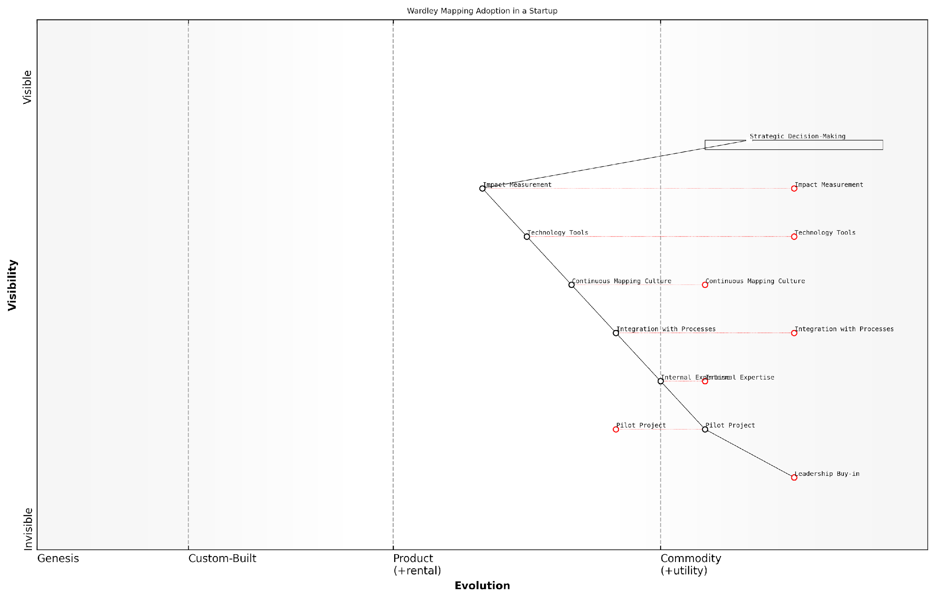

*Draft Wardley Map: [Insert Wardley Map: Steps to introduce Wardley Mapping in your startup]*

[Edit this draft Wardley Map](https://create.wardleymaps.ai/#clone:9ee3e722c8d2bd61e5)

Wardley Map Assessment

This map represents a well-structured approach to introducing Wardley Mapping in a startup environment. It highlights the critical role of leadership buy-in and the importance of building internal expertise. The focus on integration with processes and creating a continuous mapping culture is particularly noteworthy and positions the startup for long-term success. However, the startup should be cautious of potential bottlenecks in internal expertise development and process integration. The strategic positioning of components suggests a clear path to leveraging Wardley Mapping for competitive advantage, particularly in strategic decision-making. To maximise the benefits, the startup should prioritise developing a strong foundation of internal expertise while simultaneously working on seamless process integration. Future efforts should focus on innovating in the application of Wardley Mapping, particularly in areas like real-time strategy adjustment and AI-enhanced mapping tools, to stay ahead as basic mapping practices become more commonplace in the startup ecosystem.

[View full Wardley Map report](http://markdown_wardley_map_reports/wardley_map_report_73_Steps_to_introduce_Wardley_Mapping_in_your_startup.md)

By following these steps, your startup can effectively introduce and leverage Wardley Mapping as a powerful strategic tool. However, it’s important to remember that this is not a one-size-fits-all process. The specific implementation will depend on your startup’s size, industry, and existing strategic processes. As you embark on this journey, remain flexible and be prepared to adapt your approach based on feedback and results.

In my experience working with both startups and government bodies, the most successful implementations of Wardley Mapping are those that balance rigour with adaptability. They maintain the core principles of mapping while tailoring the application to their unique context and challenges. As you introduce Wardley Mapping in your startup, strive for this balance, and you’ll be well-positioned to harness its full potential for driving innovation and strategic advantage.

### Resources for further learning and practice

As we conclude our exploration of Wardley Mapping for startups, it’s crucial to emphasise that mastery of this powerful strategic tool is an ongoing journey. The resources outlined in this section will provide you with the means to deepen your understanding, refine your skills, and stay abreast of the latest developments in the field. By engaging with these resources, you’ll be well-equipped to continue leveraging Wardley Mapping to drive innovation and navigate uncertainty in your startup venture.

Let’s delve into a comprehensive set of resources that cater to various learning styles and levels of expertise, ensuring that you can continue to grow your Wardley Mapping proficiency long after you’ve finished this book.

Online Courses and Workshops:

* Wardley Mapping Fundamentals: A series of interactive online courses offered by leading strategy consultancies, covering the basics through to advanced applications of Wardley Mapping in startup contexts.
* Strategic Mapping for Innovators: Hands-on workshops conducted by experienced practitioners, focusing on applying Wardley Mapping to real-world startup challenges.
* Wardley Mapping Certification Programme: For those seeking formal recognition of their expertise, this comprehensive programme covers all aspects of Wardley Mapping and its application in various industries, including the startup ecosystem.

Books and Publications:

* ‘Wardley Maps: The Science of Strategy’ by Simon Wardley: The seminal work that introduced Wardley Mapping to the world, providing a deep dive into the theoretical foundations and practical applications.
* ‘Mapping Innovation: A Playbook for Navigating a Disruptive Age’ by Greg Satell: While not exclusively focused on Wardley Mapping, this book offers valuable insights on integrating various mapping techniques into your innovation strategy.
* ‘The Lean Startup’ by Eric Ries: A must-read companion to Wardley Mapping for startups, offering complementary methodologies for rapid iteration and validation.

Online Communities and Forums:

* Wardley Mapping Community on Slack: A vibrant community of practitioners, researchers, and enthusiasts discussing the latest developments and sharing experiences in applying Wardley Mapping across various domains, including startups.
* Wardley Maps Forum on Reddit: A platform for sharing maps, seeking feedback, and engaging in discussions about Wardley Mapping techniques and applications.
* LinkedIn Wardley Mapping Groups: Several professional groups dedicated to Wardley Mapping, offering networking opportunities and insights from industry experts.

Tools and Software:

* OnlineWardleyMaps: A free, open-source tool for creating and sharing Wardley Maps online, with features tailored for collaborative mapping in startup teams.
* Wardley Mapping Canvas: A digital canvas designed specifically for Wardley Mapping, offering templates and guides for various mapping scenarios relevant to startups.
* MapScript: An advanced scripting language for generating and analysing Wardley Maps programmatically, ideal for startups looking to integrate mapping into their data analytics workflows.

Conferences and Events:

* Annual Wardley Mapping Conference: A global gathering of Wardley Mapping practitioners, featuring keynotes, workshops, and networking opportunities focused on the latest advancements in the field.
* Startup Strategy Summit: An event series that combines Wardley Mapping with other strategic tools, offering tailored sessions for startup founders and teams.
* Map Camp: Regional events held worldwide, providing hands-on experience in creating and interpreting Wardley Maps for various business scenarios.

Research and Academic Resources:

* Journal of Strategic Mapping: A peer-reviewed academic journal publishing the latest research on Wardley Mapping and its applications across industries, including startups and innovation management.
* University Research Centres: Several leading universities have established research centres focused on strategic mapping and its intersection with entrepreneurship, offering access to cutting-edge studies and collaborations.

Wardley Mapping is not just a tool, but a way of thinking. The more you practise and engage with the community, the more intuitive and powerful it becomes in guiding your startup’s strategy.

Practical Application Exercises:

* Weekly Mapping Challenge: Commit to creating a Wardley Map for a different aspect of your startup each week, gradually building a comprehensive strategic view of your entire business.
* Peer Review Sessions: Organise regular sessions with other startup founders or team members to review and critique each other’s Wardley Maps, fostering collaborative learning and diverse perspectives.
* Industry Analysis Project: Undertake a comprehensive mapping project of your startup’s industry, identifying potential disruptive opportunities and threats over the next 3-5 years.

Mentorship and Coaching:

* Wardley Mapping Mentorship Programme: Connect with experienced practitioners who can provide personalised guidance on applying Wardley Mapping to your specific startup challenges.
* Strategic Coaching for Startups: Engage with coaches who specialise in integrating Wardley Mapping with other startup methodologies, offering tailored advice for your business growth.

By actively engaging with these resources, you’ll not only deepen your understanding of Wardley Mapping but also connect with a global community of practitioners and innovators. This ongoing learning and practice will enable you to continually refine your strategic thinking, identify new opportunities, and navigate the complex landscape of startup entrepreneurship with greater confidence and clarity.

The true power of Wardley Mapping lies not just in the maps themselves, but in the strategic conversations and insights they generate. Embrace these resources as a means to foster a culture of continuous strategic thinking within your startup.

Remember, the journey of mastering Wardley Mapping is ongoing. As you continue to apply these techniques in your startup, you’ll discover new insights and applications. Don’t hesitate to contribute your own experiences and innovations back to the community, furthering the collective knowledge and evolution of this powerful strategic tool.

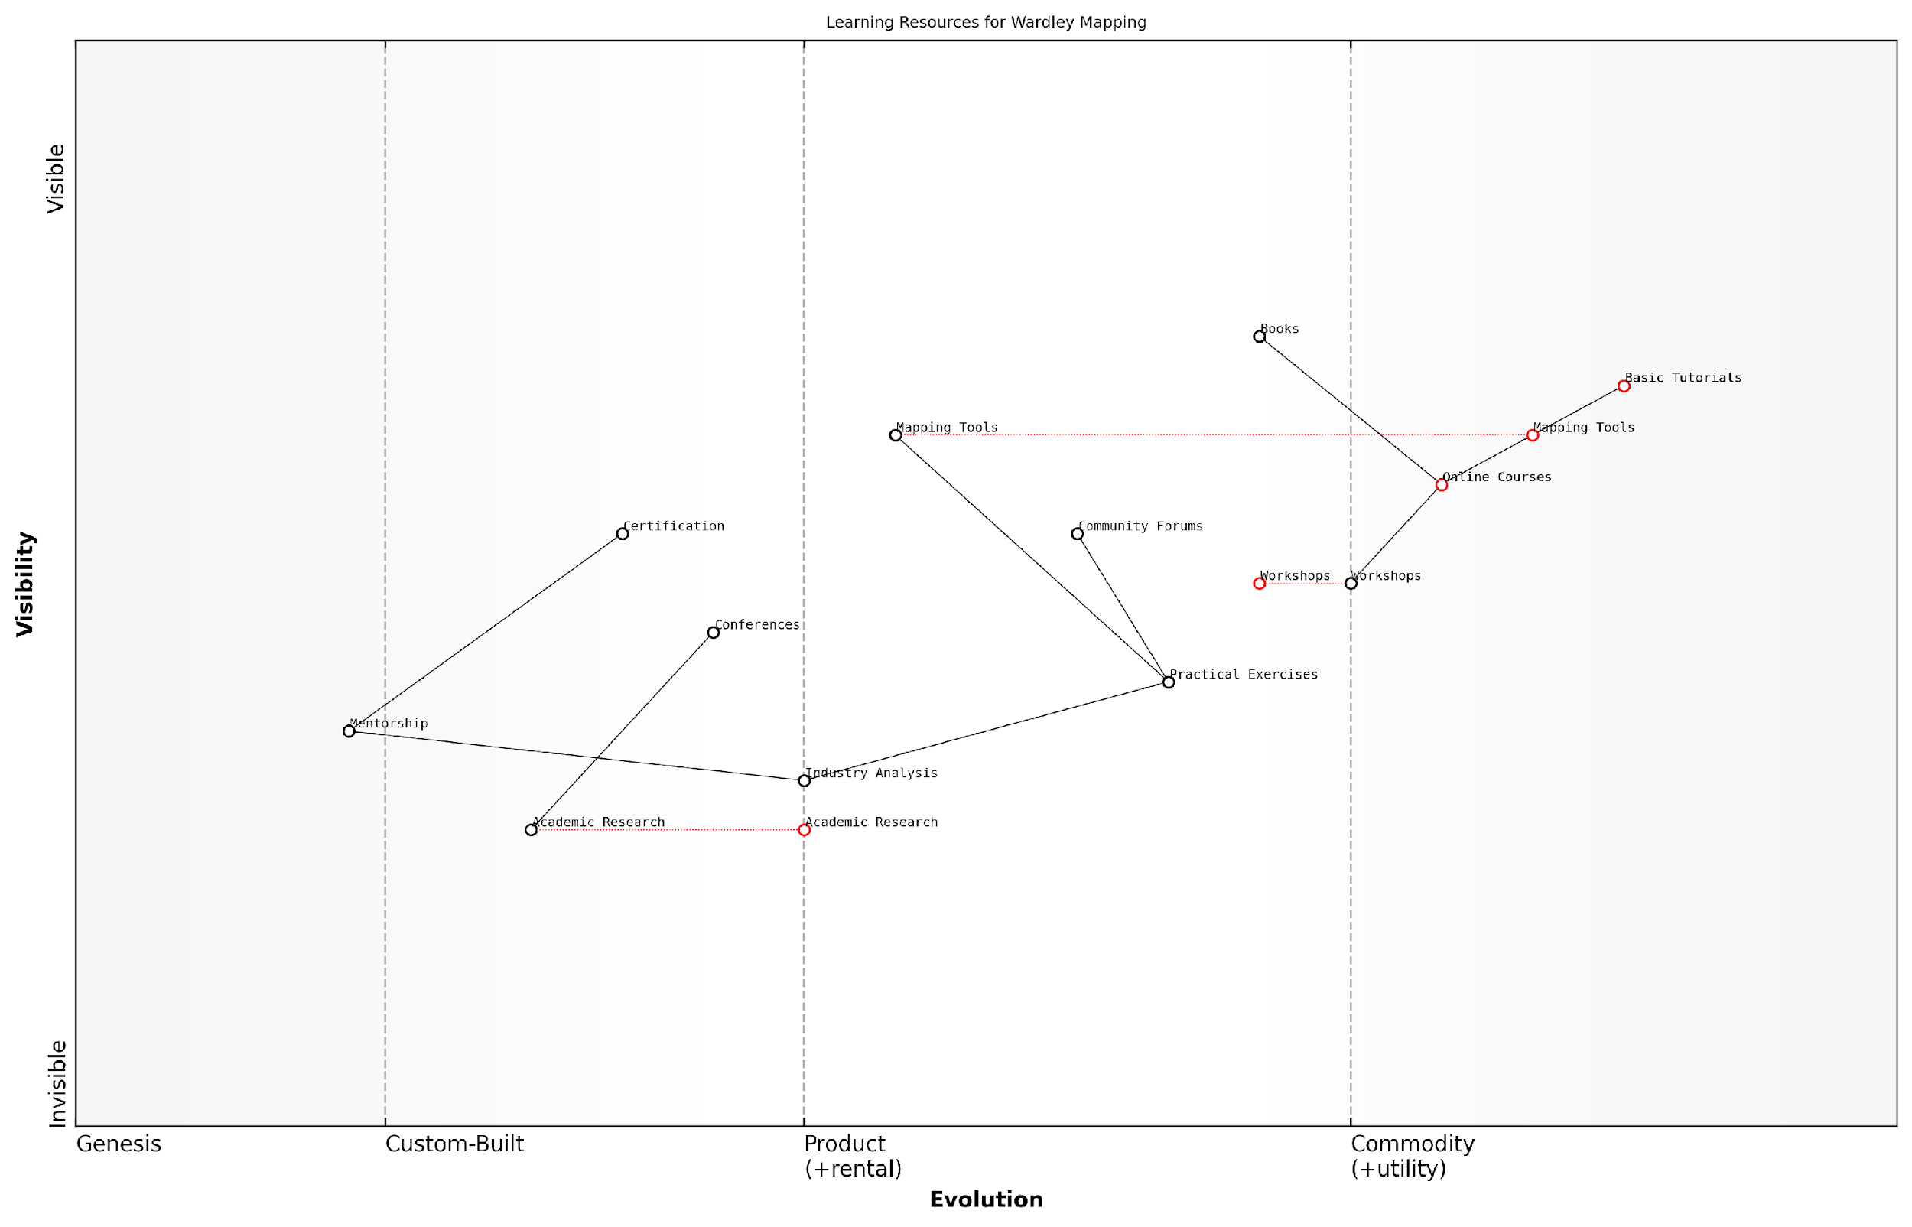

*Draft Wardley Map: [Insert Wardley Map: Resources for further learning and practice]*

[Edit this draft Wardley Map](https://create.wardleymaps.ai/#clone:5c09781c0d1b0fdc7a)

Wardley Map Assessment

The Wardley Mapping learning ecosystem is in a strong position with a solid foundation of basic resources and an emerging landscape of advanced components. The key strategic focus should be on bridging the gap between basic learning and advanced application, while simultaneously building the academic and professional infrastructure to support long-term growth and relevance. Prioritising the development of practical tools, industry-specific analyses, and a robust certification program will be crucial for wider adoption and recognition. The ecosystem is poised for significant growth and evolution, with ample opportunities for innovation and strategic partnerships.

[View full Wardley Map report](http://markdown_wardley_map_reports/wardley_map_report_74_Resources_for_further_learning_and_practice.md)

### Building a community of practice

Building a community of practice around Wardley Mapping is a crucial step in embedding this powerful strategic tool within your startup’s culture and processes. As an expert who has advised numerous government bodies and public sector organisations on implementing Wardley Mapping, I can attest to the transformative power of a strong community in driving adoption and innovation. This section will explore the key steps and considerations for establishing and nurturing a Wardley Mapping community of practice within your startup ecosystem.

A community of practice (CoP) is a group of people who share a common interest in a specific domain and come together to share knowledge, learn from each other, and advance their collective understanding. In the context of Wardley Mapping for startups, a CoP can serve as a catalyst for continuous learning, innovation, and strategic alignment.

A thriving community of practice around Wardley Mapping can be the difference between sporadic use and transformative impact. It’s the engine that drives continuous improvement and innovation in strategic thinking.

Let’s explore the key steps to building and sustaining a vibrant Wardley Mapping community of practice within your startup:

* Identify champions and early adopters
* Establish a clear purpose and goals
* Create platforms for knowledge sharing
* Develop a learning curriculum
* Encourage regular practice and experimentation
* Foster cross-functional collaboration
* Measure and celebrate progress
* Connect with the broader Wardley Mapping community

1. Identify champions and early adopters: Begin by identifying individuals within your startup who are passionate about strategic thinking and have shown interest in Wardley Mapping. These champions will be instrumental in driving adoption and enthusiasm for the practice. In my experience working with government agencies, having dedicated champions at various levels of the organisation has been crucial for successful implementation.
2. Establish a clear purpose and goals: Clearly articulate the purpose of your Wardley Mapping community of practice and set specific, measurable goals. This might include objectives such as improving strategic decision-making, enhancing cross-team collaboration, or identifying new market opportunities. Align these goals with your startup’s overall mission and vision to ensure relevance and buy-in from leadership.
3. Create platforms for knowledge sharing: Establish both physical and digital spaces for your community to interact and share knowledge. This could include regular in-person meetups, online forums, or dedicated Slack channels. In my consultancy work, I’ve found that a mix of synchronous and asynchronous communication channels works best to accommodate different working styles and time zones.
4. Develop a learning curriculum: Create a structured learning path for community members to develop their Wardley Mapping skills. This should include introductory materials for newcomers, as well as advanced topics for more experienced practitioners. Consider developing internal case studies that demonstrate the application of Wardley Mapping to your startup’s specific challenges and opportunities.

A well-designed learning curriculum is the backbone of a successful Wardley Mapping community of practice. It provides a clear path for skill development and ensures that all members have a common language and framework for strategic discussions.

1. Encourage regular practice and experimentation: Provide opportunities for community members to practise their Wardley Mapping skills in real-world scenarios. This could involve mapping exercises during team meetings, hackathons focused on strategic challenges, or dedicated time for individual exploration and mapping. Encourage experimentation with different mapping techniques and applications to foster innovation.
2. Foster cross-functional collaboration: One of the key strengths of Wardley Mapping is its ability to facilitate cross-functional understanding and collaboration. Encourage participation from diverse teams within your startup, including product, engineering, marketing, and operations. This cross-pollination of ideas and perspectives will enrich your community and lead to more holistic strategic insights.
3. Measure and celebrate progress: Establish metrics to track the impact of your Wardley Mapping community of practice. This might include measures such as the number of strategic decisions influenced by mapping, improvements in product development cycles, or increased alignment across teams. Regularly celebrate successes and share case studies of how Wardley Mapping has positively impacted your startup’s trajectory.
4. Connect with the broader Wardley Mapping community: Encourage your community members to engage with the global Wardley Mapping community. This can include participating in online forums, attending conferences, or contributing to open-source mapping projects. This external connection will bring fresh perspectives and keep your community at the forefront of Wardley Mapping developments.

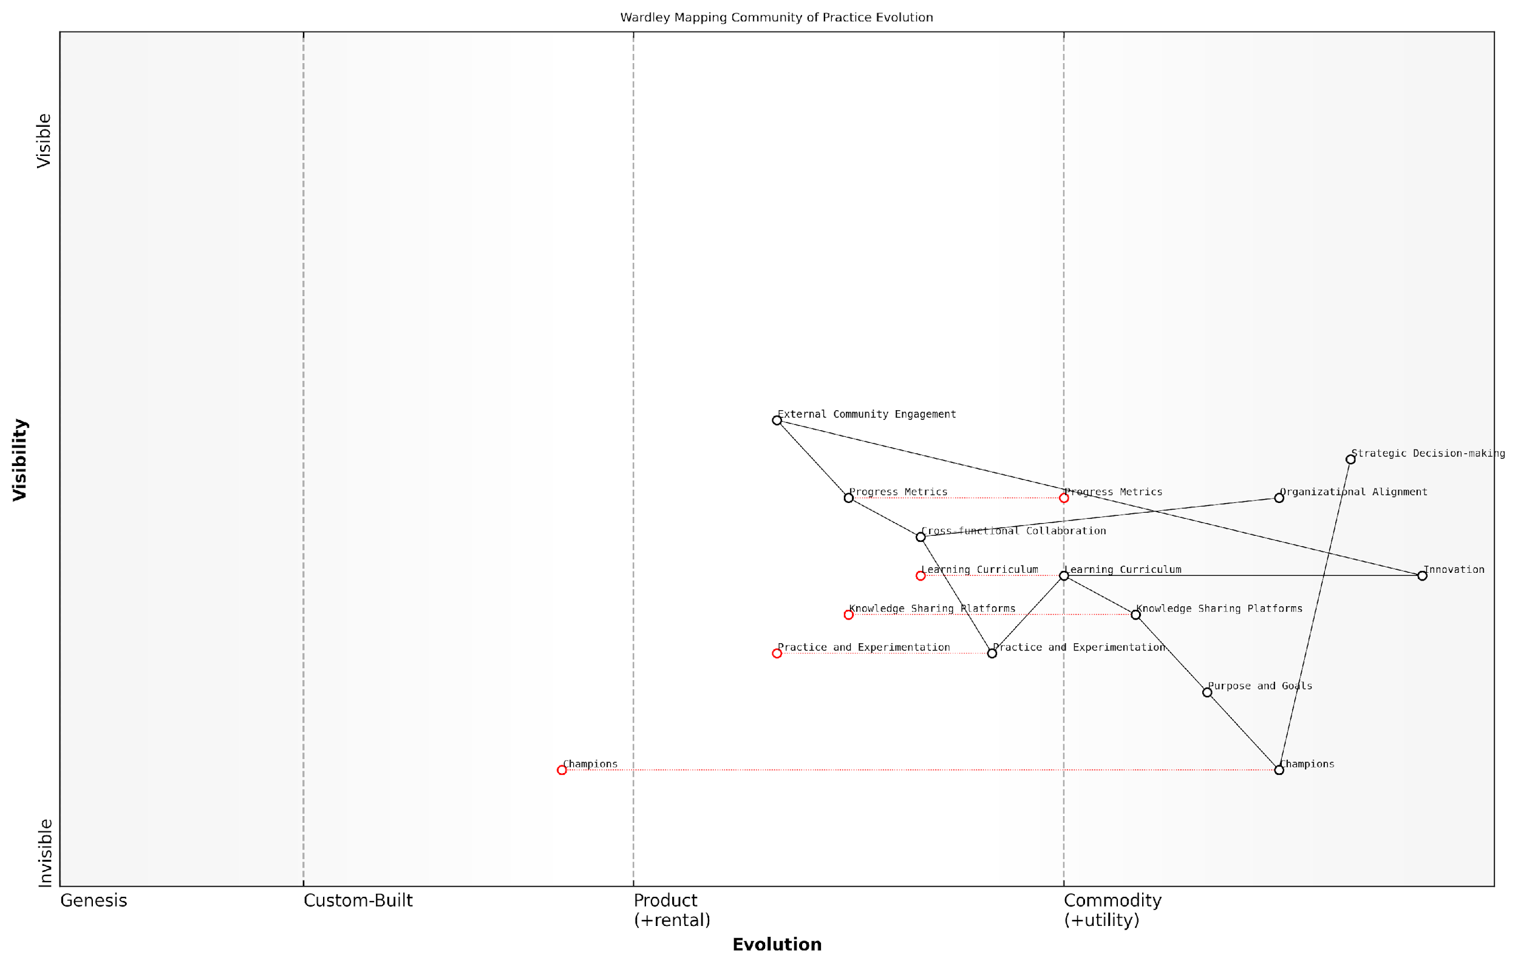

*Draft Wardley Map: [Insert Wardley Map: Building a community of practice]*

[Edit this draft Wardley Map](https://create.wardleymaps.ai/#clone:ed48f71051ed1eb4cb)

Wardley Map Assessment

This map represents a comprehensive approach to building a Wardley Mapping community of practice within a startup ecosystem. It shows a clear progression from individual champions to organisational adoption and strategic impact. The key strategic opportunities lie in standardising and evolving the learning and practice components, while simultaneously pushing for greater integration with strategic decision-making processes. The map also highlights the importance of balancing internal capability development with external community engagement. To maximise the value of this initiative, startups should focus on rapidly evolving their foundational components while keeping sight of the ultimate goal of driving innovation and strategic advantage in their specific industry context.

[View full Wardley Map report](http://markdown_wardley_map_reports/wardley_map_report_75_Building_a_community_of_practice.md)

Building a thriving Wardley Mapping community of practice requires dedication, resources, and ongoing support from leadership. However, the benefits to your startup can be transformative. In my work with government agencies, I’ve seen how a strong community of practice can accelerate the adoption of Wardley Mapping, leading to more agile decision-making, improved strategic alignment, and a culture of continuous learning and innovation.

The true power of Wardley Mapping is unleashed when it becomes embedded in the fabric of your organisation’s strategic thinking. A vibrant community of practice is the key to achieving this level of integration and impact.

As you embark on building your Wardley Mapping community of practice, remember that it’s an iterative process. Be prepared to adapt your approach based on feedback and changing needs within your startup. Encourage open dialogue, embrace diverse perspectives, and maintain a focus on practical application and value creation.

By following these steps and nurturing a culture of continuous learning and experimentation, your startup can harness the full potential of Wardley Mapping as a strategic tool for navigating uncertainty and driving innovation in the competitive landscape of entrepreneurship.

## Final Thoughts and Inspiration

### The transformative potential of strategic mapping

As we conclude our exploration of Wardley Mapping for startups, it’s crucial to reflect on the transformative potential this strategic tool holds for innovative ventures. Wardley Mapping is not merely a technique; it’s a paradigm shift in how startups can approach strategy, innovation, and decision-making in an increasingly complex and uncertain business landscape.

The transformative power of Wardley Mapping lies in its ability to provide startups with a clear, visual representation of their business landscape. This clarity is invaluable in an environment where uncertainty is the norm. By mapping out the components of their value chain and understanding the evolution of these components, startups can gain a strategic advantage that goes beyond traditional business planning methods.

Wardley Mapping has revolutionised how we approach strategy in our startup. It’s like having a GPS for business decisions in a constantly changing market.

One of the most powerful aspects of Wardley Mapping for startups is its ability to reveal hidden opportunities and potential disruptions. By visualising the entire value chain and its evolution, founders and teams can identify areas ripe for innovation or disruption that might not be apparent through other strategic tools. This foresight can be the difference between a startup that thrives and one that struggles to find its footing in a competitive market.

* Enhanced strategic decision-making
* Improved ability to anticipate and adapt to market changes
* Better alignment of resources with strategic goals
* Increased capacity for disruptive innovation
* More effective communication with stakeholders and investors

Moreover, Wardley Mapping serves as a powerful communication tool. In the fast-paced world of startups, where teams often work remotely and investors need to be kept informed, having a clear, visual representation of strategy can be invaluable. It allows for better alignment among team members, more effective pitches to investors, and clearer communication of vision and strategy to all stakeholders.

The integration of Wardley Mapping with other startup methodologies, such as Lean Startup and Agile, further amplifies its transformative potential. By combining the visual strategy of Wardley Mapping with the iterative approach of Lean Startup, for instance, startups can create a powerful framework for rapid experimentation and validation of business models. This synergy can significantly accelerate the path to product-market fit and sustainable growth.

The combination of Wardley Mapping and Lean Startup principles has been a game-changer for our team. We’re able to iterate faster and make more informed strategic decisions than ever before.

As we look to the future, the potential of Wardley Mapping in the startup ecosystem is only set to grow. With advancements in artificial intelligence and machine learning, we can anticipate more sophisticated applications of Wardley Mapping. Imagine real-time, dynamic maps that update as market conditions change, or AI-assisted strategy formulation based on Wardley Map analysis. These developments could further enhance the strategic capabilities of startups, allowing them to navigate uncertainty with even greater agility and foresight.

However, it’s important to remember that Wardley Mapping, like any tool, is only as effective as the people wielding it. The true transformative potential lies not just in the methodology itself, but in how startups embrace it, adapt it to their unique contexts, and use it to drive continuous learning and innovation.

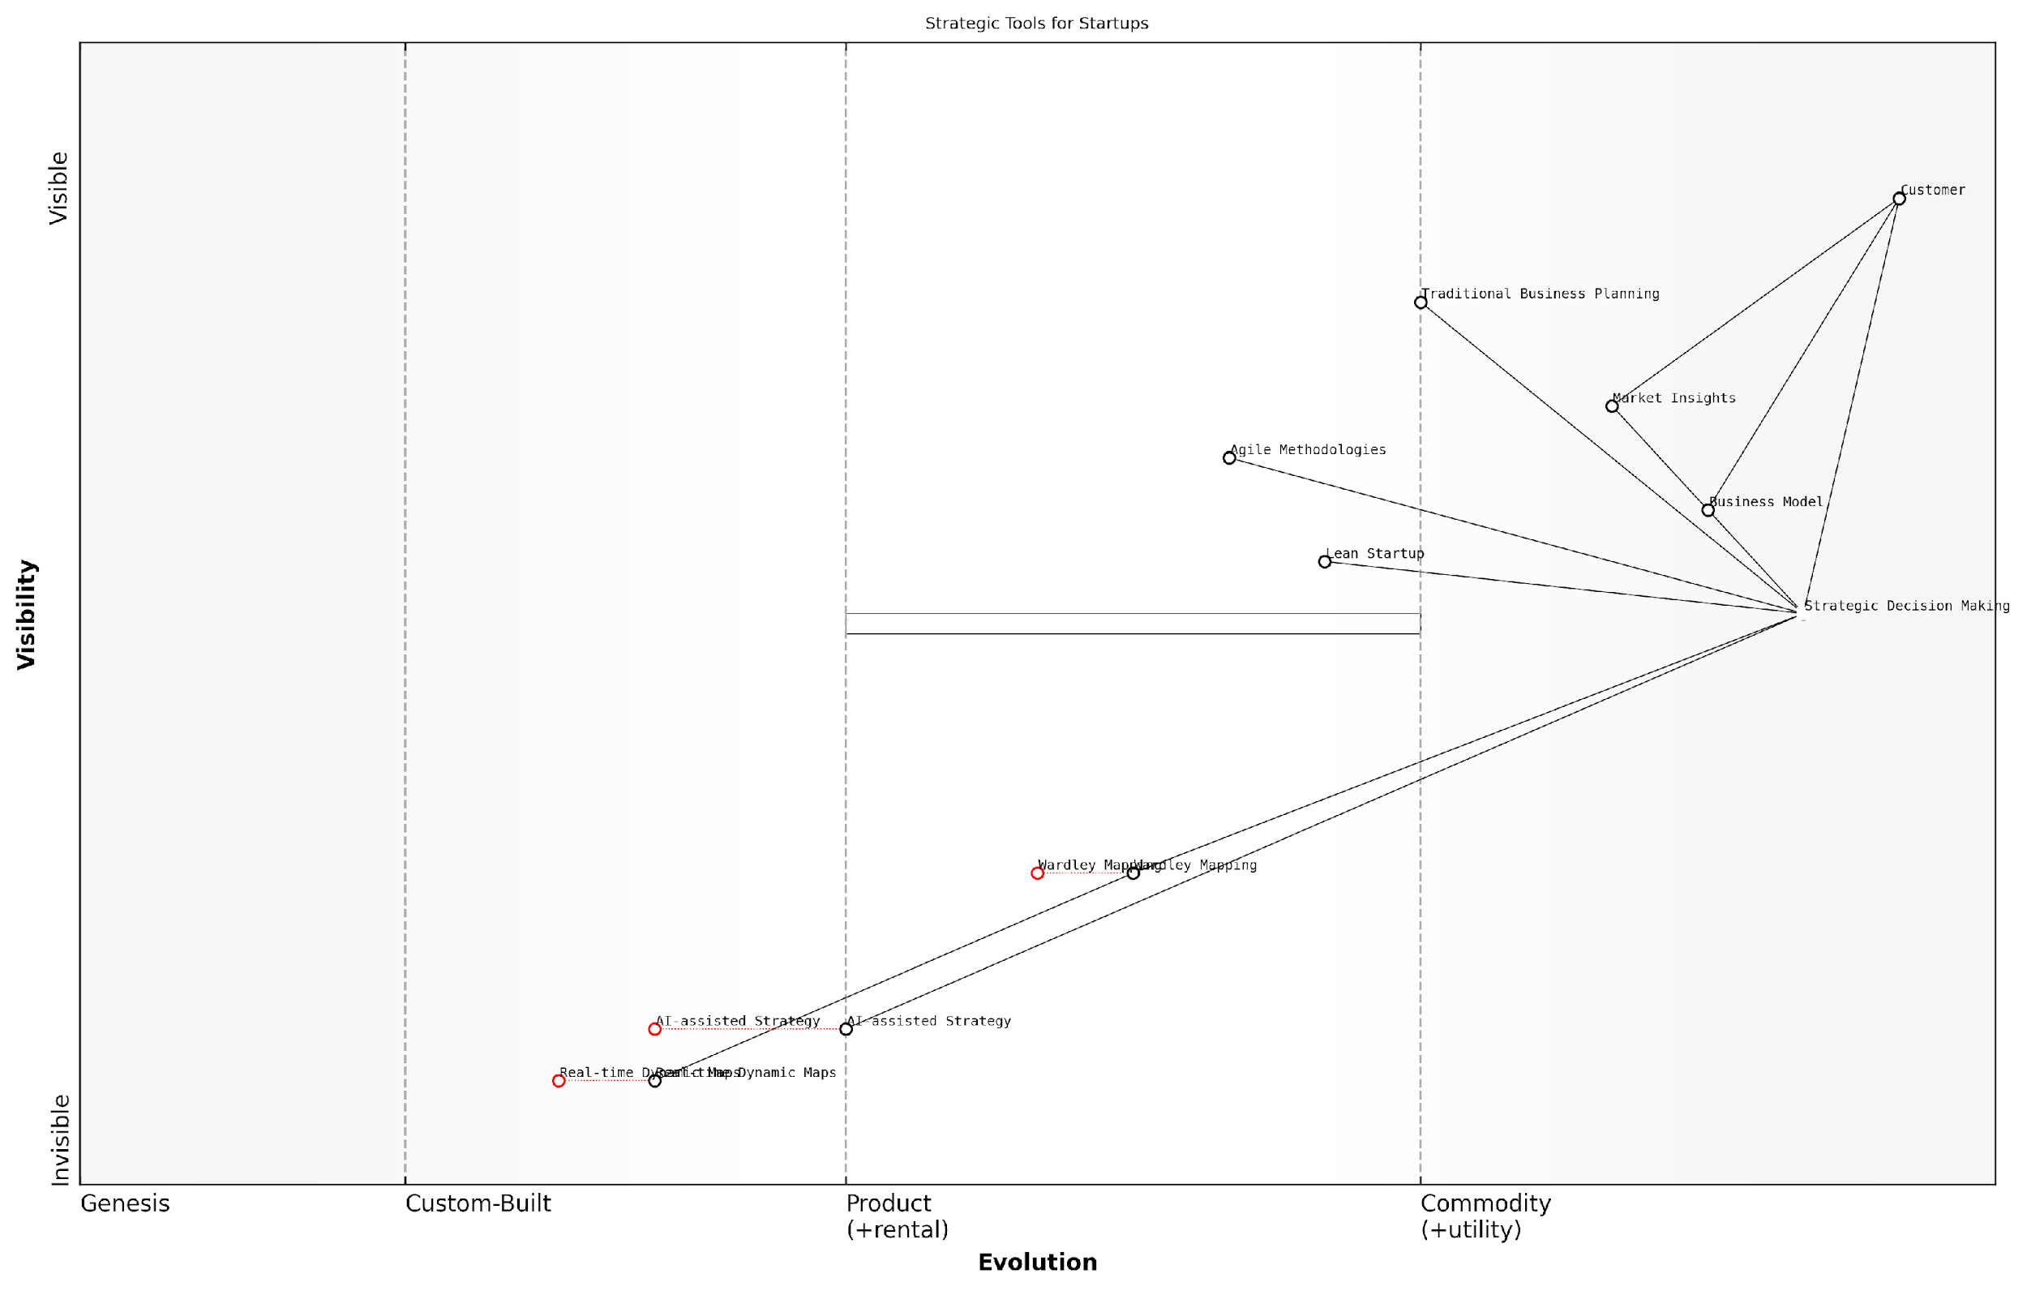

*Draft Wardley Map: [Insert Wardley Map: The transformative potential of strategic mapping]*

[Edit this draft Wardley Map](https://create.wardleymaps.ai/#clone:50bdc3bb7ad3994e4c)

Wardley Map Assessment

This Wardley Map reveals a strategic landscape in transition, with traditional methods giving way to more dynamic, data-driven approaches. Startups have a significant opportunity to gain competitive advantage by adopting emerging tools like Wardley Mapping and AI-assisted strategy. The key to success will be balancing the use of established methodologies with the integration of cutting-edge approaches, all while maintaining a strong focus on customer needs and market insights. The future of startup strategy lies in the ability to adapt in real-time to market changes, leveraging advanced analytics and AI to make informed decisions quickly. Those who can successfully navigate this evolving landscape, building capabilities in areas like Wardley Mapping and AI-assisted strategy, will be well-positioned to thrive in an increasingly complex and fast-paced business environment.

[View full Wardley Map report](http://markdown_wardley_map_reports/wardley_map_report_76_The_transformative_potential_of_strategic_mapping.md)

As you embark on your journey with Wardley Mapping, I encourage you to approach it with a spirit of curiosity and experimentation. Don’t be afraid to make mistakes or create imperfect maps – the process of mapping itself often yields valuable insights. Share your experiences with others in the startup community, contribute to the growing body of knowledge around Wardley Mapping, and be open to new applications and interpretations of this powerful tool.

Remember, the most successful startups are those that can navigate uncertainty, adapt to change, and seize opportunities before their competitors. Wardley Mapping provides a framework to do just that. By mastering this tool, you’re not just improving your chances of success – you’re equipping yourself to be at the forefront of strategic thinking in the startup world.

Wardley Mapping isn’t just about creating pretty diagrams. It’s about fundamentally changing how we think about strategy and innovation in the startup world. It’s a mindset shift that can lead to breakthrough insights and game-changing innovations.

In conclusion, the transformative potential of Wardley Mapping for startups is immense. It offers a new lens through which to view your business, your market, and your strategic options. As you continue your startup journey, I encourage you to explore, experiment, and push the boundaries of what’s possible with Wardley Mapping. The future of strategic thinking in startups is being shaped by innovators like you, and Wardley Mapping is a powerful tool to help you lead the way.

So, map on, innovate boldly, and may your startup journey be filled with strategic insights and transformative success. The world of Wardley Mapping is rich with possibility – it’s up to you to explore it and make it your own. Here’s to the future of strategic mapping and the bright future it holds for startups everywhere.

### Encouragement for continuous exploration and innovation

As we conclude our exploration of Wardley Mapping for startups, it is crucial to emphasise that the journey of strategic mapping is never truly complete. The dynamic nature of the business landscape, particularly in the startup ecosystem, demands a commitment to continuous exploration and innovation. Wardley Mapping is not merely a tool to be applied once and forgotten; rather, it is a mindset and approach that should permeate your organisation’s culture and decision-making processes.

The power of Wardley Mapping lies in its ability to reveal new insights and opportunities as your startup evolves and the market landscape shifts. By fostering a culture of continuous exploration, you position your startup to remain agile, responsive, and ahead of the curve. Let us delve into key aspects of maintaining this exploratory mindset and leveraging Wardley Mapping for ongoing innovation.

Embracing the Evolutionary Nature of Strategy

Wardley Mapping inherently recognises that strategy is not static but evolutionary. As a startup leader, it’s vital to internalise this principle and encourage your team to view strategy as a living, breathing entity that requires constant nurturing and refinement. Regular mapping exercises should be integrated into your strategic planning cycles, allowing you to reassess your position, identify emerging opportunities, and adapt to changing market conditions.

Strategy is not a document that you write, put in a drawer, and forget. It’s a living thing that you build every day through your actions and decisions.

This perspective aligns perfectly with the startup ethos of rapid iteration and continuous improvement. By regularly revisiting and updating your Wardley Maps, you create a feedback loop that informs and refines your strategic direction, ensuring that your startup remains aligned with market needs and technological advancements.

Fostering a Culture of Curiosity and Experimentation

To truly leverage the power of Wardley Mapping for ongoing innovation, it’s essential to cultivate a culture of curiosity and experimentation within your startup. Encourage your team to question assumptions, explore alternative scenarios, and push the boundaries of what’s possible. Wardley Mapping provides a framework for structured experimentation, allowing you to visualise potential futures and test hypotheses in a low-risk environment.

* Organise regular ‘mapping sessions’ where team members can collaboratively explore new ideas and challenge existing strategies.
* Create cross-functional teams to bring diverse perspectives to your mapping exercises, fostering innovation through interdisciplinary thinking.
* Implement a ‘safe-to-fail’ environment where team members feel comfortable proposing and testing unconventional ideas through Wardley Mapping.
* Celebrate and learn from both successes and failures in your strategic experiments, using Wardley Maps to document and analyse outcomes.

By embedding these practices into your startup’s culture, you create an environment where continuous exploration and innovation become second nature, driving your company’s growth and adaptability.

Leveraging Emerging Technologies and Methodologies

As the field of strategic mapping evolves, new technologies and methodologies are emerging that can enhance and augment your Wardley Mapping practices. Staying abreast of these developments and integrating them into your approach can significantly boost your startup’s innovative capacity.

* Explore AI-assisted mapping tools that can help automate the process of creating and updating Wardley Maps, allowing for more frequent and comprehensive strategic analysis.
* Investigate the integration of big data and predictive analytics with Wardley Mapping to enhance your ability to anticipate market shifts and technological advancements.
* Consider adopting real-time mapping techniques that allow for dynamic strategy formulation in response to rapidly changing market conditions.
* Experiment with virtual and augmented reality technologies to create immersive, collaborative mapping experiences that can unlock new insights and foster innovation.

By embracing these emerging technologies and methodologies, you position your startup at the forefront of strategic innovation, gaining a competitive edge in your market.

Continuous Learning and Community Engagement

The Wardley Mapping community is vibrant and constantly evolving, with practitioners from various industries sharing insights, techniques, and case studies. Engaging with this community can be a powerful driver of continuous exploration and innovation for your startup.

* Encourage team members to participate in Wardley Mapping workshops, conferences, and online forums to stay updated on the latest developments and best practices.
* Contribute to the community by sharing your own experiences and insights, fostering a culture of knowledge exchange and collaborative innovation.
* Establish partnerships or mentorship relationships with experienced Wardley Mapping practitioners to gain fresh perspectives and accelerate your learning.
* Consider creating an internal community of practice within your startup to facilitate ongoing learning and experimentation with Wardley Mapping techniques.

By actively engaging with the broader Wardley Mapping community, you ensure that your startup remains at the cutting edge of strategic thinking and innovation practices.

Innovation is not a one-time event, but a continuous journey of exploration, learning, and adaptation. Wardley Mapping provides the compass for this journey, guiding startups towards sustainable success in an ever-changing landscape.

As you embark on your Wardley Mapping journey, remember that the true power of this approach lies not just in the maps themselves, but in the mindset of continuous exploration and innovation that they foster. By embracing this mindset and integrating Wardley Mapping into the fabric of your startup’s culture, you create a powerful engine for ongoing growth, adaptation, and success.

The road ahead is filled with both challenges and opportunities. Armed with the insights and techniques of Wardley Mapping, and a commitment to continuous exploration, your startup is well-equipped to navigate the complexities of the modern business landscape. As you apply these principles, you not only drive your own success but also contribute to the broader evolution of strategic thinking in the startup ecosystem.

Let this be not the end, but the beginning of your journey with Wardley Mapping. Embrace the spirit of exploration, foster a culture of innovation, and continue to push the boundaries of what’s possible. The future belongs to those who can see it coming, and with Wardley Mapping, you have the tools to not just see the future, but to shape it.

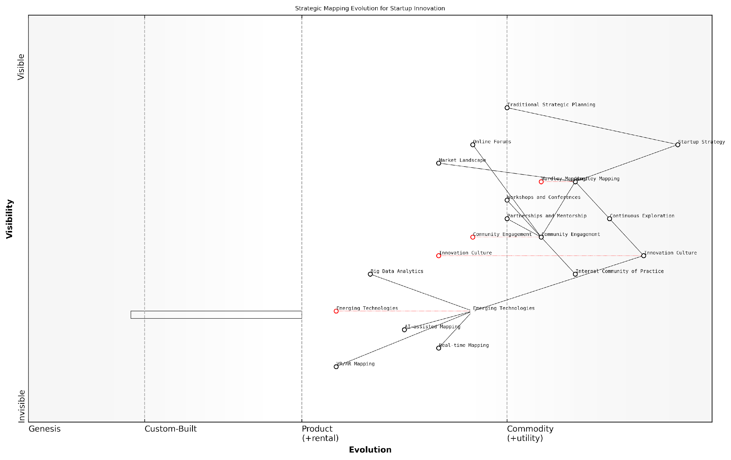

*Draft Wardley Map: [Insert Wardley Map: Encouragement for continuous exploration and innovation]*

[Edit this draft Wardley Map](https://create.wardleymaps.ai/#clone:4a534495f517c16212)

Wardley Map Assessment

This Wardley Map reveals a startup poised for significant innovation in strategic planning methodologies. By leveraging emerging technologies, fostering a strong innovation culture, and engaging with a broader community, the startup has the potential to disrupt traditional approaches to strategy formulation and execution. The key to success will be balancing the rapid adoption of new technologies with the development of a robust innovation culture and ecosystem. Prioritising AI-assisted mapping and real-time data integration while nurturing community engagement and partnerships will be crucial for maintaining a competitive edge in an increasingly dynamic business environment.

[View full Wardley Map report](http://markdown_wardley_map_reports/wardley_map_report_77_Encouragement_for_continuous_exploration_and_innov.md)

### Invitation to share experiences and contribute to the field

As we conclude this comprehensive exploration of Wardley Mapping for Startups, it’s crucial to recognise that the field is continually evolving, driven by the collective experiences and insights of practitioners worldwide. The power of Wardley Mapping lies not just in its application but in the community that surrounds it, constantly refining and expanding its potential. As an expert who has witnessed the transformative impact of this strategic tool across various sectors, I extend a heartfelt invitation to you, the reader, to become an active contributor to this vibrant field.

Your unique experiences in applying Wardley Mapping within your startup context are invaluable. Each map you create, each insight you glean, and each challenge you overcome contributes to the broader understanding of how this powerful tool can drive innovation and success in the startup ecosystem. By sharing your experiences, you not only validate the principles and techniques discussed in this book but also pave the way for new applications and refinements.

* Document your Wardley Mapping journey, including successes and setbacks
* Share your maps and insights through online platforms and communities
* Participate in Wardley Mapping workshops and conferences
* Collaborate with other practitioners on cross-industry applications
* Contribute to open-source Wardley Mapping tools and resources

The field of Wardley Mapping, particularly its application in the startup realm, is ripe for innovation. As you become more proficient in the technique, consider pushing its boundaries. Experiment with new ways of visualising data, integrating emerging technologies, or applying mapping to novel problem domains. Your creative approaches could lead to breakthroughs that benefit the entire community.

Innovation in strategic thinking often comes from those who are willing to challenge conventions and explore uncharted territories. The next big advancement in Wardley Mapping could very well come from a startup founder applying the technique in an entirely new way.

One of the most impactful ways to contribute is by mentoring others in their Wardley Mapping journey. As you gain expertise, consider sharing your knowledge with fellow entrepreneurs, either through formal mentorship programmes or informal knowledge-sharing sessions. This not only helps propagate best practices but also exposes you to fresh perspectives that can enhance your own understanding and application of the technique.

The academic community also plays a crucial role in advancing the field of Wardley Mapping. If you have an academic background or connections, consider collaborating on research projects that empirically validate the effectiveness of Wardley Mapping in startup contexts. Such studies can provide valuable evidence-based insights, further legitimising the technique and encouraging its adoption in both academic and practical settings.

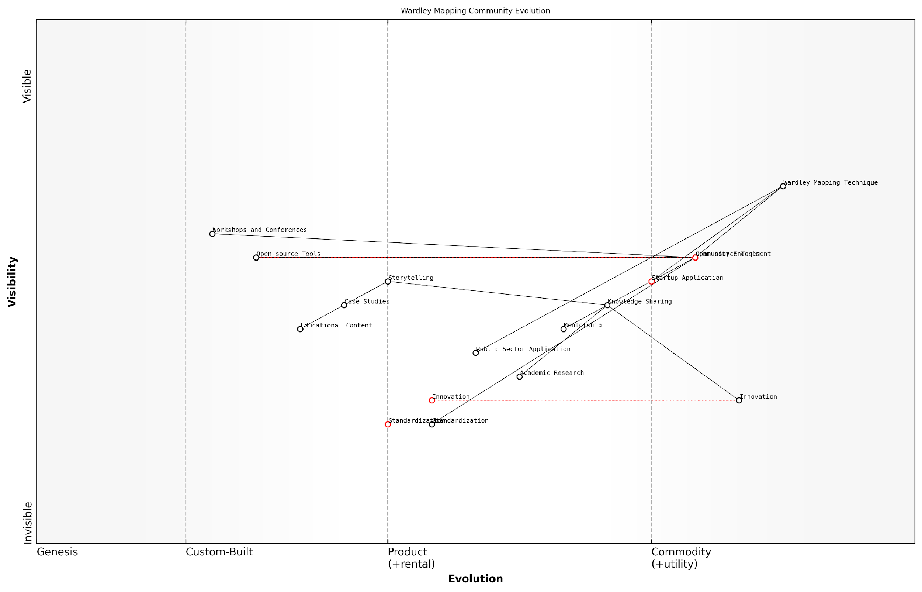

*Draft Wardley Map: [Insert Wardley Map: Invitation to share experiences and contribute to the field]*

[Edit this draft Wardley Map](https://create.wardleymaps.ai/#clone:44a9f009b66d94cb1c)

Wardley Map Assessment

The Wardley Mapping community is in a strong position with a mature core technique and an engaged community driving growth and innovation. The key strategic focus should be on balancing the rapid, community-driven evolution with efforts to standardise and academically validate the technique. This will ensure long-term sustainability and broader adoption across various sectors. Leveraging the strong startup application focus while expanding into the public sector and academic realms presents significant opportunities for growth and impact. The community should also prepare for the integration of emerging technologies, particularly AI, which could revolutionise the practice of Wardley Mapping.

[View full Wardley Map report](http://markdown_wardley_map_reports/wardley_map_report_78_Invitation_to_share_experiences_and_contribute_to_.md)

In the government and public sector context, where I have extensive experience, the potential for Wardley Mapping to drive innovation and efficiency is immense. However, the unique challenges and constraints of these sectors often require tailored approaches. Your experiences in applying Wardley Mapping within regulatory frameworks or in addressing public sector challenges could provide invaluable insights for others navigating similar terrain.

The application of Wardley Mapping in government and public sector startups has the potential to revolutionise service delivery and policy-making. By sharing our experiences, we can collectively build a body of knowledge that empowers public sector innovators to drive meaningful change.

As the field of Wardley Mapping continues to grow, there’s an increasing need for standardisation and best practices, particularly in how we teach and apply the technique. Consider contributing to the development of certification programmes, curriculum design, or standardised methodologies. Your input could help ensure that future practitioners are equipped with the most effective and up-to-date knowledge.

Lastly, don’t underestimate the power of storytelling. Your journey with Wardley Mapping, complete with its challenges, breakthroughs, and lessons learned, can inspire and guide others. Consider writing blog posts, articles, or even a book about your experiences. These narratives not only contribute to the collective knowledge but also help demystify the technique for newcomers, encouraging wider adoption.

* Write case studies detailing your Wardley Mapping experiences
* Contribute to industry publications and journals
* Speak at startup events and conferences about your mapping journey
* Create educational content such as videos or podcasts
* Engage with the Wardley Mapping community on social media platforms

In conclusion, your journey with Wardley Mapping doesn’t end with the closing of this book—it’s just beginning. By actively engaging with the community, sharing your experiences, and contributing to the field’s advancement, you not only enhance your own practice but also play a vital role in shaping the future of strategic thinking for startups. Remember, every map you create, every insight you share, and every innovation you introduce has the potential to inspire and empower others in their entrepreneurial journey.

The true power of Wardley Mapping lies not in the technique itself, but in the collective intelligence of the community that wields it. By contributing your unique perspectives and experiences, you become part of a global movement that is redefining how startups navigate uncertainty and drive innovation.

As we look to the future, the potential for Wardley Mapping to transform startup strategy and decision-making is boundless. Your contributions, no matter how small they may seem, are integral to realising this potential. So, I encourage you to take that first step—share your maps, join the conversation, and become an active participant in this exciting field. Together, we can build a more resilient, innovative, and successful startup ecosystem, powered by the strategic insights of Wardley Mapping.

# Appendix: Further Reading on Wardley Mapping

The following books, primarily authored by Mark Craddock, offer comprehensive insights into various aspects of Wardley Mapping:

## Core Wardley Mapping Series

1. **Wardley Mapping, The Knowledge: Part One, Topographical Intelligence in Business**
   * Author: Simon Wardley
   * Editor: Mark Craddock
   * Part of the Wardley Mapping series (5 books)
   * Available in Kindle Edition
   * [Amazon Link](https://www.amazon.com/dp/B0BVSXB5W5)

* This foundational text introduces readers to the Wardley Mapping approach:
  + Covers key principles, core concepts, and techniques for creating situational maps
  + Teaches how to anchor mapping in user needs and trace value chains
  + Explores anticipating disruptions and determining strategic gameplay
  + Introduces the foundational doctrine of strategic thinking
  + Provides a framework for assessing strategic plays
  + Includes concrete examples and scenarios for practical application
* The book aims to equip readers with:
  + A strategic compass for navigating rapidly shifting competitive landscapes
  + Tools for systematic situational awareness
  + Confidence in creating strategic plays and products
  + An entrepreneurial mindset for continual learning and improvement

1. **Wardley Mapping Doctrine: Universal Principles and Best Practices that Guide Strategic Decision-Making**
   * Author: Mark Craddock
   * Part of the Wardley Mapping series (5 books)
   * Available in Kindle Edition
   * [Amazon Link](https://www.amazon.com/dp/B0C2SFTR7Z)

* This book explores how doctrine supports organisational learning and adaptation:
  + Standardisation: Enhances efficiency through consistent application of best practices
  + Shared Understanding: Fosters better communication and alignment within teams
  + Guidance for Decision-Making: Offers clear guidelines for navigating complexity
  + Adaptability: Encourages continuous evaluation and refinement of practices
* Key features:
  + In-depth analysis of doctrine’s role in strategic thinking
  + Case studies demonstrating successful application of doctrine
  + Practical frameworks for implementing doctrine in various organisational contexts
  + Exploration of the balance between stability and flexibility in strategic planning
* Ideal for:
  + Business leaders and executives
  + Strategic planners and consultants
  + Organisational development professionals
  + Anyone interested in enhancing their strategic decision-making capabilities

1. **Wardley Mapping Gameplays: Transforming Insights into Strategic Actions**
   * Author: Mark Craddock
   * Part of the Wardley Mapping series (5 books)
   * Available in Kindle Edition
   * [Amazon Link](https://www.amazon.com/dp/B0C7CR9R9Q)

* This book delves into gameplays, a crucial component of Wardley Mapping:
  + Gameplays are context-specific patterns of strategic action derived from Wardley Maps
  + Types of gameplays include:
    - User Perception plays (e.g., education, bundling)
    - Accelerator plays (e.g., open approaches, exploiting network effects)
    - De-accelerator plays (e.g., creating constraints, exploiting IPR)
    - Market plays (e.g., differentiation, pricing policy)
    - Defensive plays (e.g., raising barriers to entry, managing inertia)
    - Attacking plays (e.g., directed investment, undermining barriers to entry)
    - Ecosystem plays (e.g., alliances, sensing engines)
* Gameplays enhance strategic decision-making by:
  1. Providing contextual actions tailored to specific situations
  2. Enabling anticipation of competitors’ moves
  3. Inspiring innovative approaches to challenges and opportunities
  4. Assisting in risk management
  5. Optimising resource allocation based on strategic positioning
* The book includes:
  + Detailed explanations of each gameplay type
  + Real-world examples of successful gameplay implementation
  + Frameworks for selecting and combining gameplays
  + Strategies for adapting gameplays to different industries and contexts

1. **Navigating Inertia: Understanding Resistance to Change in Organisations**
   * Author: Mark Craddock
   * Part of the Wardley Mapping series (5 books)
   * Available in Kindle Edition
   * [Amazon Link](https://www.amazon.com/dp/B0C34FX8XC)

* This comprehensive guide explores organisational inertia and strategies to overcome it:
* Key Features:
  + In-depth exploration of inertia in organisational contexts
  + Historical perspective on inertia’s role in business evolution
  + Practical strategies for overcoming resistance to change
  + Integration of Wardley Mapping as a diagnostic tool
* The book is structured into six parts:
  1. Understanding Inertia: Foundational concepts and historical context
  2. Causes and Effects of Inertia: Internal and external factors contributing to inertia
  3. Diagnosing Inertia: Tools and techniques, including Wardley Mapping
  4. Strategies to Overcome Inertia: Interventions for cultural, behavioural, structural, and process improvements
  5. Case Studies and Practical Applications: Real-world examples and implementation frameworks
  6. The Future of Inertia Management: Emerging trends and building adaptive capabilities
* This book is invaluable for:
  + Organisational leaders and managers
  + Change management professionals
  + Business strategists and consultants
  + Researchers in organisational behaviour and management

1. **Wardley Mapping Climate: Decoding Business Evolution**
   * Author: Mark Craddock
   * Part of the Wardley Mapping series (5 books)
   * Available in Kindle Edition
   * [Amazon Link](https://www.amazon.com/dp/B0BVHF2MBH)

* This comprehensive guide explores climatic patterns in business landscapes:
* Key Features:
  + In-depth exploration of 31 climatic patterns across six domains: Components, Financial, Speed, Inertia, Competitors, and Prediction
  + Real-world examples from industry leaders and disruptions
  + Practical exercises and worksheets for applying concepts
  + Strategies for navigating uncertainty and driving innovation
  + Comprehensive glossary and additional resources
* The book enables readers to:
  + Anticipate market changes with greater accuracy
  + Develop more resilient and adaptive strategies
  + Identify emerging opportunities before competitors
  + Navigate complexities of evolving business ecosystems
* It covers topics from basic Wardley Mapping to advanced concepts like the Red Queen Effect and Jevon’s Paradox, offering a complete toolkit for strategic foresight.
* Perfect for:
  + Business strategists and consultants
  + C-suite executives and business leaders
  + Entrepreneurs and startup founders
  + Product managers and innovation teams
  + Anyone interested in cutting-edge strategic thinking

## Practical Resources

1. **Wardley Mapping Cheat Sheets & Notebook**
   * Author: Mark Craddock
   * 100 pages of Wardley Mapping design templates and cheat sheets
   * Available in paperback format
   * [Amazon Link](https://www.amazon.com/dp/B09TPDM9PP)

* This practical resource includes:
  + Ready-to-use Wardley Mapping templates
  + Quick reference guides for key Wardley Mapping concepts
  + Space for notes and brainstorming
  + Visual aids for understanding mapping principles
* Ideal for:
  + Practitioners looking to quickly apply Wardley Mapping techniques
  + Workshop facilitators and educators
  + Anyone wanting to practise and refine their mapping skills

## Specialized Applications

1. **UN Global Platform Handbook on Information Technology Strategy: Wardley Mapping The Sustainable Development Goals (SDGs)**
   * Author: Mark Craddock
   * Explores the use of Wardley Mapping in the context of sustainable development
   * Available for free with Kindle Unlimited or for purchase
   * [Amazon Link](https://www.amazon.com/dp/B09PNKFHG4)

* This specialised guide:
  + Applies Wardley Mapping to the UN’s Sustainable Development Goals
  + Provides strategies for technology-driven sustainable development
  + Offers case studies of successful SDG implementations
  + Includes practical frameworks for policy makers and development professionals

1. **AIconomics: The Business Value of Artificial Intelligence**
   * Author: Mark Craddock
   * Applies Wardley Mapping concepts to the field of artificial intelligence in business
   * [Amazon Link](https://www.amazon.com/dp/B0C6V9VZ9B)

* This book explores:
  + The impact of AI on business landscapes
  + Strategies for integrating AI into business models
  + Wardley Mapping techniques for AI implementation
  + Future trends in AI and their potential business implications
* Suitable for:
  + Business leaders considering AI adoption
  + AI strategists and consultants
  + Technology managers and CIOs
  + Researchers in AI and business strategy

These resources offer a range of perspectives and applications of Wardley Mapping, from foundational principles to specific use cases. Readers are encouraged to explore these works to enhance their understanding and application of Wardley Mapping techniques.

Note: Amazon links are subject to change. If a link doesn’t work, try searching for the book title on Amazon directly.